BUDDHA COGNITIVE LAB / HIRE BUDDHA
HIRE BUDDHA

WhatsApp workspace
intended experience and user guide
How businesses connect their channel, orchestrate AI and human conversations, manage WhatsApp content, and read outcomes.
Concept guide · 03 October 2026

CONCEPT STATUS The screens in this guide show planned functionality. Every action in the prototype is simulated: it does not connect a Meta account, register a number, send a message, or save customer data.

Who this is for
Business administrators can use the guide to understand setup and controls. Supervisors and inbox teammates can follow the daily conversation flow. The last page explains the separate platform-admin readiness view for HireBuddha’s Meta partner path.

The journey at a glance
Connect | Orchestrate | Attend | Understand
Enroll a business-owned number through Meta and verify channel health. | Publish an agentic flow with permission, service-window, and template gates. | See each conversation and take human ownership when needed. | Trace sends, status events, replies, outcomes, and failures.

Read the diagrams as decision maps and the screenshots as illustrations of the intended product. Meta-hosted steps, asset eligibility, review, and approval remain under Meta’s control.

01 / ORIENT

Start in the channel overview
The overview gives the tenant one place to see readiness, attention items, conversation volume, and the next operational action.
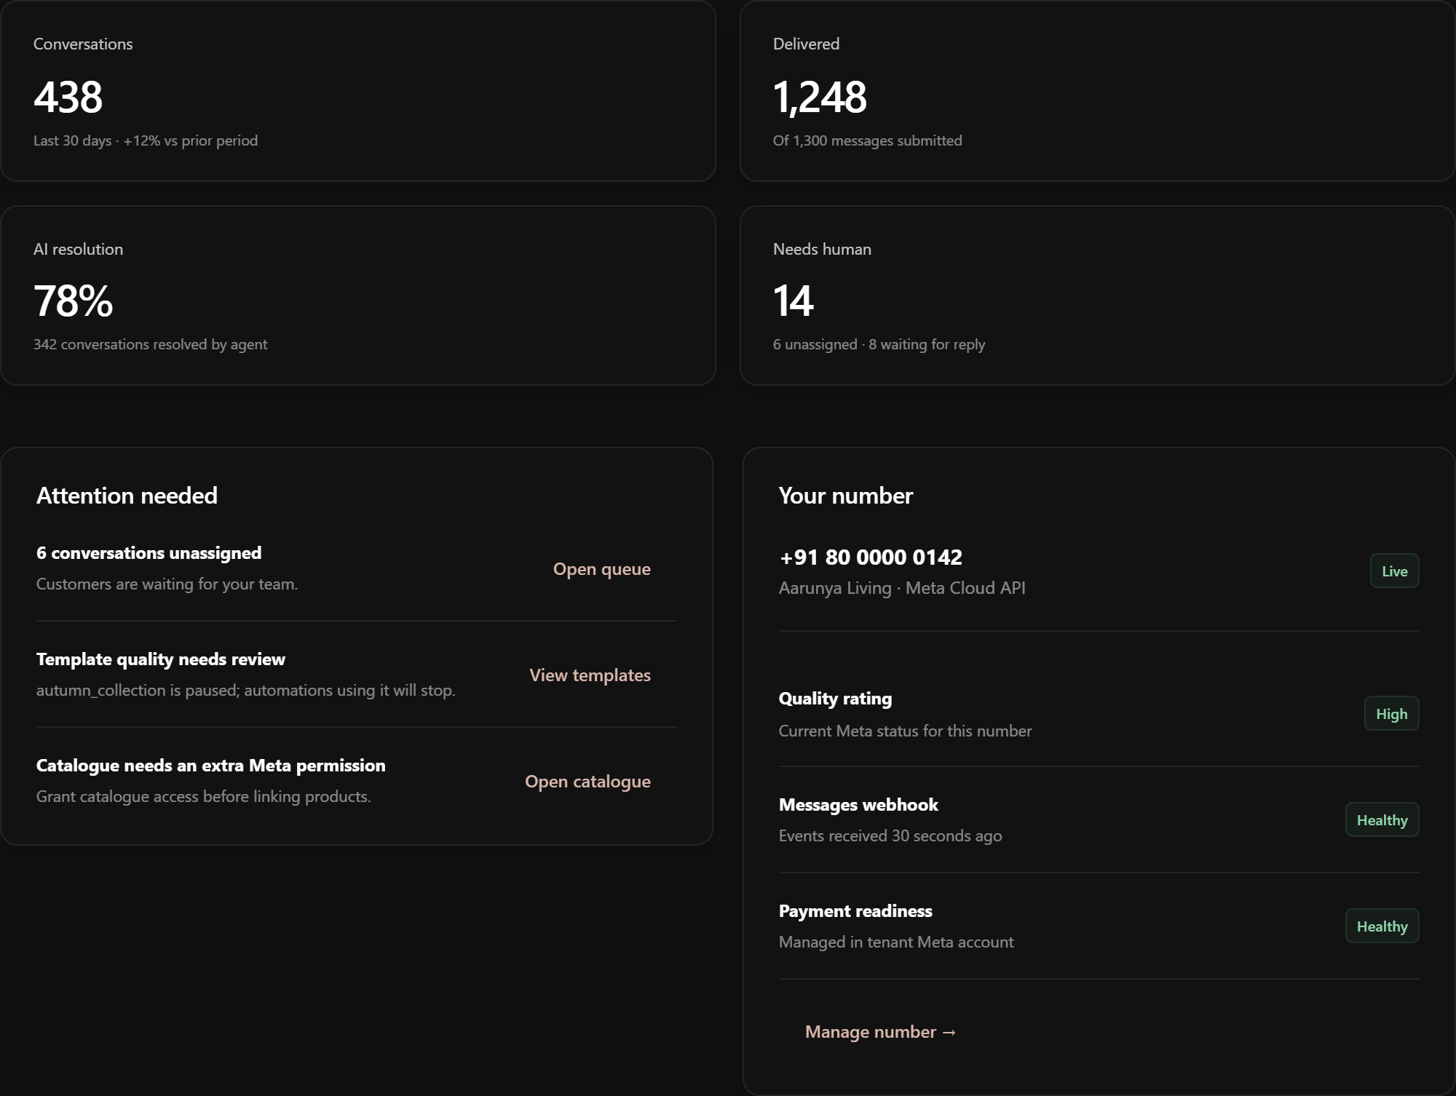
Figure 1 · Concept screen: channel overview and attention queue

What the overview answers
01 Is the channel ready. Check the number state and health alerts before enabling automatic or campaign sends.
02 Where does a person need to act. Open the attention queue for failed delivery, pending approvals, permission issues, and conversations awaiting a teammate.
03 What happened today. Use the headline counts as a starting point, then open Analytics for definitions, filters, and event-level detail.
FIND THE WORKSPACE Open Communications → WhatsApp. From there, choose Connect, Numbers, Shared inbox, Automations, Content, Contacts, Campaigns, or Analytics for the task at hand. The screenshots show only each screen’s working area.

02 / CONNECT

Enroll a business-owned number
The business initiates enrollment in HireBuddha, completes the Meta-hosted steps, then returns for access and delivery checks. The business owns the Meta assets; HireBuddha requests scoped access to operate them.
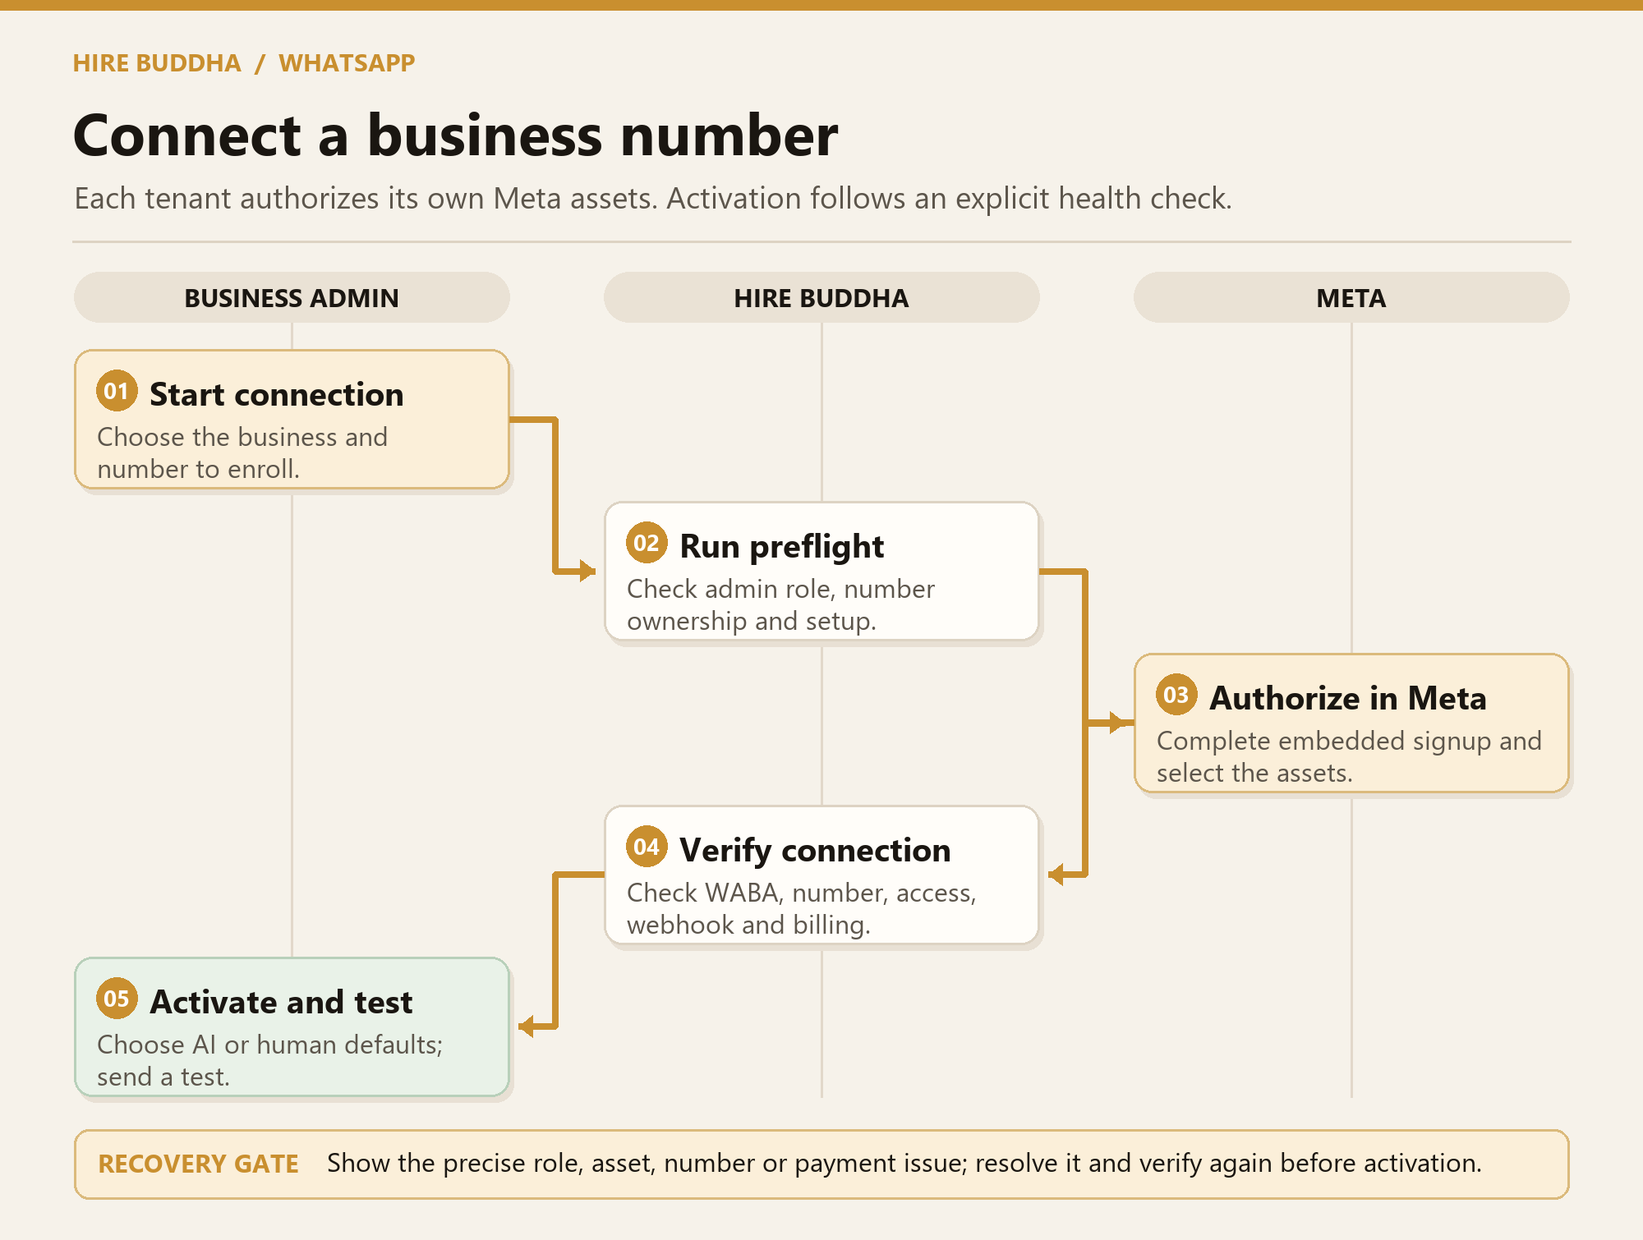
Figure 2 · Intended onboarding and recovery flow

Before you begin
Use an administrator who can act for the Meta business. Have the business identity, an eligible number, and access to any verification or billing actions Meta asks for. Existing-number migration or coexistence is conditional on Meta eligibility and should be checked in the hosted flow.

What can block activation
A completed signup is not the same as a ready channel. The planned checks cover asset permissions, number registration, webhook subscription, billing readiness, and an internal send-and-receive test. A failed or interrupted step should leave a recoverable status and a clear reconnect or resume action.

03 / CONNECT

Prepare the Meta connection
The Connect screen explains the business-owned asset model and asks the administrator to confirm the number path before leaving HireBuddha for Meta.
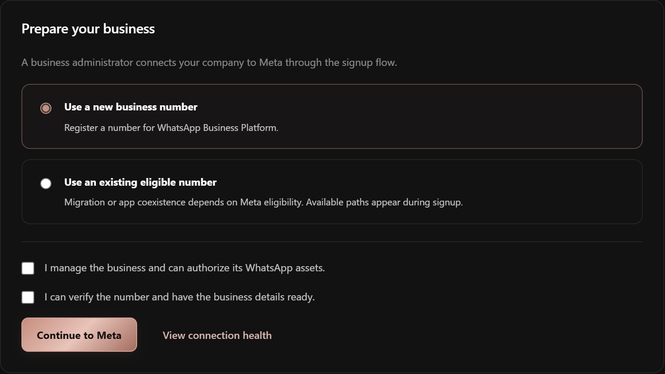
Figure 3 · Concept screen: preparation before Meta Embedded Signup

How to use it
01 Choose the number path. Select a new number or an eligible existing number. Keep the number available for verification and avoid assuming every migration path is supported.
02 Confirm authority. Review the business and number details and attest that you can grant the requested access.
03 Continue to Meta. Select or create the Meta business portfolio and WhatsApp Business Account in Meta’s hosted flow, then approve the selected assets and return to HireBuddha.

04 / CONNECT

Verify the channel before sending
On return from Meta, HireBuddha should show each requirement independently. Administrators can see what passed, what is pending, and where to recover.
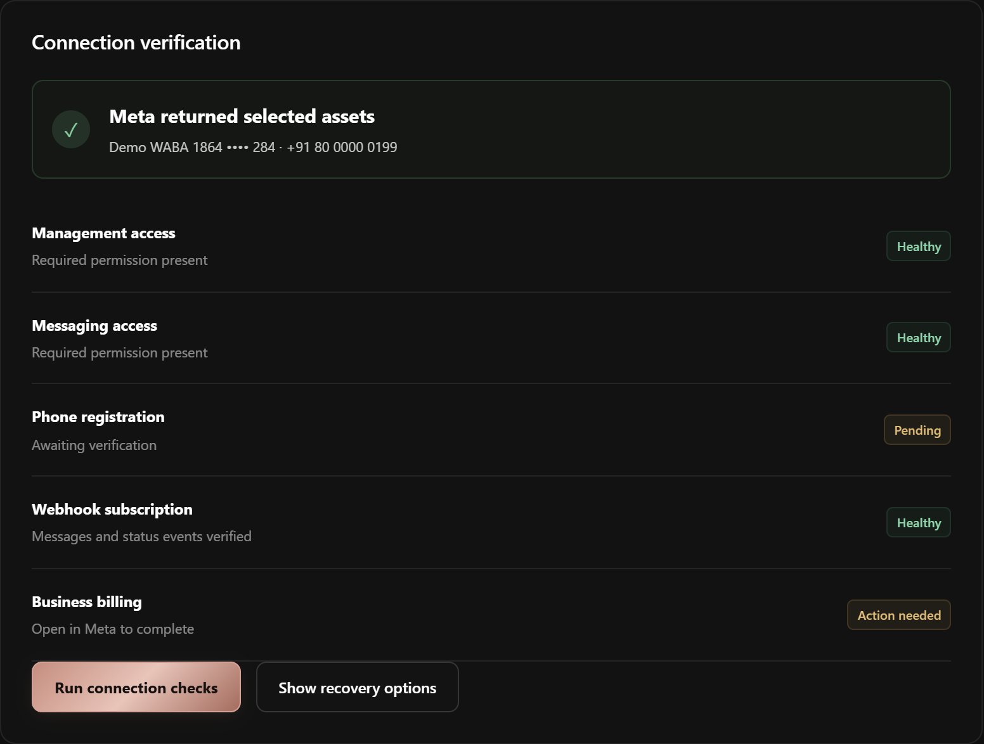
Figure 4 · Concept screen: asset, registration, webhook, and billing checks

Activation sequence
01 Inspect the checks. Resolve missing management or messaging access, incomplete number registration, webhook failures, and required Meta billing steps.
02 Run a controlled test. Send and receive with an internal test contact, then confirm that message status events arrive.
03 Activate deliberately. Assign the inbox team, business hours, escalation route, and default AI mode only after the channel is healthy.
RECOVERY An interrupted signup should resume at the correct step. A missing permission should lead to reconnect, while unresolved registration or billing should block outbound sending.

05 / OPERATE

Set the number profile and routing
A connected number needs business-facing details and operational rules so customers receive a consistent response.
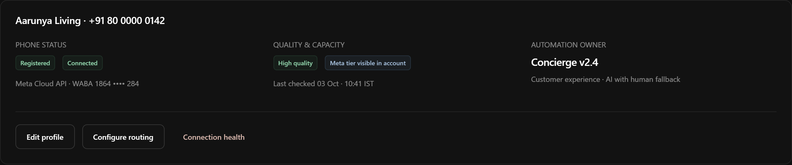
Figure 5 · Concept screen: number profile, routing, and channel controls

How to use it
01 Review the profile. Set the display and business details that the available Meta API allows, then inspect the customer-facing preview.
02 Route incoming messages. Choose the initial queue or published agent, working hours, and fallback owner.
03 Control automation. Pause automatic replies or outbound activity if the channel, agent, or business process needs attention. Keep an audit trail of who changed the state.

06 / OPERATE

Watch connection health
Health translates Meta and HireBuddha signals into specific actions. It should explain which checks affect receiving, replying, template use, and campaigns.
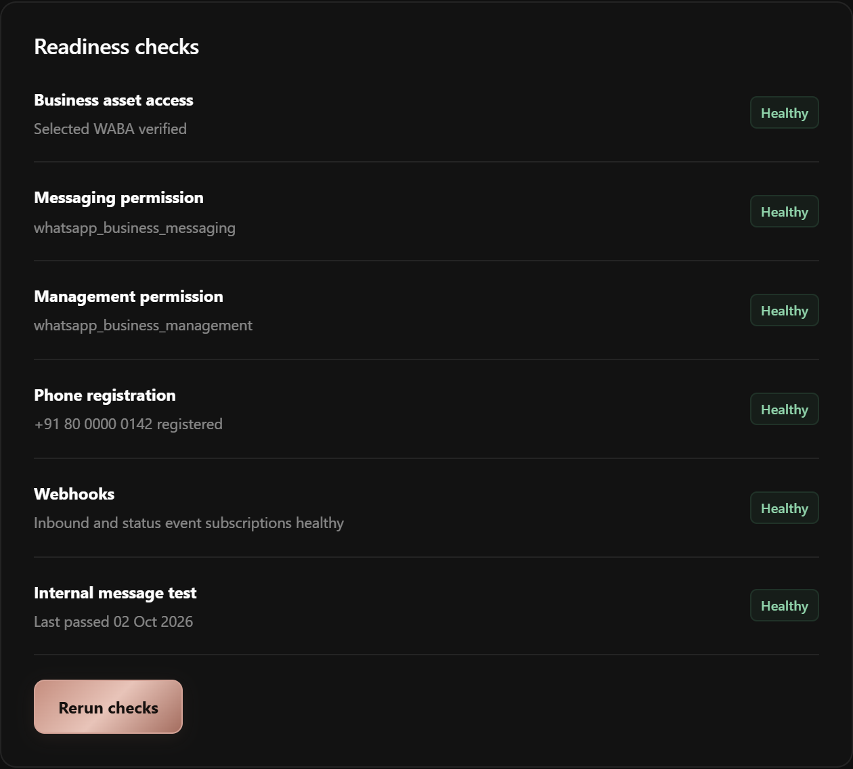
Figure 6 · Concept screen: connection status and recovery path

What to check regularly
01 Access and registration. Watch asset grants, number state, quality or limits where available, and the most recent successful API check.
02 Webhooks and status events. Check the last inbound message and delivery-status event. Delayed events should be visible as a reporting limitation.
03 Recover safely. Open the recommended fix for each failing check; retest before restoring paused sends.

07 / CONVERSATIONS

Let AI help and keep a human path
The system should decide whether a published AI flow can answer, whether a Meta-approved template is required, or whether a person must take ownership.
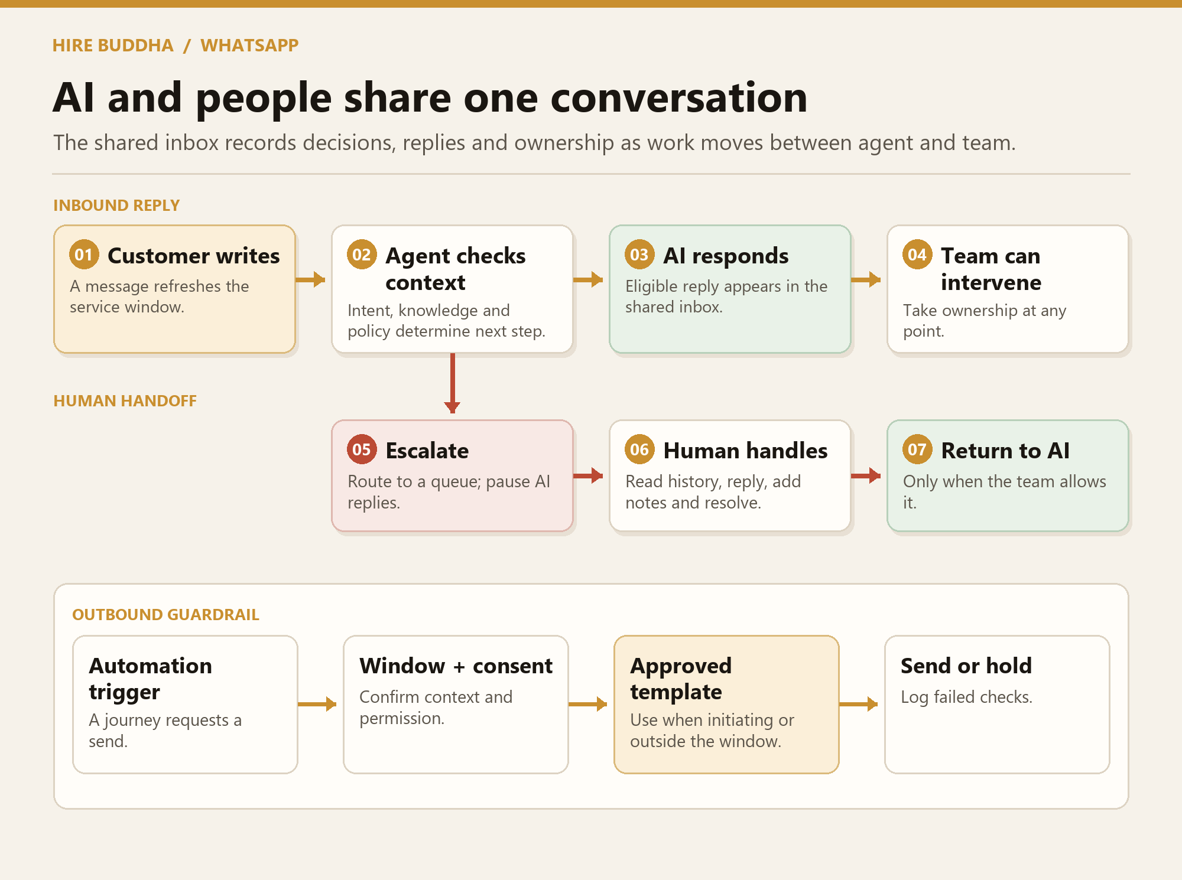
Figure 7 · Intended message window and human handoff flow

The important boundary
A customer message opens or refreshes Meta’s 24-hour customer service window. Within that window, eligible freeform replies can be sent. Outside it, a business-initiated message must use an approved template. Permission and opt-out controls apply in either case.

One owner at a time
Human takeover pauses the AI agent on that conversation. The teammate can read context, reply, assign, add an internal note, and resolve. Resuming AI is an explicit action after the human finishes; it should never race a human composer.

08 / CONVERSATIONS

Read an AI-owned conversation
The shared inbox should show what the customer said, what the agent sent, which flow version acted, and what the channel reported afterward.
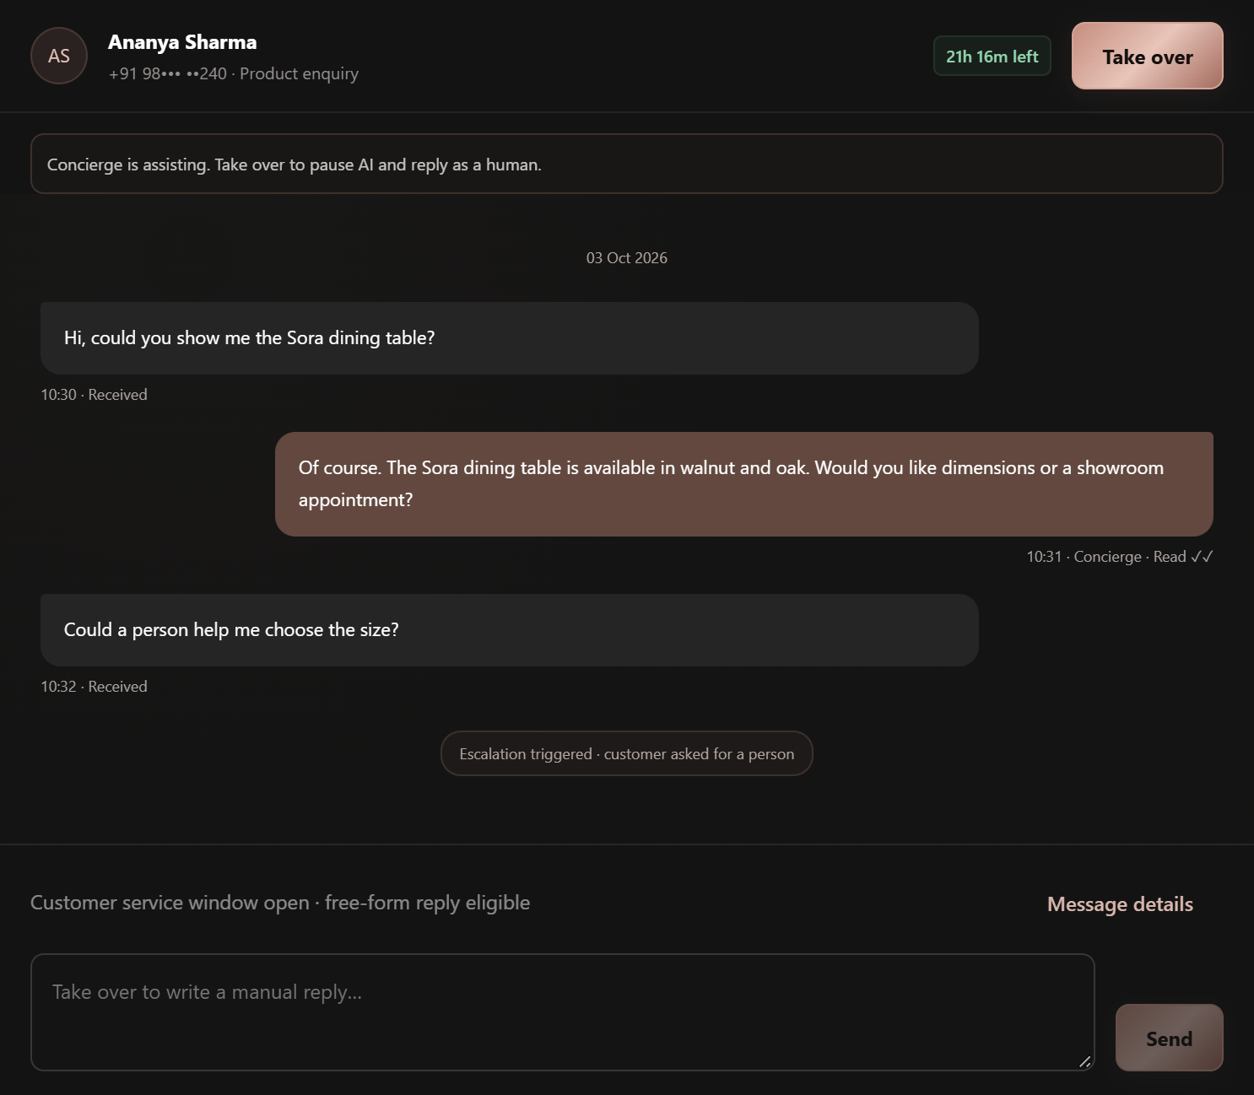
Figure 8 · Concept screen: AI-owned customer conversation

How to use it
01 Choose a queue and thread. Filter by owner, attention state, number, or campaign and open the full conversation history.
02 Check the decision context. Look at permission, service-window state, automation step, delivery status, and any failure or escalation reason.
03 Intervene when needed. If the customer asks for a person or the agent is uncertain, take over or assign a teammate. The planned system should preserve a visible event trail.

09 / CONVERSATIONS

Take over and return control
A teammate needs a clear control boundary. Taking over should stop further AI sends for that thread before the human begins typing.
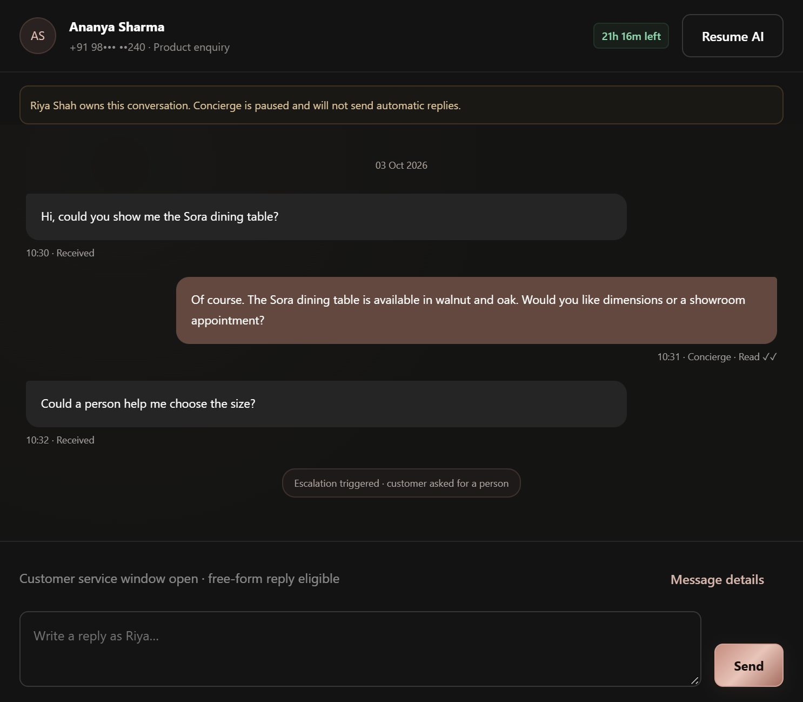
Figure 9 · Concept screen: human-owned thread with AI paused

How to use it
01 Take over. Claim the conversation and verify the owner badge changes to human. Use the conversation context before replying.
02 Reply within the channel rules. Send a freeform reply while the customer service window is open. If closed, select an approved template or wait for a customer message.
03 Resolve and decide on AI. Record an outcome, transfer or close the thread, and deliberately resume the agent only if the next step is appropriate.
ESCALATION The intended design gives customers a clear way to reach a person. A human request should be traceable from customer message through assignment and response.

10 / AUTOMATIONS

Design a safe agentic flow
An automation joins a trigger, a published AI employee, message policy gates, approved content, and escalation rules. A preview run should expose each decision before publication.
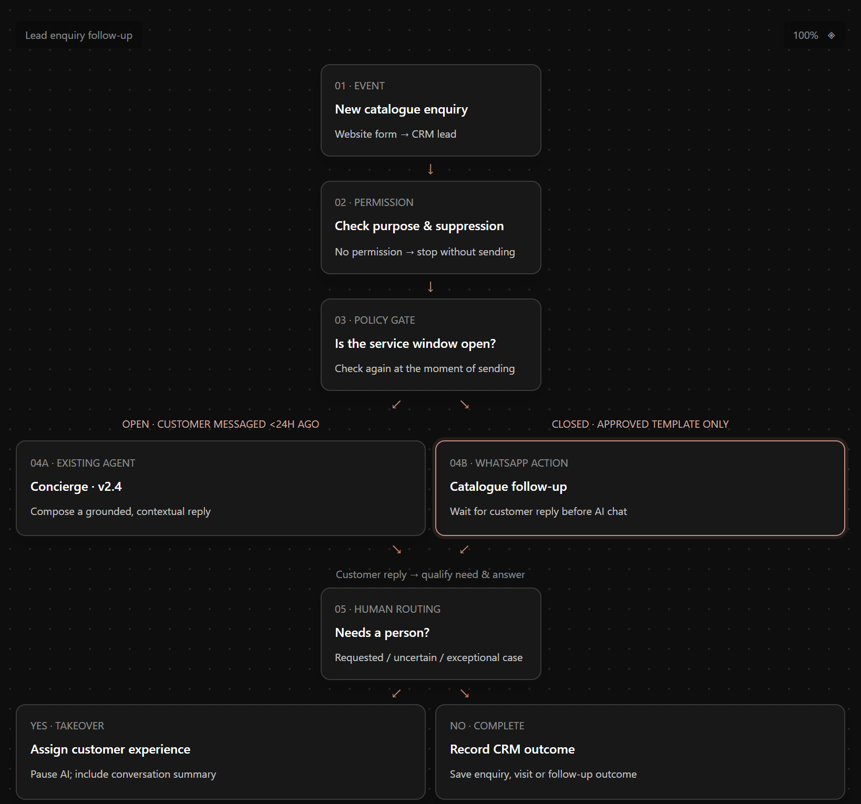
Figure 10 · Concept screen: flow canvas, policy gates, and inspector

Build and publish
01 Choose trigger and purpose. Start from an incoming enquiry, an allowed follow-up, or another supported event; attach the specific permission purpose.
02 Set both message branches. Use contextual AI within the open service window. On the closed branch, use an approved template with bounded variables; do not rewrite its approved body.
03 Test failure paths. Dry-run opt-out, closed window, human request, paused template, missing permission, and agent fallback. Publish a version only when every route has a safe outcome.

11 / CONTENT

Prepare content before using it
Templates, catalogues, and WhatsApp Flows serve different jobs. Each has its own ownership, validation, Meta state, and dependency checks.
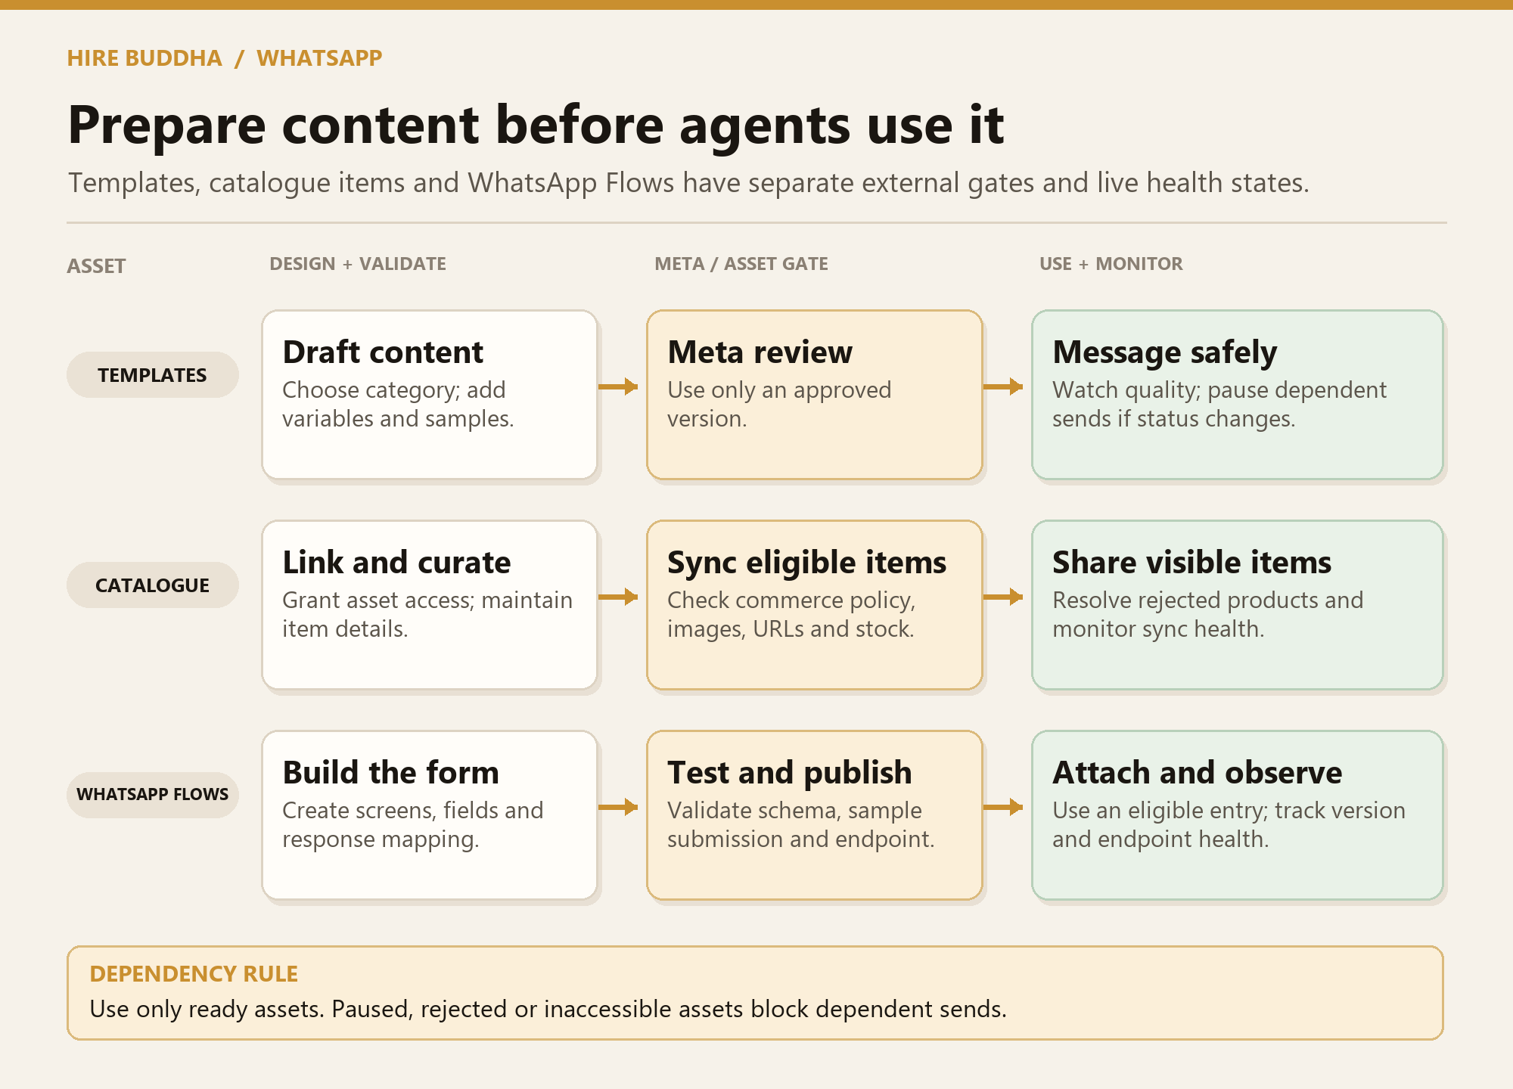
Figure 11 · Intended content lifecycle and send dependencies
Asset | What it is | When it is usable
Message template | A structured WhatsApp message with approved text, language, category, variables, and buttons. | After Meta approval and while its status is healthy.
Catalogue | A business-owned product source linked to the channel for product discovery and commerce messages. | After access, sync, and item eligibility checks.
WhatsApp Flow | An in-WhatsApp customer form or structured interaction, distinct from an AI automation flow. | After validation, test submission, and publication.

HireBuddha should prevent a dependent campaign or automation from using an unavailable asset and show the reason at the point of selection.

12 / CONTENT

Manage Meta message templates
The inventory should show which templates are drafts, submitted, approved, paused, or rejected, and which flows depend on them.
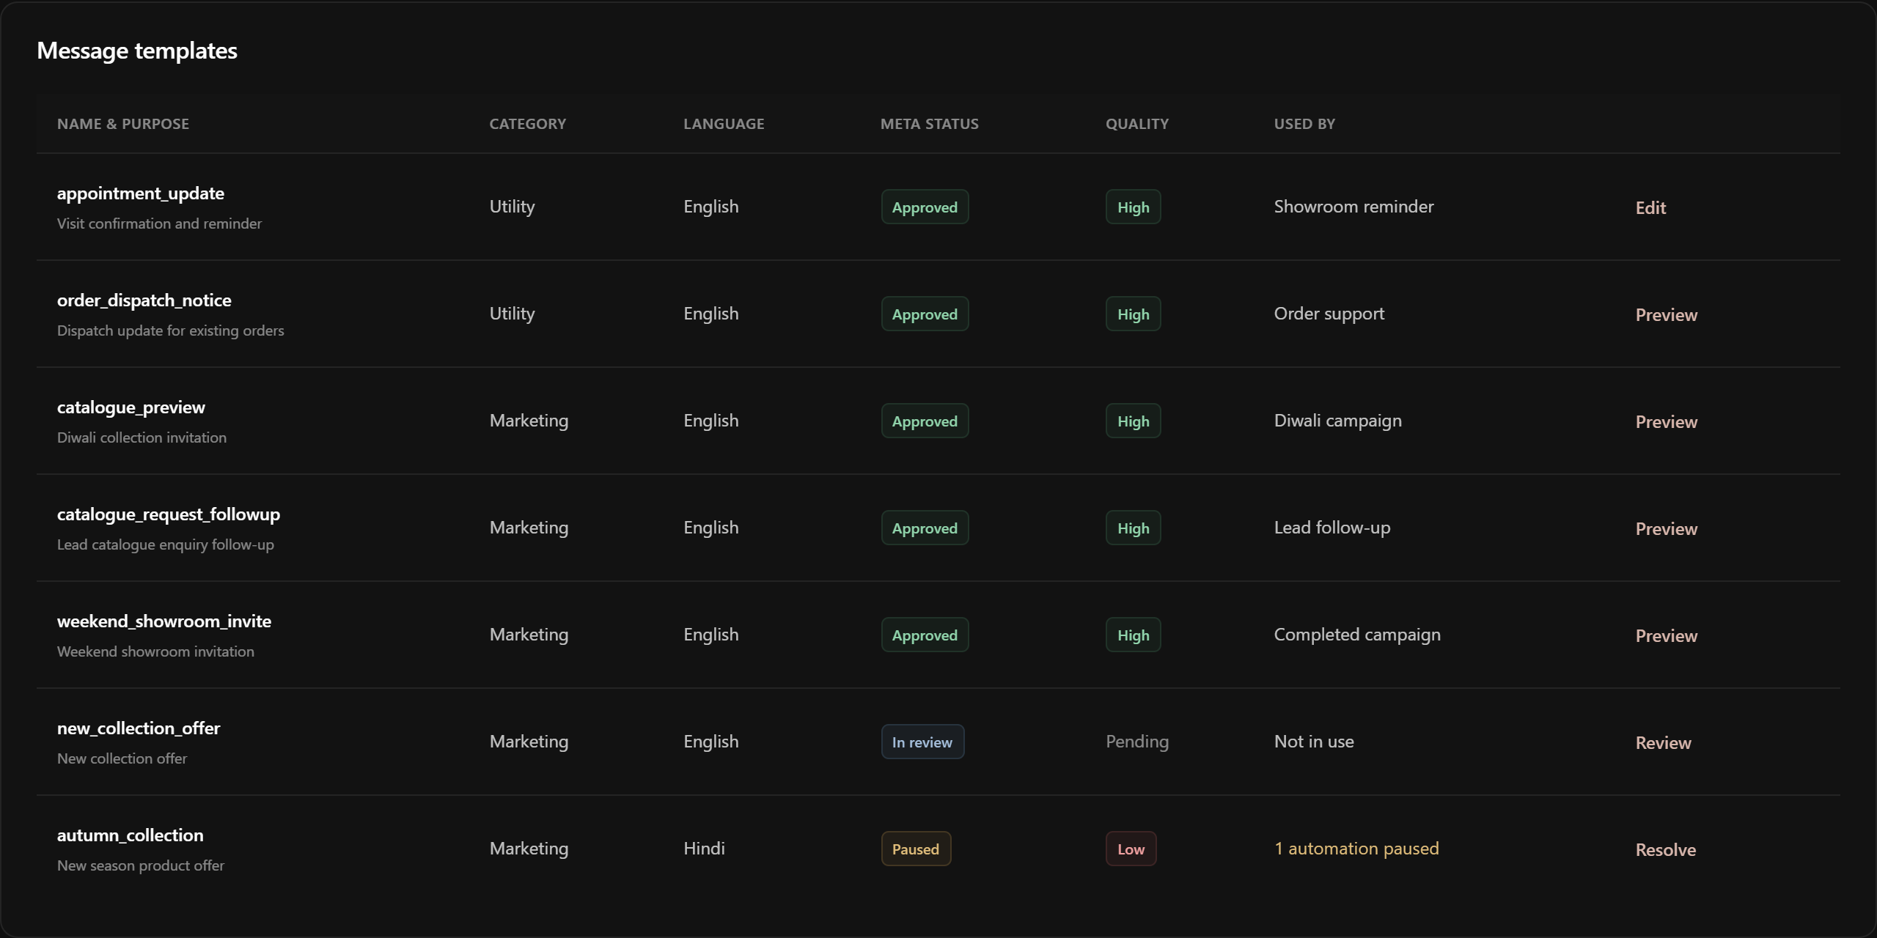
Figure 12 · Concept screen: template inventory and review state

How to use it
01 Find the right template. Filter by purpose, language, category, approval state, and linked automations or campaigns.
02 Inspect status before launch. A paused or rejected template should be unavailable for new sends, with its dependent workflows surfaced.
03 Create a new version when needed. Edit a draft or clone a reviewed template rather than silently changing a message already in use.

13 / CONTENT

Draft the template content
The editor should make every approved element explicit: category, language, header, body, buttons, and representative values for each variable.
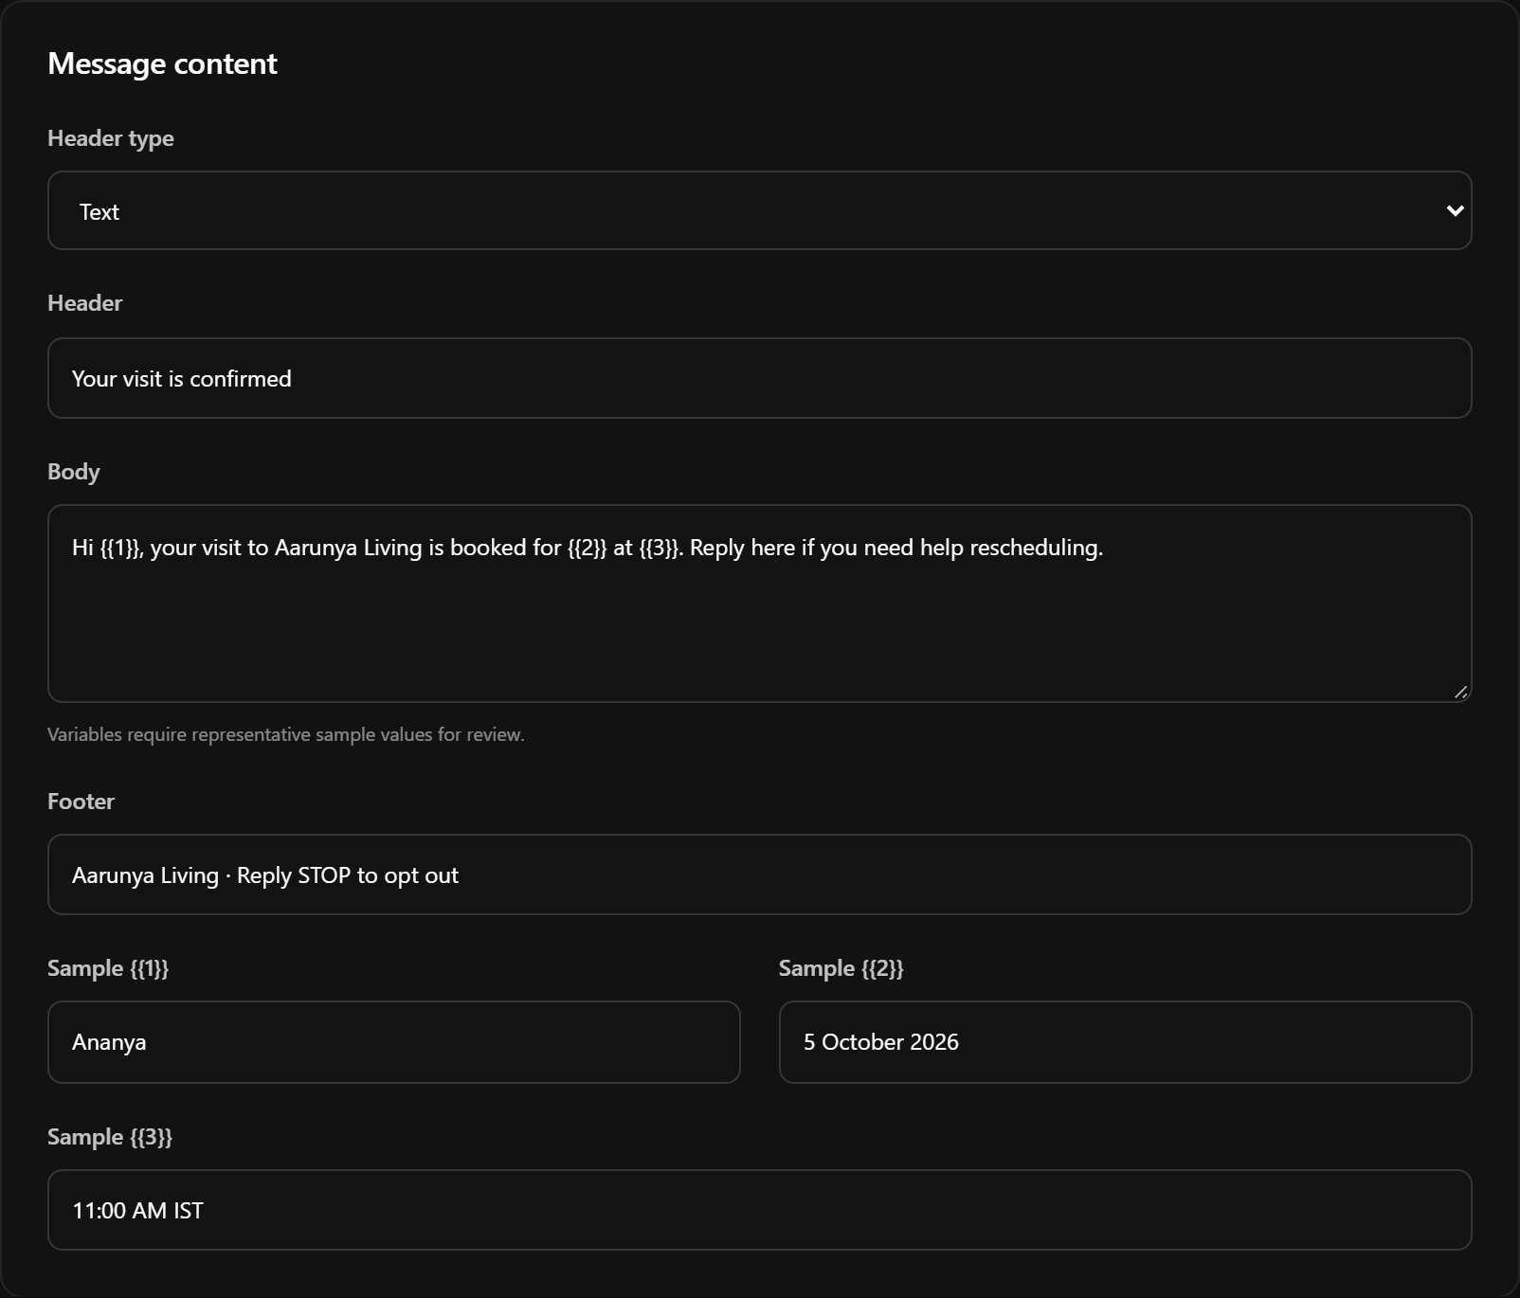
Figure 13 · Concept screen: editable template body and sample variables

Drafting sequence
01 Define purpose. Choose the correct category and language and give the template a stable name.
02 Write the structure. Enter the header, body, footer, and buttons. Keep variable placement stable so the approved message has predictable meaning.
03 Supply samples. Provide representative values for every placeholder and inspect any character or format warnings.

13 / CONTENT / PREVIEW

Check the customer view and submit
The preview is the final content check before a template goes to Meta review. It should use the same sample values that were entered in the editor.
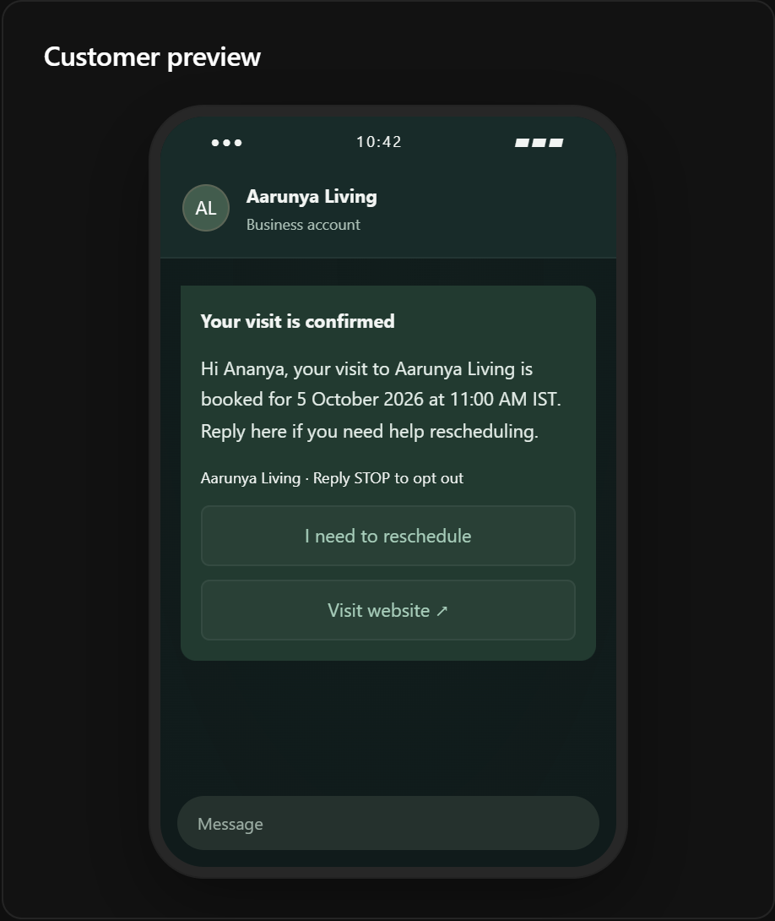
Figure 14 · Concept screen: customer preview of a draft template

Before submission
01 Read it as a customer. Check long names, date and time formats, buttons, and opt-out wording in the mobile view.
02 Validate and submit. Resolve local errors, submit to Meta, and wait for the returned review state.
03 Use only approved content. An automation or campaign should reference only the approved, healthy version; a pause or rejection blocks dependent sends.

14 / CONTENT

Link a business catalogue
A catalogue remains a tenant-owned Meta asset. HireBuddha should show the granted asset, product sync, item eligibility, and how a product appears in a message.
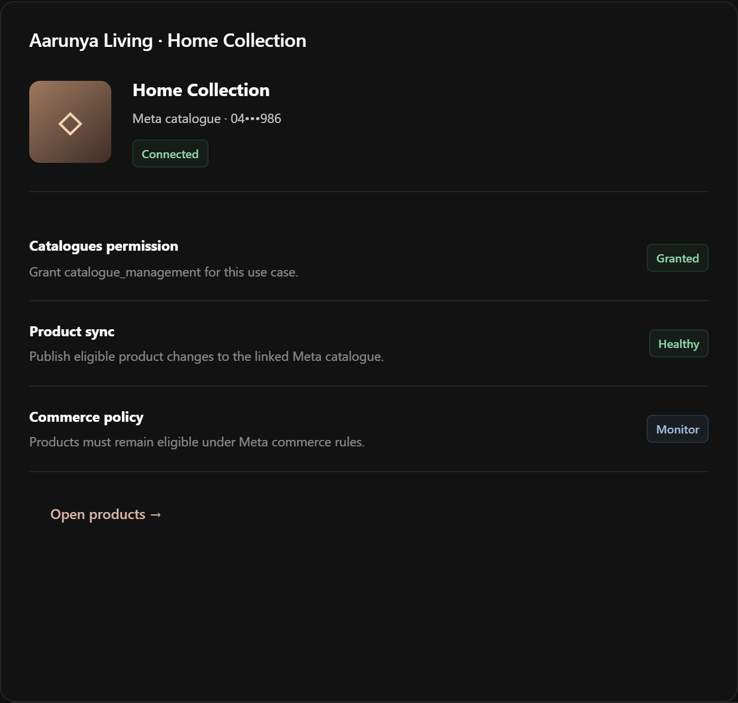
Figure 15 · Concept screen: catalogue connection and product health

How to use it
01 Grant scoped access. Select the intended catalogue for the connected business and number; verify the asset is available to the channel.
02 Review product health. Inspect sync results, missing data, rejected items, and customer-facing previews before an agent or campaign references products.
03 Keep it current. Use the latest product state at send time and block unavailable items rather than sending stale details.

15 / CONTENT

Build a customer-facing WhatsApp Flow
A WhatsApp Flow is an in-chat form or structured interaction, such as a lead intake or booking request. It is separate from the internal AI automation canvas.
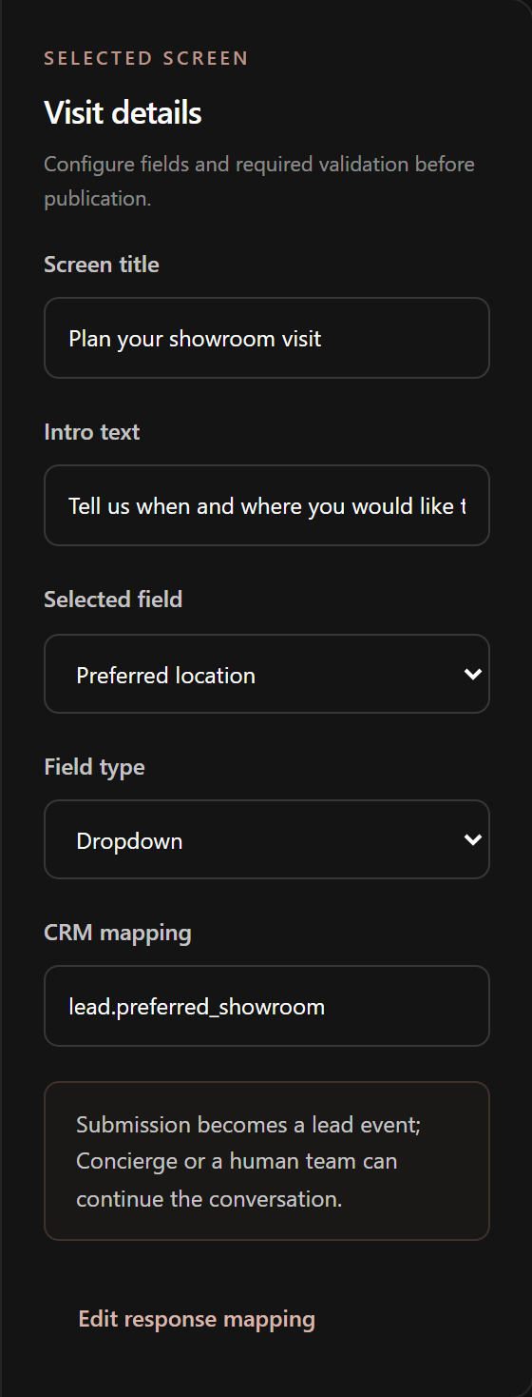
Figure 16 · Concept screen: Flow fields and CRM response mapping

How to use it
01 Design the customer path. Arrange screens and fields, keeping each request necessary and clear in the mobile preview.
02 Map responses. Connect each answer to a lead or customer field and define which agent or teammate receives the completed submission.
03 Validate the destination. Check the field schema and response endpoint before inviting a customer to fill the Flow.

15 / CONTENT / PREVIEW

Test the Flow on a customer screen
Use the mobile preview to inspect each step as the customer will see it, then run a sample submission before publication.
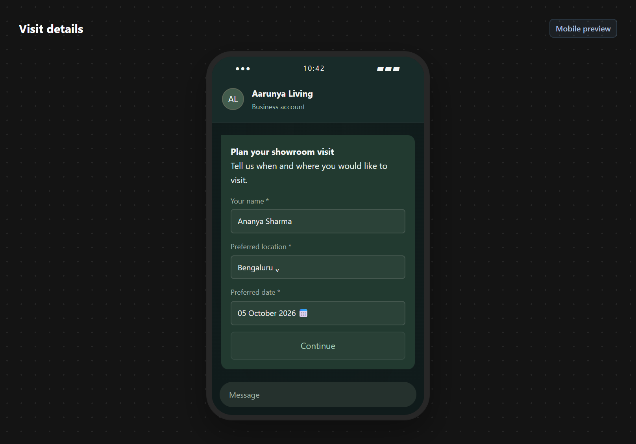
Figure 17 · Concept screen: customer-facing Flow preview

Test and publish
01 Walk every screen. Check field labels, required validation, button text, and mobile fit.
02 Submit sample data. Confirm that the answer maps to the intended lead record and reaches the right agent or team.
03 Publish a version. Attach the published Flow only to eligible messages and monitor endpoint health and submission failures.

16 / CONTACTS

Keep permission evidence with the contact
Importing or syncing a contact does not itself create WhatsApp permission. The intended contact view keeps an auditable record of why and for what purpose the business may message.
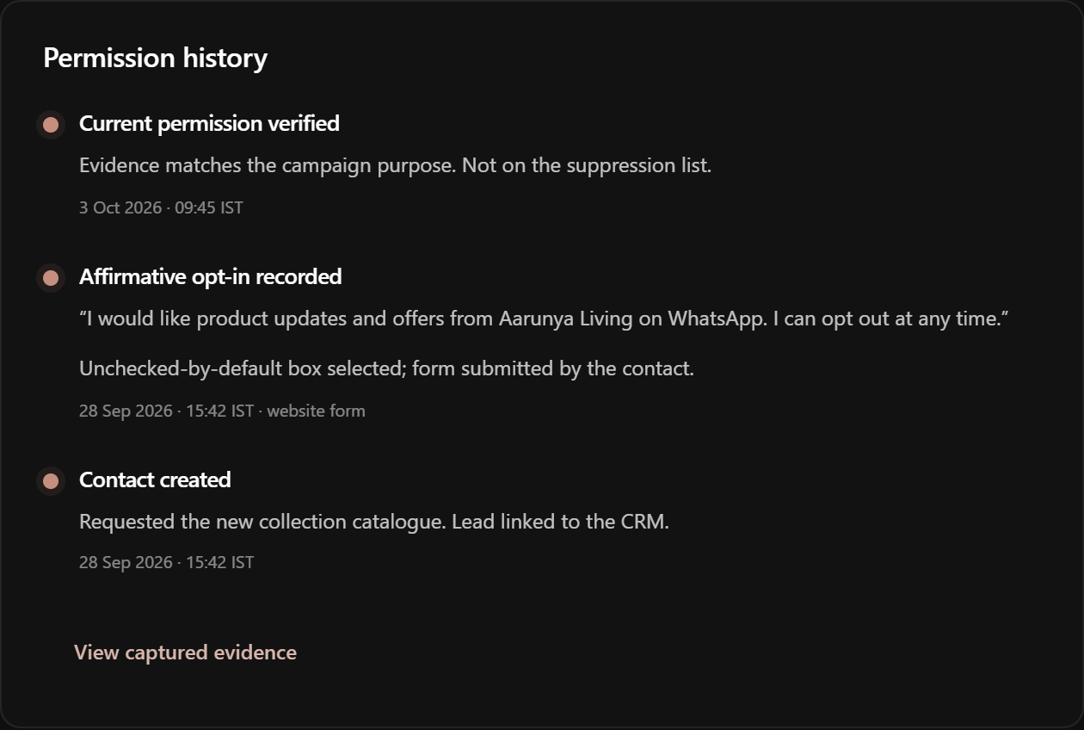
Figure 18 · Concept screen: contact permission and evidence history

What to record
01 Capture affirmative evidence. Store the business, purpose, source, notice wording or version, and timestamp or external reference for the customer’s opt-in.
02 Respect withdrawal. Apply opt-out immediately to future sends while preserving the historical evidence and message trail.
03 Recheck at send time. Campaign membership alone is not a send authorization. Suppression, permission, and channel checks should run for each recipient.

17 / CAMPAIGNS

Review eligibility before a campaign
A campaign should explain who will receive an approved template, why each recipient is eligible, what will be excluded, and how replies will return to the inbox.
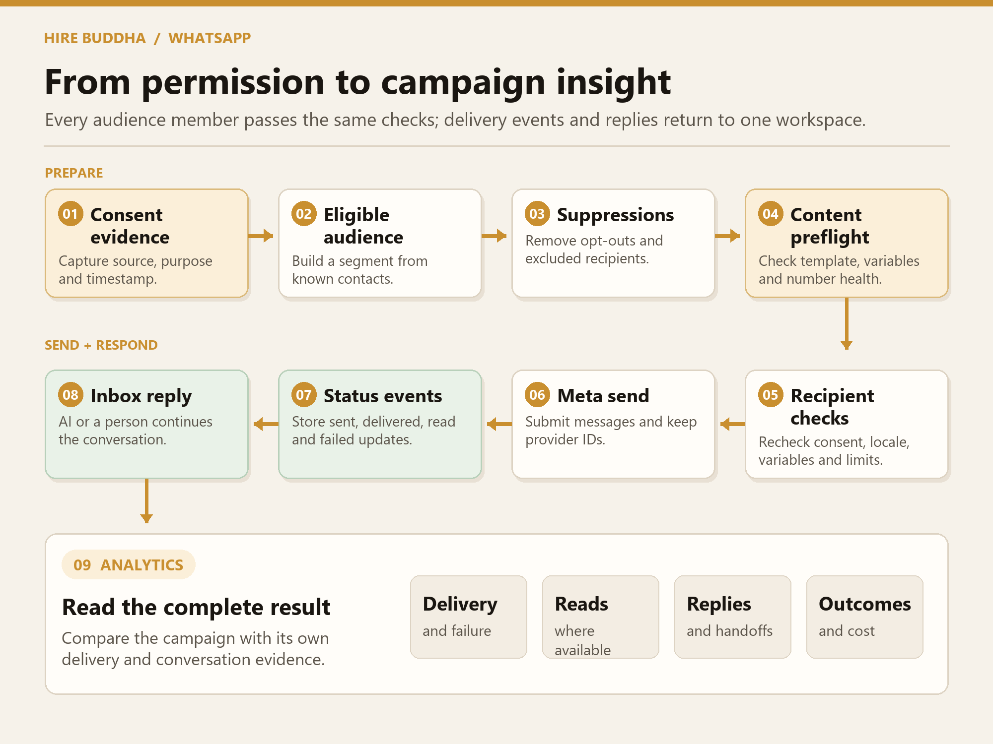
Figure 19 · Intended campaign checks and reporting loop

The preflight contract
The planned review groups exclusions by cause: opt-out, missing permission evidence, duplicates, invalid destination, unavailable template, or channel restrictions. It also shows quiet and frequency rules, capacity, a cost estimate, a spend cap, and reply routing. The estimate is illustrative until reconciled against Meta billing.

Delivery can change
Eligibility is checked again for every scheduled send. If permission is withdrawn, the template is paused, or the channel loses access, that recipient or the campaign should pause with a reason rather than continuing from an old preflight result.

18 / CAMPAIGNS

Inspect and schedule the send
The campaign review is the final business control before a message enters the outbound queue.
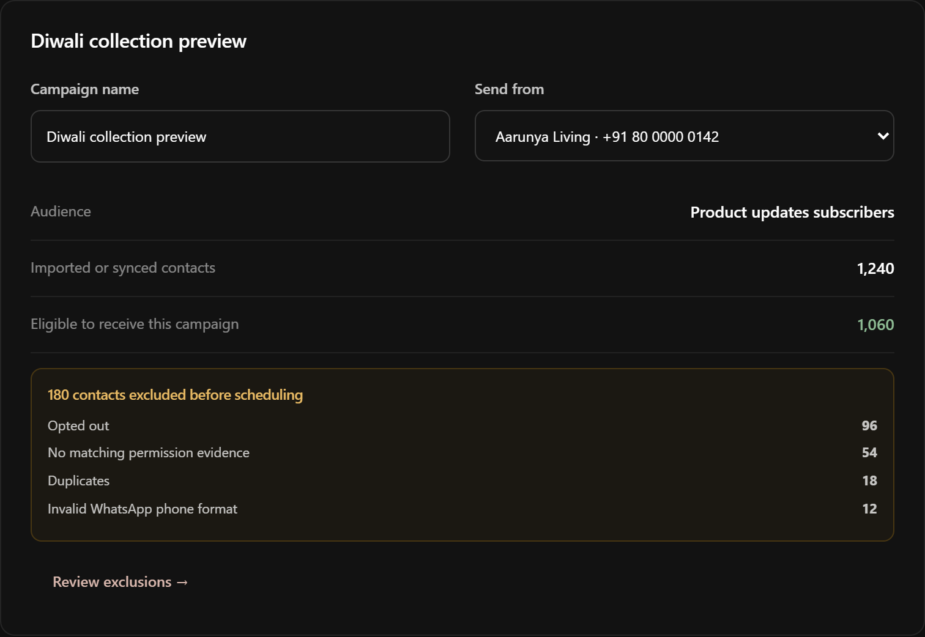
Figure 20 · Concept screen: audience eligibility and exclusions

How to use it
01 Inspect the audience. Compare total contacts with eligible contacts and open each exclusion group to correct source-data problems.
02 Inspect the message. Confirm the approved template, variable mapping, customer preview, target number, and reply owner. Send a controlled test to an internal number.
03 Set limits and schedule. Choose the permitted send window and budget cap, then schedule. Watch the launch state and stop or pause if a gate fails.

18 / CAMPAIGNS / PREVIEW

Confirm the customer-facing message
The campaign preview should show the exact approved template, example variable values, language, category, and call to action chosen for this audience.
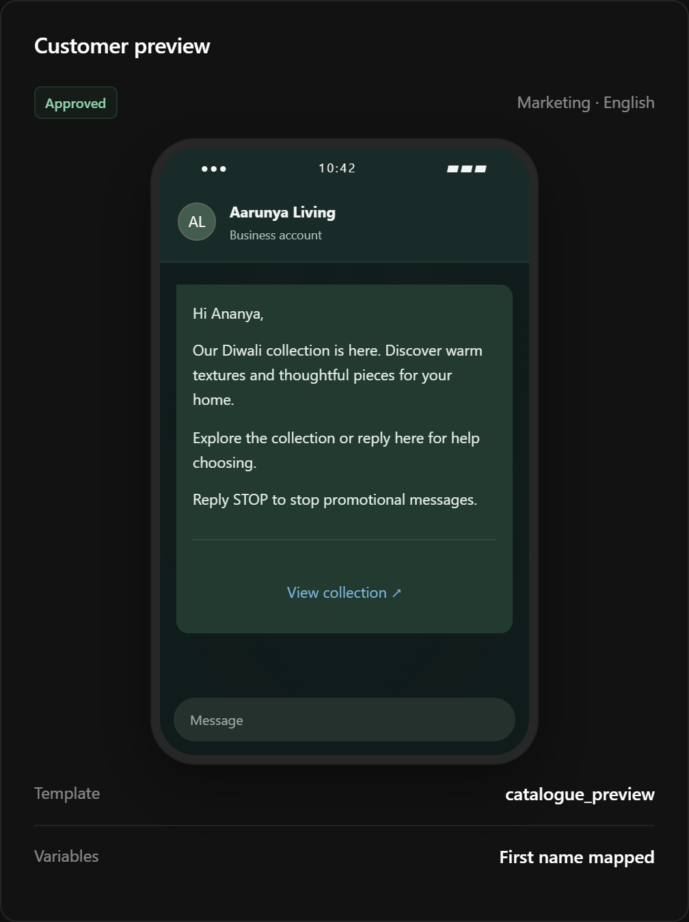
Figure 21 · Concept screen: approved campaign template and customer preview

Final message check
01 Check approval and purpose. Verify the template status, category, audience purpose, and the selected sending number.
02 Check personalization. Review representative values for every variable and ensure none changes the meaning of the approved template.
03 Check the reply path. Confirm where replies enter the shared inbox and who owns the follow-up before scheduling.

19 / REPORTING

Read message and outcome reporting
Analytics should distinguish Meta delivery events from HireBuddha’s conversation and agent calculations so business users understand what each measure means.
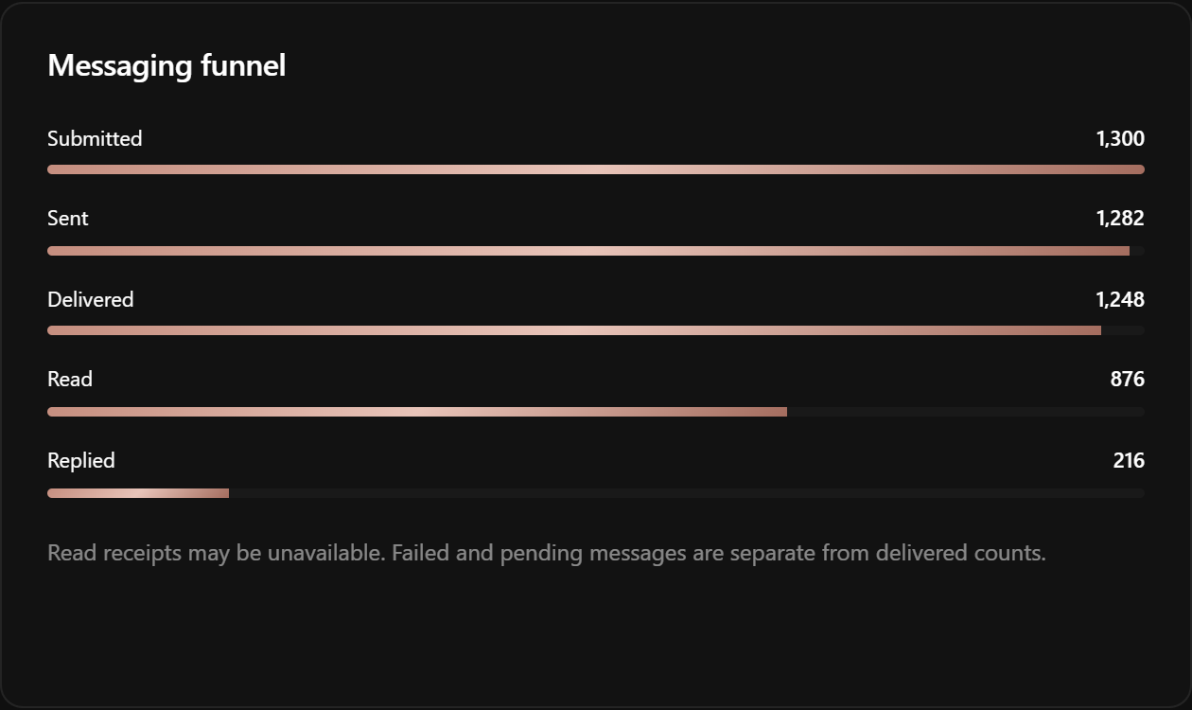
Figure 22 · Concept screen: delivery funnel, outcomes, and filters

Interpret the measures
Measure | Meaning
Submitted | HireBuddha handed a request to the API; it is not proof of delivery.
Sent, delivered, read, failed | Statuses from Meta webhook events when available. A missing read event does not prove the customer did not read it.
Replied, resolved, taken over | HireBuddha-derived conversation and ownership outcomes, subject to the selected attribution rule.
Cost | An estimate in planning views; final amounts depend on reconciled billing data.

Filter by date, number, campaign, template, agent, and owner. Open a failure group or conversation to see the underlying event rather than relying only on an aggregate.

20 / GOVERNANCE

Control access and outbound safety
Settings should make it clear who can configure the channel, approve a send, take over a conversation, export data, or disconnect an asset.
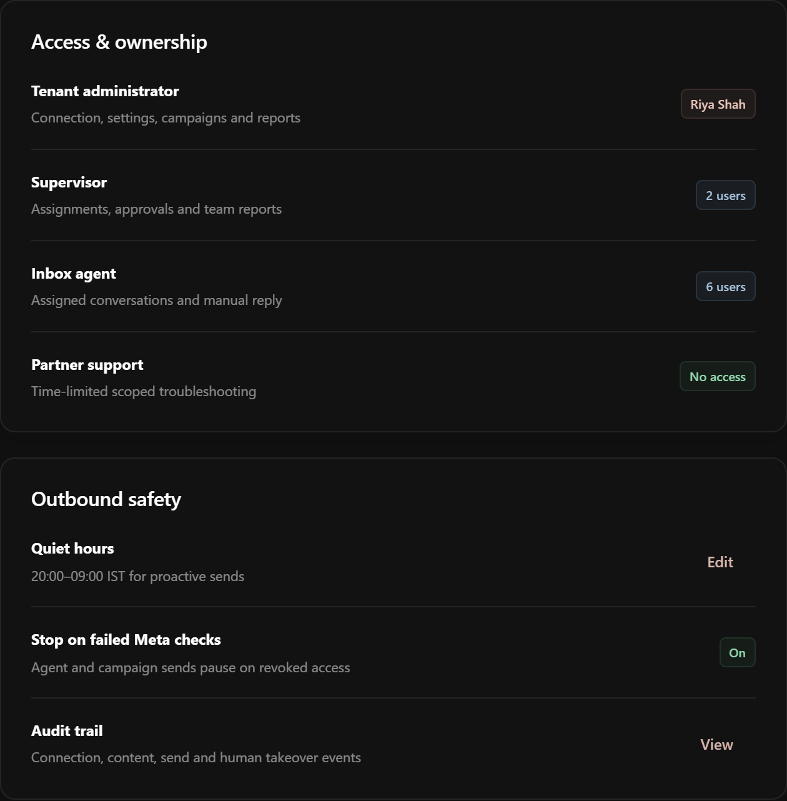
Figure 23 · Concept screen: access, ownership, privacy, and send controls

Business controls
Area | Intended control
Access | Give administrators, supervisors, and inbox teammates scoped actions for numbers, content, sends, and exports.
Audit | Record who changed AI mode, took over a thread, approved a campaign, disconnected an asset, or exported data.
Privacy | Provide retention and deletion-request workflows aligned to the business’s policy and Meta requirements.
Disconnect | Explain the effects on sends, inbound messages, automations, webhooks, and historical reporting before confirming.

21 / PLATFORM ADMINISTRATION

Track partner readiness separately
HireBuddha’s platform administrators need an evidence view for Meta’s external partner path. Tenant onboarding should remain usable only within the permissions and status actually granted.
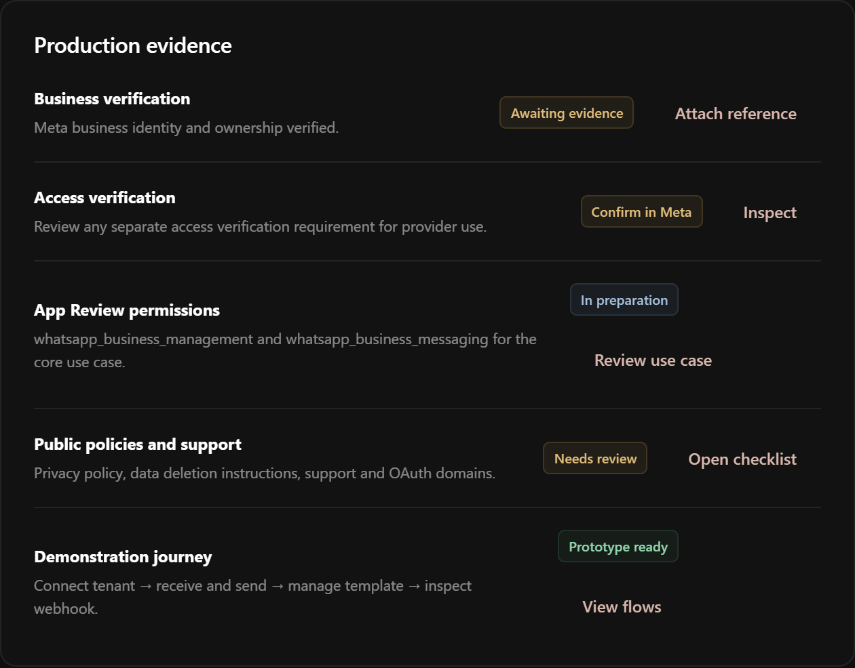
Figure 24 · Concept screen: Meta partner evidence and readiness

What the readiness view covers
The platform path runs from developer setup through Tech Provider requirements toward a later Tech Partner application. Evidence includes business and access verification, App Review use cases, privacy and support flows, a demonstrable signup journey, webhook reliability, tenant isolation, and consent handling. Meta makes the external approval decision; this screen cannot promise eligibility or approval.

Meta sources used for the intended rules
WhatsApp Business Messaging Policy
Embedded Signup collection
WhatsApp Flows
Webhook payload reference
Become a WhatsApp partner
Meta may change eligibility, review decisions, policies, and pricing. Validate them at implementation and again before launch.

