Steven Gerick
DD2404
Project: Identifying Signal Peptides
January 3, 2019

Training and Validation
For my classifier I used a linear combination of four Hidden Markov Models. Each of the four datasets (no signal peptide non-tm, signal peptide non-tm, no signal peptide tm, signal peptide tm) has 80% of its sequences selected to train one of four models (HMM1, HMM2, HMM3, HMM4 respectively), with the remaining 20% used for validation. Only the first 150 characters of the sequence and label are used, regardless of whether the sample is for training or validation. During training, the annotation (label) is available in addition to the amino acid sequence, but during validation or prediction only the amino acid sequence is provided.

Instead of training the HMMs on the protein sequences, the provided annotations are used to generate start, transition, and emission probabilities for each state. We assume 11 states for this machine:
- 0 or ‘s’: start state; the state the machine is in for the first amino acid, regardless of the annotation
- 1 or ‘S’: second and third positions, regardless of the annotation, as long as this sequence is for a signal-peptide containing protein
- 8 or ‘C’: cleavage site; corresponds to a ‘C’ label in the annotation
- 7 or ‘g’: position immediately before the cleavage site
- 6 or ‘v’: position two steps before the cleavage site
- 5 or ‘r’: positions 8 and 9, as long this is at or before the labelled cleavage site, this is a trans-membrane protein, and the label is not already ‘g’ or ‘v’
- 2 or ‘n’: ‘n’ in the annotation, if not satisfying requirements for ‘g’, ‘v’, or ‘r’
- 3 or ‘h’: ‘h’ in the annotation, if not satisfying requirements for ‘g’, ‘v’, or ‘r’
- 4 or ‘c’: ‘c’ in the annotation, if not satisfying requirements for ‘g’, ‘v’, or ‘r’
- 9 or ‘O’: any of ‘O’, ‘o’, ‘i’ in the annotation.
- 10 or ‘M’: ‘M’ in the annotation
We group the amino acids into the following classes:
- 0: positive charged side chains (RHK)
- 1: negatively charged side chains (DE)
- 2: polar uncharged hydroxide side chain (ST)
- 3: carboxamide side chain (NQ)
- 4: sulfur-containing side chain or no side chain (CMG)
- 5: no primary amino acid (P)
- 6: short hydrophobic side chain (AV)
- 7: Isoleucine (I)
- 8: phenol side chain (Y)
- 9: All other amino acids (all hydrophobic; LFW)
- 10: Anything else (X)
No selenocysteine (U) or pyrrolysine (O) was found in any of the sequences, so they did not need to be classified. Only four sequences contained symbols for unknown amino acids, and all symbols for unknown amino acids were ‘X’ (i.e. there was no ‘B’, ‘Z’, or ‘J’ in any sequence)
For each of the four classes of data, we transform the annotation into a state sequence S using the rules provided in the first list, and calculating the following using all state sequences in the class:
- The distribution of starting states π (inevitably 1.0 for state=’s’ and 0 elsewhere, but this method of calculation would work unchanged even if we were to change the state definition so this did not hold)
- The distribution of state transitions A (A_{i,j} = number of occurrences of state[t] = i and state[t+1] = j, divided by number of occurrences of state[t])
- The distribution of emissions B (B_{i,j} = number of occurrences of state[t] = i and class(sequence[t]) = j, divided by number of occurrences of state[t])
That is, we do not train the models in the standard HMM manner using observations, instead opting to train with an explicit state in order to use the information in the labels. We simply calculate the model parameters using statistics that can be drawn from the training sequences.
Once our four models have been trained, we can classify a new sample:
- Each of the four models uses the Viterbi algorithm to calculate the most likely state sequence that could produce the amino acid sequence, and returns the logarithm of the joint probability of that sequence and the observations. The four HMMs HMM1-HMM4 produce variables logprob1-logprob4
- If logprob2 + logprob4 > logprob1 + logprob3, we predict this is a signal peptide. Otherwise, we predict it is not.
  - Note that the left-hand-side is the sum of log probabilities for both models trained on positive data, and the right hand side is the sum of log probabilities for both models trained on negative data
Using 10 runs, each using a different set of 20% validation data, the 95% confidence range for the specificity of the predictor is 96.67 ± 0.86 percent, and the 95% confidence range for the sensitivity of our predictor is 90.00 ± 1.55 percent. That is, the classifier is slightly more likely to classify a signal peptide as a non-signal-peptide (10%) than to classify a non-signal peptide as a signal peptide (3.3%). Both specificity and sensitivity are lower for TM proteins than for non-TM proteins; in almost every run, non-signal tm proteins were misidentified more frequently than non-signal non-tm proteins, and signal tm proteins were misidentified more frequently than signal non-tm proteins, with the difference approaching a few percentage points for both measures.

These results are good enough to estimate the number of genes that contain a signal peptide in a given dataset, though the performance would need to be improved somewhat if this classifier were to be used in isolation to identify individual signal peptides. Linear combination with one or two more weak classifiers might improve accuracy enough to make the classifier suitable for this purpose.

Results on Proteomes

Because there four HMMs, classifying a long sequences on the scale of an entire proteome is computationally expensive (a few minutes for the entire human proteome, i.e. all protein-coding genes in human genes 1-22, X, Y sourced from BioMart)

Homo sapiens:
Species | Sequences | Valid sequences | Predicted signal peptides | predicted, % of valid
Homo sapiens | 151 100 | 98 305 | 33 445 | 34.0
Drosophila melanogaster | 25 081 | 24 687 | 13 544 | 54.9

Drosophila noticeably contains a much higher proportion of proteins that are predicted to have a signal peptide. Drosophila also has a much larger proportion of valid sequences (due to the homo sapiens data containing a large proportion of transcripts containing internal stop codons). Since the human genome is much larger, this may indicate that the number of proteins using signal peptides does not grow linearly with the size of the genome. This in turn suggests that
Sequence Logo Analysis

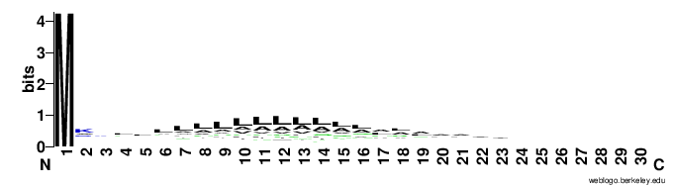
Sequence logo for first 30 peptides of non-tm signal peptide proteins

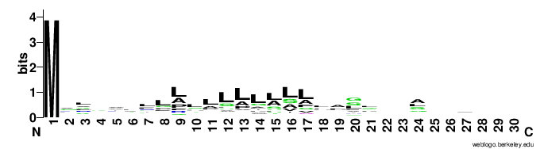
Sequence logo for first 30 peptides of tm signal peptide proteins

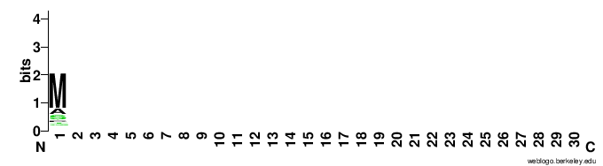
Sequence logo for first 30 peptides of non-tm non-signal-peptide proteins
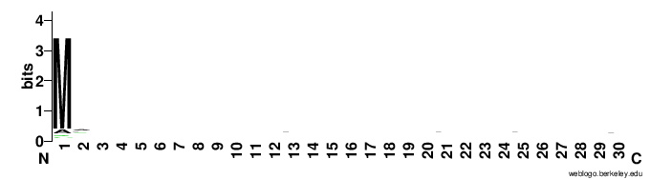
Sequence logo for first 30 peptides of tm non-signal-peptide proteins
All signal peptide proteins show an overwhelming majority of M in the first position, followed by a weak overrepresentation of A and L in positions 6 to 17. Non-signal peptide proteins have almost no defining features except for the overwhelming majority of M in the first position. For non-tm non-signal-peptide proteins, even this feature is weak. Notably, we cannot identify transmembrane proteins using sequence analysis this way.
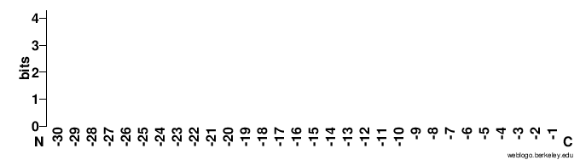
Sequence logo for last 30 peptides for non-tm non-signal-peptide proteins. No useful information is present.
Sequence logo for last 30 peptides for non-tm signal-peptide proteins. No useful information here either.

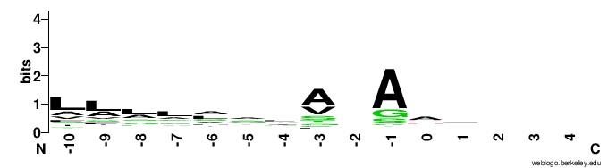
Sequence logo for peptides immediately before and after cleavage site, for all proteins with signal peptide (where cleavage site = 0). Shows a clear preference for A and G in the position immediately before the cleavage site, and a preference for A and V three spots before. A relative abundance of A and L is apparent between 15 and 5 spots before the cleavage site, though it is unclear if these abundances reflect their position relative to the cleavage site or position relative to the start of the sequence
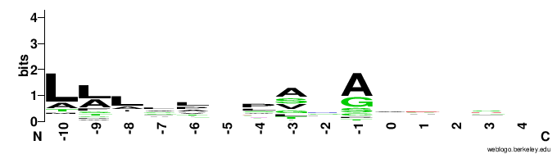
Sequence logo for peptides immediately before and after cleavage site, for only transmembrane signal peptide proteins. Compared to that for all signal peptide proteins, the L-rich protein is even more L-rich, and the region 5 acids before the cleavage site no longer carries any information.

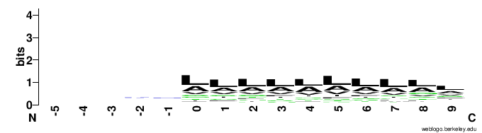
Sequence logo for peptides immediately before and after the first ‘h’ (0), for non-tm signal peptide proteins. Shows slightly higher information content for L, A, and V richness in these areas, indicating that these abundances come from their position in the ‘h’ region and not their presence at the start of the protein or end of the signal peptide. Also shows no relationship between the content of the n region and the content of the h region.
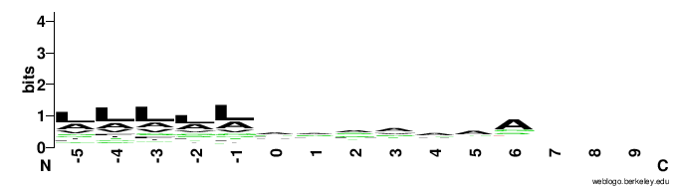
Sequence logo for peptides immediately before and after the first ‘c’ (0), for non-tm signal peptide proteins. Little information is present here, but spot 6 resembles the distribution for the spot immediately before the cleavage site, indicating that the number of c’s almost never exceeds 7.

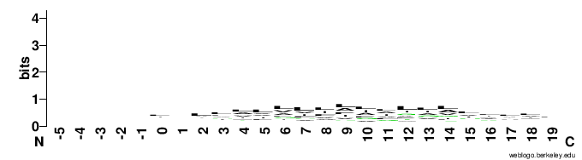
Sequence logo for peptides immediately before and after the tm non-signal-peptide proteins’ first membrane region (first ‘M’). Shows a similar L rich region to that present in the h-nucleus of signal peptides.

Controls
Several functions use some sort of controls to ensure that improper outputs do not lead to erroneous results:
- If an HMM calculates that it is impossible for it to produce a given amino acid sequence, it will return a log probability of negative infinity, which can lead to results being polluted by NaNs. Any negative infinities in log probabilities are automatically clipped to -10000, an order of magnitude larger than the largest negative values returned across all samples in the example dataset.
- Validation will print a notice and return immediately if it detects there are no validation samples, mostly to avoid dividing by zero when calculating specificity and sensitivity. Specificity will not be printed if there are no negative samples, and sensitivity will not be printed if there are no positive samples. Any class with 0 samples will not have its accuracy calculated or printed (which would require a division by zero)
- The four directories used for training and validation data are verified to exist and actually be directories before the program continues execution, with an error printed and the program terminating if any of them does not exist or is a regular file.
- If the user specifies a file to count signal peptides in, the program will guarantee that the file exists, and print an error and return if it does not.
- Validation and training will halt if any sequence has a name line not starting with ‘>’, any sequence is empty, any sequence has a label and sequence of different length, any sequence contains a symbol that is not one of the 20 “classical” amino acids nor ‘X’, or any label contains a symbol not known to the label state dictionary. In combination with the trimming of whitespace before and after the sequence and labels (excluding the ‘#’), these make it effectively impossible to misformat the lines of the example datasets.

