Name-Gondu jeevitha
Dept -CSE
Batch start date-24 -11-2025
Batch end date-28-11-2025
Project title- AI Water Quality Detection

Project link- https://my-site-8xl6c7zk-gondujeevitha.wix-vibe.com
Screenshots
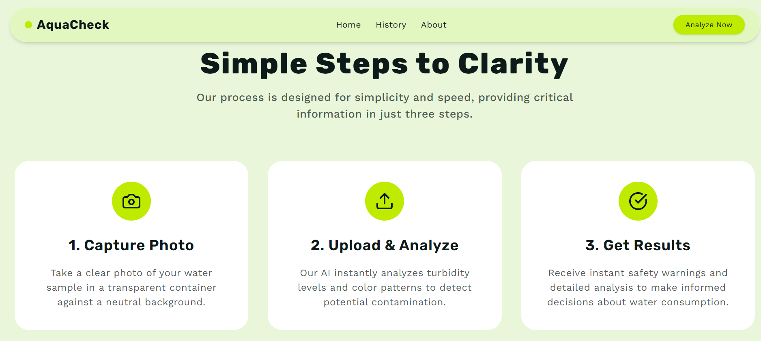
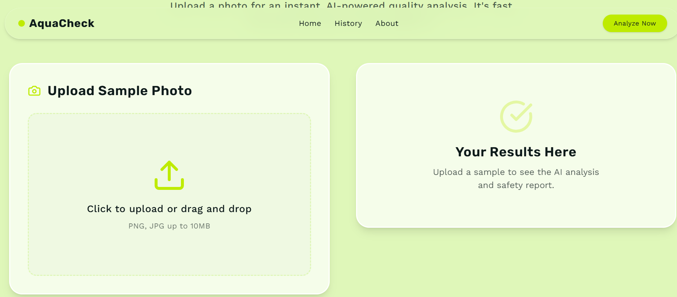
Description

Description
Thank you IBM and magic bus In The AI Water Quality Detection system is a simple, low-cost, and scalable solution designed to help communities—especially in rural or underserved areas—quickly identify whether water is safe for drinking. Using Teachable Machine, a no-code, open-source tool by Google, the project enables users to detect possible water contamination through visual analysis without requiring laboratory testing or technical expertise.
The system works by allowing users to capture a photo of a water sample using a mobile phone or a simple camera. This image is then analyzed by a machine learning model trained in Teachable Machine to recognize visual indicators of contamination, including turbidity, discoloration, suspended particles, algae presence, or unusual tones such as brown, green, or yellow. These visual cues often signal biological or chemical pollution, making them valuable early warnings for unsafe water.
Once the image is processed, the AI model classifies the sample into categories such as Safe, Suspicious, or Unsafe. The model’s decision is based on patterns learned during training, where it has been shown multiple examples of clean and contaminated water. The result is displayed instantly, providing real-time feedback to the user.
If the water appears unsafe, the system issues a clear warning alert, advising the user to avoid drinking it and offering simple suggestions like boiling water, using filters, or seeking a cleaner local source. This can prevent waterborne diseases, which are a major health concern in areas lacking proper testing facilities.
Designed as a low-tech, portable, and community-friendly tool, the system requires no specialized equipment, no lab testing, and no programming knowledge to operate. It empowers local health workers, teachers, villagers, and volunteers to monitor water safety easily and consistently. This AI-driven approach helps reduce health risks, improves access to clean water, and supports safer daily living conditions in vulnerable communities.
Thank you IBM and magic bus India foundation

