Size Guide

Discover your ideal size with our easy to use guides. Follow the face-width method to identify the size best suited to you or use your current glasses by referencing the engraved numbers on the temple for a quick match.

USe the face-width method

**Step 1 - take a credit Card**

Get a Credit, Debit or Loyalty card.

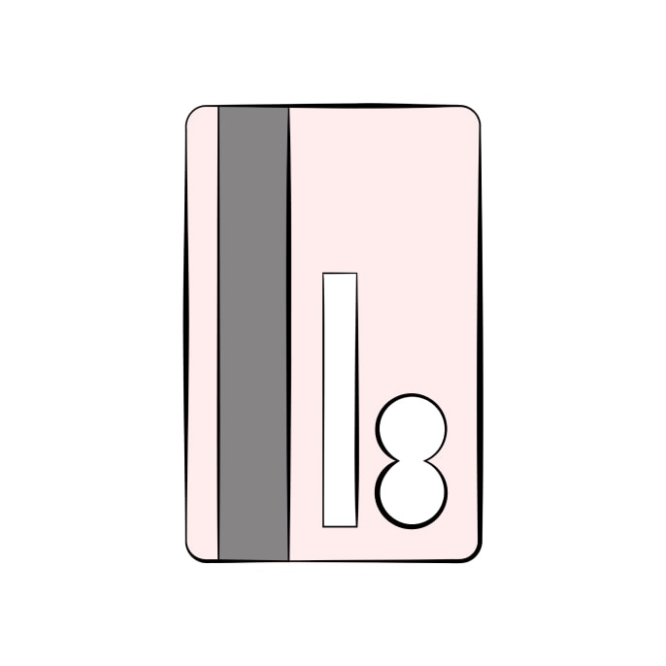

**Step 2 - Stand in front of a mirror**

Hold the card steady and align one edge with the centre of your nose.

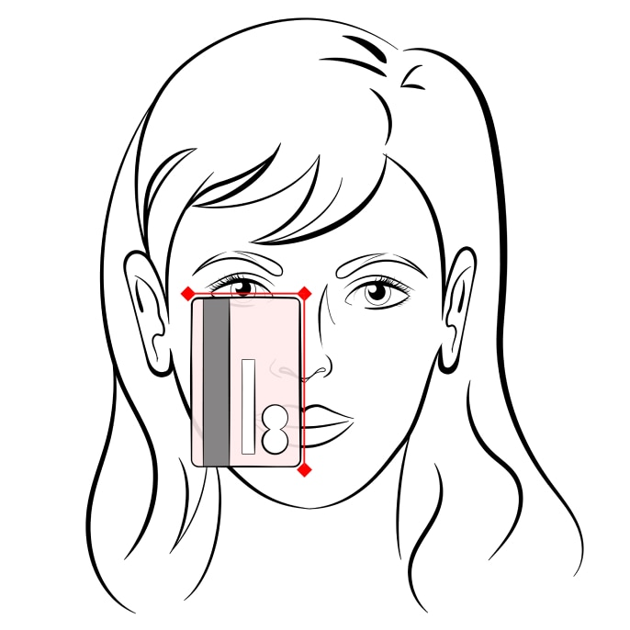

**Step 3 - Check the card position**

The size is determined based on where the opposite edge of the card aligns with your eye.

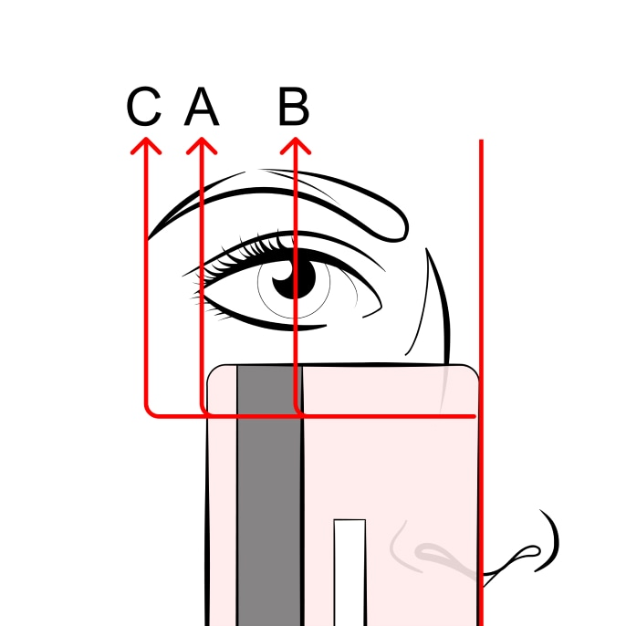

**A - Average**

If the card’s edge aligns with the outer corner of your eye.

**B - Wide**

If the card’s edge falls between the outer corner and the centre of your eye.

**C - Narrow**

If the card’s edge extends past the outer corner of your eye.

Use your CURRENT GLASSES

If you wear glasses, you’ve likely noticed some numbers on the temple and wondered what they mean:

**50□21**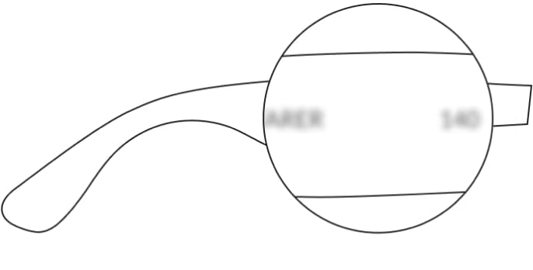

These numbers indicate **the lens and bridge width** which determine the frame size. Compare them with the measurements of this frame to find the best match for you:

**lens Width**50mm

**bridge Width**21mm

**frame size**50-21

FRAME MEASUREMENTS GUIDE

Explore the essential details about frame measurements to help you choose the perfect size.

mminches

Lens width:**50mm**

Bridge width: **21mm**

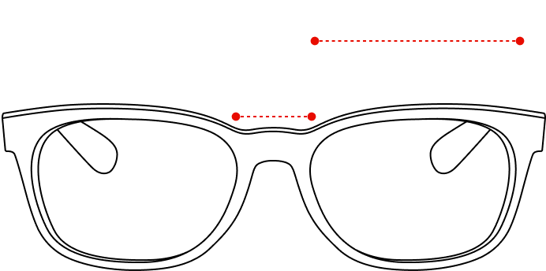

Temple length:**145mm**

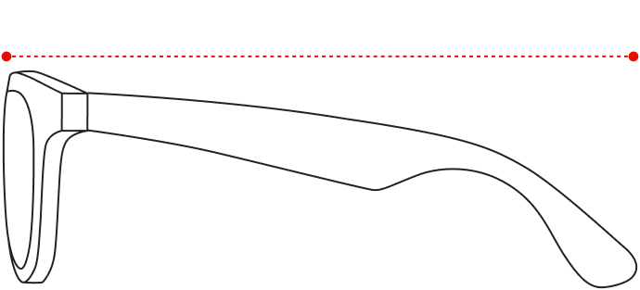

Lens width:**50mm**

Lens heigth:**46.9mm**

