## Mongo分布式集群搭建

一．服务器节点

|  |  |  |
| --- | --- | --- |
| **编号** | **主机名** | **IP** |
| 1 | bigdata-slave-01 | 192.168.2.13 |
| 2 | bigdata-slave-02 | 192.168.2.14 |
| 3 | bigdata-slave-03 | 192.168.2.15 |

二．规划集群和分片

1.规划3个shard * 3个replicat set + 配置服务

2.软件包版本：mongodb-linux-x86_64-rhel62-3.4.7.tgz

|  |  |  |  |  |
| --- | --- | --- | --- | --- |
| **shard rs name** | **Primary** | **Secondary** | **Secondary** | **port** |
| bigdata-mango-a | A1 | A2 | A3 | 28111 |
| bigdata-mongo-b | B2 | B1 | B3 | 28112 |
| bigdata-mongo-c | C3 | C1 | C2 | 28113 |
| bigdata-mongo-cs | ConfigServer1 | ConfigServer2 | ConfigServer3 | 28200 |

3.规划3个config server的mongod实例configserver1、configserver2、configserver3

|  |  |
| --- | --- |
| ip | 服务 |
| 192.168.2.13 | a1 b1 c1 configserver1 |
| 192.168.2.14 | A2 b2 c2 configserver2 |
| 192.168.2.15 | A3 b3 c3 configserver3 |

### 三．规划目录和配置文件

切换到root用户，运行visudo命令

1.创建目录结构：

**# 登录到192.168.2.13**

# 创建db目录 日志目录 mongod配置文件

sudo mkdir -p /home/hadoop/bigdata/workspace/mongodb/a1

sudo mkdir -p /home/hadoop/bigdata/workspace/mongodb/logs/a1

sudo mkdir -p /home/hadoop/bigdata/workspace/mongodb/b1

sudo mkdir -p /home/hadoop/bigdata/workspace/mongodb/logs/b1

sudo mkdir -p /home/hadoop/bigdata/workspace/mongodb/c1

sudo mkdir -p /home/hadoop/bigdata/workspace/mongodb/logs/c1

sudo mkdir -p /home/hadoop/bigdata/workspace/mongodb/configserver1

sudo mkdir -p /home/hadoop/bigdata/workspace/mongodb/logs/configserver1

1）sudo vi /home/hadoop/bigdata/workspace/mongodb/mongod-a1-config.yml

# yml

# mongod config

systemLog:

destination: file

logAppend: true

path: /home/hadoop/bigdata/workspace/mongodb/logs/a1/mongodb.log

# Where and how to store data.

storage:

dbPath: /home/hadoop/bigdata/workspace/mongodb/a1

journal:

enabled: true

# engine:

# mmapv1:

# wiredTiger:

# how the process runs

# fork : fork and run in background

# pidFilePath:location of pidfile

processManagement:

fork: true

pidFilePath: /var/run/mongod-a1.pid

# network interfaces

# Listen to local interface only, comment to listen on all interfaces.

net:

port: 28111

bindIp: 0.0.0.0

#security: enabled disabled

#security:

# keyFile: /home/hadoop/bigdata/workspace/mongodb/keyfile

# clusterAuthMode: keyFile

#operationProfiling:

operationProfiling:

slowOpThresholdMs: 1000

mode: slowOp

#replication:

replication:

replSetName: bigdata-mango-a

#sharding:

sharding:

clusterRole: shardsvr

## Enterprise-Only Options

#auditLog:

#snmp:

2）sudo vi /home/hadoop/bigdata/workspace/mongodb/mongod-b1-config.yml

# yml

# mongod config

systemLog:

destination: file

logAppend: true

path: /home/hadoop/bigdata/workspace/mongodb/logs/b1/mongodb.log

# Where and how to store data.

storage:

dbPath: /home/hadoop/bigdata/workspace/mongodb/b1

journal:

enabled: true

# engine:

# mmapv1:

# wiredTiger:

# how the process runs

# fork : fork and run in background

# pidFilePath:location of pidfile

processManagement:

fork: true

pidFilePath: /var/run/mongod-b1.pid

# network interfaces

# Listen to local interface only, comment to listen on all interfaces.

net:

port: 28112

bindIp: 0.0.0.0

#security: enabled disabled

#security:

# keyFile: /home/hadoop/bigdata/workspace/mongodb/keyfile

# clusterAuthMode: keyFile

#operationProfiling:

operationProfiling:

slowOpThresholdMs: 1000

mode: slowOp

#replication:

replication:

replSetName: bigdata-mango-b

#sharding:

sharding:

clusterRole: shardsvr

## Enterprise-Only Options

#auditLog:

#snmp:

3）sudo vi /home/hadoop/bigdata/workspace/mongodb/mongod-c1-config.yml

# yml

# mongod config

systemLog:

destination: file

logAppend: true

path: /home/hadoop/bigdata/workspace/mongodb/logs/c1/mongodb.log

# Where and how to store data.

storage:

dbPath: /home/hadoop/bigdata/workspace/mongodb/c1

journal:

enabled: true

# engine:

# mmapv1:

# wiredTiger:

# how the process runs

# fork : fork and run in background

# pidFilePath:location of pidfile

processManagement:

fork: true

pidFilePath: /var/run/mongod-c1.pid

# network interfaces

# Listen to local interface only, comment to listen on all interfaces.

net:

port: 28113

bindIp: 0.0.0.0

#security: enabled disabled

#security:

# keyFile: /home/hadoop/bigdata/workspace/mongodb/keyfile

# clusterAuthMode: keyFile

#operationProfiling:

operationProfiling:

slowOpThresholdMs: 1000

mode: slowOp

#replication:

replication:

replSetName: bigdata-mango-c

#sharding:

sharding:

clusterRole: shardsvr

## Enterprise-Only Options

#auditLog:

#snmp:

4）sudo vi /home/hadoop/bigdata/workspace/mongodb/mongod-configserver1.yml

# yml

# mongod config

systemLog:

destination: file

logAppend: true

path: /home/hadoop/bigdata/workspace/mongodb/logs/configserver1/mongodb.log

# Where and how to store data.

storage:

dbPath: /home/hadoop/bigdata/workspace/mongodb/configserver1

journal:

enabled: true

# engine:

# mmapv1:

# wiredTiger:

# how the process runs

# fork : fork and run in background

# pidFilePath:location of pidfile

processManagement:

fork: true

pidFilePath: /var/run/mongod-configserver1.pid

# network interfaces

# Listen to local interface only, comment to listen on all interfaces.

net:

port: 28200

bindIp: 0.0.0.0

#security: enabled disabled

#security:

# keyFile: /home/hadoop/bigdata/workspace/mongodb/keyfile

# clusterAuthMode: keyFile

#operationProfiling:

operationProfiling:

slowOpThresholdMs: 1000

mode: slowOp

#replication:

replication:

replSetName: bigdata-mongo-cs

#sharding:

sharding:

clusterRole: configsvr

## Enterprise-Only Options

#auditLog:

#snmp:

**# 登录到192.168.2.14**

sudo mkdir -p /home/hadoop/bigdata/workspace/mongodb/a2

sudo mkdir -p /home/hadoop/bigdata/workspace/mongodb/logs/a2

sudo mkdir -p /home/hadoop/bigdata/workspace/mongodb/b2

sudo mkdir -p /home/hadoop/bigdata/workspace/mongodb/logs/b2

sudo mkdir -p /home/hadoop/bigdata/workspace/mongodb/c2

sudo mkdir -p /home/hadoop/bigdata/workspace/mongodb/logs/c2

sudo mkdir -p /home/hadoop/bigdata/workspace/mongodb/configserver2

sudo mkdir -p /home/hadoop/bigdata/workspace/mongodb/logs/configserver2

1）sudo vi /home/hadoop/bigdata/workspace/mongodb/mongod-a2-config.yml

# yml

# mongod config

systemLog:

destination: file

logAppend: true

path: /home/hadoop/bigdata/workspace/mongodb/logs/a2/mongodb.log

# Where and how to store data.

storage:

dbPath: /home/hadoop/bigdata/workspace/mongodb/a2

journal:

enabled: true

# engine:

# mmapv1:

# wiredTiger:

# how the process runs

# fork : fork and run in background

# pidFilePath:location of pidfile

processManagement:

fork: true

pidFilePath: /var/run/mongod-a2.pid

# network interfaces

# Listen to local interface only, comment to listen on all interfaces.

net:

port: 28111

bindIp: 0.0.0.0

#security: enabled disabled

#security:

# keyFile: /home/hadoop/bigdata/workspace/mongodb/keyfile

# clusterAuthMode: keyFile

#operationProfiling:

operationProfiling:

slowOpThresholdMs: 1000

mode: slowOp

#replication:

replication:

replSetName: bigdata-mango-a

#sharding:

sharding:

clusterRole: shardsvr

## Enterprise-Only Options

#auditLog:

#snmp:

2）sudo vi /home/hadoop/bigdata/workspace/mongodb/mongod-b2-config.yml

# yml

# mongod config

systemLog:

destination: file

logAppend: true

path: /home/hadoop/bigdata/workspace/mongodb/logs/b2/mongodb.log

# Where and how to store data.

storage:

dbPath: /home/hadoop/bigdata/workspace/mongodb/b2

journal:

enabled: true

# engine:

# mmapv1:

# wiredTiger:

# how the process runs

# fork : fork and run in background

# pidFilePath:location of pidfile

processManagement:

fork: true

pidFilePath: /var/run/mongod-b2.pid

# network interfaces

# Listen to local interface only, comment to listen on all interfaces.

net:

port: 28112

bindIp: 0.0.0.0

#security: enabled disabled

#security:

# keyFile: /home/hadoop/bigdata/workspace/mongodb/keyfile

# clusterAuthMode: keyFile

#operationProfiling:

operationProfiling:

slowOpThresholdMs: 1000

mode: slowOp

#replication:

replication:

replSetName: bigdata-mango-b

#sharding:

sharding:

clusterRole: shardsvr

## Enterprise-Only Options

#auditLog:

#snmp:

3）sudo vi /home/hadoop/bigdata/workspace/mongodb/mongod-c2-config.yml

# yml

# mongod config

systemLog:

destination: file

logAppend: true

path: /home/hadoop/bigdata/workspace/mongodb/logs/c2/mongodb.log

# Where and how to store data.

storage:

dbPath: /home/hadoop/bigdata/workspace/mongodb/c2

journal:

enabled: true

# engine:

# mmapv1:

# wiredTiger:

# how the process runs

# fork : fork and run in background

# pidFilePath:location of pidfile

processManagement:

fork: true

pidFilePath: /var/run/mongod-c2.pid

# network interfaces

# Listen to local interface only, comment to listen on all interfaces.

net:

port: 28113

bindIp: 0.0.0.0

#security: enabled disabled

#security:

# keyFile: /home/hadoop/bigdata/workspace/mongodb/keyfile

# clusterAuthMode: keyFile

#operationProfiling:

operationProfiling:

slowOpThresholdMs: 1000

mode: slowOp

#replication:

replication:

replSetName: bigdata-mango-c

#sharding:

sharding:

clusterRole: shardsvr

## Enterprise-Only Options

#auditLog:

#snmp:

4）sudo vi /home/hadoop/bigdata/workspace/mongodb/mongod-configserver2.yml

# yml

# mongod config

systemLog:

destination: file

logAppend: true

path: /home/hadoop/bigdata/workspace/mongodb/logs/configserver2/mongodb.log

# Where and how to store data.

storage:

dbPath: /home/hadoop/bigdata/workspace/mongodb/configserver2

journal:

enabled: true

# engine:

# mmapv1:

# wiredTiger:

# how the process runs

# fork : fork and run in background

# pidFilePath:location of pidfile

processManagement:

fork: true

pidFilePath: /var/run/mongod-configserver2.pid

# network interfaces

# Listen to local interface only, comment to listen on all interfaces.

net:

port: 28200

bindIp: 0.0.0.0

#security: enabled disabled

#security:

# keyFile: /home/hadoop/bigdata/workspace/mongodb/keyfile

# clusterAuthMode: keyFile

#operationProfiling:

operationProfiling:

slowOpThresholdMs: 1000

mode: slowOp

#replication:

replication:

replSetName: bigdata-mongo-cs

#sharding:

sharding:

clusterRole: configsvr

## Enterprise-Only Options

#auditLog:

#snmp:

**# 登录到192.168.2.15**

sudo mkdir -p /home/hadoop/bigdata/workspace/mongodb/a3

sudo mkdir -p /home/hadoop/bigdata/workspace/mongodb/logs/a3

sudo mkdir -p /home/hadoop/bigdata/workspace/mongodb/b3

sudo mkdir -p /home/hadoop/bigdata/workspace/mongodb/logs/b3

sudo mkdir -p /home/hadoop/bigdata/workspace/mongodb/c3

sudo mkdir -p /home/hadoop/bigdata/workspace/mongodb/logs/c3

sudo mkdir -p /home/hadoop/bigdata/workspace/mongodb/configserver3

sudo mkdir -p /home/hadoop/bigdata/workspace/mongodb/logs/configserver3

1）sudo vi /home/hadoop/bigdata/workspace/mongodb/mongod-a3-config.yml

# yml

# mongod config

systemLog:

destination: file

logAppend: true

path: /home/hadoop/bigdata/workspace/mongodb/logs/a3/mongodb.log

# Where and how to store data.

storage:

dbPath: /home/hadoop/bigdata/workspace/mongodb/a3

journal:

enabled: true

# engine:

# mmapv1:

# wiredTiger:

# how the process runs

# fork : fork and run in background

# pidFilePath:location of pidfile

processManagement:

fork: true

pidFilePath: /var/run/mongod-a3.pid

# network interfaces

# Listen to local interface only, comment to listen on all interfaces.

net:

port: 28111

bindIp: 0.0.0.0

#security: enabled disabled

#security:

# keyFile: /home/hadoop/bigdata/workspace/mongodb/keyfile

# clusterAuthMode: keyFile

#operationProfiling:

operationProfiling:

slowOpThresholdMs: 1000

mode: slowOp

#replication:

replication:

replSetName: bigdata-mango-a

#sharding:

sharding:

clusterRole: shardsvr

## Enterprise-Only Options

#auditLog:

#snmp:

2）sudo vi /home/hadoop/bigdata/workspace/mongodb/mongod-b3-config.yml

# yml

# mongod config

systemLog:

destination: file

logAppend: true

path: /home/hadoop/bigdata/workspace/mongodb/logs/b3/mongodb.log

# Where and how to store data.

storage:

dbPath: /home/hadoop/bigdata/workspace/mongodb/b3

journal:

enabled: true

# engine:

# mmapv1:

# wiredTiger:

# how the process runs

# fork : fork and run in background

# pidFilePath:location of pidfile

processManagement:

fork: true

pidFilePath: /var/run/mongod-b3.pid

# network interfaces

# Listen to local interface only, comment to listen on all interfaces.

net:

port: 28112

bindIp: 0.0.0.0

#security: enabled disabled

#security:

# keyFile: /home/hadoop/bigdata/workspace/mongodb/keyfile

# clusterAuthMode: keyFile

#operationProfiling:

operationProfiling:

slowOpThresholdMs: 1000

mode: slowOp

#replication:

replication:

replSetName: bigdata-mango-b

#sharding:

sharding:

clusterRole: shardsvr

## Enterprise-Only Options

#auditLog:

#snmp:

3）sudo vi /home/hadoop/bigdata/workspace/mongodb/mongod-c3-config.yml

# yml

# mongod config

systemLog:

destination: file

logAppend: true

path: /home/hadoop/bigdata/workspace/mongodb/logs/c3/mongodb.log

# Where and how to store data.

storage:

dbPath: /home/hadoop/bigdata/workspace/mongodb/c3

journal:

enabled: true

# engine:

# mmapv1:

# wiredTiger:

# how the process runs

# fork : fork and run in background

# pidFilePath:location of pidfile

processManagement:

fork: true

pidFilePath: /var/run/mongod-c3.pid

# network interfaces

# Listen to local interface only, comment to listen on all interfaces.

net:

port: 28113

bindIp: 0.0.0.0

#security: enabled disabled

#security:

# keyFile: /home/hadoop/bigdata/workspace/mongodb/keyfile

# clusterAuthMode: keyFile

#operationProfiling:

operationProfiling:

slowOpThresholdMs: 1000

mode: slowOp

#replication:

replication:

replSetName: bigdata-mango-c

#sharding:

sharding:

clusterRole: shardsvr

## Enterprise-Only Options

#auditLog:

#snmp:

4）sudo vi /home/hadoop/bigdata/workspace/mongodb/mongod-configserver3.yml

# yml

# mongod config

systemLog:

destination: file

logAppend: true

path: /home/hadoop/bigdata/workspace/mongodb/logs/configserver3/mongodb.log

# Where and how to store data.

storage:

dbPath: /home/hadoop/bigdata/workspace/mongodb/configserver3

journal:

enabled: true

# engine:

# mmapv1:

# wiredTiger:

# how the process runs

# fork : fork and run in background

# pidFilePath:location of pidfile

processManagement:

fork: true

pidFilePath: /var/run/mongod-configserver3.pid

# network interfaces

# Listen to local interface only, comment to listen on all interfaces.

net:

port: 28200

bindIp: 0.0.0.0

#security: enabled disabled

#security:

# keyFile: /home/hadoop/bigdata/workspace/mongodb/keyfile

# clusterAuthMode: keyFile

#operationProfiling:

operationProfiling:

slowOpThresholdMs: 1000

mode: slowOp

#replication:

replication:

replSetName: bigdata-mongo-cs

#sharding:

sharding:

clusterRole: configsvr

## Enterprise-Only Options

#auditLog:

#snmp:

# 登录到192.168.2.13

# 生产和copy秘钥用户实例内部认证

openssl rand -base64 755 > /home/hadoop/bigdata/workspace/mongodb/keyfile

chmod 400 /home/hadoop/bigdata/workspace/mongodb/keyfile

scp /home/hadoop/bigdata/workspace/mongodb/keyfile hadoop@192.168.2.14:/home/hadoop/bigdata/workspace/mongodb/

scp /home/hadoop/bigdata/workspace/mongodb/keyfile hadoop@192.168.2.15:/home/hadoop/bigdata/workspace/mongodb/

解压安装包并传到其它节点

tar -zxvf /home/hadoop/bigdata/workspace/mongodb-linux-x86_64-rhel62-3.4.7.tgz

mv /home/hadoop/bigdata/workspace /mongodb-linux-x86_64-rhel62-3.4.7 /home/hadoop/bigdata/workspace/mongodb

scp -r /home/hadoop/bigdata/workspace/mongodb hadoop@bigdata-slave-02:/home/hadoop/bigdata/workspace

scp -r /home/hadoop/bigdata/workspace/mongodb hadoop@bigdata-slave-03:/home/hadoop/bigdata/workspace

### 四．启动实例

1.启动所有实例：

# 登录到192.168.2.13

/home/hadoop/bigdata/workspace/mongodb/bin/mongod -f /home/hadoop/bigdata/workspace/mongodb/mongod-a1-config.yml

/home/hadoop/bigdata/workspace/mongodb/bin/mongod -f /home/hadoop/bigdata/workspace/mongodb/mongod-b1-config.yml

/home/hadoop/bigdata/workspace/mongodb/bin/mongod -f /home/hadoop/bigdata/workspace/mongodb/mongod-c1-config.yml

/home/hadoop/bigdata/workspace/mongodb/bin/mongod -f /home/hadoop/bigdata/workspace/mongodb/mongod-configserver1.yml

# 其他两台类似，启动其他8个实例

# 登录到192.168.2.14

cd /home/hadoop/bigdata/workspace/mongodb/bin

sudo /home/hadoop/bigdata/workspace/mongodb/bin/mongod -f /home/hadoop/bigdata/workspace/mongodb/mongod-a2-config.yml

sudo /home/hadoop/bigdata/workspace/mongodb/bin/mongod -f /home/hadoop/bigdata/workspace/mongodb/mongod-b2-config.yml

sudo /home/hadoop/bigdata/workspace/mongodb/bin/mongod -f /home/hadoop/bigdata/workspace/mongodb/mongod-c2-config.yml

sudo /home/hadoop/bigdata/workspace/mongodb/bin/mongod -f /home/hadoop/bigdata/workspace/mongodb/mongod-configserver2.yml

# 登录到192.168.2.15

cd /home/hadoop/bigdata/workspace/mongodb/bin

sudo /home/hadoop/bigdata/workspace/mongodb/bin/mongod -f /home/hadoop/bigdata/workspace/mongodb/mongod-a3-config.yml

sudo /home/hadoop/bigdata/workspace/mongodb/bin/mongod -f /home/hadoop/bigdata/workspace/mongodb/mongod-b3-config.yml

sudo /home/hadoop/bigdata/workspace/mongodb/bin/mongod -f /home/hadoop/bigdata/workspace/mongodb/mongod-c3-config.yml

sudo /home/hadoop/bigdata/workspace/mongodb/bin/mongod -f /home/hadoop/bigdata/workspace/mongodb/mongod-configserver3.yml

/home/hadoop/bigdata/workspace/mongodb/bin/mongo 127.0.0.1:28111/admin

### 五．创建replicat set

# 登录到192.168.2.13

/home/hadoop/bigdata/workspace/mongodb/bin/mongo 127.0.0.1:28111/admin

>use admin



# 初始化bigdata-mango-a的副本集

>rs.initiate()

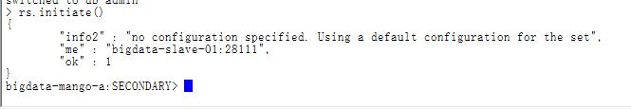

# 添加到副本集

> rs.add("bigdata-slave-02:28111")

> rs.add("bigdata-slave-03:28111")

> rs.conf()

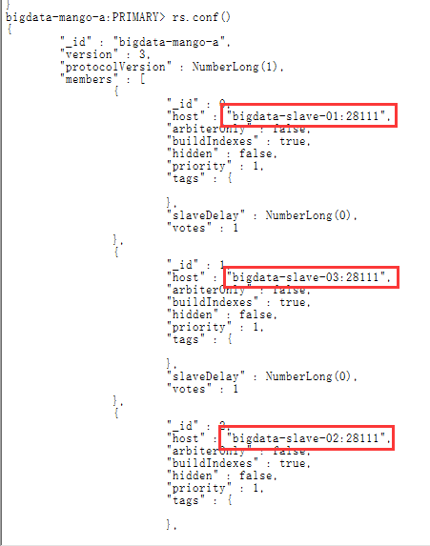

# 登录到192.168.2.14 初始化fang-s-b 添加副本集

/home/hadoop/bigdata/workspace/mongodb/bin/mongo 127.0.0.1:28112/admin

rs.initiate()

rs.add("bigdata-slave-01:28112")

rs.add("bigdata-slave-03:28112")

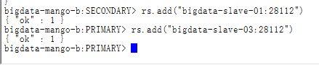

# 登录到192.168.2.15 初始化fang-s-c 添加副本集

/home/hadoop/bigdata/workspace/mongodb/bin/mongo 127.0.0.1:28113/admin

rs.initiate()

rs.add("bigdata-slave-01:28113")

rs.add("bigdata-slave-02:28113")

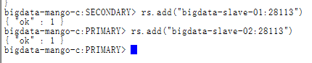

# 登录到192.168.2.13 初始化fang-cs添加副本集

/home/hadoop/bigdata/workspace/mongodb/bin/mongo 127.0.0.1:28200/admin

rs.initiate()

rs.add("bigdata-slave-02:28200")

rs.add("bigdata-slave-03:28200")

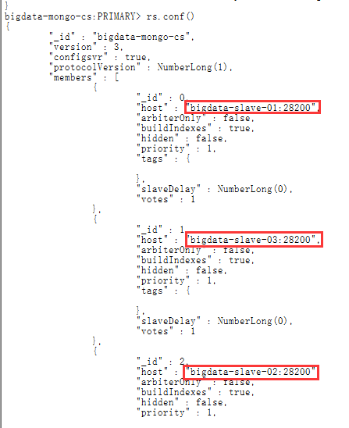

### 六．添加分片集群

sudo /home/hadoop/bigdata/workspace/mongodb/bin/mongos --port 28300 --configdb bigdata-mongo-cs/bigdata-slave-01:28200,bigdata-slave-02:28200,bigdata-slave-03:28200 --fork --logpath /home/hadoop/bigdata/workspace/mongodb/logs/mongos.log --bind_ip 0.0.0.0



通过mongos来登录

/home/hadoop/bigdata/workspace/mongodb/bin/mongo 127.0.0.1:28300/admin

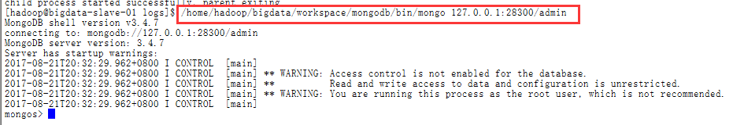

>sh.addShard("bigdata-mango-a/bigdata-slave-01:28111,bigdata-slave-02:28111,bigdata-slave-03:28111")

>sh.addShard("bigdata-mango-b/bigdata-slave-01:28112,bigdata-slave-02:28112,bigdata-slave-03:28112")

>sh.addShard("bigdata-mango-c/bigdata-slave-01:28113,bigdata-slave-02:28113,bigdata-slave-03:28113")

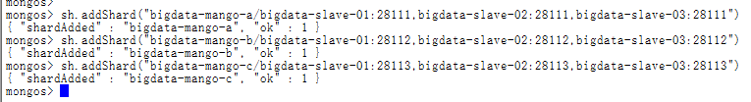

没有安全认证的集群就搭建好了，下面是关于安全认证的。

## 七．建立安全（目前没有发现卵用）

秘钥文件keyfile

生成秘钥文件

创建用户，登录到一个mongos实例，为集群创建root用户

> db.createUser({user: "root",pwd: "123456",roles: [ "root", "userAdminAnyDatabase", "userAdmin", "dbOwner" ]})

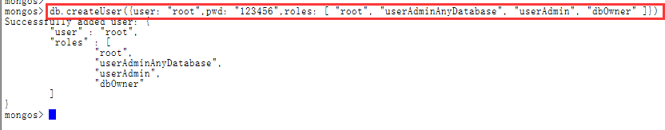

所有实例全部停止，使用

sudo /home/hadoop/bigdata/workspace/mongodb/bin/mongod -f /home/hadoop/bigdata/workspace/mongodb/mongod-a1-config.yml –shutdown

mongod实例启动添加参数 --keyFile /home/hadoop/bigdata/workspace/mongodb/keyfile --auth

启动时可以不使用 --auth参数，因为使用了 --keyFile就必须验证，也就是隐含了 --auth。但是--auth并不隐含 --keyFile。

sudo /home/hadoop/bigdata/workspace/mongodb/bin/mongod -f /home/hadoop/bigdata/workspace/mongodb/mongod-a1-config.yml --keyFile /home/hadoop/bigdata/workspace/mongodb/keyfile –auth



八．测试

iostat，观察使用情况

例如，以下命令会每隔一秒展示额外的统计数据和每次展示报表的时间（以MB/s为流量单位）：

iostat -xmt 1

%util： 这对快速查看来说是最有用的字段，它指明了设备/驱动器使用时间的百分比。

avgrq-sz：平均请求大小。该值较小的数字反映了更多的随机IO操作。

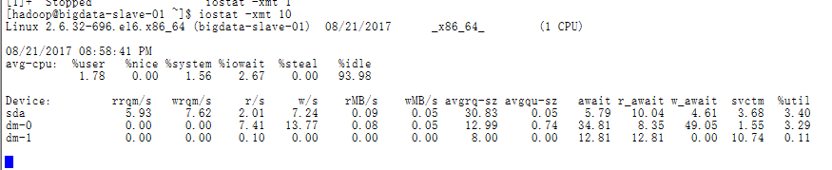

九．参考资料

<http://blog.csdn.net/fang_sh_lianjia/article/details/52352948>