AdVentSeq: A Comprehensive Bioinformatics Pipeline for Detection of Adventitious Viral Agents with RNA-seq
Binsheng Gong¹, Sayma Afroj², Aaron Scholl², Sandip De², Joshua Xu¹*
1 Division of Bioinformatics and Biostatistics, National Center for Toxicological Research, US Food and Drug Administration, Jefferson, AR, 72079, USA
2 Tumor Vaccine and Biotechnology Branch, Division of Cellular Therapy 2, Office of Cellular Therapy and Human Tissue, Center for Biologics Evaluation and Research, U.S. Food and Drug Administration, Silver Spring, MD 20993, USA
* Corresponding author: Joshua Xu (Joshua.Xu@fda.hhs.gov)

Abstract
Next-generation sequencing (NGS) is emerging as a powerful agnostic tool for detecting adventitious viral agents in biologics manufacturing. Existing bioinformatics tools often lack the ability to simultaneously achieve comprehensive pathogen characterization and precise quantification, presenting a critical gap for regulatory science applications where systematic evaluation of NGS methods is essential to define best practices.
We present AdVentSeq, a robust bioinformatics pipeline designed for paired-end short-read RNA sequencing data from virus-infected host samples. AdVentSeq enables integrated analysis of both host transcriptional responses and viral genomic features. The pipeline incorporates rigorous quality control, adapter trimming and read filtering, followed by host genome alignment to support host expression profiling and removal of host-derived reads. Non-host reads undergo alignment against FDA’s Reference Viral Database (RVDB), enabling genome coverage analysis to identify candidate viral infections. A subsequent refinement step performs combined viral genome remapping with coverage-adjusted quantification, improving accuracy of pathogen detection. The pipeline also generates downstream-ready outputs for applications such as viral variant calling, phylogenetic analysis, and host-response characterization.
Evaluation across multiple library-preparation protocols and inoculum conditions showed that host-subtraction strategy strongly influenced downstream viral candidate inflation and apparent viral burden. Conservative host read removal reduced spurious carryover into the viral-analysis stage, while coverage-aware quantification helped distinguish localized mapping artifacts from broad genome-supported viral signal. Host-expression profiles remained broadly consistent across host mappers, supporting a practical separation between mapper choices optimized for host transcriptomics and those optimized for viral detection and quantification.
AdVentSeq integrates host transcriptomic profiling with pathogen detection, quantification, and genomic characterization to provide a comprehensive pipeline tailored to regulatory science needs. Our results demonstrate that pairing conservative host read removal with coverage-aware viral interpretation improves the robustness, transparency, and biological plausibility of RNA-seq–based adventitious agent detection. This approach is particularly relevant for FDA safety evaluations of biological products, where systematic identification and characterization of adventitious viral agents are essential.
Keywords: RNA-seq, viral genomics, bioinformatics pipeline, pathogen detection, host-pathogen interactions

Introduction
Ensuring the viral safety of biological products is a central requirement of modern biomanufacturing because adventitious viral contamination can affect cell substrates, raw materials, viral seeds, bulk harvests, and final products used in vaccines, recombinant proteins, cell therapies, and gene therapy applications[1-4]. The regulatory and manufacturing importance of this problem has driven the development of multilayered viral safety strategies that combine careful selection and qualification of starting materials, upstream process controls, orthogonal clearance steps, and sensitive analytical testing for known and unknown viral agents[1, 2, 4, 5]. The ICH guideline Q5A(R2), adopted in 2023, reinforces the need for adventitious virus detection across multiple points in the manufacturing process, including cell substrates, cell banks, viral seeds, harvests, and unprocessed bulk, and for the first time explicitly recognizes next-generation sequencing as an analytical method for broad adventitious-agent detection [cite].
Historically, adventitious virus testing has relied on in vivo assays, in vitro cell-based infectivity tests, electron microscopy, and targeted molecular methods such as PCR, each of which provides useful but incomplete coverage of viral risk[1, 2, 4]. These traditional assays are limited by long turnaround times, finite assay scope, dependence on viral replication or prior sequence knowledge, and reduced ability to detect divergent, unexpected, or previously uncharacterized viruses[2, 4, 6].
Next-generation sequencing (NGS) has therefore emerged as a powerful sequence-independent technology for broad virus detection and characterization in biologics safety testing pipelines[2, 3, 6, 7]. Because NGS does not require prior knowledge of a specific target, it offers the possibility of simultaneously detecting expected, unexpected, and novel viral sequences within a single assay, making it particularly attractive for comprehensive adventitious agent testing[2, 3, 6]. The relevance of NGS-based virus detection was underscored by prominent case studies, including the detection of porcine circovirus type 1 nucleic acid in a licensed rotavirus vaccine and the discovery of an unexpected rhabdovirus in the Sf9 insect cell line, both of which demonstrated the value of broad, untargeted sequencing strategies in revealing hidden viral signals[2, 5]. These examples also highlighted a broader lesson for the field: contamination and viral sequence findings that escape conventional assays may still be detectable when sequencing data are interpreted using appropriately designed laboratory and computational pipelines[3, 5, 7]. As a result, NGS is increasingly being adopted as a complementary or alternative method for viral safety testing in biologics manufacturing, including applications involving vaccines, recombinant biologics, cell substrates, and viral vector platforms[1-3, 6, 7]. The 2019 NIST-FDA Workshop on Standards for Next-Generation Sequencing Detection of Viral Adventitious Agents in Biologics and Biomanufacturing convened regulators, standards bodies, and industry to address reference materials, assay standardization, and bioinformatics requirements needed to support routine NGS-based adventitious virus detection [NIST-FDA 2019].
However, the analytical power of NGS depends not only on sequencing chemistry and library preparation, but also on the design, optimization, and validation of the downstream bioinformatics pipeline used to separate true viral signal from technical and biological background[3, 6, 8]. Bioinformatics analysis is especially consequential in low-titer or complex samples, where viral reads may represent only a minute fraction of total sequence output and where false-positive calls can arise from database contamination, read misclassification, endogenous viral elements, or spurious alignments to repetitive or low-complexity sequence[6, 8, 9]. Accordingly, several groups and collaborative working efforts have emphasized that pipeline evaluation, reference curation, and threshold setting are essential for generating reproducible and interpretable NGS-based virus detection results in regulated settings[3, 6-8]. Among the different NGS applications relevant to viral safety and host–virus biology, RNA-seq of virus-infected host samples is particularly informative because the same dataset can capture viral RNA, host transcriptional responses, and, when coverage is sufficient, sequence variation within the infecting viral population[10-13]. This dual utility makes infected-host RNA-seq attractive not only for mechanism studies of virus–host interaction, but also for translational and industrial settings in which one wishes to understand both the presence of viral material and the corresponding impact on host-cell state[10, 13, 14]. In contrast to DNA-based broad-range sequencing approaches that may detect residual or nonreplicating nucleic acid, transcriptome sequencing can provide evidence of transcriptionally active virus while simultaneously preserving information about host pathways perturbed during infection[2, 10, 14]. For infected-cell systems, this creates an opportunity to connect viral burden with host innate immune activation, stress responses, metabolism, cell-cycle changes, or other transcriptional phenotypes within a unified analytical framework[10, 11, 13]. Despite these advantages, extracting accurate viral abundance estimates from infected-host RNA-seq data remains challenging because host reads usually dominate the library and can obscure low-level viral signal[5, 9, 10].
The host background problem is compounded when viral sequences share partial similarity with host-derived transcripts or genomic regions, which can lead to ambiguous alignment, incomplete recovery of true viral reads, or erroneous reassignment of reads during host subtraction and downstream classification[8, 9]. Method-dependent host read subtraction is itself a major analytical variable because subtraction against the host genome or transcriptome can improve computational efficiency and reduce noise, yet overly aggressive filtering may also discard biologically meaningful viral reads, particularly for viruses with host-like, endogenous, or low-complexity sequence features[8, 9]. Another recurring challenge is that viral reads are often distributed unevenly across the viral genome because of transcriptional structure, library construction bias, PCR effects, partial degradation, and local sequence composition, making raw read counts an imperfect proxy for viral abundance[12, 13]. Uneven coverage becomes especially problematic when a small number of highly covered regions dominate the apparent signal while other parts of the genome remain sparsely represented, since such patterns can inflate abundance estimates or complicate comparisons across viruses, samples, and analytical methods[12, 13]. Low-complexity or homopolymeric regions can further distort interpretation because they tend to attract spurious alignments, generate unstable read-placement behavior across mappers, and create localized coverage artifacts that are not necessarily proportional to true viral load[8, 12]. Multi-mapping introduces an additional layer of complexity because reads may align to multiple viral references, to both host and viral references, or to closely related strains within a database, thereby complicating taxonomic assignment and quantitative inference[6, 9, 12]. These issues are amplified by differences among aligners and classifiers, since distinct tools vary in sensitivity, specificity, handling of mismatches and indels, treatment of multi-mapped reads, and susceptibility to misleading low-complexity matches[6, 8, 12]. Reference strategy is likewise critical, as viral detection and quantification can change depending on whether one uses broad taxonomic databases, curated virus-only references, host-plus-virus composite references, or strain-resolved panels tailored to the experimental system[6, 8, 9].
Taken together, these factors mean that infected-host RNA-seq analysis requires more than simple read counting or off-the-shelf metagenomic classification if one aims to obtain robust viral quantification alongside interpretable host-response results[10, 12, 13]. Yet many existing pipelines emphasize only one side of the problem: some focus primarily on metagenomic virus identification and broad taxonomic screening, while others center on host differential expression without providing dedicated support for viral quantification or viral sequence analysis after infection[9, 12, 13]. Comparatively fewer pipelines provide an integrated approach that supports host gene-expression quantification, virus-aware abundance estimation, and post-infection viral mutation analysis while explicitly accounting for alignment ambiguity, coverage heterogeneity, and host-subtraction artifacts[12, 13]. This gap is especially relevant for controlled experimental infection studies and spike-in systems, where the analytical objective is not merely to detect whether virus is present, but to quantify how much virus is present, characterize how the host responds, and determine whether viral sequence changes emerge under the tested conditions[10, 11, 13]. Such integrated analysis is also valuable for evaluation purposes because controlled mixtures and spike-in designs can reveal where specific tools succeed or fail under conditions of known composition, read imbalance, and varying degrees of host background[3, 6, 7].
In this study, we address these needs by developing AdVentSeq, a comprehensive bioinformatics pipeline for Illumina paired-end RNA-seq data from virus-infected host samples, which includes ViraQuant, a coverage-aware viral quantification module designed to improve abundance estimation in the presence of uneven coverage and alignment artifacts. AdVentSeq is intended to support end-to-end analysis by combining viral detection, coverage-aware viral quantification, host transcriptional profiling, and post-infection viral mutation analysis within a single pipeline tailored to infected-host transcriptomic data rather than generic metagenomic sequencing alone. Because mapper choice and reference composition can strongly influence both sensitivity and quantitative accuracy, we further emphasize systematic evaluation of alignment tools and comparison of reference strategies as core components of the pipeline rather than as incidental implementation details[6, 8, 9]. To evaluate performance under controlled conditions, we leverage a controlled multi-virus spike-in dataset that enables direct comparison of viral detection and quantification behavior across tools, references, and analytical settings while preserving the infected-host RNA-seq context relevant to downstream host-response analysis. By integrating host and viral analyses in a common framework and by explicitly confronting the sources of bias that complicate infected-host RNA-seq interpretation, AdVentSeq, including its ViraQuant module, aims to provide a practical and transparent solution for studying virus–host interactions and for improving the analytical rigor of sequencing-based viral characterization pipelines[3, 6, 8].

Results

AdVentSeq pipeline and evaluation dataset
We developed AdVentSeq as a comprehensive pipeline for infected-host RNA-seq that jointly evaluates viral and host-derived information from the same sequencing dataset. The pipeline includes several key steps, including quality control (QC), host/virus read separation, host gene-expression quantification, taxonomic screening, viral quantification and coverage analysis. The pipeline generates downstream-ready data for host-response analysis and viral evolution analysis (Figure 1). This design was motivated by the need to move beyond pipelines that emphasize either virus detection alone or host transcriptomics alone, and instead provide a unified framework for interpreting viral support together with host transcriptional responses.
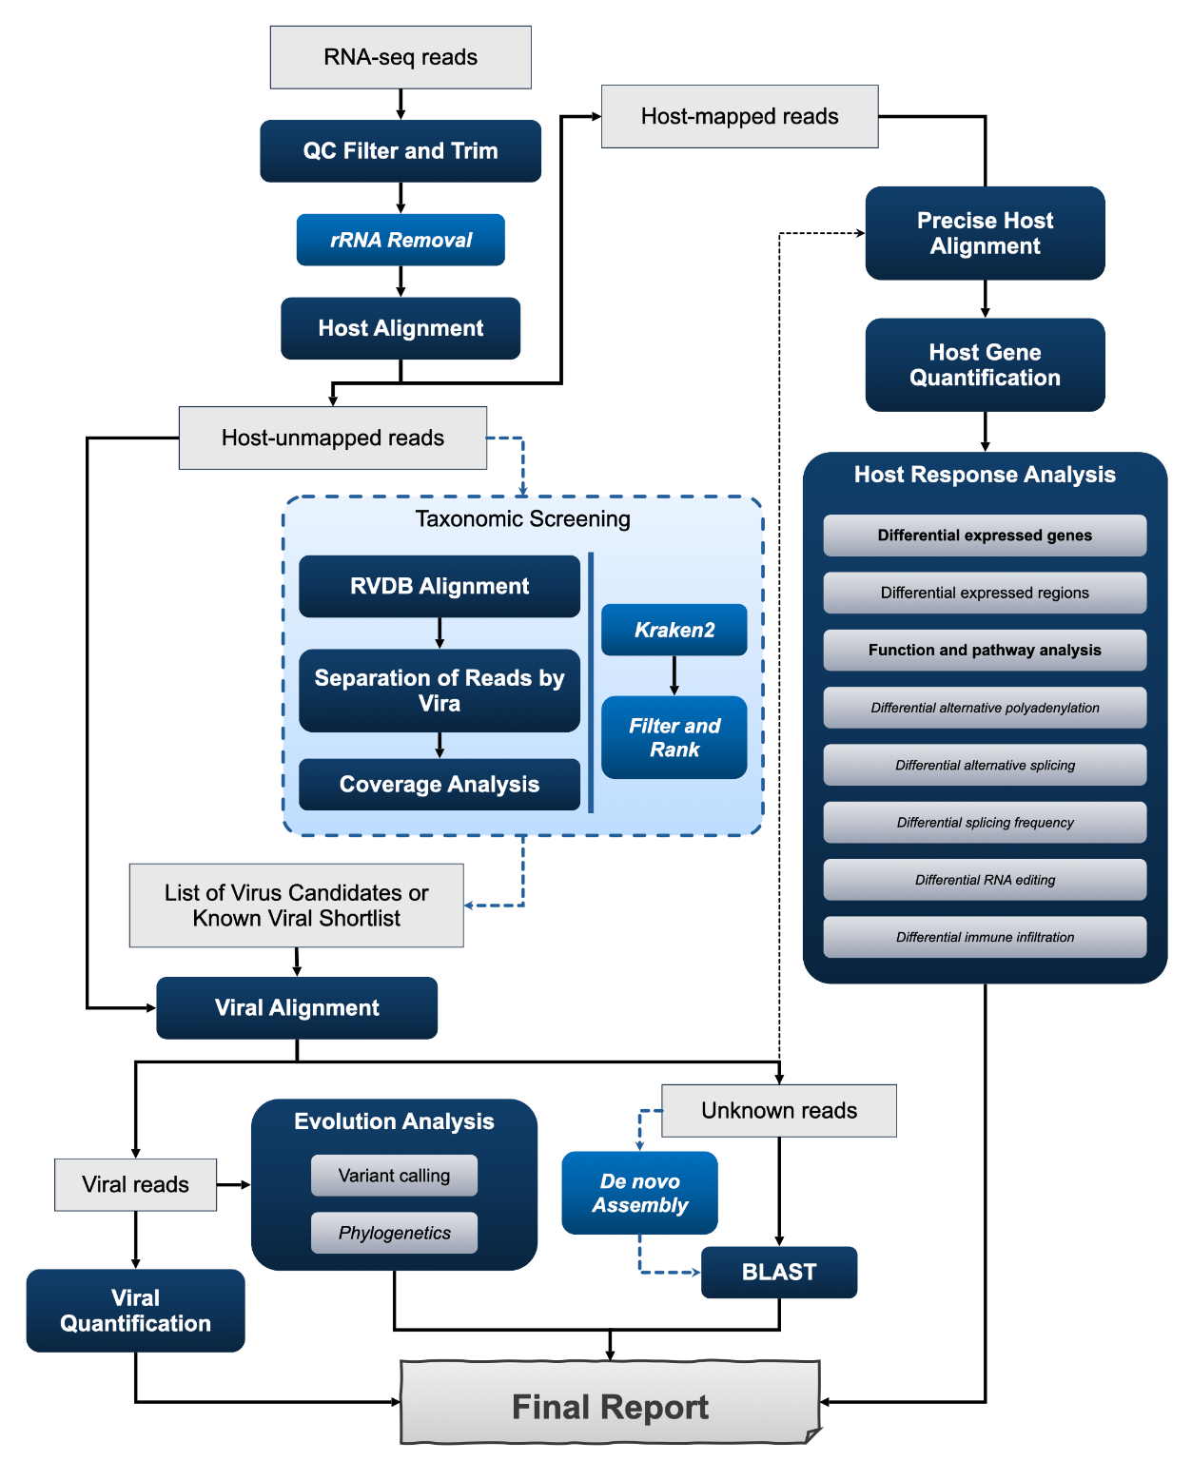
Figure 1: AdVentSeq pipeline diagram
The QC includes QC assessment, read filtering, and adapter trimming. Optionally, rRNA reads can be removed according to the study interests. In the host/virus read separation, quality reads are first mapped to host genome and host gene expression can be quantified. The host gene expression profile can be used for host response analyses, such as differential expressed gene analysis, function and pathway enrichment analysis, etc. The proper host mapped reads are then removed to create host-unmapped reads data. This data then undergoes through an optimal taxonomic screening for non-target analysis concluding with a list of virus candidates. Taxonomic screening can be done with either Kraken2 (see Materials and Methods), or with mapping to RVDB followed by coverage analysis using ViraQuant (see Materials and Methods). The mapped reads can be separated per virus using TaxonomyClassifier (see Materials and Methods) to create BAM files for visualization and manual inspection. The targeted analysis involves mapping the host-unmapped reads to a combined genome of known viruses as targets, optionally combined with the virus candidates from the taxonomic screening results. A simple read counting is performed by TaxonomyClassifier. Comprehensive coverage analysis and quantification can be done with ViraQuant. The TaxonomyClassifier also creates BAM files for the virus mapped reads that can be used for evolutionary analysis. For exploration purposes, de novo assembly can be applied to the reads that are unmapped to either host or viruses to create contigs to search for possible species/strain/isolation through BLAST. For detailed tool information, please see Materials and Methods.
The evaluation dataset (See Materials and Methods) covered 42 human-cell RNA-seq libraries spanning seven library-preparation protocols, three inoculum groups (Control, 1:1, and 10:1), and two technical replicates per group (Table 1). In 1:1, and 10:1 groups, a mixture of seven viruses was introduced in the human cell lines at different dilution ratio. Median post-filtering sequencing depth varied widely by protocol, ranging from 95.3 million reads for RepliG+Nextera_XT libraries to 274.5 million reads for NEB_WO_RD libraries.
Table 1: Metadata of the evaluation dataset
experiment_protocol | included_samples | control_samples | inoculum_1to1_samples | inoculum_10to1_samples | median_after_filtering_reads | median_retained_fraction | median_non_host_reads_HISAT2 | median_non_host_reads_STAR | median_non_host_reads_bwa_mem
NEB_WO_RD | 6 | 2 | 2 | 2 | 2.75E+08 | 0.978 | 13648710 | 32091234 | 1039257
Ribozero+NEBNext | 6 | 2 | 2 | 2 | 1.48E+08 | 0.947 | 15406349 | 3322807 | 784526
Jumpcode_Trio | 6 | 2 | 2 | 2 | 1.44E+08 | 0.753 | 56560500 | 36937322 | 1847508
NEB_RD | 6 | 2 | 2 | 2 | 1.28E+08 | 0.96 | 10603779 | 4985445 | 731842
Jumpcode | 6 | 2 | 2 | 2 | 1.22E+08 | 0.983 | 6963799 | 1973248 | 344223
Trio | 6 | 2 | 2 | 2 | 1.01E+08 | 0.948 | 26966927 | 11636559 | 471313
RepliG+Nextera_XT | 6 | 2 | 2 | 2 | 95267067 | 0.917 | 23457962 | 29408401 | 663777

Read QC, adapter trimming, and polyX trimming preserved most reads for downstream analysis
As the first stage of the AdVentSeq pipeline, read QC, adapter trimming, and polyX trimming remove low-quality, adapter-derived, and low-complexity terminal sequence while retaining the sequencing depth needed for reliable downstream host- and virus-oriented analysis. Across the evaluated libraries this step preserved the large majority of reads, with a median per-sample post-filtering retention of 95.1% of raw reads. Adapter and polyX trimming each removed only a small fraction of reads overall (medians of roughly 0.5% and 1.3% of raw reads, respectively), and QC modestly improved base quality, raising median Q20 and Q30 rates by about 1.5% and 1.7%. By cleaning reads without sacrificing depth, this step provides high-quality input for the host-subtraction and viral-screening stages that follow.

Host subtraction dominated the amount of sequence entering the viral mapping stage
The clearest method effect emerged before viral alignment. Across the seven protocols, BWA-MEM host subtraction left median non-host read pools of 3.4 x 10⁵ to 1.8 x 10⁶ reads, whereas HISAT2 left 7.0 x 10⁶ to 5.7 x 10⁷ reads and STAR left 2.0 x 10⁶ to 3.7 x 10⁷ reads (Figure 2A; Table 1). Relative to BWA-MEM, HISAT2 passed 13.1- to 57.2-fold more reads into the viral stage and STAR passed 4.2- to 44.3-fold more. Thus, the choice of host mapper strongly determined how ambiguous host-like sequence was allowed to propagate into downstream viral analyses.
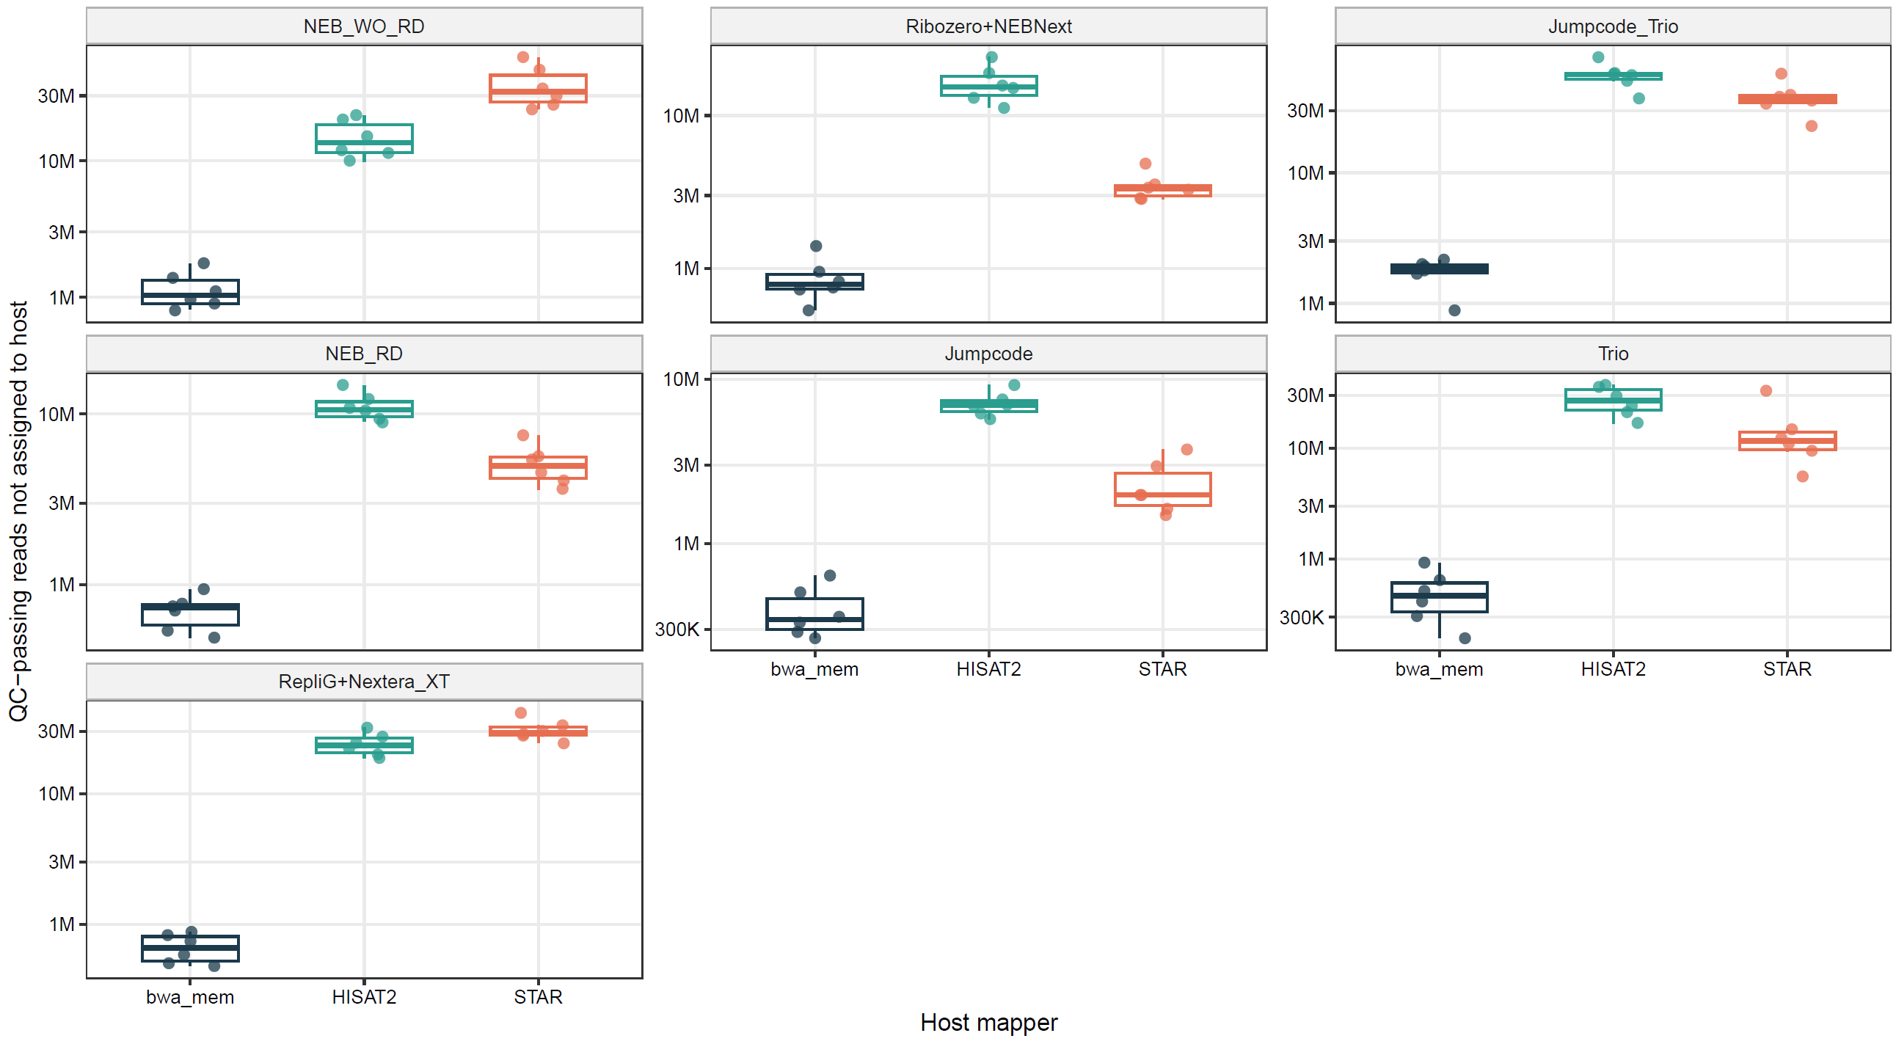
Figure 2A: Host subtraction leaves sharply different non−host read portions

Untargeted viral screening yields high false-positive rates without stringent host subtraction and coverage-aware filtering
Three screen methods, including Kraken2, RVDB read-count screening, and ViraQuant scan mode, were compared against a shared 8,469 taxids (ranks S/S1/S2) between RVDB and Kraken2 viral db (see Methods), ensuring that each method was evaluated over the same taxonomic universe (Figure 2B). The per-taxon counts of Kraken2 and RVDB read-count were normalized to reads per million (RPM) and a taxon was counted as detected at RPM ≥ 1, whereas ViraQuant scan mode required at least half of the reference covered at least 1 depth (see Methods). RVDB read-count reported the most virus candidates, Kraken2 reported relatively less numbers, and ViraQuant scan mode reported significantly smaller numbers. Host-subtraction strategy strongly influenced the number of virus candidates, with median counts substantially higher after host-read removal by STAR and HISAT2 than by BWA-MEM. The effect was most pronounced in negative controls, where BWA-MEM host subtraction reduced detection to a median of zero for both Kraken2 and ViraQuant scan and to only about 6 taxids for read-count screening, whereas HISAT2 and STAR still reported tens of virus candidates in the same controls. Among viral mappers, Bowtie2 slightly reduced the number of virus candidates in most cases. These results demonstrate that false-positive viruses arise from two major sources: the host-subtraction methods, for which BWA-MEM was the best choice for this dataset, and the viral screening method, for which the coverage-aware ViraQuant scan mode provided the most stringent control.
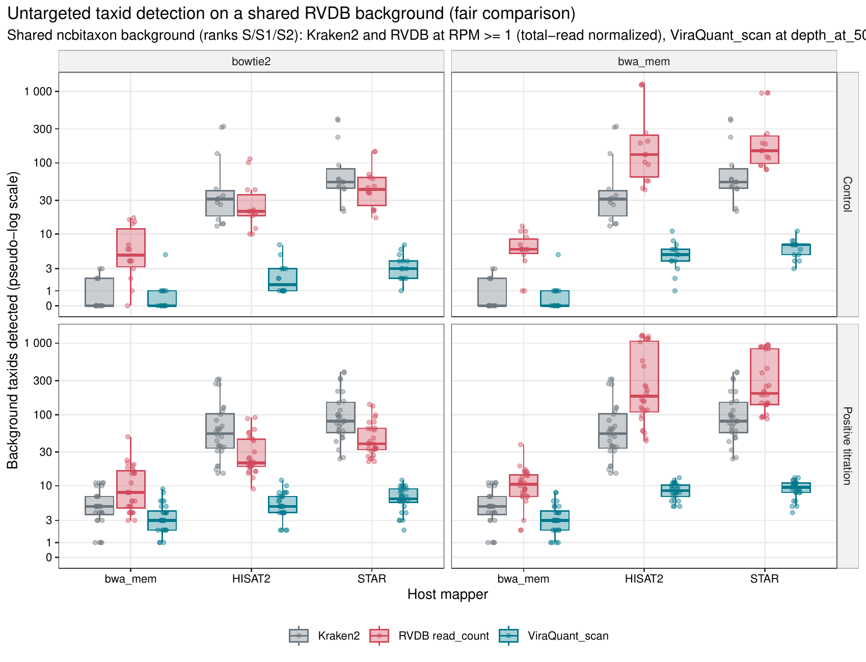
Figure 2B: On a shared RVDB background, untargeted taxid inflation is dominated by host-subtraction and viral-mapper choice

Targeted viral burden was most conservative after BWA-MEM host subtraction
Panel-mode alignment to the targeted virus bundle retained clear viral signal in positive titration libraries, but the separation between controls and positives depended strongly on host subtraction strategy (Figure 3; Table 2). With BWA-MEM as the host mapper, median viral burden in the controls was 1.93 normalized units with Bowtie2 and 0.51 with BWA-MEM, compared with 37.49 and 36.90 in positive titration libraries. After HISAT2 or STAR host subtraction, median viral burden in the controls increased substantially: 24.67 and 33.13 with Bowtie2 viral mapping, and 205.42 and 235.33 with BWA-MEM viral mapping. The median number of target viruses detected in control libraries dropped to 2.0 with the BWA-MEM/BWA-MEM combination, whereas HISAT2- and STAR-based subtraction generally reported 6.0 to 7.5 target viruses even in controls. Positive titration libraries still showed median detection of 6 to 8 target viruses across the mapper combinations, indicating that conservative host subtraction reduced background much more than it reduced expected panel recovery.
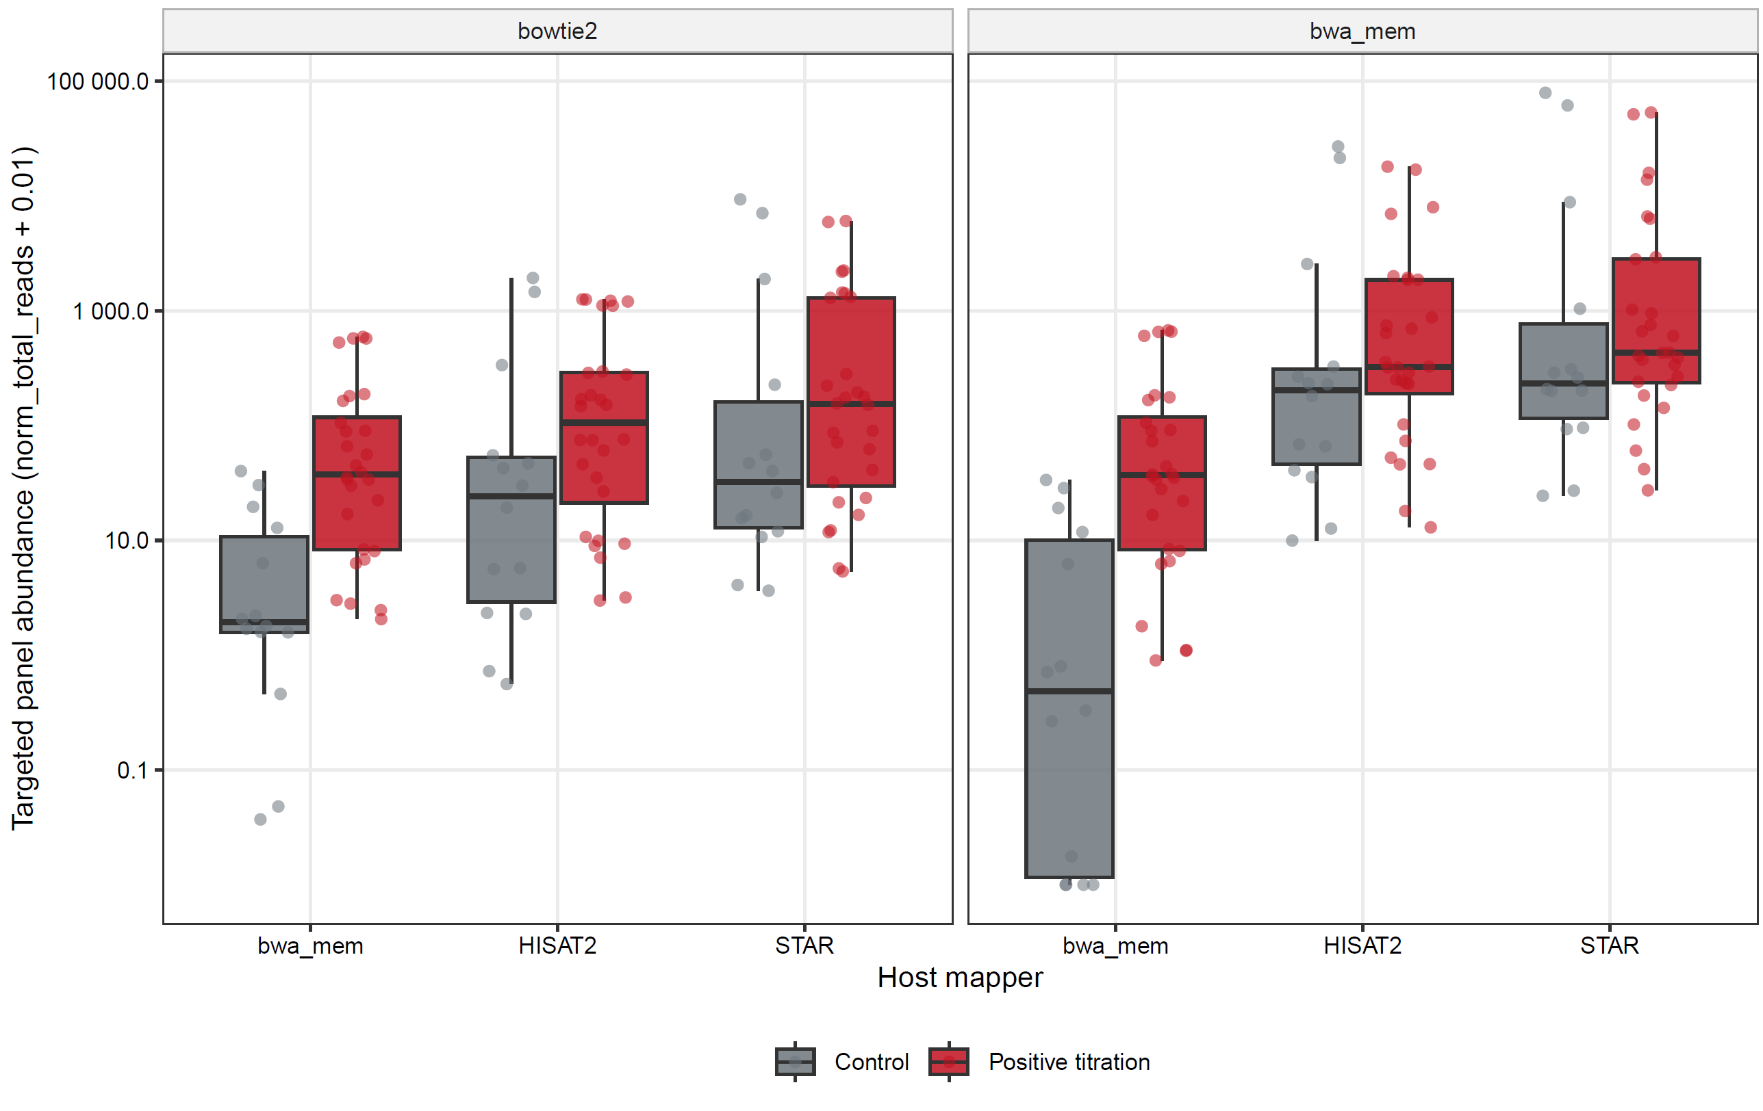
Figure 3: Targeted viral burden still depends strongly on host subtraction strategy

Table 2: cross-method comparison of alignment results (need format)
host_mapper | virus_mapper | median_target_norm_total_reads_negative_control | median_target_norm_total_reads_positive_titration | median_target_viruses_detected_negative_control | median_target_viruses_detected_positive_titration | median_untarget_norm_total_reads_negative_control | median_untarget_norm_total_reads_positive_titration | median_untarget_taxa_detected_negative_control | median_untarget_taxa_detected_positive_titration | median_viraquant_primary_negative_control | median_viraquant_primary_positive_titration | median_viraquant_pass90_negative_control | median_viraquant_pass90_positive_titration | median_kraken_taxids | median_rvdb_read_count_taxids | median_viraquant_scan_taxids | median_shared_all_three_taxids | median_kraken_only_taxids | median_shared_all_three_rvdb_fraction | median_host_assigned_fraction
bwa_mem | bowtie2 | 1.926 | 37.489 | 6.5 | 7 | 132.955 | 396.795 | 909 | 671.5 | 0.159 | 0.497 | 0 | 1 | 276 | 818 | 818 | 18.5 | 255 | 0.441 | 0.995
bwa_mem | bwa_mem | 0.511 | 36.904 | 2 | 6 | 123.448 | 472.679 | 429 | 667 | 0.028 | 0.415 | 0 | 1 | 276 | 483.5 | 483.5 | 18 | 254.5 | 0.446 | 0.995
HISAT2 | bowtie2 | 24.667 | 111.8 | 6.5 | 7.5 | 1078.966 | 1809.751 | 1324.5 | 1412.5 | 0.879 | 1.307 | 0 | 1 | 2091.5 | 1342.5 | 1342.5 | 131.5 | 1903.5 | 0.208 | 0.893
HISAT2 | bwa_mem | 205.415 | 324.762 | 7.5 | 8 | 6712.066 | 11897.27 | 8878.5 | 10164.5 | 13.903 | 5.867 | 0 | 1 | 2091.5 | 9638 | 9638 | 498 | 1593.5 | 0.158 | 0.893
STAR | bowtie2 | 33.131 | 154.001 | 6 | 7 | 6306.7 | 5260.362 | 1294.5 | 1558 | 2.831 | 1.871 | 0 | 1 | 2331 | 1391 | 1391 | 162.5 | 2176.5 | 0.204 | 0.887
STAR | bwa_mem | 235.331 | 431.052 | 6.5 | 8 | 67955.8 | 34054.33 | 7884 | 8550.5 | 33.557 | 9.326 | 0 | 1 | 2331 | 8171.5 | 8171.5 | 535.5 | 1779.5 | 0.166 | 0.887

Coverage breadth distinguished localized pileups from genome-wide support
Mapped-read totals alone did not reliably reflect biologically plausible support. Sample 1_S1 provided a representative contrast between narrow and broad viral evidence (Figure 4A-B; Table 3). Under the host/virus mapper combinations HISAT2/BWA-MEM and STAR/BWA-MEM, HEV accumulated 19,328 and 21,847 mapped reads, respectively, exceeding the corresponding Zika counts of 2,031 and 2,027 reads. However, HEV breadth remained only 3.49% to 3.53% and never passed the ViraQuant 90%-breadth criterion, whereas Zika covered 95.38% to 99.15% of positions and passed the 90%-breadth criterion under every mapper combination. Even the more permissive HISAT2/Bowtie2 and STAR/Bowtie2 combinations showed the same contrast: HEV breadth remained below 4.4%, while Zika breadth remained near complete. These results show why raw read counts can be misleading when a small genomic interval absorbs many alignments, and why breadth-style filters are required alongside depth summaries.
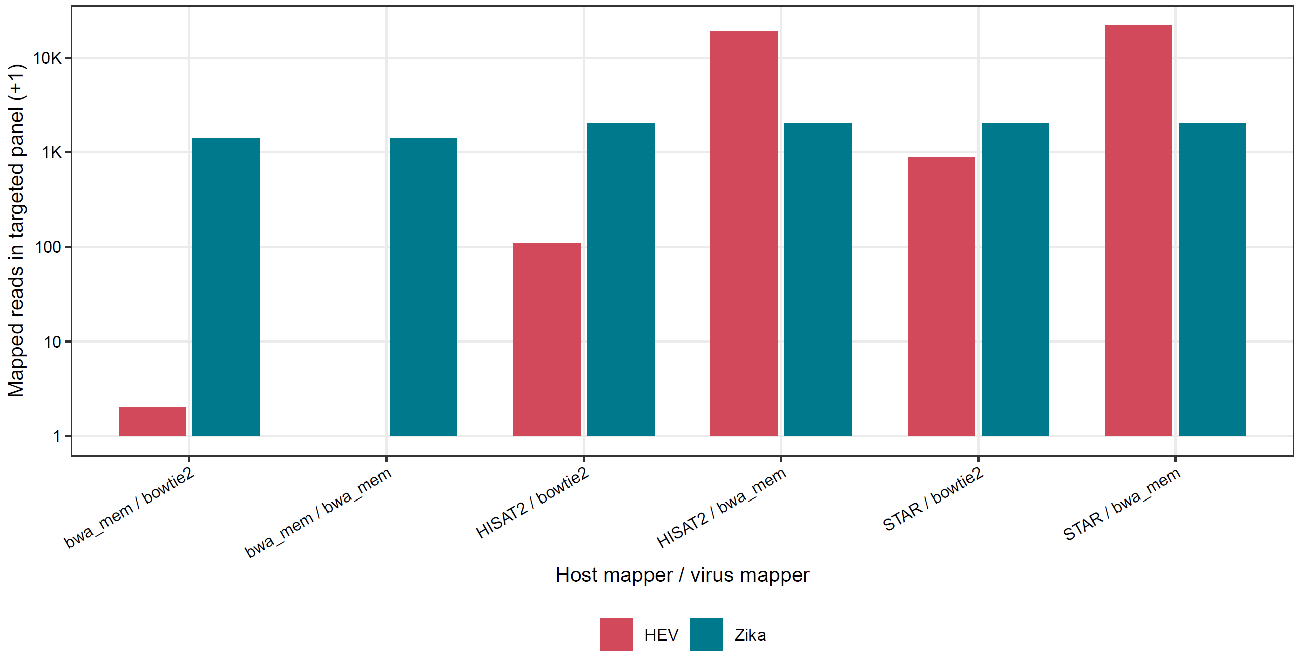
Figure 4A: Representative sample 1_S1: mapped−read totals alone can mislead
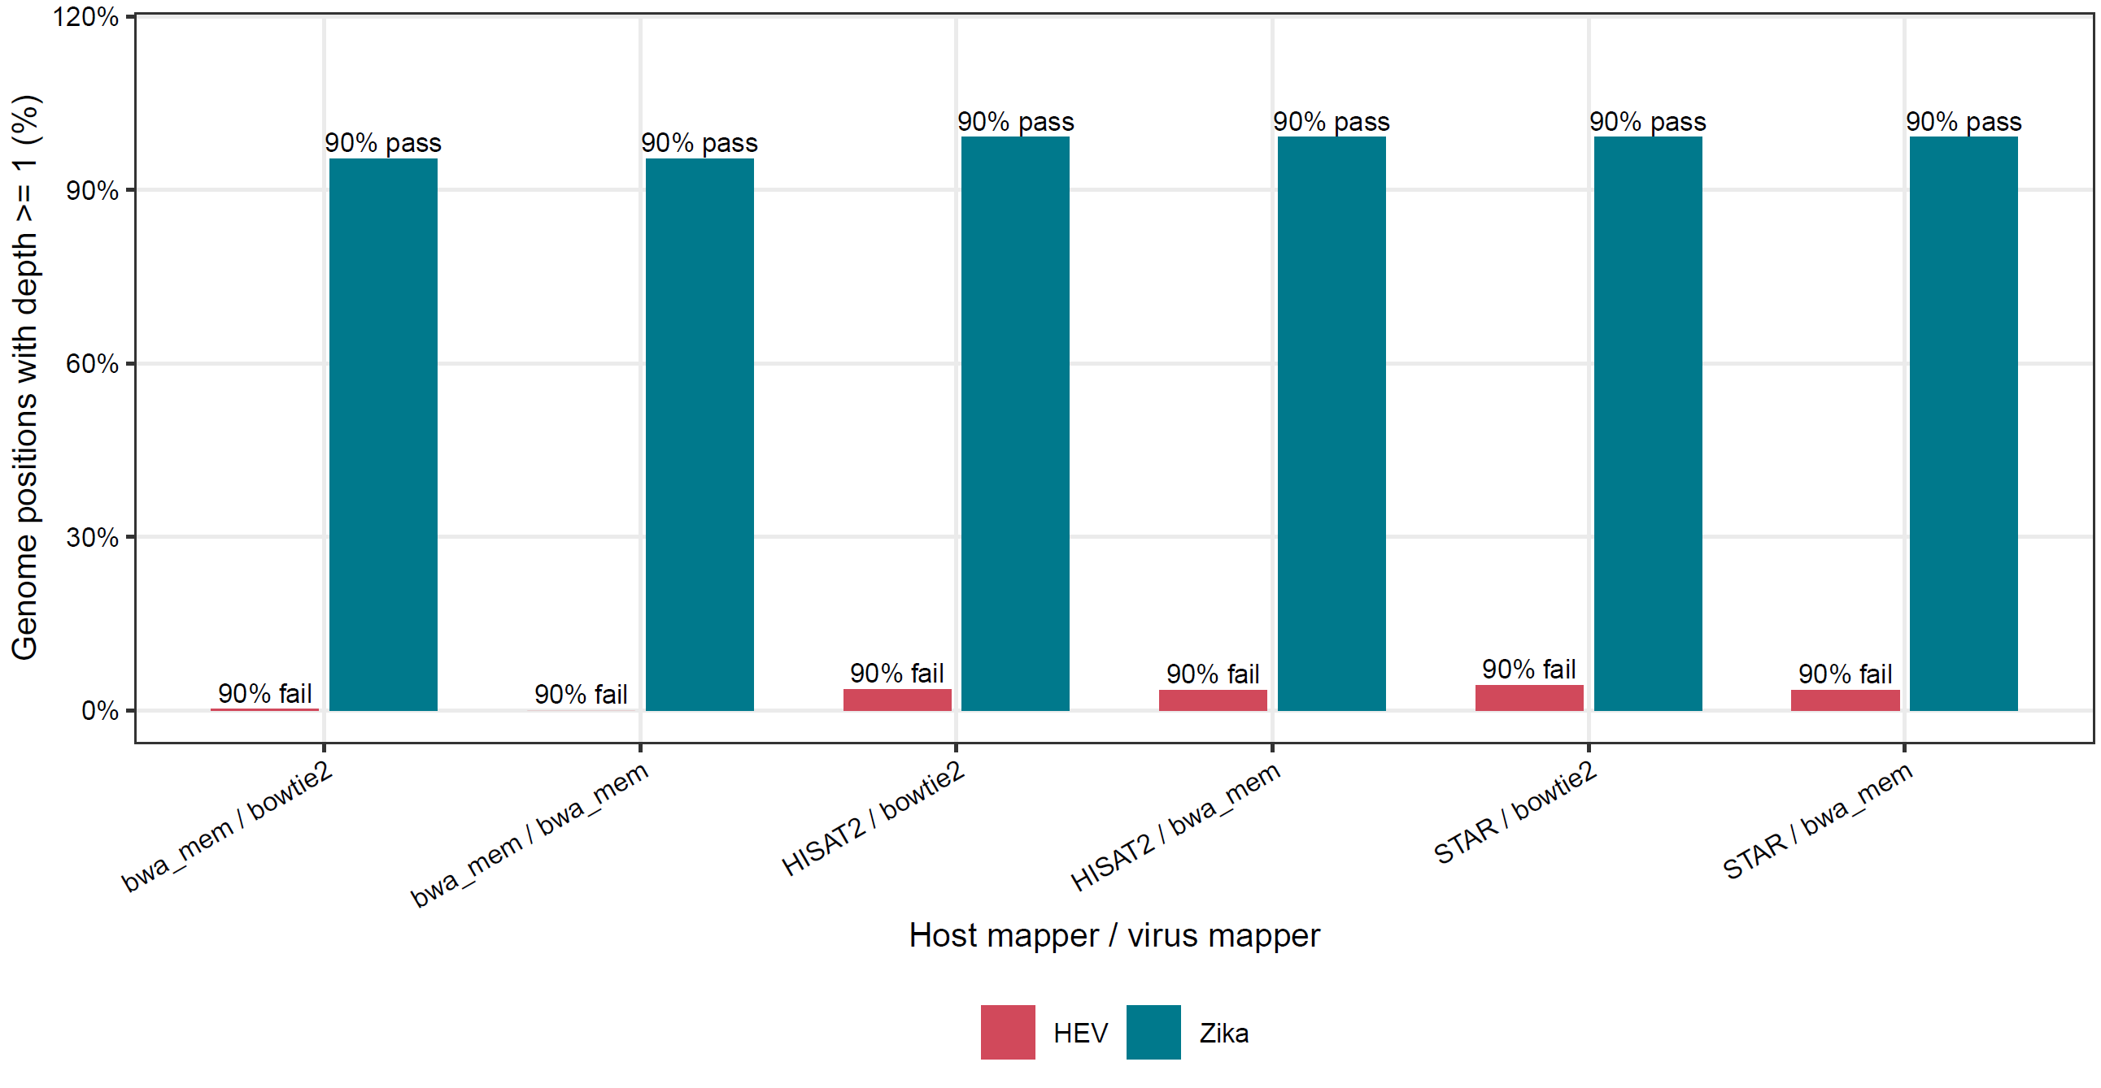
Figure 4B: Coverage breadth separates local pileups from genome−wide support
Table 3: sample-level comparison for sample `1_S1`
sample_id | experiment_protocol | host_mapper | virus_mapper | virus | abundance_raw_read_count | norm_total_reads_read_count | frac_ge_1 | mean_depth_ge_1 | pass_k_90pct_ge_1
1_S1 | NEB_RD | bwa_mem | bowtie2 | HEV | 1 | 0.008327 | 0.002 | 1 | 0
1_S1 | NEB_RD | bwa_mem | bwa_mem | HEV | 0 | 0 | 0 | NA | 0
1_S1 | NEB_RD | HISAT2 | bowtie2 | HEV | 108 | 0.899285 | 0.036938 | 34.3574 | 0
1_S1 | NEB_RD | HISAT2 | bwa_mem | HEV | 19328 | 160.9386 | 0.034938 | 2150.042 | 0
1_S1 | NEB_RD | STAR | bowtie2 | HEV | 889 | 7.402445 | 0.043606 | 195.1865 | 0
1_S1 | NEB_RD | STAR | bwa_mem | HEV | 21847 | 181.9136 | 0.035338 | 3052.442 | 0
1_S1 | NEB_RD | bwa_mem | bowtie2 | Zika | 1396 | 11.62409 | 0.953771 | 13.40427 | 1
1_S1 | NEB_RD | bwa_mem | bwa_mem | Zika | 1409 | 11.73233 | 0.953771 | 13.47518 | 1
1_S1 | NEB_RD | HISAT2 | bowtie2 | Zika | 2013 | 16.76167 | 0.991477 | 18.54803 | 1
1_S1 | NEB_RD | HISAT2 | bwa_mem | Zika | 2031 | 16.91155 | 0.991477 | 18.62605 | 1
1_S1 | NEB_RD | STAR | bowtie2 | Zika | 2013 | 16.76167 | 0.991477 | 18.54803 | 1
1_S1 | NEB_RD | STAR | bwa_mem | Zika | 2027 | 16.87824 | 0.991477 | 18.61671 | 1

ViraQuant preserved overall virus ranking while exposing coverage quality
At the virus level, ViraQuant remained strongly concordant with read-count-based summaries despite operating on a different quantitative scale. Across 336 matched virus-level observations per host/virus mapper combination, Spearman correlation between read-count and ViraQuant summaries ranged from 0.824 to 0.972. The highest concordance was observed for the BWA-MEM/BWA-MEM pipeline, whereas the HISAT2/BWA-MEM and STAR/BWA-MEM combinations showed lower agreement, consistent with the greater opportunity for carryover-driven pileups under permissive host subtraction. In practice, these results support using mean_depth_ge_1 as a quantitative descriptor only when it is interpreted jointly with coverage breadth metrics such as frac_ge_1 or pass_k_90pct_ge_1.

Host-expression structure was stable across host mappers
Host-side quantification was much less sensitive to mapper choice than downstream viral carryover. Pairwise mapper concordance for count-pair matrices was high across the 42 analyzed libraries, with median sample-wise Spearman correlations of 0.986 between HISAT2 and STAR, 0.945 between BWA-MEM and HISAT2, and 0.941 between BWA-MEM and STAR. The median fraction of reads assigned to host was 0.995 for BWA-MEM, 0.893 for HISAT2, and 0.887 for STAR. BWA-MEM yielded the largest median number of detected genes (28,909), whereas HISAT2 and STAR produced similar medians of about 26,100 genes. Despite those count differences, the overall host-expression topology was preserved across all three mappers: samples clustered primarily by library-preparation protocol, while Control, 1:1, and 10:1 libraries separated within protocols along the principal components (Suppl Figure 1).

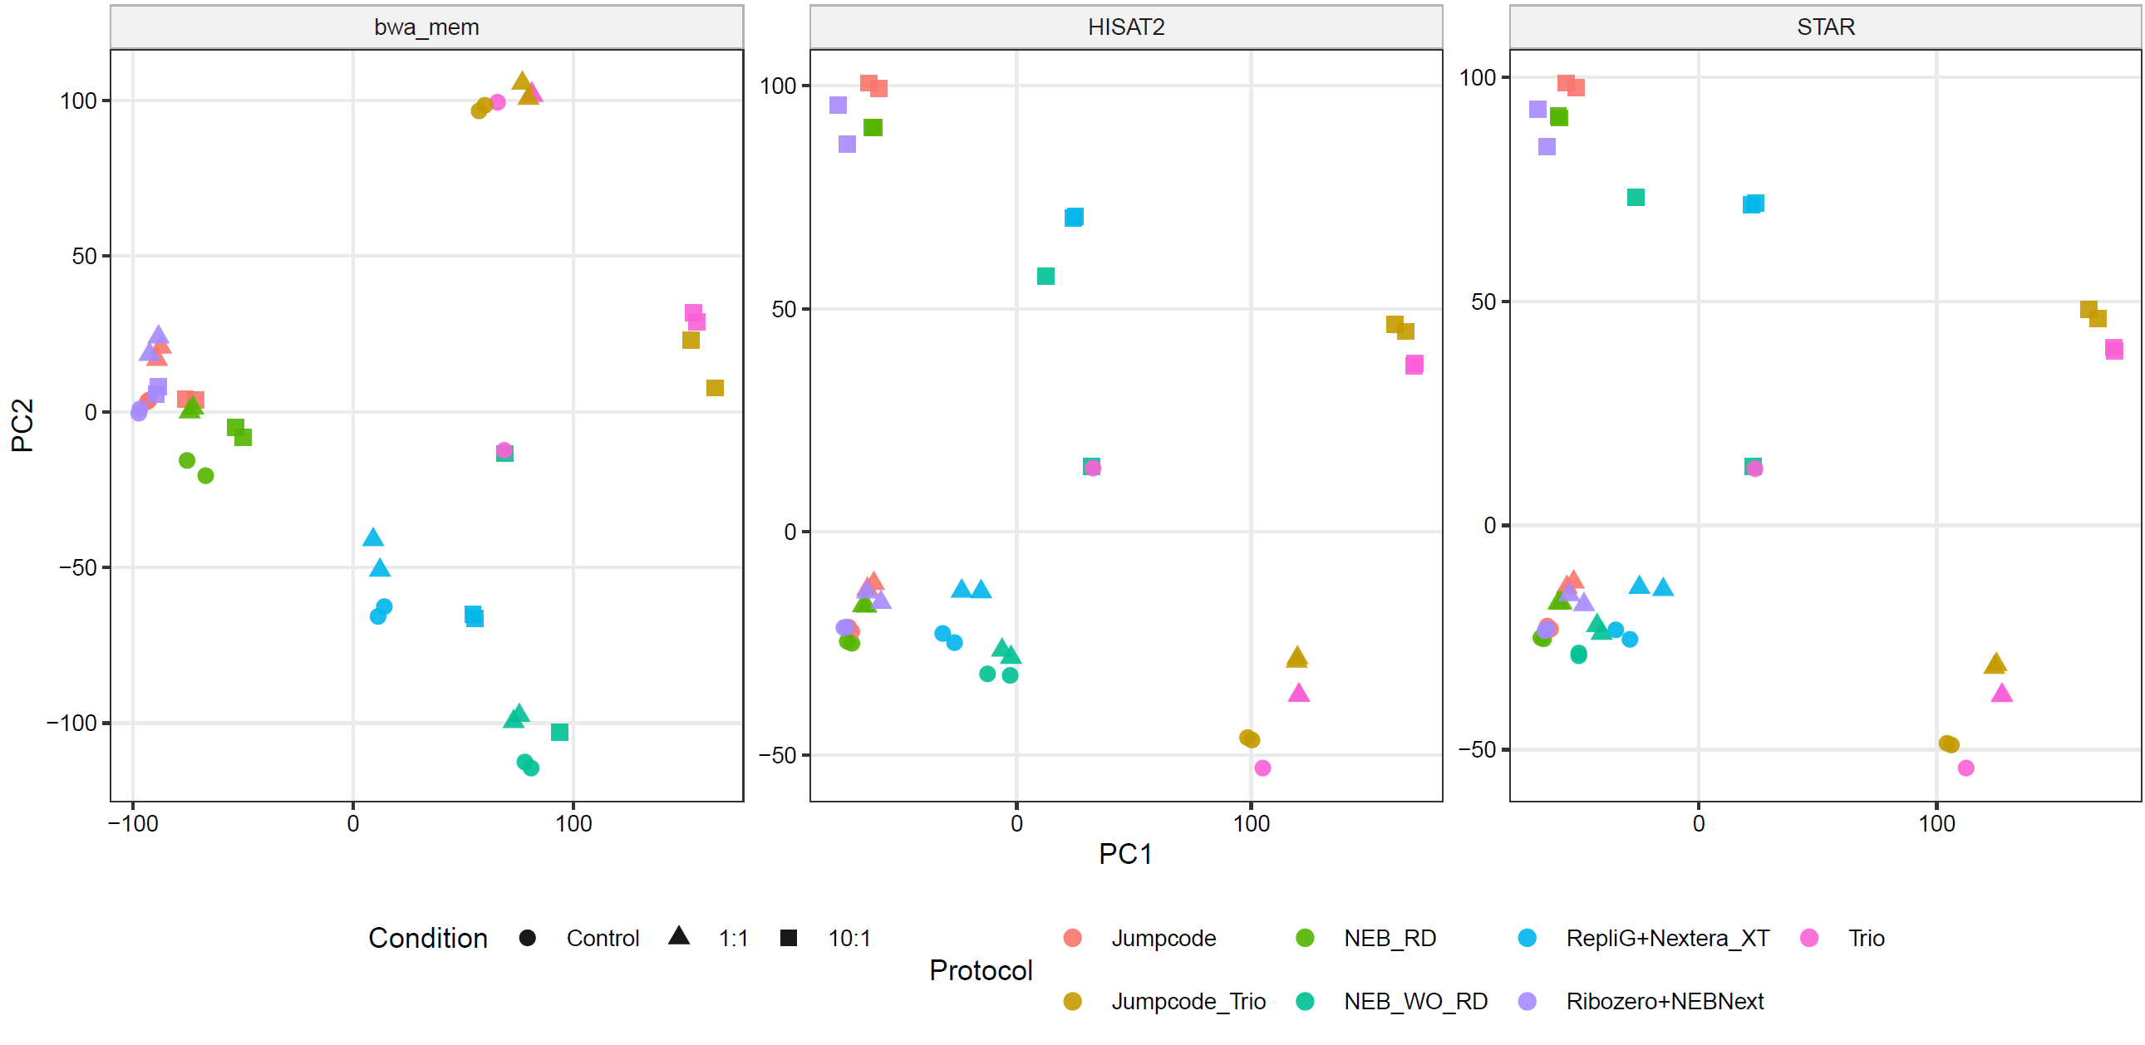
Suppl Figure 1: Host−expression sample structure is preserved across host mappers

Recommended configuration from the evaluation
Taken together, the evaluation supported a split configuration rather than a single universal mapper. For viral inference, the most conservative pipeline combined BWA-MEM host subtraction with targeted viral alignment by BWA-MEM or Bowtie2, followed by ViraQuant review using mean_depth_ge_1 together with breadth-style presence filters. For host-transcriptome-focused analyses, splice-aware mappers remained appropriate because host-expression structure was highly consistent across mappers and HISAT2/STAR agreed most closely with one another. AdVentSeq also produces downstream-ready outputs for host-response, variant-calling, and phylogenetic follow-up, but those analyses were outside the scope of the present evaluation and are therefore not interpreted further here.

Discussion
Infected-host RNA-seq is an appealing substrate for virus analysis because it can, in principle, support several objectives at once: detection of viral sequences, estimation of viral abundance, characterization of host transcriptional responses, and assessment of viral sequence variation[15]. In practice, however, these objectives place different demands on the computational pipeline, and our results show that methods that appear favorable for one task are not necessarily optimal for another. The central finding of this study is that viral quantification in infected-host RNA-seq is especially vulnerable to coverage artifacts and alignment ambiguity, and that reliable interpretation therefore requires a coverage-aware strategy rather than naïve counting of mapped reads alone.
A major reason naïve quantification fails is that viral reads are often distributed unevenly across reference genomes. Uneven coverage can arise from several sources simultaneously. First, some viral regions share local similarity with host-derived sequences, including repetitive elements and other duplicated or compositionally biased regions, which can cause ambiguous placement of reads during host subtraction or viral alignment[16]. Second, low-complexity and homopolymer-rich regions can attract spurious alignments because a read may match multiple loci with similarly weak specificity[17]. Third, the structure of RNA-seq libraries themselves can introduce nonuniform representation through priming bias, fragmentation bias, amplification bias, RNA degradation, and positional effects[18-20]. In infected-host datasets, these issues are magnified because viral reads are typically sparse relative to host reads. As a result, a small cluster of ambiguously aligned reads in one short viral interval can create the appearance of a positive signal even when broader genome support is absent. Under those conditions, total mapped read count becomes a misleading summary, because it gives disproportionate weight to localized pileups that may reflect alignment artifacts rather than true viral abundance.
This is precisely why breadth-aware and depth-distribution-aware quantification is important. A robust viral signal should generally be supported across a meaningful fraction of the viral reference rather than collapsing onto one narrow region. Measures such as the fraction of positions with nonzero depth, the mean depth among covered positions, and coverage quantiles provide a more informative description of evidence than raw read totals. These metrics do not eliminate ambiguity entirely, but they reduce the risk of over-interpreting isolated high-depth artifacts. In this respect, ViraQuant is less a replacement for read counting than a correction to the assumption that all mapped reads contribute equally to biological interpretation. Our results suggest that once uneven coverage is acknowledged explicitly, apparent differences in viral support can be re-evaluated more realistically.
The evaluation results also support an important practical conclusion: splitting analytical objectives across tools is rational rather than inconsistent. In many pipelines there is an implicit desire to identify a single “best” mapper, but infected-host RNA-seq does not present a single optimization problem. Host transcriptomic profiling benefits from splice-aware alignment and mature gene-quantification support, which make tools such as STAR or HISAT2 well suited for host-side analysis[21, 22]. At the same time, repeated-sequence contexts can induce erroneous splice-aware alignments, underscoring the value of more conservative alignment strategies for some downstream tasks[23]. Our results indicate that BWA-MEM is advantageous in this context because it can be used more aggressively for host subtraction, leaving fewer ambiguous reads available for viral realignment and reducing some of the misleading signal retained by more permissive strategies. This division of labor is methodologically justified: one tool need not be forced to perform optimally for every downstream objective when the objectives themselves differ in what they reward. Using STAR for host transcriptomics and BWA-MEM for subtraction and viral quantification is therefore not a compromise, but a recognition that integrated host–virus analysis is inherently multi-objective.
These findings also have implications for how users should think about “discovery mode” versus “panel mode” pipelines. Discovery-mode analysis aims to cast a wide net across diverse viral space, often using broad reference databases or metagenomic classifiers. The advantage is obvious: unexpected or divergent viral signals may be captured. The drawback is that noise increases substantially as database breadth expands. Tools such as Kraken2 are highly useful for rapid taxonomic screening[24], but realistic expectations are essential. In complex infected-host RNA-seq data, broad k-mer-based classification can surface numerous low-level candidate taxa arising from shared sequence content, contamination, endogenous viral elements, or simple compositional matches[25, 26]. Such tools are valuable for triage and prioritization, but they should not be treated as definitive evidence of infection without secondary validation. Panel-mode pipelines, by contrast, use curated and narrower references tailored to the experimental context. They trade breadth for interpretability and are typically better suited for quantification once plausible candidate viruses are known. Our results support a staged strategy in which discovery-mode screening is followed by panel-mode confirmation and coverage-aware quantification. In other words, broad classification is best viewed as hypothesis generation, whereas quantitative interpretation should rely on more constrained references and explicit coverage reviews.
The current study has several limitations. First, the evaluation dataset is a controlled spike-in design, which is valuable for evaluation because expected viral composition is known, but it does not capture the full biological and technical variability of naturally infected or manufacturing-relevant samples. Real-world specimens may contain more heterogeneous host backgrounds, broader dynamic ranges of viral burden, mixed infections, degraded RNA, and unanticipated contaminants. Second, the virus set tested here is limited in diversity. Performance observed on the evaluated panel may not generalize uniformly across all genome types, segment architectures, transcript structures, or sequence-complexity profiles. Third, the pipeline remains dependent on reference completeness and curation. Any alignment-based or classification-based framework can miss viruses that are too divergent from the available references, and even known viruses may be underrepresented if references are incomplete, misannotated, or taxonomically redundant[27]. Fourth, while AdVentSeq includes support for post-infection viral mutation analysis, mutation calling sensitivity is inherently constrained by sequencing depth, local error profiles, amplification bias, and mapping ambiguity. Low-frequency variant detection is particularly vulnerable to false positives when depth is shallow or concentrated in problematic regions, and any conclusions about viral evolution must therefore be interpreted in the context of site-level coverage and platform-specific error characteristics[28, 29].
These limitations point directly to several areas for future work. One priority is explicit low-complexity masking or annotation, either at the reference level or during post-alignment filtering, to reduce the influence of homopolymer-driven artifacts[17]. Better handling of multimapping is also needed. Current strategies often reduce ambiguity to a binary keep-or-discard decision, but more nuanced probabilistic or weighting-based methods may improve quantification when reads are shared across related viruses or between host and viral sequences[16]. Another important extension would be tighter integration of assembly-based or contig-based validation. Read-level quantification is useful, but local assembly can provide orthogonal evidence that a signal reflects coherent viral sequence rather than scattered short-read artifacts; assembly can also improve recovery of divergent viral sequence by generating longer contigs[27, 30]. In regulated or quality-control settings, assembly-supported confirmation may be especially persuasive for follow-up interpretation.
Standardized reporting is another important future direction. For applications relevant to biologics safety or other regulated environments, users need outputs that are transparent, reproducible, and easy to review across studies. Standardized summary tables, coverage plots, alignment evidence categories, thresholds, and audit-friendly provenance would make the framework more practical for routine use. Reporting conventions that clearly distinguish screening hits, quantifiable signals, and validated calls would also help prevent over-interpretation. More broadly, future evaluation should extend beyond controlled spike-ins to include experimentally infected models, orthogonally validated samples, and challenging negative controls. Such work would help define where coverage-aware quantification is most robust and where additional safeguards are required.
Overall, this study argues that infected-host RNA-seq should not be analyzed with a single simplistic metric or a one-size-fits-all mapping strategy. Viral quantification, host transcriptomics, and viral sequence characterization are related but distinct goals, and integrated pipelines perform best when they acknowledge those differences explicitly. By combining objective-specific alignment choices with coverage-aware viral quantification, AdVentSeq move toward a more realistic and interpretable framework for host–virus RNA-seq analysis. The broader implication is that the field may benefit less from chasing a universally optimal tool and more from designing transparent, modular pipelines that match method choice to analytical objective while preserving clear standards for evidence and reporting.

Conclusion
In this study, we developed AdVentSeq as an integrated pipelinepipeline for the analysis of virus-infected host RNA-seq data, including ViraQuant as a coverage-aware viral quantification and screening module. AdVentSeq aims to address a central challenge in infected-host transcriptomic analysis: how to extract reliable viral abundance information while preserving the parallel value of the dataset for host gene-expression profiling and downstream viral sequence analysis.
Our results show that apparent viral read recovery is highly dependent on mapper choice and host-subtraction strategy, and that higher viral read counts do not necessarily correspond to more accurate viral detection. In particular, localized pileups in low-complexity or homopolymer-rich regions can create misleading viral signals, especially when read assignment is influenced by ambiguous host–virus similarity or tool-specific alignment behavior. These findings highlight that raw mapped-read totals alone are insufficient for robust interpretation of infected-host RNA-seq data.
By explicitly incorporating genome coverage breadth, depth distribution, and covered-position summaries, ViraQuant provides a more informative view of viral support than conventional count-based approaches. This coverage-adjusted strategy helps distinguish biologically plausible viral signal from artifacts driven by uneven coverage or spurious alignment, and it supports both contig-level and virus-level interpretation in complex reference settings. More broadly, AdVentSeq demonstrates that integrated analysis of viral signal and host transcriptional response is feasible within a single framework and can provide a more complete picture of virus–host interactions than pipelines focused on only one side of the problem.
Taken together, AdVentSeq offers a practical foundation for infected-host RNA-seq analysis in both research and applied settings, including viral characterization, evaluation studies, and sequencing-based pipelines relevant to biologics safety assessment. Future work should expand validation across larger spike-in panels, diverse host backgrounds, and experimentally confirmed infection models, and further evaluate how coverage-aware quantification relates to orthogonal viral load measurements and viral variant recovery. With these extensions, AdVentSeq has the potential to become a robust and transparent framework for integrated host–virus transcriptomic analysis.

Materials and Methods

Dataset Preparation
The evaluation dataset[cite the dataset] consisted of paired-end Illumina NovaSeq 6000 RNA-seq libraries from a human cell-line study distributed across seven library-preparation protocols: Jumpcode, Jumpcode_Trio, NEB_RD, NEB_WO_RD, RepliG+Nextera_XT, Ribozero+NEBNext, and Trio. Each included protocol contributed two Control libraries, two 1:1 libraries, and two 10:1 libraries, yielding 42 libraries for the main comparison.

Evaluation of mapping tools
Host alignment was evaluated with BWA-MEM[31], HISAT2[22], and STAR[32]. Viral alignment in the finalized evaluation was evaluated with BWA-MEM and Bowtie2[21] on the read pairs that remained after host subtraction. The earlier presentation deck also reflected exploratory minimap2 examples, but the finalized Analyses/full_run outputs presented here were generated from the BWA-MEM and Bowtie2 viral-alignment comparison. All aligners were run with [INSERT EXACT COMMAND-LINE PARAMETERS: BWA-MEM, HISAT2, STAR, and Bowtie2 settings, including any non-default options], and the full commands are provided in the Code Availability repository.

Read QC and preprocessing
Raw RNA-seq reads were processed with fastp[33] to generate before- and after-filtering read totals, retention fractions, and the read denominators used for downstream normalization. The manuscript figures and tables use the after_filtering_total_reads field as the primary total-read denominator.

Host alignment and host gene quantification
Reads were aligned to hg38 with each host mapper. Host gene quantification was generated from the hg38_ncbiRefSeq_exon using featureCounts[34], and both count_pairs and count_reads matrices (two gene-by-sample count matrices: count_pairs, which counts fragments/read pairs, and count_reads, which counts individual reads) were retained. The evaluation figures focus on the count_pairs (read-pair) matrices.

Host read-pair removal
For each sample and host mapper, the primary host-removal denominator was defined from the matching samtools[35] stats output as after_filtering_total_reads - with_itself_and_mate_mapped. This denominator quantified the read pool that remained available for viral mapping after host subtraction and was propagated to the targeted and untargeted viral summaries.

Viral Taxonomic Screening and Alignment
Two viral-reference modes were used. In panel mode, non-host read pairs were aligned to the legacy 7viruses bundle, which in the finalized outputs contained eight virus groups: EBV, FeLV, HEV, PCV1, REO1, REO3, RSV, and Zika. In untargeted mode, the same read pairs were aligned to RVDB[36] v31. In both modes, the quantification and coverage analysis were performed using our in-house tools, TaxonomyClassifier and ViraQuant tools. The non-host read pairs were also analyzed by Kraken2[24] using its official viral database, and the viral TaxID reports were used for assessing the discovery-mode agreement.

Coverage Analysis, Quantification, and Screening
We developed an in-house Python script, “ViraQuant.py”, to quantify viral signals in Illumina paired-end sequencing data from coordinate-sorted, indexed BAM files using per-base depth summaries. The tool supports both targeted analysis of user-specified viral contigs and an unbiased full-BAM scan mode. In targeted mode, ViraQuant computes contig-level metrics and, when a virus list groups multiple contigs under a shared virus label, also generates virus-level summaries by pooling per-base depth information across member contigs in a position-weighted manner, equivalent to concatenating contigs end-to-end. Reported metrics include reference length, mapped read counts, mapped reads per base, breadth of coverage, mean depth across all positions, depth quantiles summarizing the minimum depth observed across specified genome fractions, and threshold-based coverage statistics such as the fraction of positions meeting a minimum depth cutoff together with the mean and median depth among covered bases. In scan mode, the program evaluates all contigs in the BAM file and reports those meeting a user-defined numerical criterion based on mapping or depth-derived metrics, enabling systematic screening for candidate viral references without a predefined target list. The tool writes a tab-delimited results file together with a YAML sidecar capturing the effective run parameters, supporting reproducible assessment of both viral detection and relative abundance.
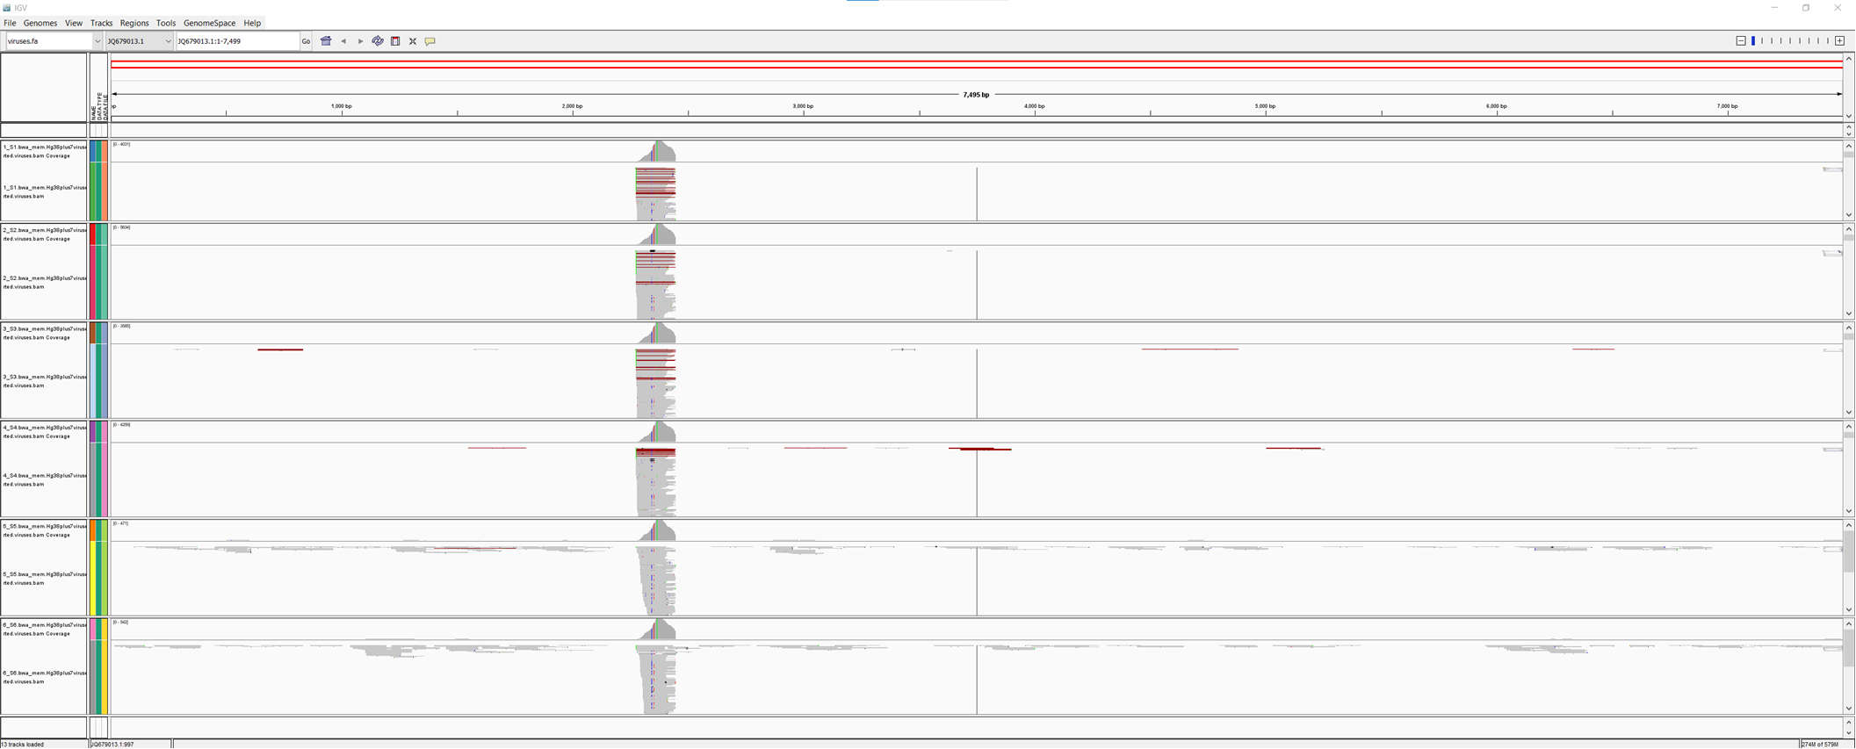
Non-specific mapping
Evenly distributed across the entire virus genome
Suppl Figure 2: visualization of several possible measures for better estimation of read coverage
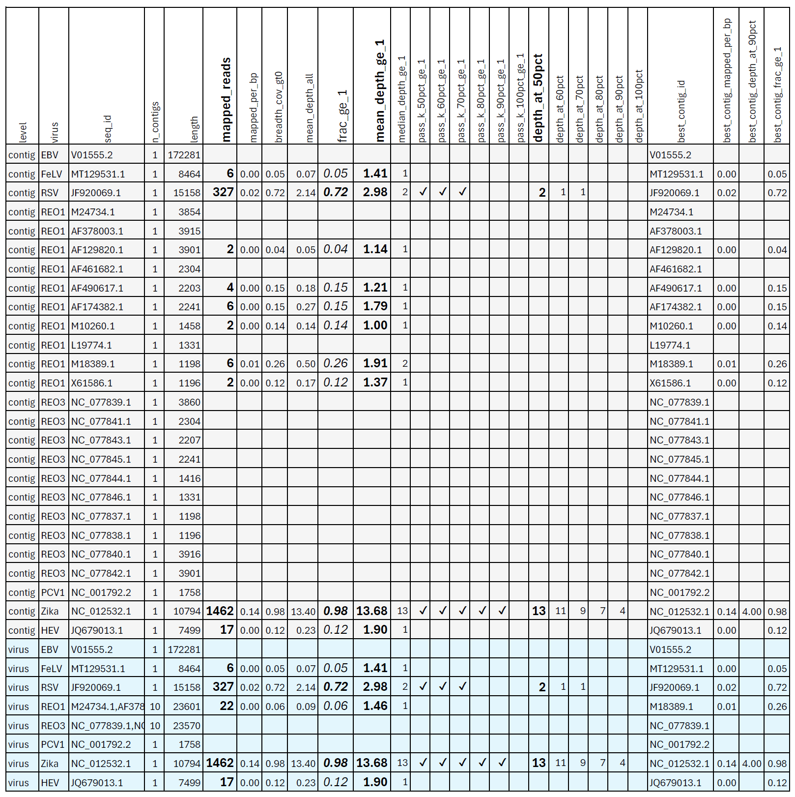

Suppl Figure 3: An example ViraQuant report

Virus Read Counting with TaxonomyClassifier
We developed an in-house Python tool, “taxonomy_classifier.py”, to classify paired-end sequencing reads from query-name-sorted BAM files into host, viral, discordant, secondary, supplementary, QC-fail, and unmapped outputs. The TaxonomyClassifier determines host origin by parsing reference contig names with viral assignments linked to a contig metadata table, and when applicable, an accession-to-taxonomy mapping file for grouping by organism, NCBI taxonomy ID, or taxonomy name. Read pairs were evaluated jointly so that concordant host-host pairs mapping to the same chromosome context were assigned to the host category, concordant virus-virus pairs mapping to the same selected viral group were assigned to the viral category, and mixed host-virus or otherwise discordant pairs were separated into a discordant output. Reads flagged as secondary, supplementary, or QC-fail were written to dedicated BAM files, whereas unmapped or half-mapped pairs were exported as paired FASTQ files. The tool also generated tab-delimited summary reports of total reads, mapped and unmapped reads, host and viral counts, discordant pairs, and per-virus read and pair counts, enabling downstream quantitative assessment of host and viral sequence composition.
Cross-method Comparison of Untargeted Viral Screening
To compare Kraken2, RVDB read-count screening, and ViraQuant scan mode on equal terms, all detections were mapped to species-level NCBI Taxonomy identifiers (ranks S, S1, S2) and restricted to a shared background of taxa represented in both the Kraken2 viral database and RVDB, and agreement between the two database-search methods was summarized as taxids detected by both, by Kraken2 only, and by RVDB only. To make thresholds comparable across libraries, read counts were normalized to reads per million using a single per-sample factor (1,000,000 / total reads passing fastp filtering) applied to every taxon for both Kraken2 and RVDB, and a taxon was scored as detected at RPM >= 1; because ViraQuant scan mode quantifies coverage depth rather than reads, its detections instead required at least half of the reference covered at >= 1x (depth_at_50pct >= 1).

Advanced Analytics
The AdVentSeq pipeline is intended to generate downstream-ready inputs for host-response analysis and viral mutation analysis after the alignment and quantification stages. These analyses were not in scope for the present study. Accordingly, the finalized project outputs supplied here were used to evaluate detection, subtraction, and coverage-aware quantification rather than to interpret differential-expression, pathway-enrichment, variant-calling, or phylogenetic results.

Code Availability
The project directory contains the source codes of `AdVentSeq.py`, `pipeline_creator.py`, ` taxonomy_classifier.py`, ` ViraQuant.py `, and Python and R scripts used to prepare data and generate Analysis results. A public repository URL, license statement, and release tag should be inserted at the time of manuscript submission or release.

References
1. Cleveland MH, Anekella B, Brewer M, Chin PJ, Couch H, Delwart E, et al. Report of the 2019 NIST-FDA workshop on standards for next generation sequencing detection of viral adventitious agents in biologics and biomanufacturing. Biologicals. 2020;64:76-82. Epub 20200222. doi: 10.1016/j.biologicals.2020.02.003. PubMed PMID: 32094072; PubMed Central PMCID: PMCPMC9987593.
2. Khan AS, Blumel J, Deforce D, Gruber MF, Jungback C, Knezevic I, et al. Report of the second international conference on next generation sequencing for adventitious virus detection in biologics for humans and animals. Biologicals. 2020;67:94-111. Epub 20200711. doi: 10.1016/j.biologicals.2020.06.002. PubMed PMID: 32660862; PubMed Central PMCID: PMCPMC7351673.
3. Khan AS, Mallet L, Blumel J, Cassart JP, Knezevic I, Ng SHS, et al. Report of the third conference on next-generation sequencing for adventitious virus detection in biologics for humans and animals. Biologicals. 2023;83:101696. Epub 20230719. doi: 10.1016/j.biologicals.2023.101696. PubMed PMID: 37478506; PubMed Central PMCID: PMCPMC10522920.
4. Khan AS, Theuns S, Mallet L, Cirefice G, Bhuller R, Goios A, et al. IABS/DCVMN webinar on next generation sequencing. Biologicals. 2023;81:101662. Epub 20221219. doi: 10.1016/j.biologicals.2022.12.001. PubMed PMID: 36543633.
5. Ng SH, Braxton C, Eloit M, Feng SF, Fragnoud R, Mallet L, et al. Current Perspectives on High-Throughput Sequencing (HTS) for Adventitious Virus Detection: Upstream Sample Processing and Library Preparation. Viruses. 2018;10(10). Epub 20181016. doi: 10.3390/v10100566. PubMed PMID: 30332784; PubMed Central PMCID: PMCPMC6213814.
6. Khan AS, Mallet L, Blumel J, Deneyer N, Keersmaecker SCJ, de Saint-Vis B, et al. Report of the fourth conference on next-generation sequencing (NGS) for adventitious virus detection in biologics for humans and animals: Validation and implementation of NGS. Biologicals. 2025;92:101859. Epub 20250912. doi: 10.1016/j.biologicals.2025.101859. PubMed PMID: 40945333; PubMed Central PMCID: PMCPMC12720287.
7. Alston A, Bova RA, Hasson B. Validation of a Next Generation Sequencing Method for adventitious agents detection in a live vaccine matrix. Biologicals. 2025;90:101828. Epub 20250402. doi: 10.1016/j.biologicals.2025.101828. PubMed PMID: 40179635.
8. Khan AS, Benetti L, Blumel J, Deforce D, Egan WM, Knezevic I, et al. Report of the international conference on next generation sequencing for adventitious virus detection in biologicals. Biologicals. 2018;55:1-16. Epub 20180806. doi: 10.1016/j.biologicals.2018.08.002. PubMed PMID: 30093175.
9. Lambert C, Braxton C, Charlebois RL, Deyati A, Duncan P, La Neve F, et al. Considerations for Optimization of High-Throughput Sequencing Bioinformatics Pipelines for Virus Detection. Viruses. 2018;10(10). Epub 20180927. doi: 10.3390/v10100528. PubMed PMID: 30262776; PubMed Central PMCID: PMCPMC6213042.
10. Wesolowska-Andersen A, Everman JL, Davidson R, Rios C, Herrin R, Eng C, et al. Dual RNA-seq reveals viral infections in asthmatic children without respiratory illness which are associated with changes in the airway transcriptome. Genome Biol. 2017;18(1):12. Epub 20170119. doi: 10.1186/s13059-016-1140-8. PubMed PMID: 28103897; PubMed Central PMCID: PMCPMC5244706.
11. Fabozzi G, Oler AJ, Liu P, Chen Y, Mindaye S, Dolan MA, et al. Strand-Specific Dual RNA Sequencing of Bronchial Epithelial Cells Infected with Influenza A/H3N2 Viruses Reveals Splicing of Gene Segment 6 and Novel Host-Virus Interactions. J Virol. 2018;92(17). Epub 20180816. doi: 10.1128/JVI.00518-18. PubMed PMID: 29976658; PubMed Central PMCID: PMCPMC6096831.
12. Bhuvaneshwar K, Song L, Madhavan S, Gusev Y. viGEN: An Open Source Pipeline for the Detection and Quantification of Viral RNA in Human Tumors. Front Microbiol. 2018;9:1172. Epub 20180605. doi: 10.3389/fmicb.2018.01172. PubMed PMID: 29922260; PubMed Central PMCID: PMCPMC5996193.
13. Yasumizu Y, Hara A, Sakaguchi S, Ohkura N. VIRTUS: a pipeline for comprehensive virus analysis from conventional RNA-seq data. Bioinformatics. 2021;37(10):1465-7. doi: 10.1093/bioinformatics/btaa859. PubMed PMID: 33017003; PubMed Central PMCID: PMCPMC7745649.
14. Beurdeley-Fehlbaum P, Pennington M, Hegerle N, Albert M, Bennett A, Cheval J, et al. Evaluation of a viral transcriptome Next Generation Sequencing assay as an alternative to animal assays for viral safety testing of cell substrates. Vaccine. 2023;41(37):5383-91. Epub 20230718. doi: 10.1016/j.vaccine.2023.07.019. PubMed PMID: 37468389.
15. Abu Mazen N, Luc J, Lobb B, Hirota JA, Banerjee A, Doxey AC. Metatranscriptomic RNA-Seq Data Analysis of Virus-Infected Host Cells. Methods Mol Biol. 2024;2813:79-94. doi: 10.1007/978-1-0716-3890-3_5. PubMed PMID: 38888771.
16. Deschamps-Francoeur G, Simoneau J, Scott MS. Handling multi-mapped reads in RNA-seq. Comput Struct Biotechnol J. 2020;18:1569-76. Epub 20200612. doi: 10.1016/j.csbj.2020.06.014. PubMed PMID: 32637053; PubMed Central PMCID: PMCPMC7330433.
17. Frith MC. Gentle masking of low-complexity sequences improves homology search. PLoS One. 2011;6(12):e28819. Epub 20111219. doi: 10.1371/journal.pone.0028819. PubMed PMID: 22205972; PubMed Central PMCID: PMCPMC3242753.
18. Hansen KD, Brenner SE, Dudoit S. Biases in Illumina transcriptome sequencing caused by random hexamer priming. Nucleic Acids Res. 2010;38(12):e131. Epub 20100414. doi: 10.1093/nar/gkq224. PubMed PMID: 20395217; PubMed Central PMCID: PMCPMC2896536.
19. Archer N, Walsh MD, Shahrezaei V, Hebenstreit D. Modeling Enzyme Processivity Reveals that RNA-Seq Libraries Are Biased in Characteristic and Correctable Ways. Cell Syst. 2016;3(5):467-79 e12. Epub 20161110. doi: 10.1016/j.cels.2016.10.012. PubMed PMID: 27840077; PubMed Central PMCID: PMCPMC5167349.
20. Gallego Romero I, Pai AA, Tung J, Gilad Y. RNA-seq: impact of RNA degradation on transcript quantification. BMC Biol. 2014;12:42. Epub 20140530. doi: 10.1186/1741-7007-12-42. PubMed PMID: 24885439; PubMed Central PMCID: PMCPMC4071332.
21. Langmead B, Salzberg SL. Fast gapped-read alignment with Bowtie 2. Nat Methods. 2012;9(4):357-9. Epub 20120304. doi: 10.1038/nmeth.1923. PubMed PMID: 22388286; PubMed Central PMCID: PMCPMC3322381.
22. Kim D, Paggi JM, Park C, Bennett C, Salzberg SL. Graph-based genome alignment and genotyping with HISAT2 and HISAT-genotype. Nat Biotechnol. 2019;37(8):907-15. Epub 20190802. doi: 10.1038/s41587-019-0201-4. PubMed PMID: 31375807; PubMed Central PMCID: PMCPMC7605509.
23. Shinder I, Hu R, Ji HJ, Chao KH, Pertea M. EASTR: Identifying and eliminating systematic alignment errors in multi-exon genes. Nat Commun. 2023;14(1):7223. Epub 20231109. doi: 10.1038/s41467-023-43017-4. PubMed PMID: 37940654; PubMed Central PMCID: PMCPMC10632439.
24. Wood DE, Lu J, Langmead B. Improved metagenomic analysis with Kraken 2. Genome Biol. 2019;20(1):257. Epub 20191128. doi: 10.1186/s13059-019-1891-0. PubMed PMID: 31779668; PubMed Central PMCID: PMCPMC6883579.
25. Jurasz H, Pawlowski T, Perlejewski K. Contamination Issue in Viral Metagenomics: Problems, Solutions, and Clinical Perspectives. Front Microbiol. 2021;12:745076. Epub 20211020. doi: 10.3389/fmicb.2021.745076. PubMed PMID: 34745046; PubMed Central PMCID: PMCPMC8564396.
26. Ritsch M, Brait N, Harvey E, Marz M, Lequime S. Endogenous viral elements: insights into data availability and accessibility. Virus Evol. 2024;10(1):veae099. Epub 20241123. doi: 10.1093/ve/veae099. PubMed PMID: 39659497; PubMed Central PMCID: PMCPMC11631435.
27. Deng X, Naccache SN, Ng T, Federman S, Li L, Chiu CY, et al. An ensemble strategy that significantly improves de novo assembly of microbial genomes from metagenomic next-generation sequencing data. Nucleic Acids Res. 2015;43(7):e46. Epub 20150113. doi: 10.1093/nar/gkv002. PubMed PMID: 25586223; PubMed Central PMCID: PMCPMC4402509.
28. Xiang X, Lu B, Song D, Li J, Shu K, Pu D. Evaluating the performance of low-frequency variant calling tools for the detection of variants from short-read deep sequencing data. Sci Rep. 2023;13(1):20444. Epub 20231122. doi: 10.1038/s41598-023-47135-3. PubMed PMID: 37993475; PubMed Central PMCID: PMCPMC10665316.
29. Ma X, Shao Y, Tian L, Flasch DA, Mulder HL, Edmonson MN, et al. Analysis of error profiles in deep next-generation sequencing data. Genome Biol. 2019;20(1):50. Epub 20190314. doi: 10.1186/s13059-019-1659-6. PubMed PMID: 30867008; PubMed Central PMCID: PMCPMC6417284.
30. White DJ, Wang J, Hall RJ. Assessing the Impact of Assemblers on Virus Detection in a De Novo Metagenomic Analysis Pipeline. J Comput Biol. 2017;24(9):874-81. Epub 20170417. doi: 10.1089/cmb.2017.0008. PubMed PMID: 28414526; PubMed Central PMCID: PMCPMC5610382.
31. Li H. Aligning sequence reads, clone sequences and assembly contigs with BWA-MEM. arXiv. 2013. Epub 26 May 2013. doi: 10.48550/arXiv.1303.3997v2 [q-bio.GN].
32. Dobin A, Davis CA, Schlesinger F, Drenkow J, Zaleski C, Jha S, et al. STAR: ultrafast universal RNA-seq aligner. Bioinformatics. 2013;29(1):15-21. Epub 20121025. doi: 10.1093/bioinformatics/bts635. PubMed PMID: 23104886; PubMed Central PMCID: PMCPMC3530905.
33. Chen S. fastp 1.0: An ultra-fast all-round tool for FASTQ data quality control and preprocessing. Imeta. 2025;4(5):e70078. Epub 20250909. doi: 10.1002/imt2.70078. PubMed PMID: 41112039; PubMed Central PMCID: PMCPMC12527978.
34. Liao Y, Smyth GK, Shi W. featureCounts: an efficient general purpose program for assigning sequence reads to genomic features. Bioinformatics. 2014;30(7):923-30. Epub 20131113. doi: 10.1093/bioinformatics/btt656. PubMed PMID: 24227677.
35. Danecek P, Bonfield JK, Liddle J, Marshall J, Ohan V, Pollard MO, et al. Twelve years of SAMtools and BCFtools. Gigascience. 2021;10(2). doi: 10.1093/gigascience/giab008. PubMed PMID: 33590861; PubMed Central PMCID: PMCPMC7931819.
36. Goodacre N, Aljanahi A, Nandakumar S, Mikailov M, Khan AS. A Reference Viral Database (RVDB) To Enhance Bioinformatics Analysis of High-Throughput Sequencing for Novel Virus Detection. mSphere. 2018;3(2). Epub 20180314. doi: 10.1128/mSphereDirect.00069-18. PubMed PMID: 29564396; PubMed Central PMCID: PMCPMC5853486.

