Methodological paper: Effects of prior experience with experimental paradigms on direction of preference in infant learning studies
Authors:
Brief Outline

1. Introduction
- We will briefly introduce the concept of familiarity and novelty preference in perception and learning studies in infancy. We will start with seminal paper by Fantz (1964), showing that, after repeated exposure to a visual stimulus, infants prefer to attend to a novel stimulus when presented with both familiar and novel stimuli. We will mention additional studies confirming this assumption in different topics in infant perception and cognition (e.g., Kinney & Kagan, 1976; Colombo & Bundy, 1983; Hunter & Ames, 1988; Roder, Bushnell & Sasseville, 2000; Houston-Price & Nakai, 2004; Civan, Teller & Palmer, 2004; Aslin, 2007; Perone & Spencer, 2013; DePaolis, Keren-Portnoy & Vihman, 2016). The generally accepted idea is that when infants process a given stimulus, the efficiency of such processing influences their subsequent preferences. The Hunter & Ames’ model of infant preferential responses (1988) proposes that infant preferences progress on a continuum from familiarity to novelty, and that infants’ position in such continuum depends on the difficulty of the task (see also Wagner & Sakovits, 1986). As a general rule, the more difficult a task is, the more likely an infant is to show a familiarity preference (Thiessen & Saffran, 2003).

- We will describe the most common factors inducing a flip in preference in looking time studies:
- Infants’ age; younger infants tend to show familiarity preference, as opposed to older ones
- Length of exposure; when exposure is short, infants show familiarity preference. For instance, Thiessen et al. (2005) showed a flip in preference from familiarity to novelty after doubling the amount of time the infants were exposed to the stimulus. Length of exposure is, of course, related to the complexity of the stimulus. One could imagine that a sequentially-presented stimulus likely needs more time to be processed than a spatially-presented one, in which all components are simultaneously available. During sequential presentation, in fact, stimulus components must be stored in working memory, and continuously updated until getting to an overall representation of the object.
- Task difficulty which comprises different other factors like complexity of the learning problem, length/type of stimuli used, length of exposure (e.g., Aslin, 2000; Hunter & Ames, 1988; Saffran & Thiessen, 2003)
- Stage of stimulus processing; familiarity preference seems to occur more often when infants are still processing the familiarization stimuli by the time the test phase begins. In this case, it has been suggested that infants start the test with a partial memory representation of the familiarization stimulus, therefore keep being interested in the familiar test stimulus to complete such representation. In contrast, novelty preference occurs when processing is near completion (Roder, Bushnell & Sasseville, 2000).
- Match between familiarization and test stimuli; when there is a mismatch between familiarization and test items infants are more likely to show familiarity than novelty preference (Gibson & Walker, 1984; see also Thiessen & Saffran, 2003).

- An important aspect to consider when interpreting differences in direction of preference is the type of paradigm used to run the study. Habituation (Jeffrey & Cohen, 1976) and HeadTurn Preference Procedure (Kemler-Nelson et al, 1995) are the most common methods in infant behavioral research. The rationale of these methods is quite similar, as they both test discrimination between two stimuli, however their familiarization phase is different. In Habituation, familiarization terminates once the infant spontaneously stops looking at the familiar stimulus, thus, likely when learning is completed. Whereas in HeadTurn, familiarization consists of a fixed amount of exposure to the stimulus, with no direct measure of whether infants have completed the learning process before testing. This difference seems to affect post-familiarization preferences. Habituation normally predicts novelty preference at test, since stimulus processing is likely to be over by the time infants begin the testing phase (although some cases of post-habituation familiarity preferences have been reported in the literature, e.g., Fiser & Aslin, 2000). In contrast, HeadTurn seems to be less sensitive to directionality as it is difficult to predict how much exposure infants will need to discriminate at test.

- In the last part of the Introduction, we will outline the purpose of this article: to propose an additional factor that would explain a flip in preference from novelty to familiarity, in infant learning studies. We will suggest that prior experience with the experimental setting influences infants’ direction of preference. We hypothesized that infants who have already participated in HeadTurn studies are more likely to show novelty preference than infants who do not have this previous experience. In HeadTurn studies, there are at least two types of information that must be encoded: 1) auditory – the “real” stimuli of the study (e.g., artificial languages, sequences of words or sounds), and 2) visual –blinking light appearing in conjunction with auditory stimuli. Such contingency is necessary to engage the infant in a looking behavior that would reflect her listening preference, and it is common practice to use the same of visual stimulation (i.e., same blinking light) in different HeadTurn studies. Importantly, infants learn the sound-light contingency during the course of the experiment. Therefore, when an infant experience the HeadTurn setting for the very first time, she will have to process both types of information simultaneously. In contrast, when the infant returns to the lab for a second HeadTurn study, she is already familiar with the setting, and does not “waste” cognitive resources to process the visual inputs all over again (e.g., computer screens, blinking lights, etc.). Moreover, returner infants understand more about, and probably remember, the contingency of the sounds-light contingency (I have to look at the flashing light to hear a sound), and do not have to learn it during the course of the experiment.
- We decided to look into this hypothesis after conducting a replication study of a recently published study on statistical learning (Santolin & Saffran, 2019). We obtained a puzzling pattern of results showing a flip in preference between the original study and the replication: in one case, we saw novelty preference, in the other familiarity preference. We reasoned that the more the infants were familiar with the task (e.g., sound-light contingency), the more they found it easy, and go for the novel stimulus. We thus hypothesized that infants’ degree of familiarity with the HeadTurn setting may have played a key role in driving such change in preference. To reinforce our hypothesis, we looked into another dataset from Saffran & Wilson (2003; Experiment 2) showing the exact same flip in preference. We noticed that also in that case first-timer infants were more prone to show familiarity preference than returners. We will provide evidence in favor of this hypothesis in the following part (“Experimental section”). The main purpose of our paper is thus to suggest researchers to look at previous lab experience of their infant participants when interpreting direction of preference.

2. Experimental section

- We pulled together data from 3 different statistical learning studies conducted on 12-month-old infants with the Headturn Preference Procedure in two different labs: the Infant Learning Lab at the University of Wisconsin-Madison (Madison, Wisconsin, USA), and the CBC Baby Lab at the University Pompeu Fabra (Barcelona, Spain).

- Santolin & Saffran (2019 – Condition 1) & Replication study by Santolin, Saffran & Sebastian-Galles (2019; WILD Workshop). We will briefly describe the rationale of the study, which is a non-linguistic artificial grammar learning experiment conducted in Madison (WI) and Barcelona. We will describe dependent variables, statistical analysis, and results obtained. In both experiments, infants successfully learned the structure of the grammar as they could discriminate between test strings following the grammar from strings violating the grammar. Interestingly, Wisconsin babies showed novelty preference, listening longer to grammar-inconsistent (novel) test strings whereas Barcelona babies showed familiarity preference, listening longer to grammar-consistent (familiar) strings (Graph 1).

Graph 1. On the Y axis, looking time in ms; on the X axis, the two groups of infants participating in the study in Wisconsin and Barcelona. Columns represent looking times for familiar and novel test strings, and asterisks indicate significant differences.
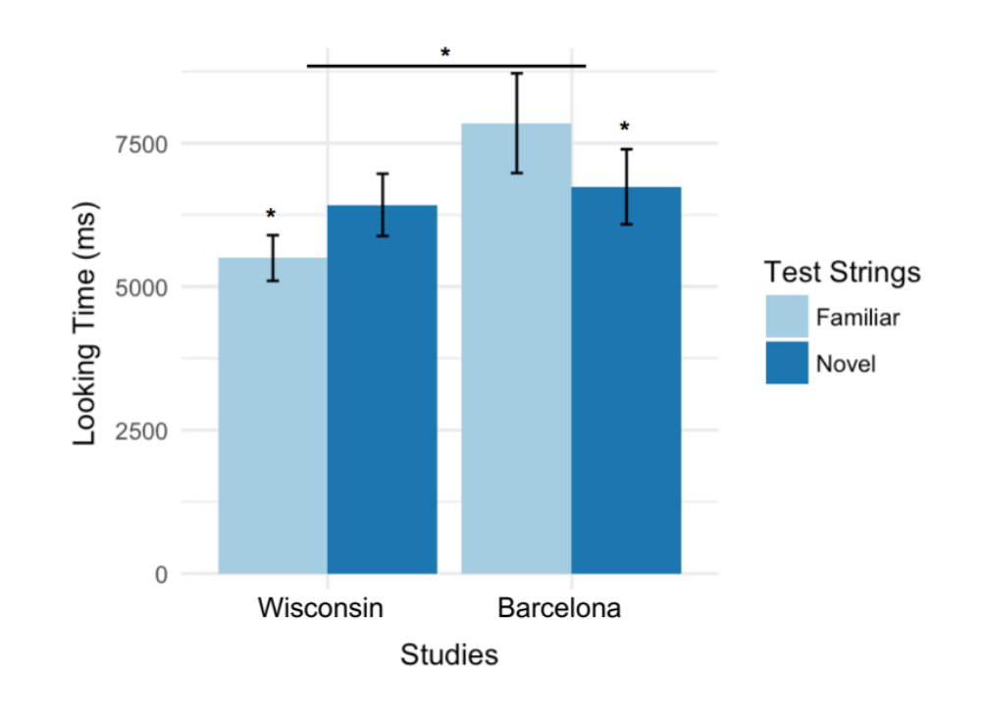

Procedure, stimuli, software and infant age were otherwise identical across studies. We hypothesized that the flip in preference might be related to infants’ prior experience with the HeadTurn setting. Indeed, most of the Wisconsin babies (20 out of 27) participated in 1 or more HeadTurn study before the current one (Syntax). In contrast, only 2 out of 24 Barcelona babies participated in another HeadTurn study before; for most of them, the current study was their very first HeadTurn experiment. This hypothesis is supported by statistical analysis showing positive correlation between direction of preference (expressed as novelty score = looking time for novel item – looking time for familiar item) and number of HeadTurn studies (r= 0.345, p= 0.014; Graph 2). Therefore, infants for which the current study was not the first HeadTurn study showed novelty preference. In contrast, infants for which it was the first HeadTurn study showed familiarity preference, possibly indicating a more complex task.

Graph 2. On the Y axis, novelty score; on the X axis, number of HeadTurn studies

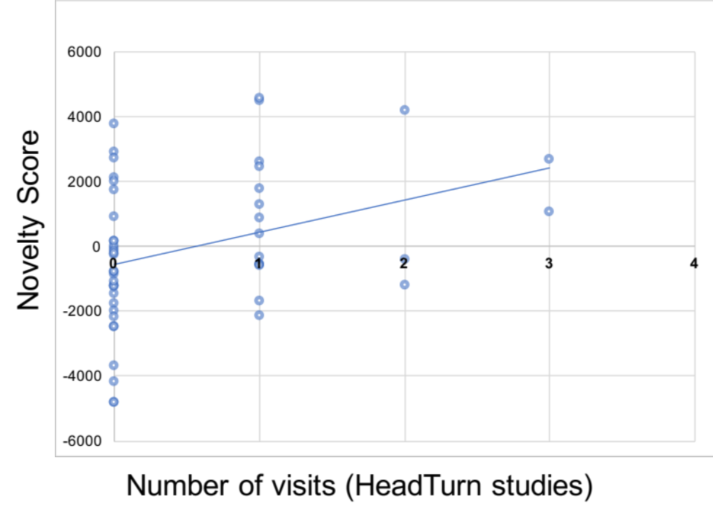

- Saffran & Wilson, 2003 – Experiment 2. We will describe another statistical learning experiment conducted at the Infant Learning Lab - UW Madison, showing the same flip in preference. This study was conducted using the exact same setting of the studies described above (e.g., same blinking lights). Also, infant age range and dependent measure were the same. We found the same positive correlation between direction of preference at test and number of HeadTurn studies in which infants had participated (r=-0.42, p<.01; Graph 3).

Graph 3. Y axis shows familiarity score (looking time for familiar – looking time for novel) and X axis shows number of HeadTurn studies.

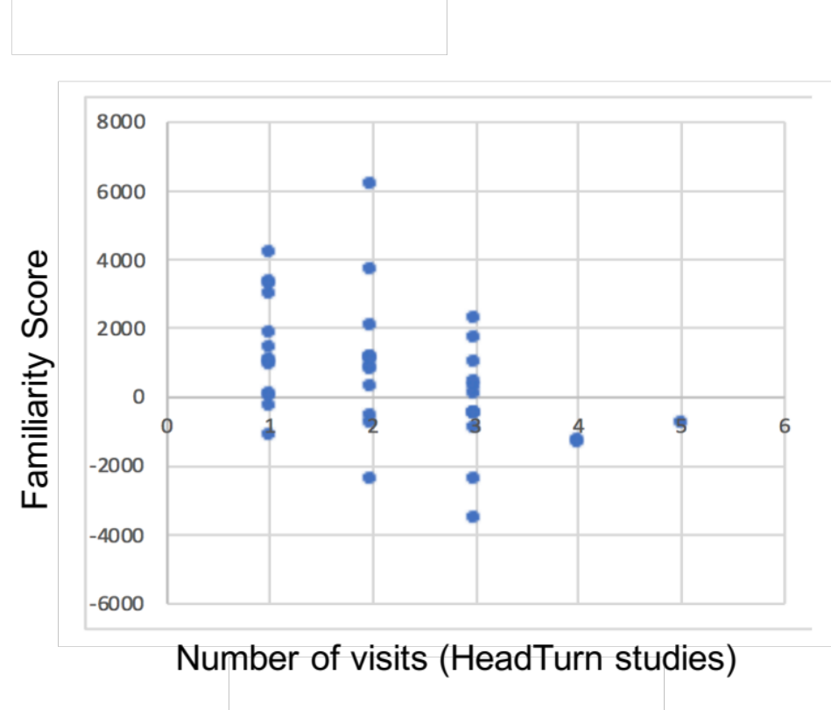

3. Conclusions

- Wrap up: looking at infants’ prior experience with experimental paradigms seems to be informative when interpreting preferences for novel vs. familiar stimuli in learning studies. In a broader sense, our theory fits with existing theories of cognitive development suggesting that immature infants are very selective at sampling the information from the environment. In fact, given their limited cognitive abilities, infants avoid “wasting” resources in examining every available information, and direct their greatest effort to the most relevant ones (for starters: Kidd et al., 2012; 2014; see also Saffran & Kirkham, 2017). Within this framework, we propose that, when infants experienced a given experimental setting for the first time, their cognitive resources are splitted between understanding the task (e.g., the sound-light contingency; If I look at the blinking light I can hear a sound, in the case of HeadTurn), and the learning problem under investigation (e.g., Are these sounds different? Which one do I like the most?). Such double-processing is likely to increase the overall complexity of the study, and leads infants to show familiarity preference. In contrast, when infants are already familiar with the paradigm, their resources are entirely dedicated to the processing of the experimental stimuli to solve the learning problem. This reduces the difficulty of the study for returner infants, as demonstrated by novelty preference.

- We will conclude saying that our theory is not limited to HeadTurn studies, and can be potentially apply to other paradigm used in infant research. It will be useful to combine evidence from different paradigms to create a comprehensive model of the factors inducing familiarity versus novelty preferences in infant studies.

References
Fantz, R. L. (1964). Visual experience in infants: Decreased attention to familiar patterns relative to novel ones. Science, 146(3644), 668-670.

Colombo, J., & Bundy, R. S. (1983). Infant response to auditory familiarity and novelty. Infant Behavior and Development, 6(2-3), 305-311.

Hunter, M. A., & Ames, E. W. (1988). A multifactor model of infant preferences for novel and familiar stimuli. Advances in infancy research.

Roder, B. J., Bushnell, E. W., & Sasseville, A. M. (2000). Infants' preferences for familiarity and novelty during the course of visual processing. Infancy, 1(4), 491-507.

Houston‐Price, C., & Nakai, S. (2004). Distinguishing novelty and familiarity effects in infant preference procedures. Infant and Child Development: An International Journal of Research and Practice, 13(4), 341-348.

Civan, A., Teller, D. Y., & Palmer, J. (2005). Relations among spontaneous preferences, familiarized preferences, and novelty effects: Measurements with forced‐choice techniques. Infancy, 7(2), 111-142.

Aslin, R. N. (2007). What's in a look?. Developmental science, 10(1), 48-53.

Perone, S., & Spencer, J. P. (2013). Autonomous visual exploration creates developmental change in familiarity and novelty seeking behaviors. Frontiers in psychology, 4, 648.

DePaolis, R. A., Keren-Portnoy, T., & Vihman, M. (2016). Making sense of infant familiarity and novelty responses to words at lexical onset. Frontiers in psychology, 7, 715.

Wagner, S. & Sakovits, L. (1986). A process of analysis of infant visual and cross-modal recognition memory. In L. Lipsitt & C. Rovee-Collier (Eds.). Advances in infancy research (Vol. 4, pp. 195-217). Norwood, NJ: Ablex.

Thiessen, E. D., & Saffran, J. R. (2003). When cues collide: use of stress and statistical cues to word boundaries by 7-to 9-month-old infants. Developmental psychology, 39(4), 706.

Thiessen, E. D., Hill, E. A., & Saffran, J. R. (2005). Infant-directed speech facilitates word segmentation. Infancy, 7(1), 53-71.

Saffran, J. R., & Thiessen, E. D. (2003). Pattern induction by infant language learners. Developmental psychology, 39(3), 484.

Gibson, E. J., & Walker, A. S. (1984). Development of knowledge of visual-tactual affordances of substance. Child development, 453-460.

Jeffrey, W. E., & Cohen, L. B. (1971). Habituation in the human infant. In Advances in child development and behavior (Vol. 6, pp. 63-97). JAI.

Nelson, D. G. K., Jusczyk, P. W., Mandel, D. R., Myers, J., Turk, A., & Gerken, L. (1995). The head-turn preference procedure for testing auditory perception. Infant behavior and development, 18(1), 111-116.

Fiser, J., & Aslin, R. N. (2002). Statistical learning of new visual feature combinations by infants. Proceedings of the National Academy of Sciences, 99(24), 15822-15826.

Saffran, J. R., & Wilson, D. P. (2003). From syllables to syntax: multilevel statistical learning by 12‐month‐old infants. Infancy, 4(2), 273-284.

Santolin, C., & Saffran, J. R. (2019). Non-Linguistic Grammar Learning by 12-Month-Old Infants: Evidence for Constraints on Learning. Journal of Cognition and Development, 1-9.

Santolin, C., Saffran, J. R. & Sebastian-Galles, N. (2019). Non-linguistic artificial grammar learning in 13-month-old infants: a cross-lab replication study. In Proceedings of the 4th Workshop on Infant Language Development.

Saffran, J. R., & Kirkham, N. Z. (2018). Infant statistical learning. Annual review of psychology, 69.

Kidd, C., Piantadosi, S. T., & Aslin, R. N. (2012). The Goldilocks effect: Human infants allocate attention to visual sequences that are neither too simple nor too complex. PloS one, 7(5), e36399.

Kidd, C., Piantadosi, S. T., & Aslin, R. N. (2014). The Goldilocks effect in infant auditory attention. Child development, 85(5), 1795-1804.

