**The impact of cognateness on bilingual lexical access: a longitudinal priming study**

Bilinguals activate both languages during word recognition and production, even in fully monolingual contexts. They perform differently when recognising or producing cognates (form-similar translation equivalents, like *sofa*-*sofá*) than non-cognates (like *table*-*mesa*) (e.g., Costa et al., 2000, for adults; Von Holzen & Mani, 2012, for toddlers). How this parallel activation impacts the early lexicon remains unclear. In addition, recent studies have brought attention to the role of the similarity between the languages bilingual toddlers are learning. For instance, toddlers learning languages that share many cognates have larger vocabulary sizes (Floccia et al., 2018). In this study, we explore the role of cognateness in bilingual word recognition in a sample of Spanish/Catalan monolinguals and bilinguals from Barcelona (two languages sharing many cognates), and a sample of Spanish/English monolinguals and bilinguals in Oxford (two languages sharing fewer cognates).

We planned a mixed data collection, with longitudinal and cross-sectional toddlers tested at 21, 25, and 30 months of age using an adaptation of the Visual World Paradigm priming task from Mani and Plunkett (2010). Each trial began with the presentation of a prime picture in silence. The prime disappeared after 1.5 seconds, and then an auditory label was played. Finally, two pictures were displayed side-by-side. One of these pictures corresponded to the uttered label (target). In line with M&P’s findings, toddlers should lexicalise the prime picture. When the prime and target label share phonological onset (e.g., *dog-door*), target recognition should be impaired, leading to shorter target looking times, compared to when prime and target labels do not share phonological onset (e.g., *dog-apple*). In our task, in 16 trials, prime and target shared phonological onset. In half of those trials the prime label was *cognate* (e.g., a cat, *gat-gato*), and in the other half it was a *non-cognate* (e.g., a dog, *gos-perro*). In the remaining 16 trials, prime and target labels did not share phonological onset (e.g., *taula-mesa*).

We expected participants to lexicalise the prime picture. If bilinguals lexicalised the prime label in *both* languages, the two labels should interfere with target recognition in cognate trials. In non-cognate trials only the label in the testing language should interfere with target recognition. Therefore, we predict impaired target looking preference in cognate trials as compared to non-cognate and unrelated trials.

We present preliminary data from 73 monolinguals and 28 bilinguals. We used Growth Curve Analysis (3rd degree polynomial) to model the target fixations during the presentation of target and distractor. We found a statistically significant interaction between trial type (cognate vs. non-cognate) and language profile (monolingual vs. bilingual), in the linear time term. Target fixations grew faster in non-cognate trials, only in bilinguals (*b*=−1.1, *SE*=0.49, 95% *CI*=[−2.07, −0.14], *p*=.025). This suggests that, in line with our hypothesis, the cognate prime condition showed impaired target recognition as compared to the non-cognate condition. In future steps, we will analyse the effect of language distance comparing Spanish-Catalan and Spanish-English bilinguals in our sample.

(483 words)

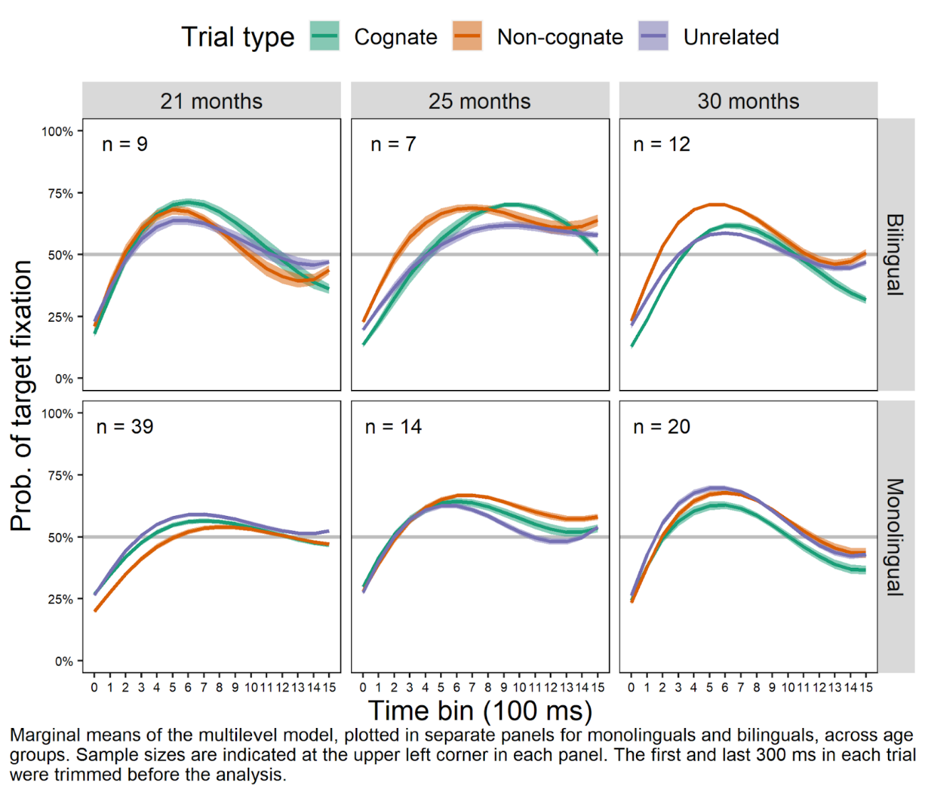

**References**

Costa, A., Caramazza, A., & Sebastian-Galles, N. (2000). The cognate facilitation effect: implications for models of lexical access. Journal of Experimental Psychology: Learning, Memory, and Cognition, 26(5), 1283.

Von Holzen, K., & Mani, N. (2012). Language nonselective lexical access in bilingual toddlers. Journal of Experimental Child Psychology, 113(4), 569-586.

Mani, N., & Plunkett, K. (2010). In the infant’s mind’s ear: Evidence for implicit naming in 18-month-olds. Psychological science, 21(7), 908-913.