Project3

Part1

Problem 1

P(Rain5|Umbrella1=True,Umbrella2=True,Umbrella3=True,Umbrella4=False,Umbrella5=True)

= 0.73194

P(Umbrella1=True,Umbrella2=True,Umbrella3=True,Umbrella4=False,Umbrella5=True)

= 0.04099

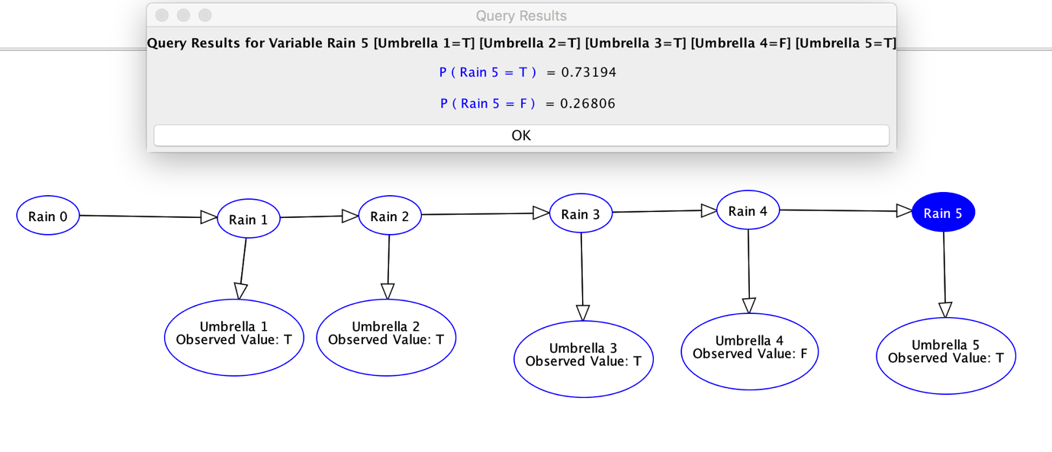

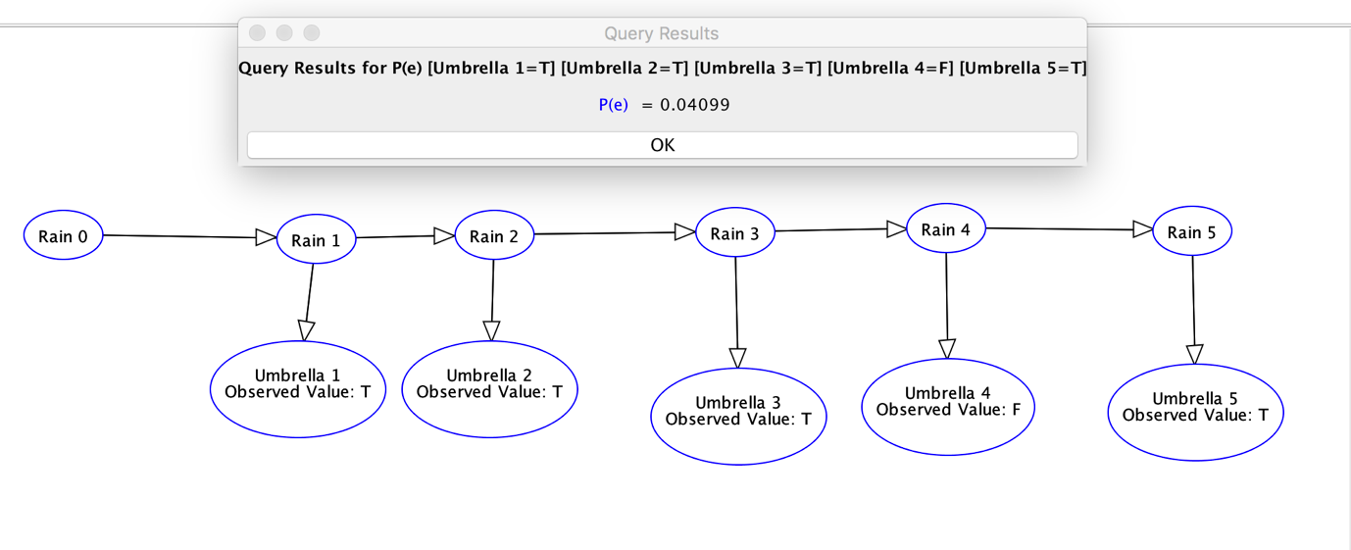

An example real-world problem that can be solved using filtering (with a suitable DBN)

Estimate the progression of cancer (at stage 3 yet) based on the patient’s symptom (cough with blood)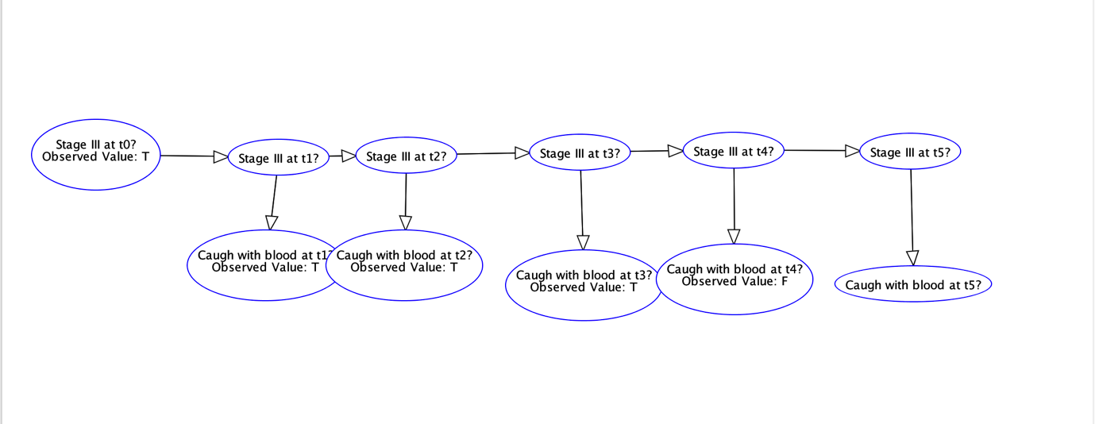

Problem 2

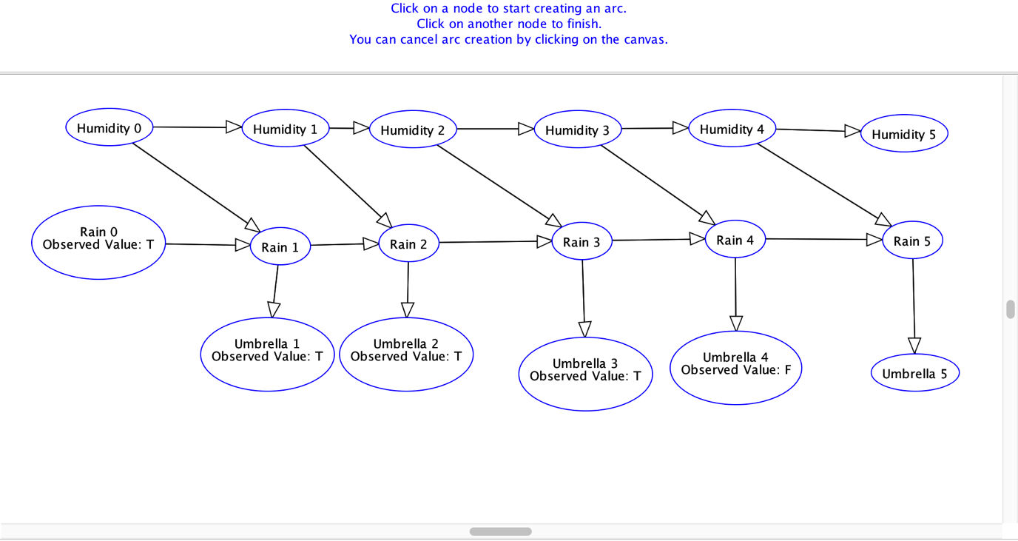

Humidity0 is independent of Rain0

Yes because there’re many undirected paths between “Humidity0” and “Rain0”, and all paths are blocked because its part “Rain0→ Rain1 ← Humidity0” is blocked. (This is the only blocked part.)

Humidity(t) is conditionally independent of Umbrella(t) given Rain(t)

Yes because there’re more than one undirected path between “Humidity(t)” and “Umbrella(t) ”,  and all paths are blocked because its part “Rain(t) → Rain(t+1)” is blocked. (This is the only blocked part.)

Problem 3

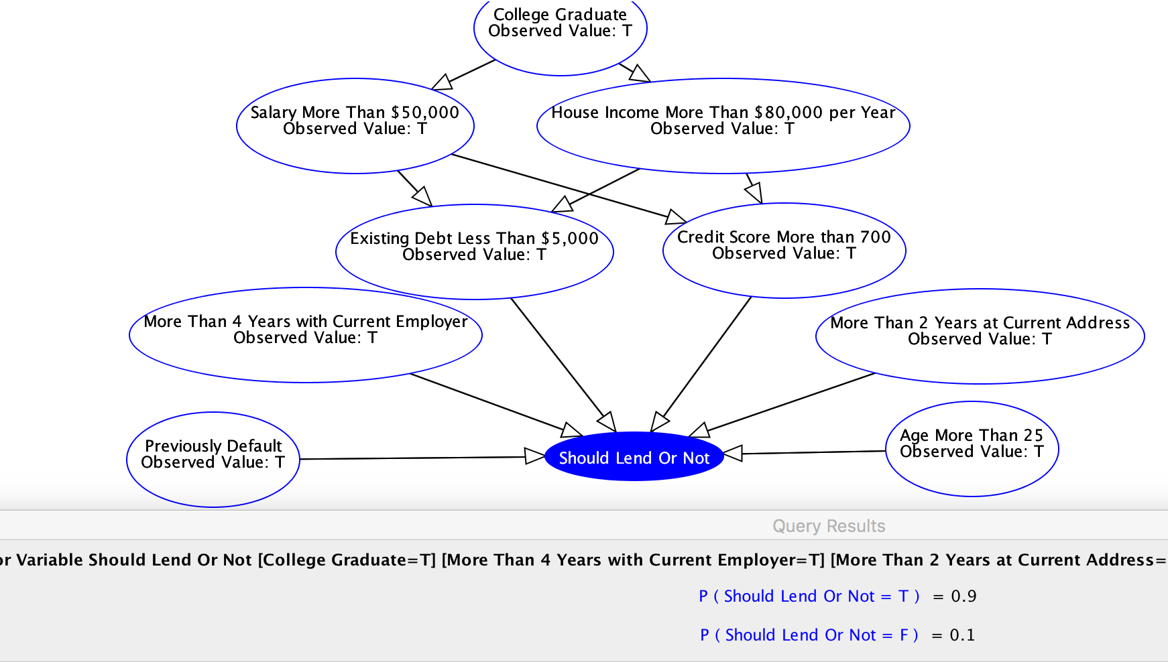

For the first scenario when all of the nodes have observed result T, the lending result is true (P(T) = 0.9) so the bank should lend to the customer. It makes sense because all observations indicate that the customer will be able to pay back the loan.

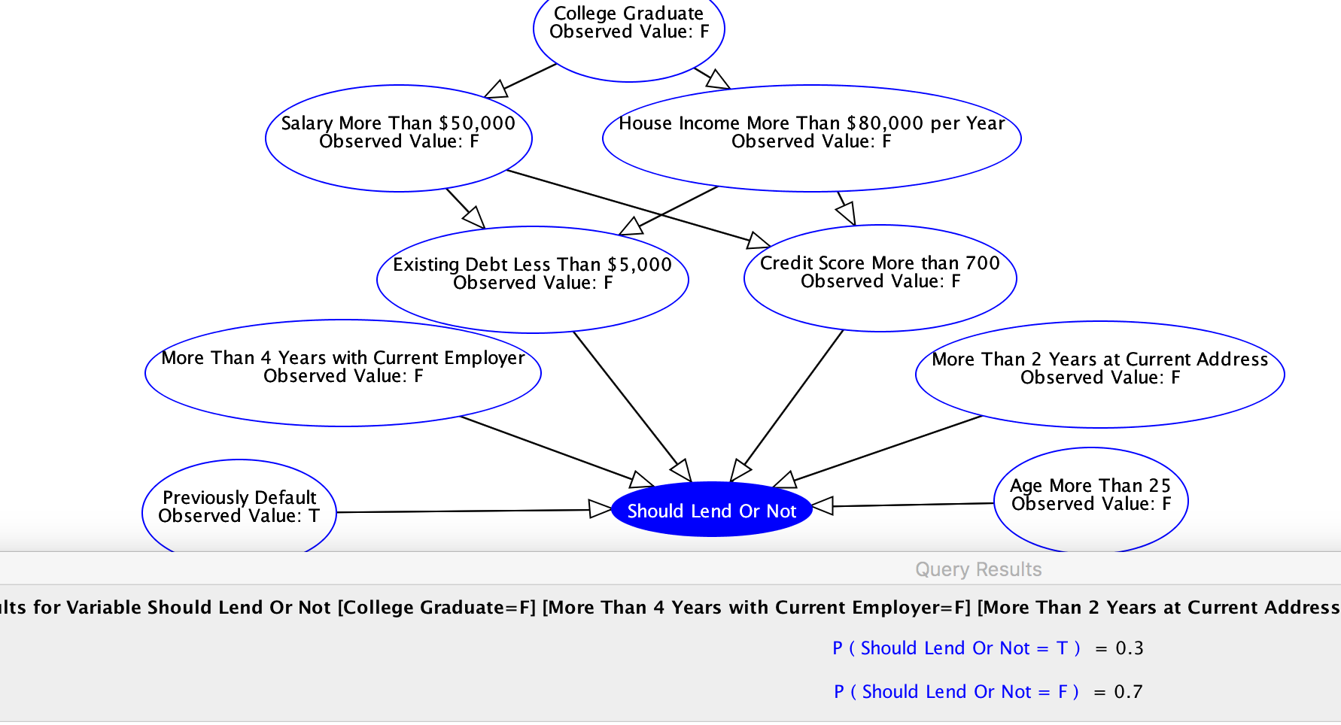

For the second scenario when all of the nodes have observed result F, except “Previous Default”, the lending result is false (P(T) = 0.3) so the bank should NOT lend to the customer. It makes sense because all observations indicate that the customer will NOT be able to pay back the loan.

Problem 4

Our naive Bayesian classifier in Figure 3 visualizes the conditional probabilities that each pixel is white given the label of the picture is one number from {1,2,…,9}. The “fuzziness” is caused by the fact that some pixels are neither certainly white not certainly black (the probability that some pixels are white is 0.5). This visualization lets us know that our Bayesian classifier does not predict the color of pixel very well by showing the fuzziness.

One mean to improve the predictive accuracy is to use use more training data. Another mean is to divide one image to more pixels than 768, so one image vector has more elements than 768.