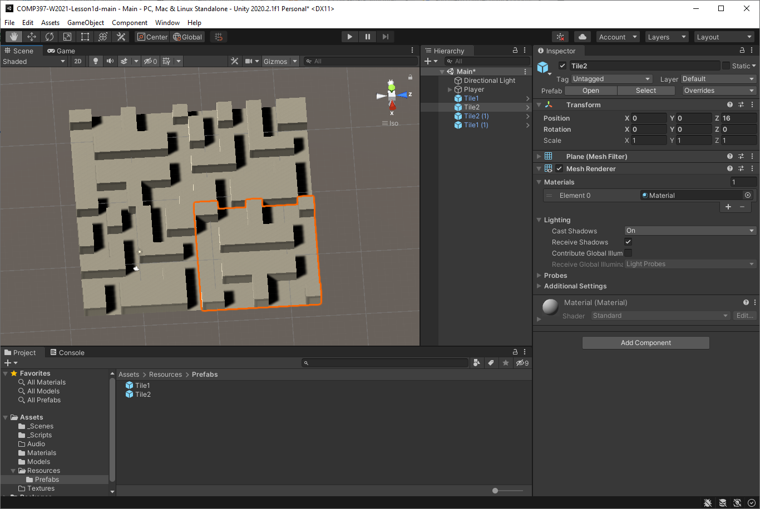

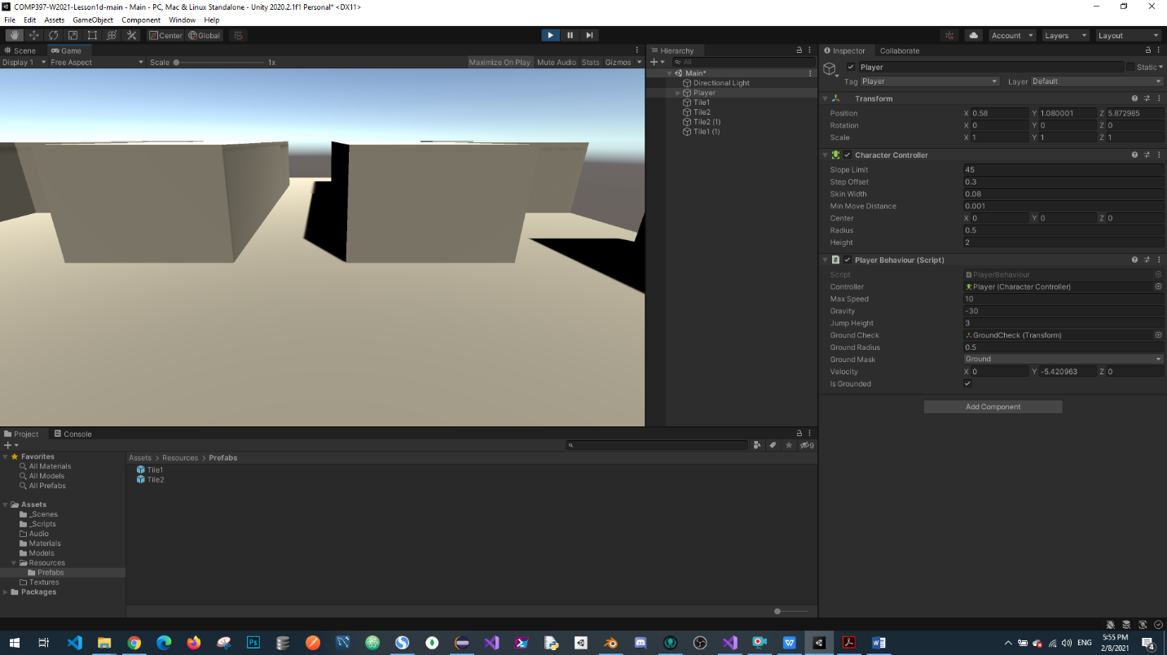

<https://github.com/gongdao/COMP397-W2021-Lesson2begin>