Johan Ospina

HW 2

I partnered with Elizabeth Kenny and Evan Lowell for this part.

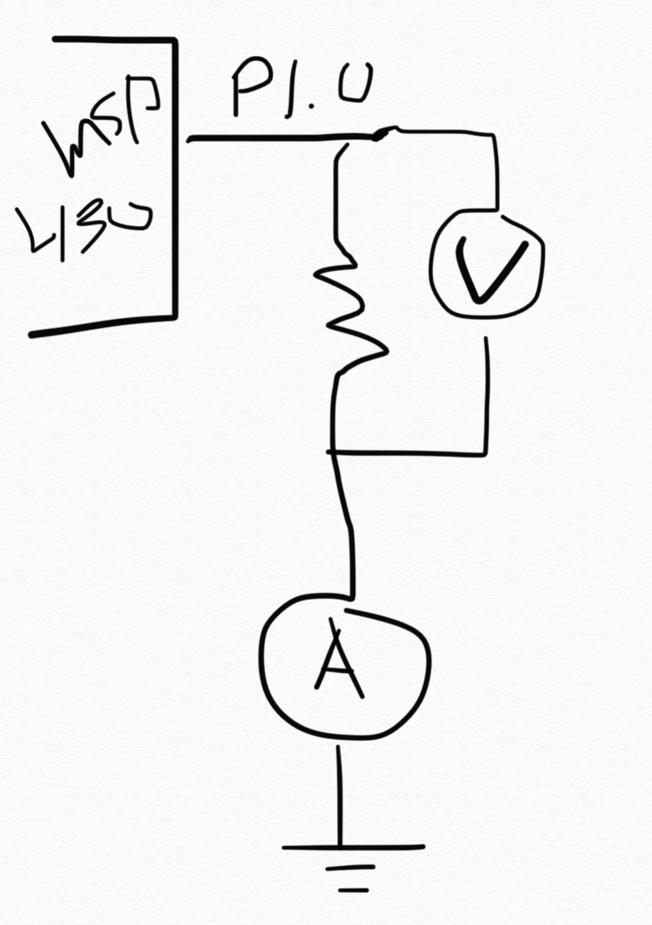 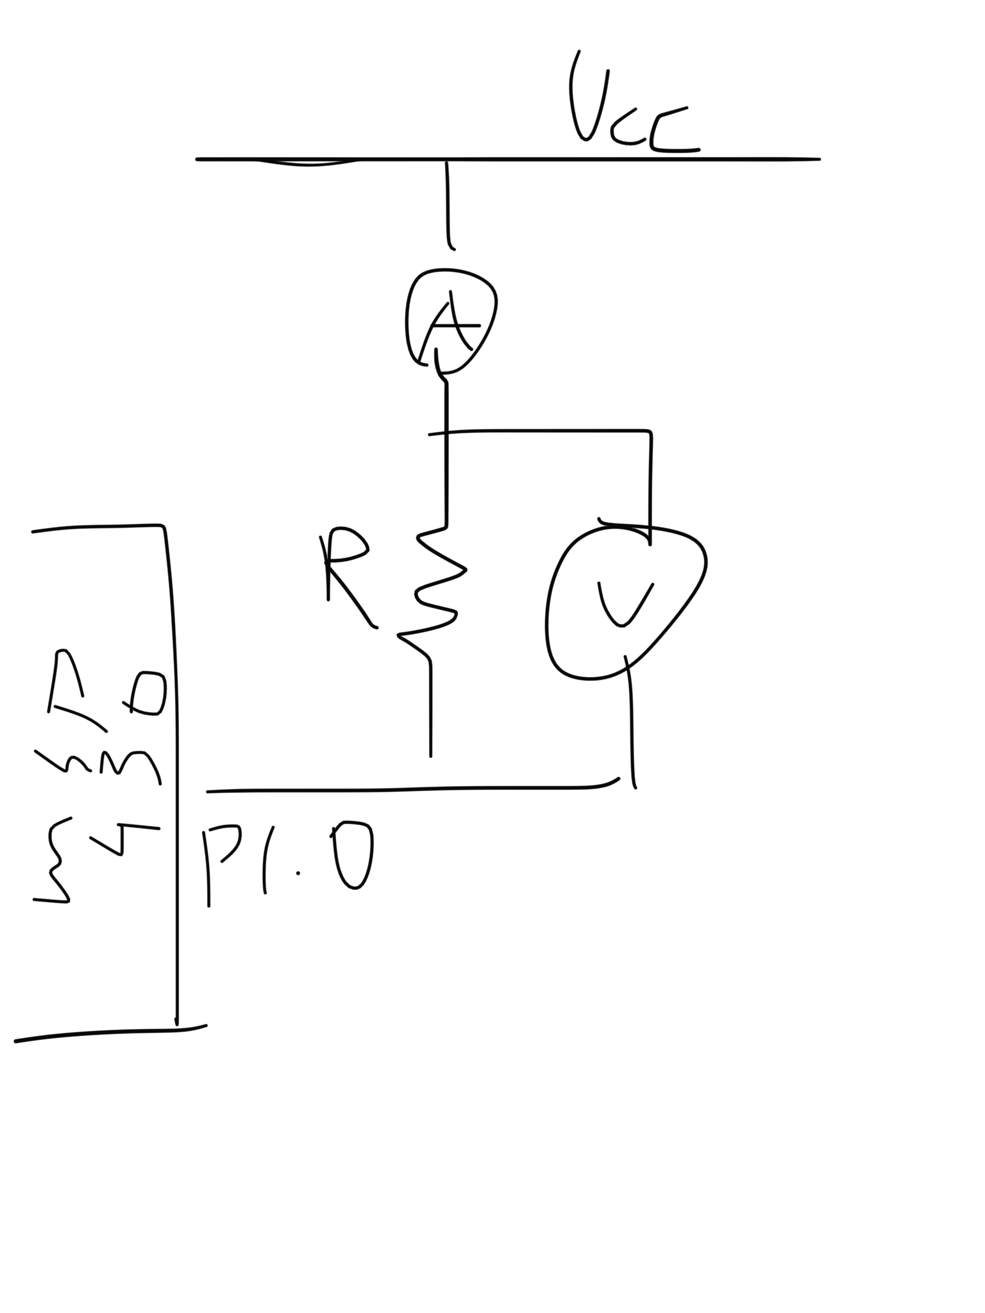

FIG 1 – Active High Circuit FIG 2 – Active Low Circuit

For the Active High Circuit, we measured values from 10 to 10000

|  |  |  |
| --- | --- | --- |
| **Resistance in Ohms** | **Voltage in V** | **Current in A** |
| 10 | 0.524 | 0.0524 |
| 100 | 2.831 | 0.02831 |
| 330 | 3.21 | 0.009727273 |
| 560 | 3.46 | 0.006178571 |
| 820 | 3.48 | 0.004243902 |
| 1000 | 3.55 | 0.00355 |
| 10000 | 3.48 | 0.000348 |

From this data we plotted some graphs and saw that as resistance went up the active high voltage remained at about 3.5

**Active Low Configuration**

We measured the same resistances but this time in the configuration seen in FIG 2.

|  |  |  |
| --- | --- | --- |
| **Resistance in Ohms** | **Voltage in mV** | **Current in A** |
| 10 | 0.036 | 0.0036 |
| 100 | 0.112 | 0.00112 |
| 330 | 0.134 | 0.000406061 |
| 560 | 0.142 | 0.000253571 |
| 820 | 0.138 | 0.000168293 |
| 1000 | 0.14 | 0.00014 |
| 10000 | 0.141 | 0.0000141 |

**Procedure for measuring DCO frequency.**

For this part, a simple program was set up to run a counter until the Watchdog timer’s interrupt was called. From there the assembly code of the program was analyzed to come up with a rough but acceptable estimate of the frequency the at which the Digitally Controlled Oscillator was operating using the equation

From there, the values of DCO, RSEL and MOD were changed to modify the clock speed of the MCLK to different values.

The data gathered is below and it shows that the clock can be set to around 10MHz by setting bits 0-2 of the DCO and bits 4-1 of the RSEL.

|  |  |  |  |  |
| --- | --- | --- | --- | --- |
| **DCO Configuration** | **Frequency in MHz** | **DCO value** | **RSEL value** | **MOD value** |
| Default | 1.065218286 | 3 | 7 | 0 |
| Maximum | 19.805613 | 7 | 15 | 0 |
| Tuned to 10MHz from above | 10.50110514 | 3 | 14 | 0 |
| Tuned to 10MHz from below | 9.810361143 | 2 | 14 | 0 |

The accuracy is rough at best due to the fact that optimal board operation took place with completely constant values. Though by taking the average of 15 samples, some error was fixed.