Assignment 1 Report
71121666 San Zhang

- Assignment Requirements
- Familiar with MS Access
- ...
- ...
- ...

- Platforms and Tools
- Windows XP sp2 pro
- MS Access 2003
- ...
- ...

- Implementation Plan
3.1 Create a Database

After opening MS Access, select the "File" tab, select "New", and then create a "blank database", named the university, which completes the establishment of the database.
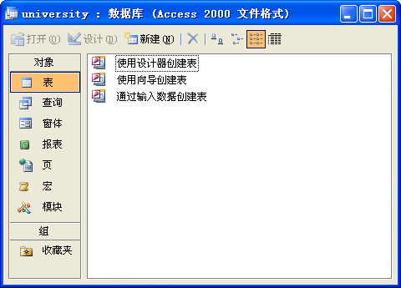
Fig. 1
Other steps are omitted here. Please note that the report needs to include the code written and the results of the run.(To Delete)

- Experimental Feelings
After this experiment, I learned ....

