Assignment 1
Report
-
71121666 San Zhang

Our first assignment concerns the familiarization with MS Access. I had to…
{some content}

First: make the structure of the database

The main part of this step is to fill the tables with elements. The main challenge of this part is …
{some more content}
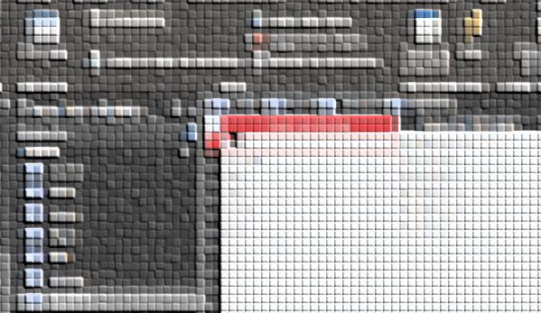
Figure 1 : the Student table and its fields

Second: …
{some more content}

Third:…
{some more content}

Conclusion
This project is about getting along with the MS Access program and the database structures. With it, I learned:
- …
- …
- …

