# 希望组HiFi测序数据质控报告

报告时间：{{ report_time }}

HiFi数据量统计：

|  |  |  |  |  |  |
| --- | --- | --- | --- | --- | --- |
| **movie** | **Reads**  **Number** | **Bases**  **Number(bp)** | **Mean**  **Length(bp)** | **N50**  **Length(bp)** | **Max**  **Length(bp)** |
| {%tr for line in table_qc %} | | | | | |
| {{ line.0 }} | {{ line.1 }} | {{ line.2 }} | {{ line.3 }} | {{ line.4 }} | {{ line.5 }} |
| {%tr endfor %} | | | | | |

HiFi数据长度分布统计：

|  |  |  |  |  |  |
| --- | --- | --- | --- | --- | --- |
| **movie** | **Read**  **Length(bp)** | **Reads**  **Number** | **Reads**  **Ratio(%)** | **Yield**  **(bp)** | **Yield**  **Ratio(%)** |
| {%tr for line in table_length %} | | | | | |
| {{ line.0 }} | {{ line.1 }} | {{ line.2 }} | {{ line.3 }} | {{ line.4 }} | {{ line.5 }} |
| {%tr endfor %} | | | | | |

HiFi数据质量分布统计：

|  |  |  |  |
| --- | --- | --- | --- |
| **movie** | **Read Quality(Phred)** | **Reads Number** | **Reads Ratio(%)** |
| {%tr for line in table_quality %} | | | |
| {{ line.0 }} | {{ line.1 }} | {{ line.2 }} | {{ line.3 }} |
| {%tr endfor %} | | | |

HiFi数据长度分布图：

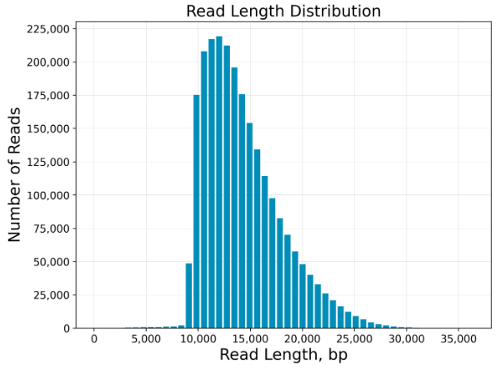

HiFi数据长度与质量分布图：

