Anaconda-navigator:打开Anaconda

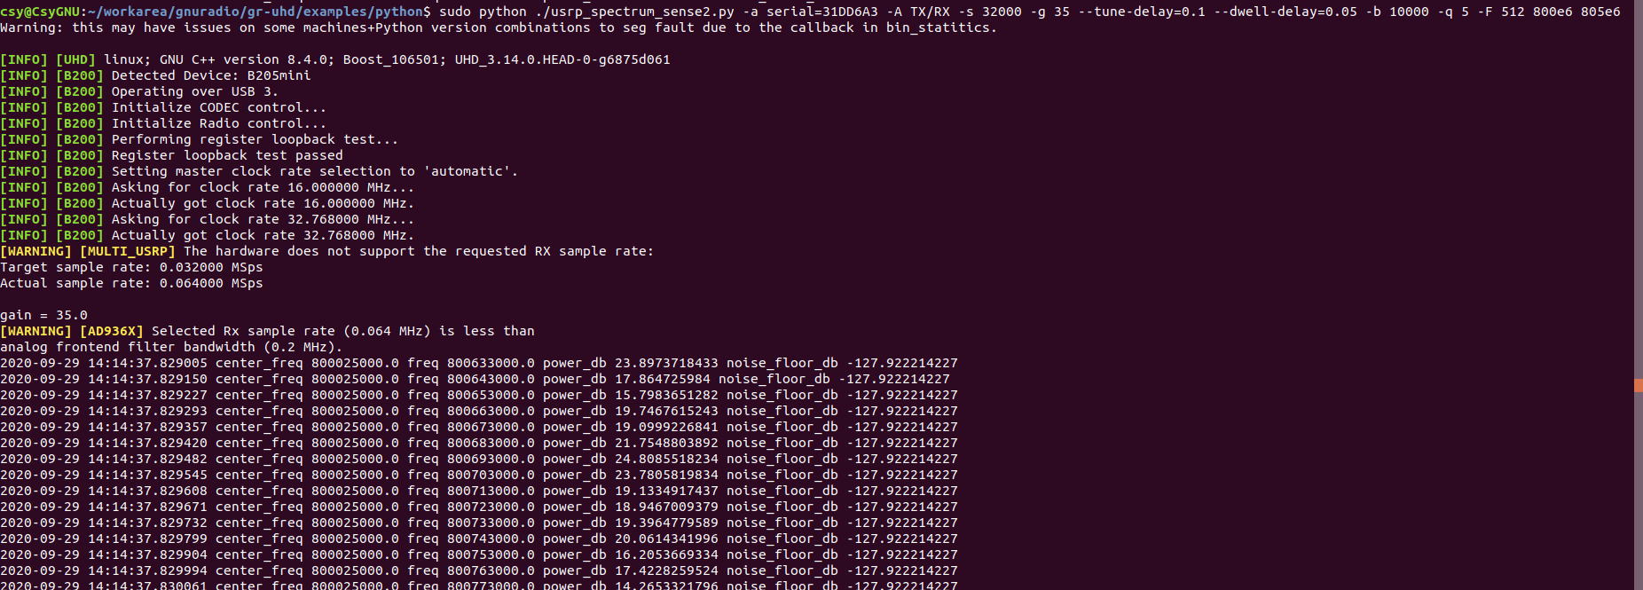
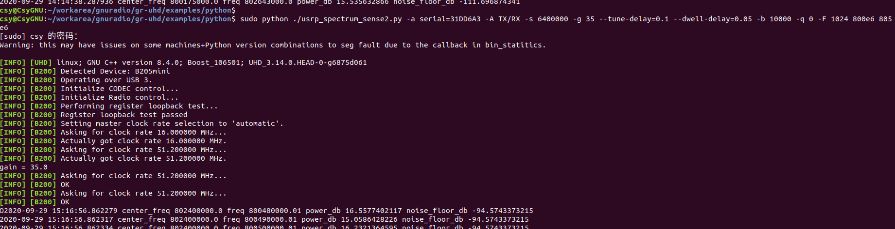

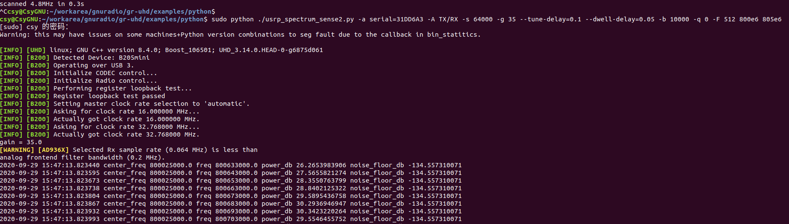

#print "usrp_rate=",self.usrp_rate,"channel_bandwidth（频谱分辨率）=",self.channel_bandwidth,"fft_size= ",self.fft_size ,"freq_step（扫频长度）=", self.freq_step,"tune_delay=",tune_delay,"dwell_delay=",dwell_delay

参数：每次扫42MHz,扫描3GHz,扫描周期72次，共用时间为5.3s.
采样速率56MHz,FFT=512,频率分辨率为109.375kHz,
Options:
-h, --help show this help message and exit
-a ARGS, --args=ARGS UHD device device address args [default=]
--spec=SPEC Subdevice of UHD device where appropriate
-A ANTENNA, --antenna=ANTENNA
select Rx Antenna where appropriate
-s SAMP_RATE, --samp-rate=SAMP_RATE
set sample rate [default=1000000.0]
-g GAIN, --gain=GAIN set gain in dB (default is midpoint)
--tune-delay=SECS time to delay (in seconds) after changing frequency
[default=0.25]
--dwell-delay=SECS time to dwell (in seconds) at a given frequency
[default=0.25]
-b Hz, --channel-bandwidth=Hz
channel bandwidth of fft bins in Hz [default=6250.0]
-l Hz, --lo-offset=Hz
lo_offset in Hz [default=0]
-q dB, --squelch-threshold=dB
squelch threshold in dB [default=none]
-F FFT_SIZE, --fft-size=FFT_SIZE
specify number of FFT bins
[default=samp_rate/channel_bw]
--real-time Attempt to enable real-time scheduling
