How to run the program

Run server first then client.

Below is a simple example of the program.

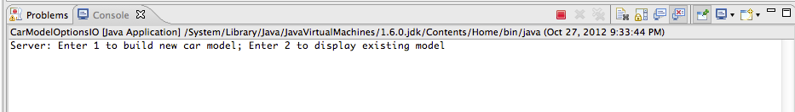

Input 1 to create a new model on the server using the file at client side. A new car will be added into the kbbSystem on server.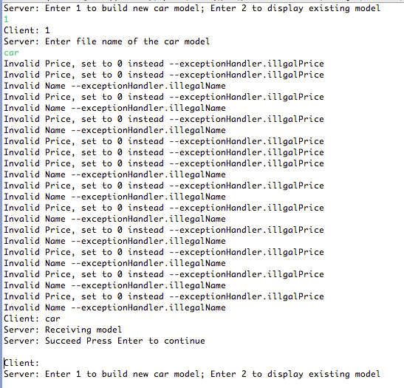Green words are input from keyboard on client side.

Now, input 2 to display existing model at server side.

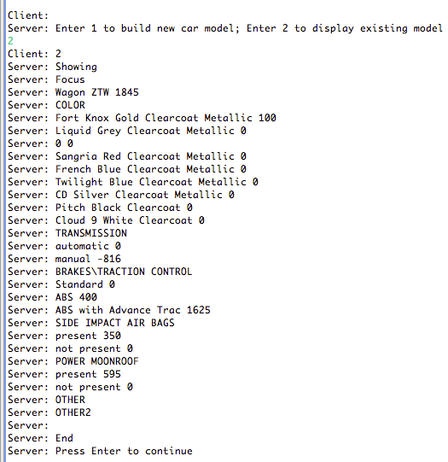

Now, edit this car model, we need to input 1, server will ask you again if you gave it other inputs

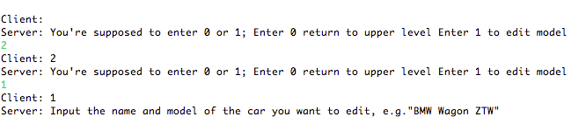

Now, input the make and model of the car

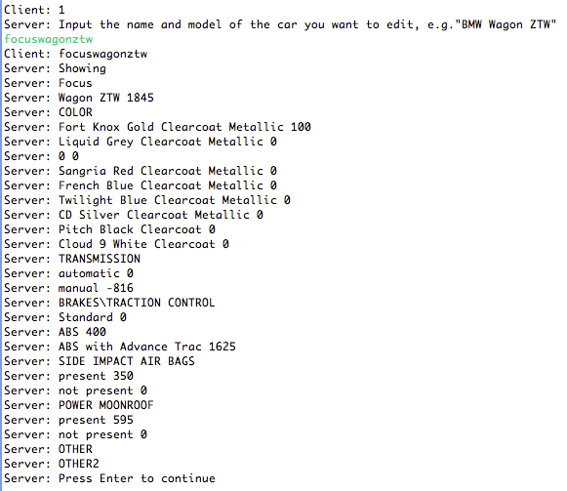

Now, input the options set name, option name and price to replace or create new option. The new data will be displayed.

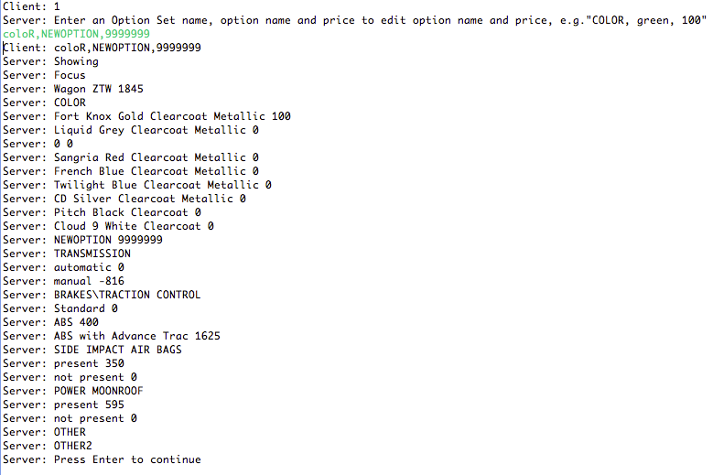

Keyboard Input format

Input can be upper or lower case with before and after spaces.

File Input Format

The text file uses <> and </> to separate OptionSet names, uses comma to separate option names and prices.

Input Logic

The program parse the file and construct an Automobile object, serialize and deserialize the data to recreate Automobile object.

Special Cases

Program is implemented to accept extra space at beginning or ending of each line or invalid price (e.g. No price).

Duplicated option will be overwritten by the latest record.

Duplicated OptionSet will be merged into one OptionSet.