|  |
| --- |
|  |
| WDEvelopment |
| COMP 4970/7970: Project 1 |
|  |
| Steven Whaley, Leo Reyes, Nathan Plotts, Tausif Muzaffar, Zhitao Gong, Kelly Perkins, Kevin Boyd, Jordan Hullett |
| **2/13/2013** |

|  |
| --- |
| This is the first draft of our goals for WDEvelopment’s semester long project in game development. |

**1.**

# General Game Description

In this project, our goal is to work as a team to create an interesting game, which will contain all the elements of gaming detailed in our course, COMP 4970/7970. We have decided on a concept for a game, which will feature a fast paced series of mini-games which will be played on a mobile platform, with possible multiplayer implementation. The game will have uniformity in its theme of nature. Each mini-game will relate to a character’s travels through a forest for continuity. The gameplay will be similar to games like Warioware Inc., Fusion Frenzy, and Mario party, where there are many stages. Each stage will feature a different and unique gameplay, but they will all attribute to an overall goal. An interesting design aspect of our game is we plan to use the built-in sensors found in most cellphones (accelerometers, gyroscopes, compass, or even camera) to interact with the stages. All of these things combined will make the game more interesting. The elements of a uniformed environment will allow players to get engrossed in our game, the quick style of play and learning will allow for a wide demographic, and the use of mobile sensors will prevent players from getting bored.

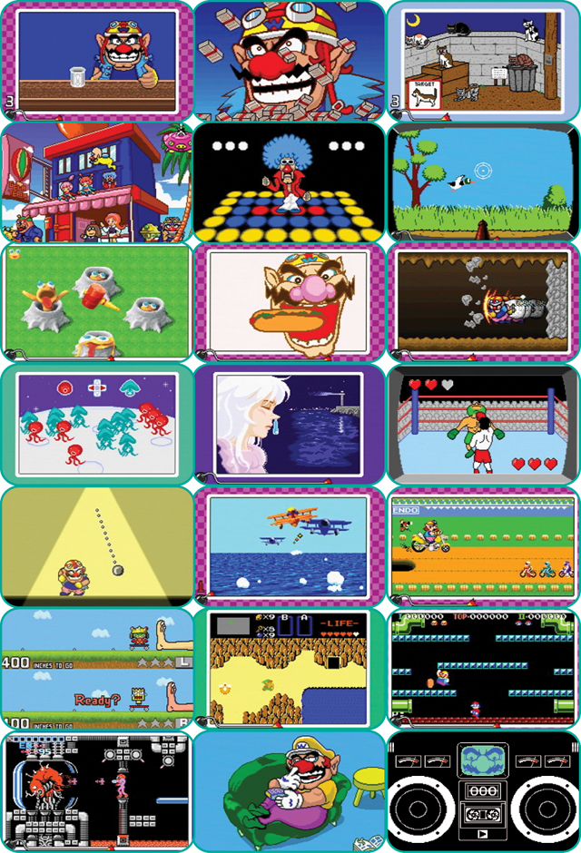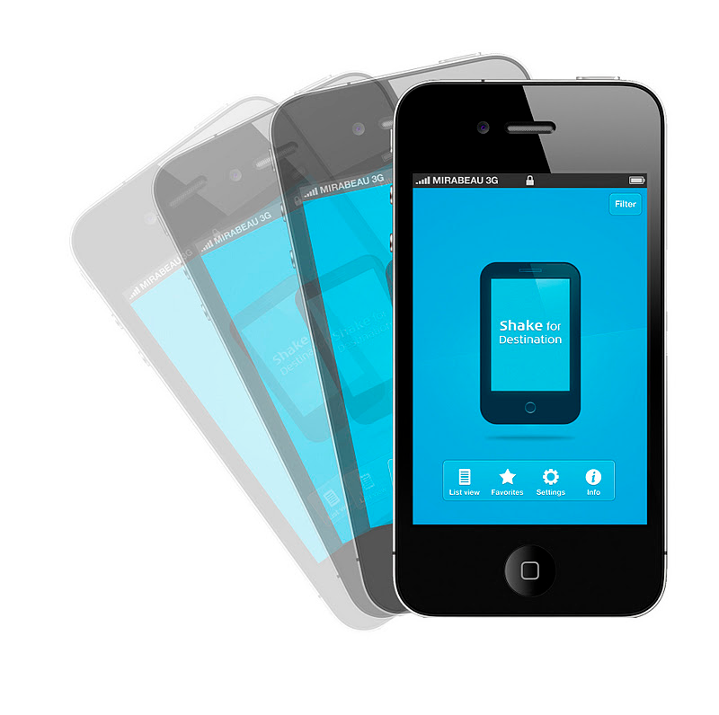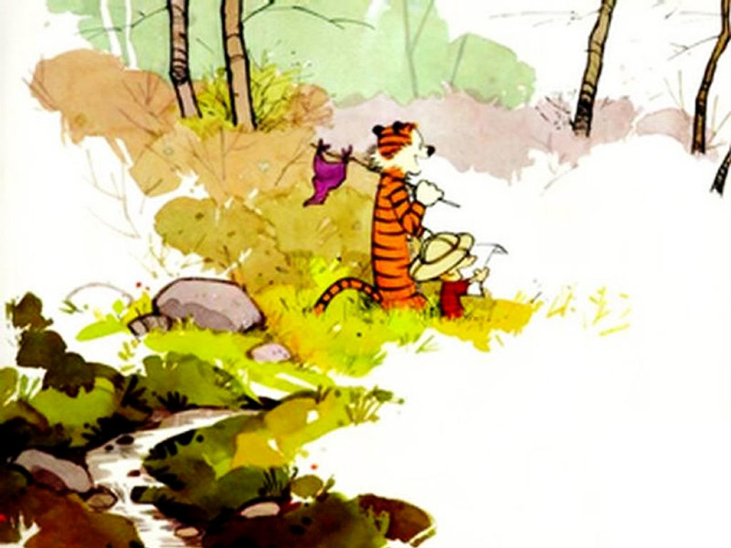

Figure 1: These are the 3 elements which we want to incorporate in our game. Mini-games as seen in the first image, mobile devices moving, and 2D nature exploring theme/style

# Part A; Players

The ultimate goal for our game is to create multilateral competition between people utilizing multiple devices. This means we hope to make a game where each player will play through a series of mini-games in competition to earn the most points, but they will also be making decisions about which player they want to receive the fewest number of points.

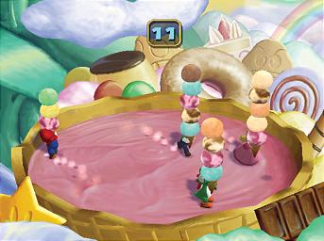

Figure 2: Ultimate goal have 4 players interacting in the same environment

That being said, we have a limited production time to complete the game, so we will first start with a single player dynamic where the player is simply trying to obtain their best score. If time allows, we move to a multi-individual vs. game dynamic, where each player is trying to get a high score, but they will not directly affect each other, and finally if time permits we will get to the ultimate goal of player vs. player as discussed previously.

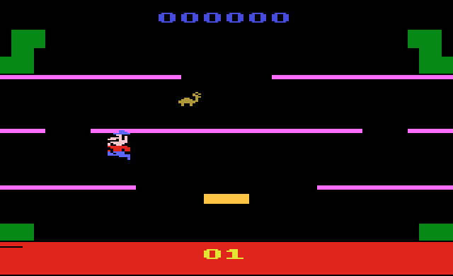

Figure 3: In worse case, it’ll be a game where one player trying to beat a high score.

# Part B; Gameplay Objectives

There are many objectives in our game. The most important one will be moving a character to the end of a forest while attempting to earn a high score by playing through mini-games. While each mini game will have its own secondary objectives (i.e. to catch the most butterflies, to hit the most targets, or to hold the eggs up the longest), these secondary objectives will simply determine how many points you recieve and whether or not you can complete your primary objective.

# Part C; Procedures or Rules

The procedures to play the game will vary from mini-game to mini-game, but for an expositional map, the broad stroke concept will be to move a character closer to the end of the forest by playing mini games. The rule to continue moving is to simply finish playing a mini-game; however, doing well or poorly on a mini-game will not prevent you from getting anything except the most points possible.

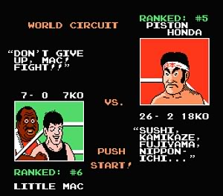

Figure 4: Like this game did, between matches it will create a storyline and give hints, we will be doing the same for between our mini-games.

# Part D; Resources or Conflicts

Being a game of mini-games, the conflict throughout the path of our player will be the mini-games. Each mini-game will act like an obstacle in the way of user, and only after completing that level can they move on. As for resources, the player will be given very little help throughout the game. Even the mini-games will appear a tad random for a new player, be the essence of the game is to throw the player into as many different situations as possible, keeping them off balanced. That being said, each mini game will steer the user how to play it, so the play doesn’t get too frustrated. Also, on screen narration may will be a sort of resource because it will tie the games together, perhaps providing an insight how to play.

# Part E; Boundaries or Formal Elements

As discussed earlier, this game will be a frame if many games. Meaning there are many smaller games framed in a larger game which aggregates the smaller ones. Each mini-game will have its own set of boundaries, but in a larger frame the boundaries are path in which the player is allowed to move. Each position of the path will be full of mini-games so players are both bounded by the mini-game at the farthest traveled spot and each additional unlocked spot on the map. The next spot is only unlocked once the previous is unlocked, so you will be bounded until passing each of the other mini-games.

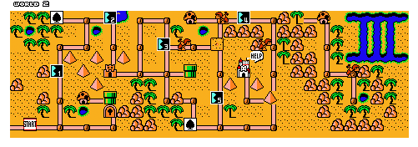

Figure 5: Much like this game you will be stuck to a map, where each dot are mini-games.

# Part F; Outcome

Once playing every path-point, players will reach the end of the game, and leave the forest. When players reach the end of the path, they will be presented with a score. The game is supposed to be easy to beat, because players are supposed to end up at the end of the forest. If a player is playing alone, the score at the end will be saved as high score so the player can continue to compete against themself. The performance may be scored A-F so that the user can judge how well they are doing. In a multiplayer situation, the outcome of the game will rank the winners and losers by number of points.

# Development Tools

To build our project, we will mainly focus on Android Development. Android is Google’s, Java based mobile platform. We will be using the Eclipse Java IDE to build out game, because Eclipse also has built in Android emulators. As for graphics, we still have to research a graphical engine to see if it will fit our needs better. Otherwise we may stick to hardcoding images we create and edit in Photoshop.

# Development Levels

We, as a group, will do our communicating through a combination of Dropbox, Skydrive, email, and face-to-face discussion.

Some milestones we have planned out include:

02/15 – Storyboard game layout

02/20 – Present and discuss all mini-games we want to develop

02/21 – Divide up games and start development

03/18 – Min Target: Create unifying interface

03/25 – Finalize story (text and timing)

03/30 – First set of mini-games must be completed

04/01 – Alpha Testing

04/05 – Second set of mini-games completed

04/09 – Music and interface art work must be completed

04/10 – Beta Testing

04/13 – Finalized interface and story

04/16 – High Target: All mini-games, music, interface has been implemented but still needs stress checks.

04/20 – Delivery Date

# Sketches & Prototyping

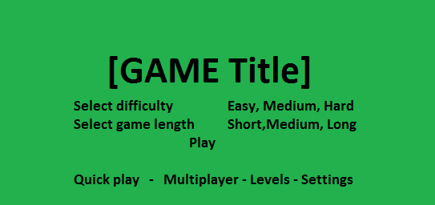

Figure 6: A splash screen for the game. You can play on 3 difficulties, determine length of game, play online, play particular mini-game, and more.

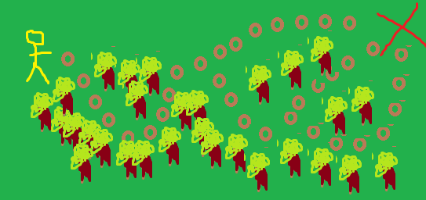

Figure 7: This is a concept of the player map of a long form game. Each circle contains mini-game(s), and you can choose the path to win.

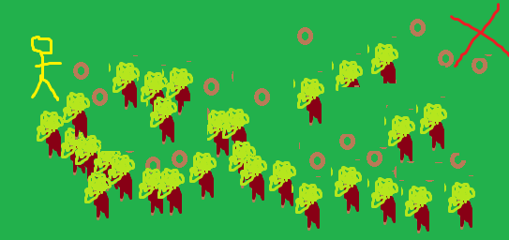

Figure 8: this is an example of a shorter version of the game, less levels till the end



Figure 9: This is an example of a possible mini-game you need to shake the apple off the tree, there isn’t much information except the movement lines, once shook the apple will fall and we will access points.