WDEvelopment

Comp 4970/7970: Final Report

Steven Whaley, Leo Reyes, Nathan Plotts, Tausif Muzaffar, Zhitao Gong, Kelly Perkins, Kevin Boyd, Jordan Hullett, Jamal Adams

**4/26/2013**

This is the final report for WDEvelopment’s accomplishments in Game Design & Development Spring 2013

**Section 1**

Progress made between assignments P3 and P4 primarily involved integrating each mini-game into a single unified program, as well as, improving the aesthetics of the game. A strong point of emphasis for our P4 was depth and also a sense of completeness. We felt a highly polished game would allow each of our simple mini-games to appear more advanced and deep.

* A score element was added to Act 1 which was based on the length of gameplay time and the number of squirrels flicked away. Text was changed to a GUIText for sharpness.
* In Act 2, the self-contained GUI was replaced in lieu of a more integrated GUI across each act. A scoring element based on traveled height was incorporated. Lastly, we added the falling rocks as obstacles to avoid while going up the mountain.
* For Act 3, we replaced all the text with GUIText so it would appear sharper. Rules were changed to where grey rocks do not kill the character; instead, they subtract 100 points from the total score.
* Act 4 had the most changes. Animated stick figures were changed to the character model, Calvin. The generating platforms were made to be more responsive, so a player would not die immediately during the start of the game. Platforms have been skinned with the canyon theme. Finally, a score element was added based on the length of time a player managed to continue jumping across the platforms.

After all the acts were individually updated, we packaged them together. We kept a variable from being destroyed during level transitions so the score could be carried through the game. A splash screen was included at the beginning that started a special musical theme created for the game. Cut-scenes were added in between each act that tells the story of our main character (through a poem). Finally, the game ends with a screen that displays the final score.

**Section 2**

Play testers were asked a series of questions in order to evaluate Squirrel Canyon’s playability and quality. Players were asked to rate six statements based on their level of agreement on the subject. Two additional questions could be answered with yes or no. These eight questions were quantified into the chart in Figure 1. Players were asked if the game was easy to begin, if the menu was clear, if the instructions were clear, if navigating through the game was confusing, if the game’s menu screens were clear, if the overall game was appealing, if the game was long enough, and, if given the chance, would the play tester want to play the game again. As Figure 1 shows, a variety of answers were accumulated from game testers. The most interesting of these statistics can be seen in Figure 2, which displays a closer, more detailed view of the responses to whether or not the game had clear instructions. Although each of the members in WDEvelopment understood how to operate all four mini-games, it seemed that many users could have used clearly defined instructions to help them progress through each of the four acts.

Figure 1: Game Questions and corresponding responses for play testers.

Figure 2: Responses for “Instructions were clear.”

Another four short answer questions were asked of the play testers. These were, “Was there anything about the game that was frustrating?” “Were there parts of the games that you enjoyed and explain?” “What part(s) would you change about the game?” “Overall, did you like the game?” When asked about the frustrating aspects of the game, testers commonly responded that the difficulty varied greatly between games, and many games were overly difficult to finish and progress. The lack of instruction and device response were also frustrating to certain players. Testers did seem to enjoy several aspects of the game including: variety between levels, music, art and the control system utilizing the mobile device sensors. Game players suggested adding instructions, adjusting difficulty, further utilizing the mobile device sensors, and having clearly defined objectives. For the final question, testers seemed to like the game overall. A few testers seemed impartial and one user did not enjoy the game. Many of these questions provided valuable information for how the game could be improved to make it more enjoyable to players. Changes that the group would make based on user feedback will be covered more thoroughly in the following sections of this document.

**Section 3.1**

The mini-games were programmed by pairs or triplets of people within the main WDEvelopment group making it difficult to separately express the aspects of Squirrel Canyon each group member was most proud of. The list below describes each group member’s favorite qualities of the game.

* Kevin – The design flow and graphics are his personal favorites. He created the character models and background models making sure each image is vectorized to work on multiple sized screens.
* Jordan – The smoke cloud element in Act 1 is something he is proud of because of the dynamic feature that adds depth to Act 1. It broke up the monotony of simply swiping the squirrels at regular intervals and added a strategic element.
* Nathan – He is proud of the Act 2 mini-game. He was able to figure out how to give the floating boy perspective, giving it the excitement and sense of speed it needed.
* Steven – He was proudest of his personal music, not only because it was time consuming, but because the music sets the tone of a whimsical, cartoony atmosphere that we aimed to present to players.
* Tausif – Increasing the difficulty near the mid-point of the game is what he is proudest of in Squirrel Canyon. The appearance of the squirrels and speed of falling rocks are dynamically controlled allowing the game to be different each time.
* Jamal – He was enthusiastic about the use of android sensors and other unique components of mobile and hand-held devices. The controls reacted quickly and worked quite well for most Android devices.
* Kelly – She was proud of how the storyline integrated all the mini-games together without leaving out too many key details. The transitional scenes between acts seem to be properly timed.
* Zhitao – He really enjoyed working with animation. In Act 4, Calvin was given the illusion of running. It provided an interesting touch to give the game greater detail than the alternative of translating an image.
* Leonardo – He was proud of his work with Act 4, especially with the generation of the platforms. They are randomly distributed and sized, but he was able to make it so the game was winnable.

**Section 3.2**

Not too many technical changes were made to Squirrel Canyon. Our original implementation plan was to hardcode the game for android devices. This means we would not have used Unity as our game engine or physics engine. This idea was scrapped because the majority of the group is not well versed in Android development, which would have made the learning curve greater. We originally wanted to use an Android graphics engine, but changed to making the graphical components in Adobe Illustrator since .png files could be imported into Unity as mesh materials for our object. This made the game larger in file size because the graphics were not optimized for our platform, but it was the most direct way of developing the game since we were all novice Unity programmers. Static variables were originally used to carry the total score across the scenes; this was method was changed to using a “dontdestroy” command since static variables caused many problems within some scenes of our game. Initially, we wanted cut-scenes with voice-overs so it would feel like players were being lead through the story. That idea was scrapped because our recording software did not have the quality represented by the rest of the game. Lastly, it was decided that we would include a detailed, linear, storyline as opposed to multiple sets of paths detailed on a map, in which short mini-games were found along each path. Our acts quickly emerged to be longer and more detailed than originally planned.

**Section 3.3**

As previously mentioned in Section 2, a survey was distributed to play testers in order to evaluate the difficulty of Squirrel Canyon and the level of enjoyment players experienced while playing the game. Many results can be derived from their responses as well as from the players’ reactions during the testing phase. The first major observation was that the game needed some degree of instruction to begin interacting with each act. Although it was intended for the game to be somewhat puzzling to begin, we had not realized the level of difficulty some users would experience. Many play testers did not know the objective of each game until they restarted the game many times. Small transitional dialogue scenes were included in the form of cartoony poems. This provided some hints to the objective of the game without directly telling players what they must do in order to win. Difficulty and problem-solving skills would still be part of the game, but players would be able to determine the goal each act without be overly-frustrated. As seen in Figure 1, most players thought the game was long enough. This could indicate that the players were either content with the length of the game or that the players thought the game was too long. To compensate for the latter possibility, we made each game approximately the same length. Players seemed somewhat satisfied in most categories with few players completely dissatisfied with the gameplay.

**Section 3.4**

A few key changes would have drastically improved the playability of Squirrel Canyon as indicated by the play testers. Transitional cut-scenes in the form of poems were added to give certain hints to the objectives of the game, but these hints did not describe how a player must interact with the mobile device to complete the objectives. Players must tilt the device to move Calvin, the protagonist, or touch the screen to prevent Calvin from being attacked by squirrels, or touch the screen to make Calvin jump. Given extra time, instructions that show finger-swiping or touching and figures showing the phone being tilted would have been added to help players easily navigate through each level. The second major change would have been to add multiple levels of difficulty. The speed of each act would be adjusted according to the player’s choosing. The music pitch would be adjusted according to the difficulty; the more difficult settings would have higher pitched music which would seem to increase the gameplay intensity.

**Section 3.5**

If given more time, small detailed animations, a menu screen, cut-scenes, and additional acts would be added. Squirrels and Calvin would be given jointed appendages to emulate more realistic movements. During the first act, the balloon would start from a fully deflated state and be blown up slowly by Calvin using his balloon pump. Calvin would defend the balloon by blowing away attacking squirrels. Animations showing a popping balloon would be added to the first two acts. Currently the balloon is destroyed immediately during a collision. A menu system and detailed cut scenes would also be incorporated into Squirrel Canyon. Players would be given the chance to skip to previously completed levels and choose the game difficulty level. A stored high score would also be displayed on the menu screen. We would also have liked to include more acts or levels to continue the adventures and storyline of Calvin. Additional levels could better explain the gargantuan size of the squirrels, why the squirrels attack Calvin, and provide additional adventures once Calvin manages to escape the canyon.

Jordan M. Hullett

<http://www.cnn.com/2011/TECH/gaming.gadgets/01/31/video.games.smarter.steinberg/index.html>

Video games are commonly seen as sources of degradation to a player’s social skills and intelligence; however, it is a recent belief that games increase one’s intelligence by encouraging critical thinking and dynamic decision-making through teamwork and hands-on learning. These games can also build a player’s confidence by allowing them to play, fail, and retry without worrying about embarrassment. The author claims that there are four ways in which video games encourage intellectual growth. They provide hands-on experience, job training, contextual learning, and teamwork through collaboration. Hands-on experience is gained by applying gained knowledge during gameplay to problem-solve within the game or within the real world. Player’s cannot idly sit watching the screen such as with a movie or TV; they must be actively engaged. Job training using video games has been employed by numerous corporations, organizations and colleges to teach their employees and students. Test scores and job skills can often be improved by providing an informative virtual reality. “Serious games and virtual environments are the future of education,” according to Dr. Jeffrey Taekman, director of Duke University’s Human Simulation and Patient Safety Center. Contextual learning, especially in the health care industry, will heavily rely on allowing students to make decisions, see the consequences and apply gained knowledge to the situation. Results from such simulations can be benchmarked against peers and become available for review by others. The ability to work in a team and collaborate with others for a common goal are also skills gained from video games. Multiplayer games often require project management, active teamwork, and leadership to take over a certain territory or achieve a common objective which ironically conditions players to become ideal employees for many of today’s jobs.

Kevin Boyd

**Snow, Blake. "Why Console Gaming is Dying." CNN Tech. 9 November 2012. Cable News Network. 22 April 2013. <http://www.cnn.com/2012/11/09/tech/gaming-gadgets/console-gaming-dead>.**

In recent years, Nintendo, Sony, and Microsoft have seen drastic declines in sales on their consoles, game discs, and accessories. While some may claim that this is a result of the consoles reaching the end of their life cycle, many argue that the era of console games is being ushered out in favor of new, low priced games for mobile platforms. The author of this article points out that casual games such as “Angry Birds,” “Words with Friends,” and “Plants vs. Zombies” have thrived in recent years. Mobile games provide consumers with easily accessible games, that can be played for short increments of time, and often feature social networking capabilities. These features, along with the low price point of mobile games, are gradually taking their toll on the big three console developers.

Is this to say that the consoles are going away completely? The author argues no, but he also claims that the pressure placed on the consoles by the mobile market is indeed forcing the big three console developers to be more creative in terms of development. With the most recent generation of consoles, Nintendo, Sony, and Microsoft have been forming “Trojan horses” to get the consoles into the living rooms of consumers. In doing so, they have begun marketing the consoles as full entertainment systems rather than simply video game consoles. The author makes note of the fact that 40% of all Xbox activity is now non game related, with Nintendo and Sony boasting similar figures. That 40% primarily consists of Netflix and Amazon streaming accounts. While this is great for the movie industry, it’s certainly not good news for the profit margins related to console gaming. It will likely take at least one more console cycle to determine the long term sustainability of the console market; however, sales of video games in their broadest sense are very much on the rise, and although the market may be very different than it was a decade ago, new platforms are fostering many new types of games and interfaces, and for the casual gamer, this is very good news.

Tausif Muzaffar

<http://bostinno.streetwise.co/2012/12/16/gamification-in-education-educational-games-that-work/>

This article discusses adding gaming to education, as it termed, gamification. By this they mean education is not going be replaced by gaming, but rather supplemented by it. The game industry is large and they even say it’s getting bigger. As educators teachers are supposed to tap into the psyche of their students and try to reach them however they can, and but taking the evidence shown in this article gaming is a growing part of that psyche so getting familiar with educational games is a must. That is why the article then outlines some of the most popular elementary games: Math Blaster, Carmen San Diego, and SimCity. Each of these games teach a different utility from math to geography to economics. The article then explains how each of these games can help to reinforce ideas learned from school, this is an important idea to think about because while gaming have been villainized in some media for things like violence, it’s important to remember that it’s not the first time some is exposed to something it’s a reinforcement to things the kids have already seen.

After simply discussing the benefits of games the article talks about the steps to creating a new one. The first thing about games it to make it have a sense of agency because people get frustrated in school from the fact they don’t see how to apply the knowledge to do something they will do. So if you are saving a castle using math, then math class all of a sudden makes sense. The next element is to worry about the education after getting the fun in, this is important because kids don’t want to play a game that is boring and the point of creating educational games is to have the kids play them, as supplement for their work. Last is exploring different ways to be engaged. If the games are engaging then let them do that if they finish their work; if the game is losing interest maybe watch an episode of Carmen San Diego to get the interest back in the game which in turn gets their interest back in geography. Educators have to figure out how to keep kids interested in learning once they leave the class rooms. Games can be played at home so if they explore every way to make educational games the games the kids are playing then the better chance the concepts taught in school will stick.

Kelly Perkins

Summary of Article

Educational Gaming

KC Phillips is a sophomore in high school in Madison, Wisconsin and played Gamestar Mechanic. Gamestar Mechanic is an educational video game that asks players to solve a set of puzzles in order to win enough power to design and create their own games. Since KC Phillips played Gamestar Mechanic, he says that he now will “think about how the designers built it and what mechanics went into it.” Gamestar Mechanics is also part of the curriculum of Quest to Learn. Quest to Learn is a New York City public school that is focused on game-based learning that opened in New York City in the fall of 2009. Institute of Play, a nonprofit group, set up the school.

Many modern video games are now online and social based allowing for the children to interact and work together to achieve the goals set forth by the games. Most of the games are set in a virtual world where players can be different character and try to solve problems related to the world the game is set in, giving the students problem solving skills. In addition, video games now try to work in math, science, or language into the game. In Gamestar Mechanic, KC had to use physics concepts to solve problems and then had to defend his world against other Gamestar Mechanic players. Gamestar Mechanic is free, but you can do a monthly subscription to get extended versions of the game for $3 to $5. Mr. Gershenfeld wants to reach as many children and help them with their critical thinking and ability to solve complex problems, which is why Gamestar Mechanic is free. Due to multiple educational video games being played in school, students test scores have increased. Teachers agree that games like Quest Atlantis covers the core curriculum for tests, but the games take several classes to complete limiting the time that teachers have to teach textbook-based material.

http://www.nytimes.com/2009/11/02/technology/02games.html?_r=1&

Leonardo Reyes

Tetris to help with lazy eye

A team from McGill University recently came up with an idea to treat lazy eye through playing Tetris, a puzzle game where the player tries to arrange blocks to survive. There is an estimate that says one in fifty children has lazy eye. Lazy eye can lead to permanent loss or weakening of vision in one eye. The team from McGill University use a special pair of goggles that help to make both eyes work as a team. The goggles let one eye see only the falling blocks and the other eye only sees the blocks on the ground. This method could work with a variety of video games and not just Tetris.

http://www.bbc.co.uk/news/health-22245620

Steven Whaley

Article: Super Mario Bros 3 Level Design Lessons (Parts 1-3)

by Radek Koncewicz of Incubator Games on significant-bits.com

This article describes the writers play-through of the classic game Super Mario Bros 3 and some game design lessons that can be learned from analyzing the structure and mechanics of the game. Super Mario Bros 3 is a famous and popular platform game published by Nintendo for the Nintendo Entertainment System that was released in the United States in 1990. As the writer moves through each level or "world" in the game, he makes comments about the design. Some topics he mentions are gradual layering of complexity, different possible paths through the game, unique player experience with each replay, how the game teaches the player, ability of player to circumvent major portions of the game, etc.

An example that is interesting to note is the mention of Super Mario Bros 3's variety in art and layer design. The following quote illustrates this example :"Even when the Worlds are themed — such as Ice Land — each of their consecutive stages use different tilesets and gameplay." The main idea is that this game does a great job of using a large variety of art assets to create a stimulating gameplay experience for the player. Another example is the games use of the warp zone. The player can use this feature to skip entire levels and large portions of the gameplay if they decide to, which is an interesting design choice, but even more interesting is how this feature of the game essentially replaces a user interface, instead using the way the player is already accustomed to navigating the map to make choices. You can read the article Super Mario Bros 3 Level Design Lessons Parts 1 at the following link and navigate on the site to find parts 2 and 3. Part 1: http://www.significant-bits.com/super-mario-bros-3-level-design-lessons

Nathan Plotts

Article: Rapid-Prototyping: Tips for Running an Effective R&D Process http://gamasutra.com/view/feature/179501/rapid_prototyping_tips_for_.php

This article first provides a good description of what prototyping is and why good prototyping is crucial to game development. It explains that with good prototyping you can actually find out if your game will be a flop before you ever enter development. The way to find this out is simply seeing if your prototype is fun to play in the prototype stage. If it’s not fun to play in the prototyping stage then there’s no reason that it will change once the game is fully built. The article then explains that if your game is not fun as a prototype, then you’ve got a lot of work to do through changing of game mechanics in your prototyping and doing tests with each new prototype.

The article then explains how to create and run an effective prototyping and R&D team. One highlight I think is worth mentioning is that each member of the team must realize that their job is to make the game fun, which is the most important part of development. They are the most important people in the development cycle and should treat their jobs as such. The article then explains that when prototyping it is important to set attainable goals for the team for each iteration and that the team should move between iterations rapidly, not lingering on one build for too long. It’s also worth mentioning that during prototyping idea creation and presentation should be a very open process so that ideas are not missed. The last portion of the article covers how to know when you should end prototyping and how to choose which prototype build you should move into actual development.

Jamal Adams

April 26, 2013

Game Design & Development: Project 4 Summary

Just over a week ago, three people were killed and 264 were injured when two bombs went off near the finish line of the Boston Marathon. However, the website Lolokaust.com has hosted a game entitled “Boston Marathon 2013: Terror in the Streets, that is based off of the recent tragedy. The main player is a sprinter that must dodge pressure cooker bombs similar to the bomb used in the attack. While running during gameplay, the game displays “suspicious people” in crowd, people in wheelchairs with missing limbs and images from the actual bombing site. Nevertheless, the description of the game states “Tired of watching the Boston Marathon disaster on TV? Well now you can live it. It’s a video game!”

This is not the first video game based off of tragedies in American history. The game “Super Columbine Massacre RPG” replicated scenes from the mass murder of the Columbine High School shooting that left twelve students and one teacher dead. Other related games include “Kindergarten Killer”, “Pico’s School” and “Ethnic Cleansing”. The creators of these games are known for extremely offensive cartoons including LAPD cop killer Christopher Dorner and Sandy Hook shooter Adam Lanza. Although, the developers are exercising their First Amendment right given in the U.S. Constitution, critics are complaining that they have gone too far by offending the citizens of Boston, as well as the families that were affected by the disaster. This game can be downloaded free from [www.lolokaust.com](http://www.lolokaust.com).

<http://www.bostonmagazine.com/news/blog/2013/04/26/the-marathon-attack-inspired-the-worst-video-game-of-all-time/>

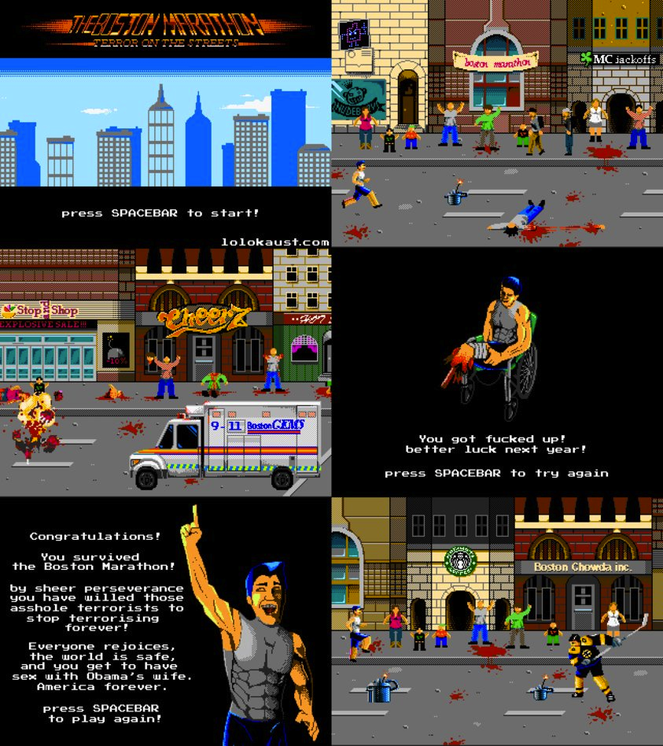

# Thoughts on Your Brain on Video Games by Daphne Bavelier

Zhitao Gong

April 26, 2013

Daphne Bavelier showed some amazing facts about video games in terms of human brains, most of which are really counter intuitive. In particular, most of her studies and experiments suggest that playing video games can actually benefit people in various ways.

First , traditionally it's believe that more screen time makes your eye sight worse. But according to her survey and experiments, lovers of action games actually have better eye sight on average than normal people. She argues the action games actually help train people to distinguish small things, thus those players are better at resolving small details in the context of clutter. And also they are better to resolve different levels of gray which is of great help for driving in frog. So her team are trying to develop games to help people with low eyesight.

The second assumption about video games is that they could lead to attention problems and greater distractibility. In her experiment, action gamers actually do better at those activities that require great attention. Especially, they are good at tracking more moving objects around them.

So we could leverage those findings about the brain and development more beneficial and fun games for people.

Here is the link: [Your Brain on Video Games by Daphne Bavelier](http://www.ted.com/talks/daphne_bavelier_your_brain_on_video_games.html)