Multi-scale coding of bat place cells

- does not require prior experience

- reduces decoding errors in large environments

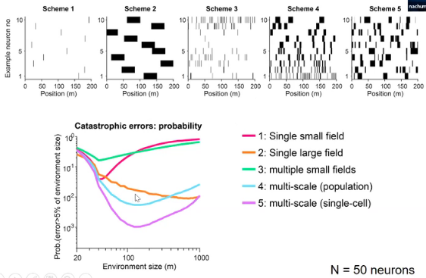

- many fields per neuron

Non-separable representation of position x inter-bat distance

- A place cell responses differently given different position under the same inter-bat distance, and given different inter-bat distance under the same position.