How To Host the Queue Bot

1. Create a discord account
2. Navigate to <https://discordapp.com/developers/applications/> and log in
3. Select New Application in the top right, it’s a blue button

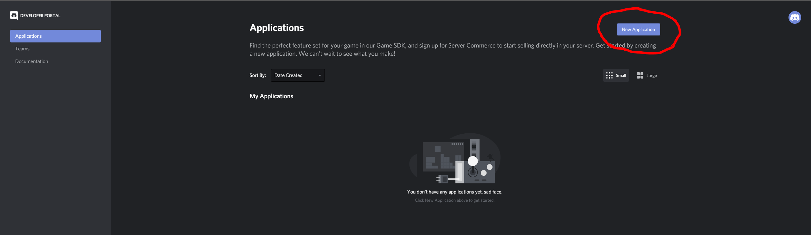

1. Give your app a name (e.g. officeHoursBot) and click create
2. 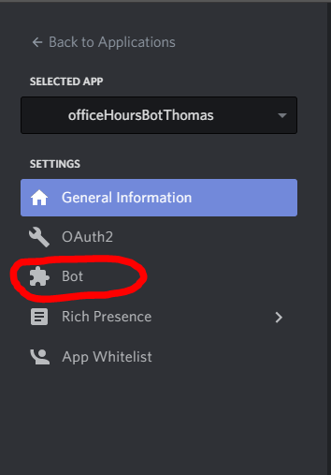On the left hand navigation pane select the Bot option, the one with a puzzle piece icon next to it
3. On this page click the blue button that says add a bot. A confirmation window will pop up, agree and continue.

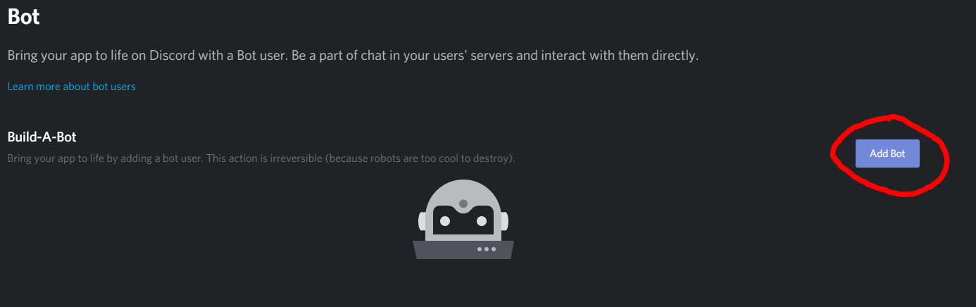

1. Once the Bot has been created it will come up with a settings page for your bot. A few things here can and should be changed.
   1. The username can be made anything you like. Should make this readable and easy to recognize among other users on your server.
   2. The token is the unique identifier for your bot. We will need this later when we set up the code so keep it in mind.
   3. The public bot setting is set to on by default. This means anyone can add our bot. We want to turn this off so only we can add it.

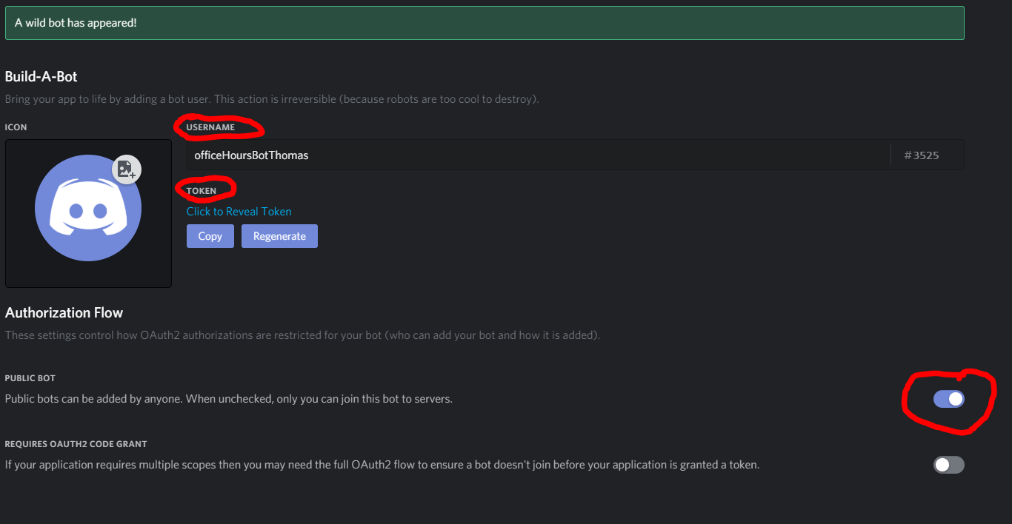

1. Now to add the bot to your server. On the left hand navigation pane select the OAuth2 tab. There you should see a section called scopes like the one pictured below. Check the box for the bot scope and then copy the url that is generated.

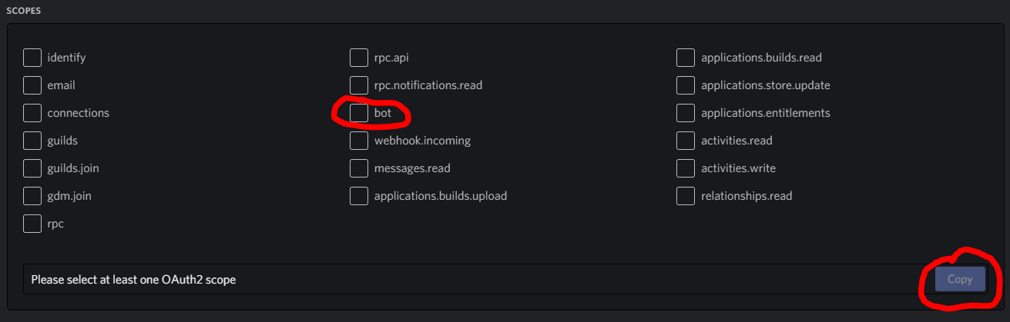

1. Paste that URL into a new tab. It should bring up a page that looks like this

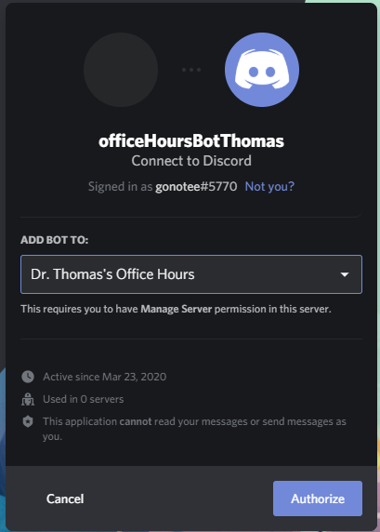

1. Select the server you wish to add the bot to from your list of servers and then click Authorize. This assumes you have created the server already. If you haven’t, pause this guide and go do that first.
2. The bot is now added to the server. But it’s offline and can’t do anything. To fix that we need to download the bot code from github. <https://github.com/gonotee/QueueBotDiscord>
3. Download the discordQueueBot.js file and save it to a new easy to find folder on your computer.
4. There are a few things that must be changed in this file to get it to work.
   1. The const mainLobby variable should have its value changed to the name of your main channel (Discord defaults to general).
   2. The const privilegedRole variable should have its variable changed to whatever name you chose for your privileged role in the Discord server (i.e the role that you want to be able to run the !take command)
   3. At the very bottom of the code is a line that says ENTER CLIENT TOKEN HERE. Remember when I said to we would need that token later? Now is that time. Copy the token and replace the ENTER CLIENT TOKEN HERE with the token you copied. (Refer to step 7 for how to find the token if you don’t remember)
5. Now save your code and open a browser
6. We need to install node.js on our computers, to do this navigate to this website <https://nodejs.org/en/> and select the version recommended for most users.
7. Follow the instructions in the installer to finish installing Node.js
8. When Node.js has finished installing open up a Windows Command Prompt terminal
9. Navigate to the folder you saved your code in in the command prompt

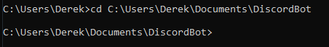

1. Next we need to install the discord.js api that the bot code uses to communicate with discord. To do this type npm install discord.js in the command prompt you already have open. It may or may not ask you for a confirmation, say yes and proceed.
2. Once discord.js has finished installing you can type node FILENAME.js and your bot should run and you should see it come online in Discord.

