# Work Analysis Report for: Web App Development

## Summary

Tasks completed: 5

Pull Requests: 4

Total hours spent: 0.05

Average time per task: 0.01 hours

## Time Analysis Chart

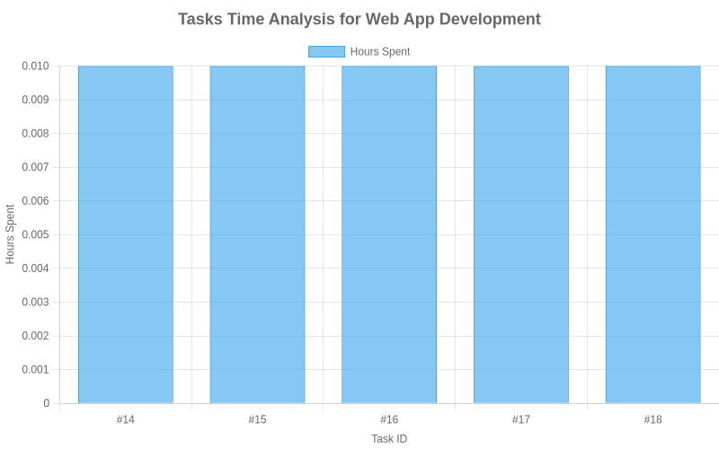

## Completed Tasks

| ID | Task | Description | Pull Request | Hours Spent |
| --- | --- | --- | --- | --- |
| 14 | Project setup | Initialize project structure and dependencies | N/A | 0.01 |
| 15 | Database schema | Create database models and migrations | github.com/user/webapp/pull/42 | 0.01 |
| 16 | User authentication | Implement login, registration, and password reset | github.com/user/webapp/pull/43 | 0.01 |
| 17 | Product catalog | Implement product listing and search functionality | github.com/user/webapp/pull/44 | 0.01 |
| 18 | Checkout process | Implement shopping cart and payment integration | github.com/user/webapp/pull/45 | 0.01 |