1. Project
   1. Count 1s of binary strings with length 20
2. Date
   1. June 24, 2017
3. Engineer
   1. Gonsoo Moon
4. Environment
   1. Mac Pro 2.6 GHz Intel Core i5, 16 GB RAM
   2. Python 2.7.11
   3. Tensorflow 1.0.0
5. How to run
   1. On the command line, type Python2 count1sBinaryString.py
6. Result
   1. With epoch 5, error rate is 83.7 (Training example: 10,000, Test example: 1,038,576

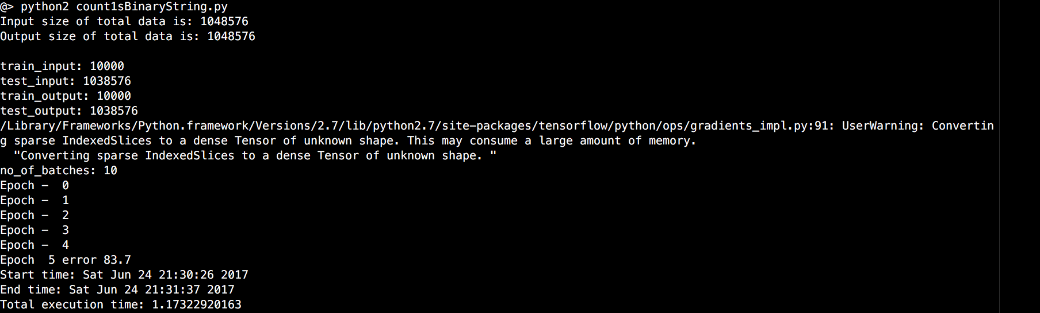

* 1. With epoch 5000, error rate is 0.1 (Training example: 10,000, Test example: 1,038,576

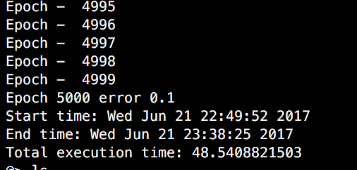

1. Reference
   1. MONIK’s blog (2016), A noob’s guide to implementing RNN-LSTM using Tensorflow, http://monik.in/a-noobs-guide-to-implementing-rnn-lstm-using-tensorflow/