Simple Computer Simulator
This program simulates an 8-bit microcontroller based on the Mansfield University Computer Organization MUCPU. The program can also simulate the Atmel ATMega 328P 8-bit AVR microcontroller, the same chip that is used on the Arduino boards.

MUCPU mode
The simulated CPU has 4 general purpose 8-bit registers named A through D (A is the accumulator). There is a single 256 byte memory address space. The address space runs from 0x00 to 0xFF and contains both code and data. Memory is accessed via indirect addressing. There are 20 different instructions supported.

Each instruction consists of two bytes. The first byte is a hex number that identifies the instruction. The second byte is a hex number that is either the address of a memory location or a port number or a push/pop register.

For example, LOD A, [10] would load the value stored at memory address 10 (hex) into register A.
STO B, [NUM] would store the contents of register B into the memory address of where the “NUM” label is.

Here is a small sample that displays an 8-bit number on the Port 0 LED being counted down by one.
All labels like “LOOP1” must be followed by an instruction or variable definition.
LOD A, [NUM1]
LOOP1: SUB A, [NUM2]
OUT 00,A
JNZ LOOP1
HLT
NUM1: DB 00
NUM2: DB 01

Here is a list of the available instructions and their opcode values (0x## is the hex code):
Opcode Instruction
0x00 NOP
0x10 LOD A,[k]
0x11 STO [k],A
0x20 ADD A,[k]
0x21 SUB A,[k]
0x22 ADC A,[k]
0x30 JMP k
0x31 JZ k
0x32 JNZ k
0x33 JC k
0x34 JNC k
0xA0 IN A,p
0xA1 OUT p,A
0xB0 CALL k
0xB1 RET
0xB2 PUSH SR
0xB2 PUSH A
0xB3 POP SR
0xB3 POP A
0xFF HLT

k is an address label.
p is a port number.
A – D are four general purpose registers.
SR is the status register.

Output ports:
00 is Port 0 LEDs
01 is Port 1 LEDs
04 is Port 4 LCD (4x40)

Input ports:
02 is Port 2 DIP switches
03 is Port 3 DIP switches

Instruction meanings
NOP; means “no operation” it performs no action other than consuming CPU cycles.
LOD A,[k]; “loads” the value at memory address 'k' into register 'A'.
STO [k],A; “stores” the value in register 'A' into the memory address pointed to by 'k'.
ADD A,[k]; “adds” the value at memory address 'k' to the value in register 'A'.
SUB A,[k]; “subtracts” the value at memory address 'k' from the value in register 'A'.
ADC A,[k]; “adds with carry” the value at memory address 'k' to the value in register 'A'.
The carry bit is also added.
JMP k; “jumps” to address location 'k' unconditionally.
JZ k; “jumps” to address location 'k' when the zero flag is on.
JNZ k; “jumps” to address location 'k' when the zero flag is not on.
JC k; “jumps” to address location 'k' when the carry flag is on.
JNC k; “jumps” to address location 'k' when the carry flag is not on.
IN A,p; “input” reads the bits from input port 'p' into register 'A'.
OUT p,A; “output” writes the value in register 'A' to the output port 'p'.
CALL k; “calls” a subroutine. Execution resumes after the call instruction.
RET; “returns” from a called subroutine. (Another words, return to the caller)
PUSH SR; “push status register” the value of the status register will be pushed (saved) onto the stack.
PUSH A; “push register” the value of a register will be pushed (saved) onto the stack.
POP SR; “pop status register” the value of the status register will be restored from the stack.
POP A; “pop register” the value of a register will be restored from the stack.
HLT; “halt” halt or terminate the program.

The figure below shows the GUI user interface of the program and describes what each component does.
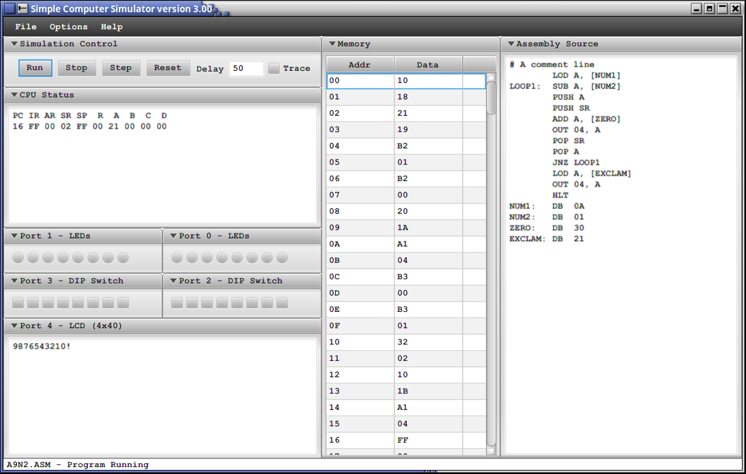
The menu items under “File”
The menu item called “New” clears the contents of “Assembly Source”
And prepares the program for a new assembly program.
The menu item called “Open...” allows you to open and load an existing assembly source program.
The menu item called “Save As...” allows you to save your assembly source program into a file.
The menu item called “Print Trace...” allows you to print the trace logs to a printer.
The menu item called “Print Code...” allows you to print the assembly source program to a printer.
The menu item called “Print Listing...” allows you to print the assembly listing to a printer.
The menu item called “Exit” terminates the program.

The menu items under “Options”
The menu item called “MUCPU” allows you to toggle into MUCPU mode.
The menu item called “Simplified AVR CPU” allows you to toggle into AVR CPU mode.

The menu items under “Help”
The menu item called “Overview” shows a dialog describing how the current CPU mode works.
The menu item called “Opcodes” shows a dialog describing the opcodes for the current CPU mode.
The menu item called “About” presents a dialog showing the program name, version and run mode.

The figure below explains the control panel.

The “Run” button starts the execution of the assembly program.
The “Stop” button terminates the execution of the assembly program.
The “Step” button allows you to execute one single instruction at a time. (Debug mode)
The “Reset” button reinitializes the assembly program. (As if it started over new)
The “Delay” box allows you to increase the execution speed. (The value is in milliseconds)
Important!!! When you change this value, you must hit the enter key.
The “Trace” button turns on the debugging trace logs.

The figure below explains the CPUs status.
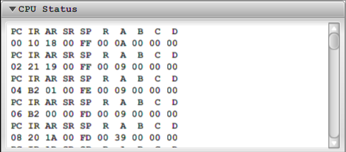

When the trace button is checked, trace logs are generated for each instruction executed.
The output is in two separate lines, the top line shows a legend and the bottom line shows the values.
“PC” is the program counter or instruction pointer.
“IR” is the instruction register.
“AR” is the address register.
“SR” is the status register.
“SP” is the stack pointer.
“R” is reserved and is not used.
“A” is a general purpose register.
“B” is a general purpose register.
“C” is a general purpose register.
“D” is a general purpose register.

The figure below explains the output ports.
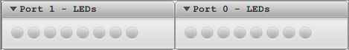

Port 1 LEDs is for “OUT 01, A” each radio button corresponds to a specific bit in an 8-bit byte.
Port 0 LEDs is for “OUT 00, A” each radio button corresponds to a specific bit in an 8-bit byte.

The figure below explains the input ports.
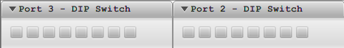

Port 3 DIP is for “IN A, 03” each check box button corresponds to a specific bit in an 8-bit byte.
Port 2 DIP is for “IN A, 02” each check box button corresponds to a specific bit in an 8-bit byte.

The figure below explains the LCD output port.
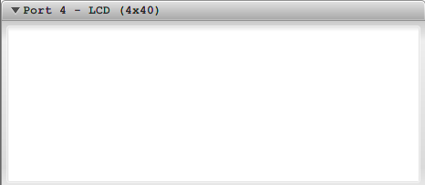

Port 4 LEDs is for instruction “OUT 04, A”, this behaves like a little LCD screen.
(Writing ASCII bytes is preferred)

The figure below shows the memory addresses, opcodes and ports.
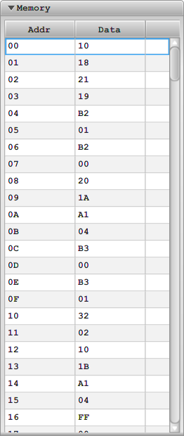

“Addr” shows the memory address for a particular instruction.
“Data” shows either the opcode, address or port number.

The figure below shows the assembly source code.
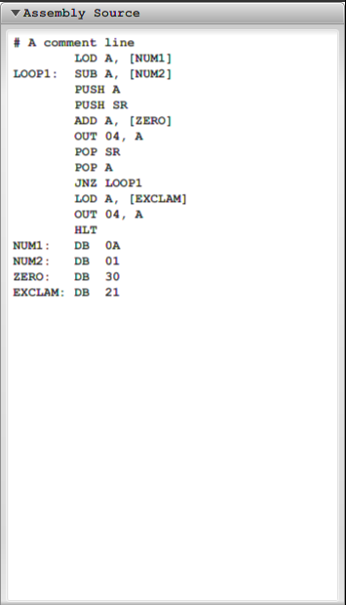

You write and edit your assembly source code in this text box.

AVR CPU mode
The simulated CPU has 8 general purpose 8-bit registers named R0 to R7. Direct and register-indirect addressing is supported by all registers. There is a single 256 byte memory address space that is separate from the registers. The address space runs from 0x00 to 0xFF and contains both code and data. There are 30 different instructions supported with a total of 907 variations.

Each instruction consists of two bytes. The first byte is a hex number that identifies the instruction. The second byte is a hex number that can identify registers, a port, or a number.

Rd is the destination register and Rr is the source register. K indicates an 8-bit data or address value. P indicates one of the 5 available ports on the simulator.

For many instructions a register is identified by a 4 bit pattern. Therefore 2 registers can be stored in a byte. For example, to add together R2 and R7 and to store the result in R2, the assembly code would be ADD R2,R7 and the machine code would be 04 27 where the 04 is the opcode for ADD and 27 indicates R2 and R7.

Jump, call, and branch instructions all use an absolute address. For example, suppose a subroutine named MySub is located at address 60. CALL MySub would then go to address 60. The opcode would be 44 60.

Here are a list of the instructions and their opcode values:
Opcode ASM
00 00 NOP 00
04 RdRr ADD Rd, Rr
08 RdRr ADC Rd, Rr
14 RdRr SUB Rd, Rr
20 RdRr AND Rd, Rr
24 RdRr OR Rd, Rr
28 RdRr EOR Rd, Rr
30 0Rd INC Rd
31 0Rd DEC Rd
32 0Rd TST Rd
40 K JMP K
44 K CALL K
48 00 RET 00
50 RdRr CP Rd, Rr
60 K BREQ K
61 K BRNE K
62 K BRCS K
63 K BRCC K
64 K BRSH K
65 K BRLO K
6F K MOV Rd, Rr
70 K LDI R0, K
71 K LDI R1, K
72 K LDI R2, K
73 K LDI R3, K
74 K LDI R4, K
75 K LDI R5, K
76 K LDI R6, K
77 K LDI R7, K
90 RdRr LD Rd, Rr
91 RdRr LD Rd, Rr+
94 RdRr ST Rd, Rr
95 RdRr ST Rd+, Rr
A0 RdP IN Rd, P
A1 PRd OUT P, Rr
A2 Rr PUSH Rr
A3 Rd POP Rd
FF FF HLT FF

All values are in hex
K is an 8 bit address or data value
P is a port number
Rd is the destination register
Rr is the source register

Output ports:
00 LEDs
01 LEDs
04 LCD

Input ports:
02 DIP switches
03 DIP switches

