**Gontla mahesh**

**14-10-20**

**1.Write a Java program to sort a list of names in ascending** order.

import java.io.*;

public class Main

{

public static void main(String[] args) throws IOException{

String name[] = new String[5];

String temp="";

int i=0;

BufferedReader br = new BufferedReader(new InputStreamReader(System.in));

for(i=0;i<5;i++){

name[i]=br.readLine();

}

for (i = 0; i < 5; i++)

{

for (int j = i + 1; j < 5; j++)

{

if (name[i].compareTo(name[j])>0)

{

temp = name[i];

name[i] = name[j];

name[j] = temp;

}

}

}

System.out.println("names in alphabetical order");

for(i=0;i<5;i++){

System.out.println(name[i] + " ");

}

}

}

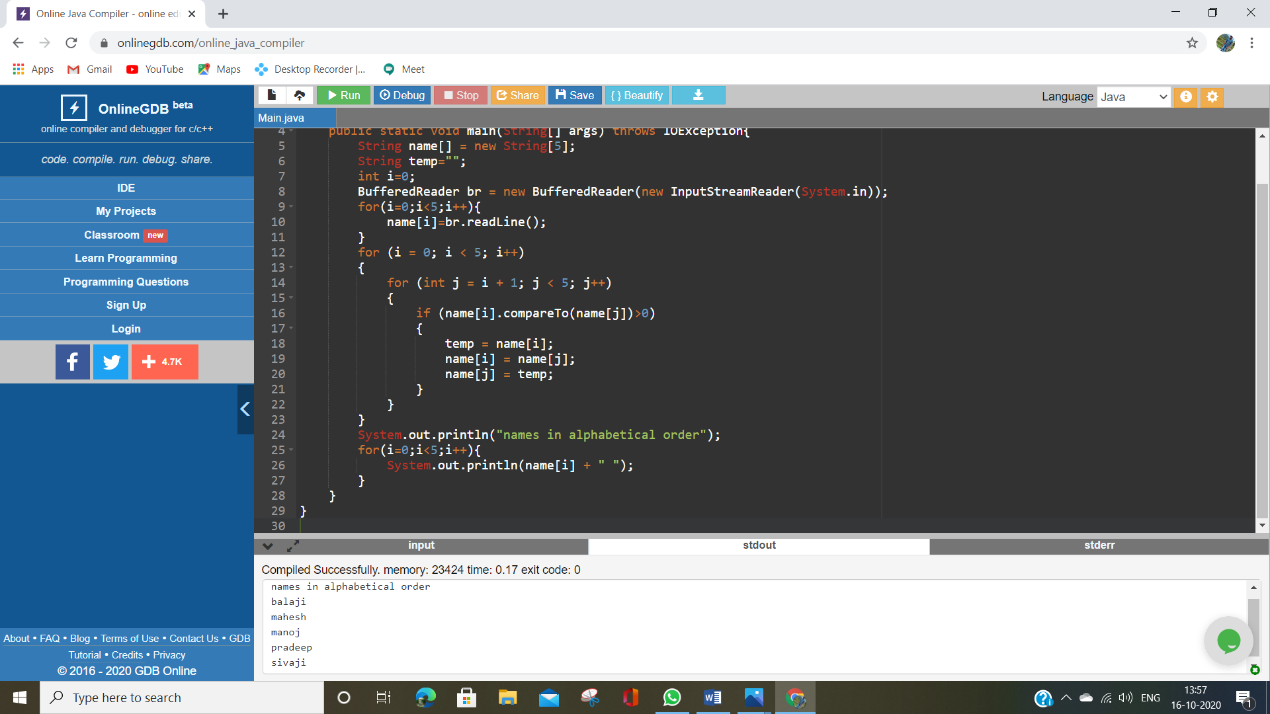

2.Write a Java program to concatenate a given string with itself of a given number of times.

import java.io.*;

public class Main

{

public static void main(String[] args) throws IOException{

String name;

String temp="";

int n;

int i=0;

BufferedReader br = new BufferedReader(new InputStreamReader(System.in));

name=br.readLine();

n = Integer.parseInt(br.readLine());

for(i=0;i<n;i++){

temp+=name;

}

System.out.println("printing name as given no of times " + temp);

}

}

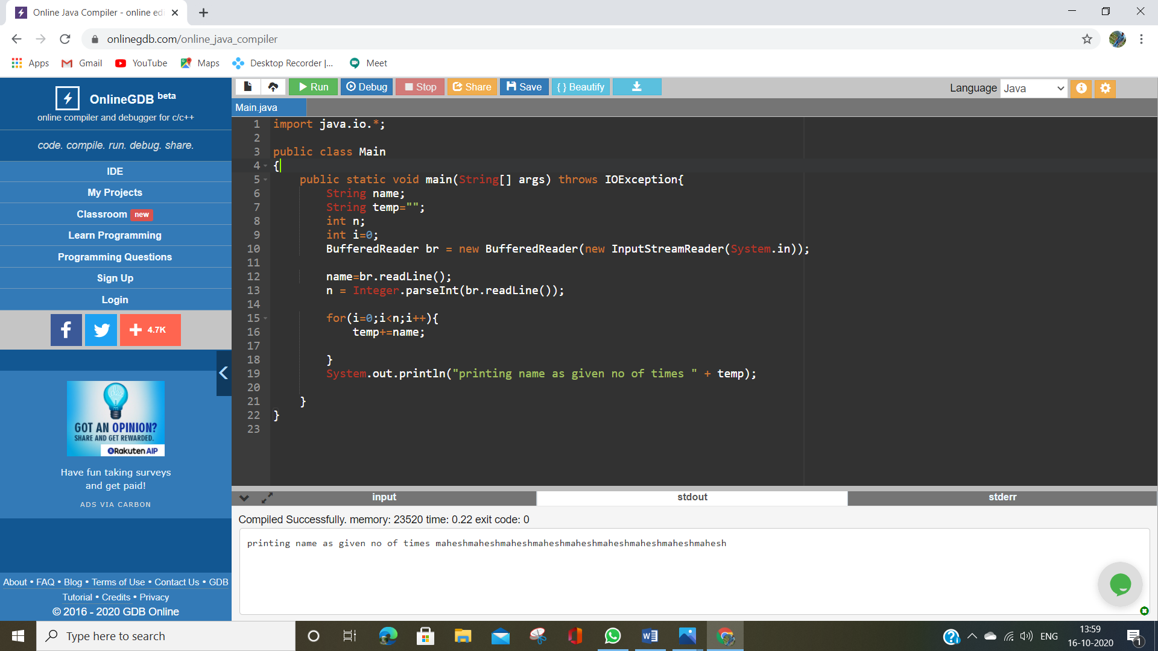

3.Write a Java program to counts occurrences of a certain character in a given string.

import java.io.*;

public class Main

{

public static void main(String[] args) throws IOException{

String name;

int i=0;

int count=0;

char ch;

BufferedReader br = new BufferedReader(new InputStreamReader(System.in));

name=br.readLine();

ch = br.readLine().charAt(0);

for(i=0;i<name.length();i++){

if(name.charAt(i)==ch){

count++;

}

}

System.out.println("the input is | "+ name);

System.out.println("total num of occurences of "+ ch + " is " + count);

}

}

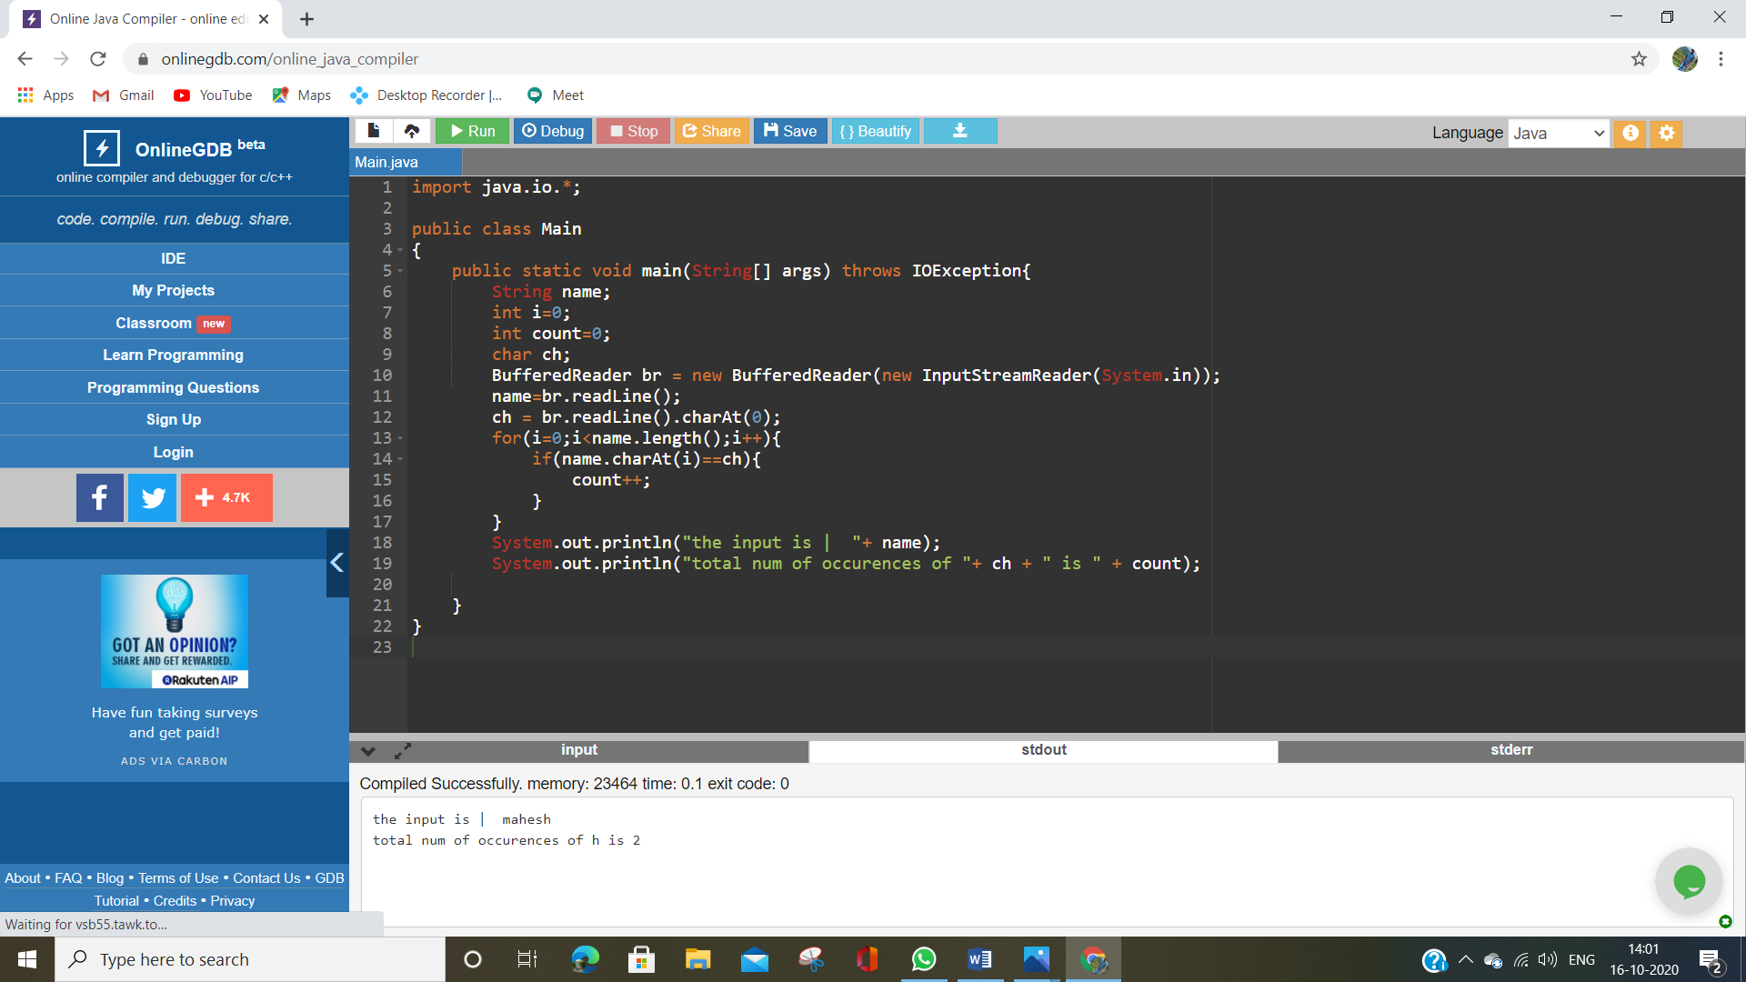

**4. Write a Java program that reads a file and displays the file on the screen, with a line number before each line.**

import java.io.*;

public class Main

{

public static void main(String[] args) throws IOException{

FileWriter f = new FileWriter("test.txt");

//BufferedReader br = new BufferedReader(new InputStreamReader(System.in));

String str;

for(int i =0;i<args.length;i++){

f.write(args[i] + "\n");

}

f.close();

FileReader fr = new FileReader("test.txt");

int ch;

int lno=1;

while((ch=fr.read()) != -1){

if ((char)ch == '\n'){

System.out.print((char)ch);

System.out.print( ++lno + " : ");

}

else

System.out.print((char)ch);

}

}

}

s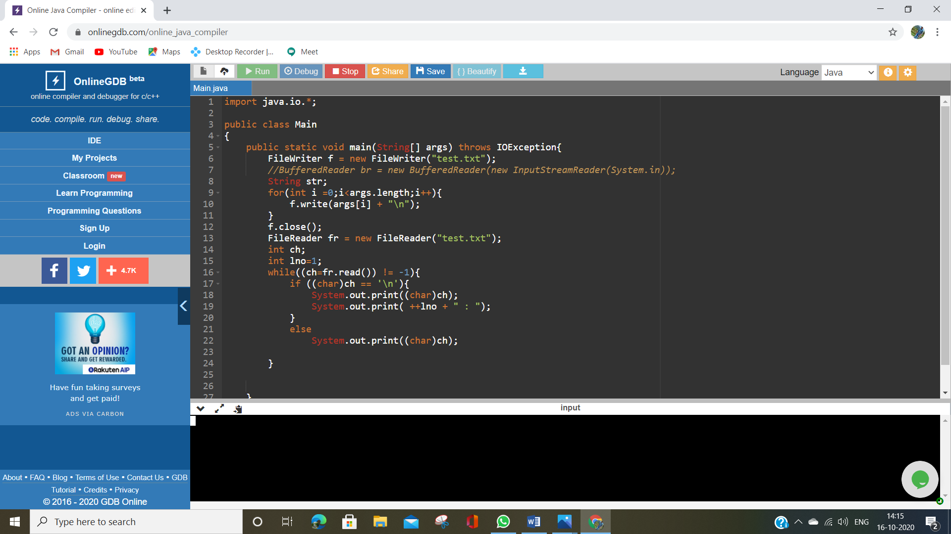

5.Write a Java program that displays the number of characters, lines and words in a text file.

import java.io.*;

public class MyClass {

public static void main(String args[]) throws IOException{

FileWriter fw = new FileWriter("Test.txt");

String str;

for(int i=0; i<args.length; i++)

fw.write(args[i]+"\n");

fw.close();

int cc=0, lc=0, wc=1, allc=0;

FileReader fr = new FileReader("Test.txt");

int ch;

while((ch=fr.read()) !=-1)

{

if (Character .isLetter ((char)ch))

cc++;

else

if ( (char)ch == '\n' )

lc++;

else

if ((char)ch == ' ')

wc++;

allc++;

}

fr.close();

System.out.println("Character Count " + cc + " lines : " + lc + "words = " +wc+ " Total Count "+allc);

}

}

6.Convert the content of a given file into the uppercase content of the same file.

import java.io.*;

public class MyClass {

public static void main(String args[]) throws IOException{

FileWriter fw = new FileWriter("Text.txt");

String str;

for(int i=0; i<args.length; i++)

fw.write(args[i].toUpperCase()+"\n");

int lno=1;

fw.close();

FileReader fr = new FileReader("Text.txt");

int ch;

System.out.println(lno + " : ");

while((ch=fr.read()) !=-1)

{

if((char)ch == '\n')

{

System.out.println((char)ch);

System.out.println(++lno+ " : ");

}

else

System.out.println((char)ch);

}

}

}