“Blood Bank Management System”
A Project Report Submitted in the partial fulfillment of the requirements for the award of the degree of

BACHELOR OF TECHNOLOGY
In
DEPARTMENT OF COMPUTER SCIENCE AND INFORMATION TECHNOLOGY
By

S. AKSHITHA REDDY 2520090178
D. KAVERI 2520090068
G. NAVYA SRI 2520090077

Under the Esteemed Guidance of Khaja shareef Assistant Professor

Department of Computer Science and Information Technology




K L (Deemed to be) University

DEPARTMENT OF COMPUTER SCIENCE AND INFORMATION TECHNOLOGY

Declaration

The Project Report entitled “Blood Bank Management System” is a record of bonafide work of S. AKSHITHA REDDY – 2520090178, D. KAVERI – 2520090068, G. NAVYA SRI – 2520090077 submitted in partial fulfillment of the requirements of the course DATABASE SYSTEMS ENGINEERING AND DISTRIBUTED BACKEND DEVELOPMENT (25CS1302E), Section [12], Team [21], during 2026–2027, Trimester 4, at KLH University. The results embodied in this report have not been copied from any other student, department, or institution.

S. AKSHITHA REDDY – 2520090178
D. KAVERI – 2520090068
G. NAVYA SRI – 2520090077

K L (Deemed to be) University

DEPARTMENT OF COMPUTER SCIENCE AND INFORMATION TECHNOLOGY

CERTIFICATE

This is to certify that the project report entitled “Blood Bank Management System” is a bonafide work done and submitted by S. AKSHITHA REDDY – 2520090178, D. KAVERI – 2520090068, G. NAVYA SRI – 2520090077 in partial fulfillment of the requirements of the course DATABASE SYSTEMS ENGINEERING AND DISTRIBUTED BACKEND DEVELOPMENT (25CS1302E), Section [_12_], Team [21__], at KLH University
during 2026–2027, Trimester 4.

Signature of the Guide

Signature of the Course Coordinator Signature of the HOD

ACKNOWLEDGEMENT
The success in this project would not have been possible but for the timely help and guidance rendered by many people. We wish to express our sincere thanks to all those who have assisted us in one way or the other for the completion of our project.

Our greatest appreciation to our Course Coordinator Dr and our guide Khaja shareef, Department of Computer Science and Information Technology, which cannot be expressed in words, for their tremendous support, encouragement and guidance for this project.

We express our gratitude to Dr. Khaja Shareef, Head of the Department for Computer Science and Information Technology for providing us with adequate facilities, ways and means by which we are able to complete this project-based Lab.

We thank all the members of teaching and non-teaching staff, and all those who have assisted us directly or indirectly in the successful completion of this project. Finally, we sincerely thank our parents, friends and classmates for their kind help and cooperation during our work.

S. AKSHITHA REDDY – 2520090178

D. KAVERI – 2520090068

G. NAVYA SRI – 2520090077

Abstract

The Blood Bank Management System is a computerized application designed to manage blood bank activities in an organized and efficient way. The system maintains important information about blood donors, patients, blood groups, blood stock and blood requests in a centralized database, replacing the notebooks and registers that are still used in many blood banks.
The system allows blood bank staff to add and update donor and patient records, monitor the availability of different blood groups, and manage blood requests. When blood is donated, the available stock is updated, and when blood is requested, the system checks the availability of the required blood group before the request is processed.
The application uses an HTML, CSS and JavaScript frontend, a Node.js and Express.js backend exposing a REST API, and a MySQL relational database. Administrative functions are protected by authentication, and the database enforces data integrity through primary keys, foreign keys and validation constraints. The main purpose of the project is to reduce manual paperwork, save time, maintain accurate records and provide quick access to blood availability information, which is critical in emergencies.

Index
S.No. | Chapters | Topics | Page No.
 |  | Acknowledgement
 |  | Abstract
1 | Introduction | 1.1 Background of the Project  1.2 Problem Statement  1.3 Scope of the Project  1.4 Objectives  1.5 Importance of the Application  1.6 Target Users / Audience | 5
2 | System Requirements | 2.1 Hardware Requirements  2.2 Software Requirements  2.3 Development Tools and Frameworks | 7
3 | Technology Stack | 3.1 Frontend  3.2 Backend  3.3 Database  3.4 Version Control  3.5 Authentication and Security Libraries | 8
4 | System Architecture | 4.1 High-Level Architecture Diagram  4.2 Description of Each Layer  4.3 Deployment Architecture | 9
5 | Design | 5.1 Database Design Principles  5.2 ER Diagram / Database Schema  5.3 Design Decisions and Assumptions | 10
6 | Implementation | 6.1 Module-wise Implementation  6.2 Front-end Logic  6.3 API Integration  6.4 Authentication and Authorization | 12
7 | Features | 7.1 List of Main Features  7.2 How Each Feature Works | 14
8 | Testing | 8.1 Postman API Testing  8.2 Integration Testing  8.3 Tools Used for Testing  8.4 Test Cases and Results | 15
9 | Deployment | 9.1 Steps to Deploy  9.2 Environment Configuration  9.3 Hosting of Frontend and Backend | 16
10 | Challenges & Limitations | 10.1 Issues Faced During Development  10.2 Solutions Applied  10.3 Current Limitations or Known Bugs | 17
11 | Future Enhancements | 11.1 Planned Features  11.2 Possible Integrations or Optimizations | 18
12 | Conclusion | 12.1 Summary of the Project  12.2 What Was Achieved  12.3 Skills Learned | 19
13 | References | Documentation, tools and resources used | 20
14 | Appendices | Appendix A: Sample Code Snippet  Appendix B: Installation and Setup Instructions  Appendix C: API Reference Summary  Appendix D: Database Tables  Appendix E: Screenshots | 21

CHAPTER 1: INTRODUCTION

1.1 Background of the Project
Blood is one of the most important resources in medical care. It is needed during surgeries, accidents, childbirth, cancer treatment and many other emergencies, and it cannot be manufactured artificially; it can only be donated by healthy volunteers. Blood banks therefore have to keep track of who has donated, which patients need blood, how many units of each blood group are available, and which requests are still waiting to be fulfilled.
In many blood banks this information is still recorded in notebooks, registers or loosely maintained files. Searching such records is slow, stock figures are easily outdated, and a small mistake in a blood group or a unit count can delay treatment. The Blood Bank Management System replaces this manual routine with a computerized application that keeps donor, patient, stock and request records in one central database and makes them available to authorized staff within seconds.

1.2 Problem Statement
Manual blood-bank records make donor and patient information difficult to maintain, blood-stock availability difficult to check, and blood requests time-consuming to manage. Staff cannot quickly answer basic questions such as “Do we have enough units of B-negative blood right now?”, “Which donors belong to a particular blood group?” or “What is the status of this patient’s request?”. The project aims to provide a centralized system for storing, updating and retrieving this information accurately and quickly.

1.3 Scope of the Project
The system covers the day-to-day record keeping of a blood bank. It includes the following functions:
    - Donor registration and management.
    - Patient registration and management.
    - Blood-group and blood-stock management.
    - Blood-request management with status tracking.
    - Blood availability search by blood group.
    - Automatic stock updates after a donation or an approved request.
    - Centralized database storage with administrator login.
Payment handling, multi-branch synchronization, laboratory test management and a native mobile application are outside the scope of this submission and are listed under future enhancements.

1.4 Objectives
    - Develop a computerized blood-bank application that is simple enough for non-technical staff.
    - Maintain accurate donor and patient records.
    - Monitor blood stock separately for every blood group.
    - Manage blood requests from the moment they are raised until they are fulfilled or rejected.
    - Reduce paperwork and manual effort.
    - Provide faster retrieval of information.
    - Keep records organized, consistent and up to date.

1.5 Importance of the Application
In emergencies, the time taken to find out whether the required blood group is available can affect a patient’s life. By keeping stock information in a central database, the application removes guesswork and lets staff respond quickly. It also reduces human error, keeps a permanent and searchable record of every donor, patient and request, and supports systematic handling of blood requests.
    - Saves time during record entry and search.
    - Reduces manual work and paperwork.
    - Makes blood-stock information easy to access.
    - Helps maintain organized and permanent records.
    - Supports systematic blood-request management.
    - Provides centralized information to all authorized users.

1.6 Target Users / Audience
    - Blood bank staff – register donors and patients, update stock and process requests.
    - Administrators – manage records and have access to protected operations.
    - Hospital staff – check blood availability and raise requests.
    - Authorized donor users – view and maintain their own donor details.
    - Authorized patient / request users – raise and track blood requests.

CHAPTER 2: SYSTEM REQUIREMENTS

2.1 Hardware Requirements
The application is lightweight because the Node.js backend and the database handle only a small volume of records. The following minimum hardware is sufficient to run the complete stack – frontend, backend and database – on a single computer.
Table 2.1: Hardware requirements
Component | Minimum Requirement
Processor | Dual-Core processor or higher
Memory (RAM) | 4 GB or higher
Storage | At least 500 MB of free disk space
Input / Output | Keyboard, mouse and monitor
Network | Network connection, if the system is accessed from other computers

2.2 Software Requirements
Table 2.2: Software requirements
Software | Purpose
Windows or Linux | Operating system
Node.js and npm | Runs the backend server and installs packages
MySQL | Relational database for all records
Visual Studio Code | Code editor / development environment
Chrome / Edge browser | Opens and tests the web application
Git (if required) | Version control of the source code

2.3 Development Tools and Frameworks
The frontend is written with HTML, CSS and JavaScript. The backend is a REST API built with Node.js and the Express.js framework. MySQL stores the data and is accessed through the mysql2 driver. Postman is used to test the API endpoints, Git is used for version control, and Visual Studio Code is the main development environment.

CHAPTER 3: TECHNOLOGY STACK

3.1 Frontend
The frontend provides forms and pages for donor registration, patient registration, blood-stock viewing and blood requests. It is built with HTML for the structure of the pages, CSS for layout and styling, and JavaScript for form validation and for communicating with the backend through HTTP requests. Because no heavy framework is used, the pages load quickly and the code remains easy to read and modify.

3.2 Backend
Node.js runs the server and Express.js handles API requests and application logic. The backend is organized into routes, controllers and database access code. Routes define the URLs, controllers validate the input and apply the rules (for example, checking stock before approving a request), and the database layer runs the SQL queries.

3.3 Database
MySQL is used as the relational database. It stores donor records, patient records, blood groups, blood stock and blood requests in separate related tables. Primary keys give every record a unique identity, and constraints such as NOT NULL and CHECK (for example, units cannot be negative) protect the quality of the data.

3.4 Version Control
Git is used to track project changes and maintain versions of the source code, so that earlier versions can be recovered and team members can work on different modules without overwriting each other’s work.

3.5 Authentication and Security Libraries
Authentication restricts administrative functions to authorized users. Passwords are hashed using the bcrypt library before being stored, so plain-text passwords are never saved in the database. After a successful login, the server issues a JSON Web Token (jsonwebtoken library) that must accompany every protected request. Database credentials are kept in an environment file and not in the source code.

CHAPTER 4: SYSTEM ARCHITECTURE

4.1 High-Level Architecture Diagram
The system follows a three-tier architecture that separates the user interface, the application logic and the stored data. Figure 4.1 shows the three layers and the direction in which a request flows.
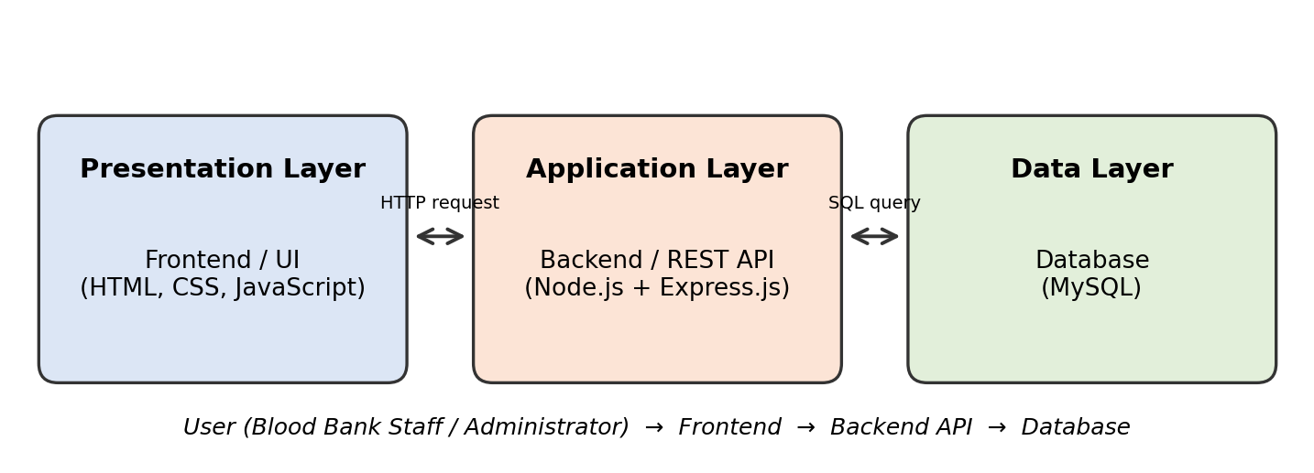
Figure 4.1: High-level architecture of the Blood Bank Management System

4.2 Description of Each Layer
Table 4.1: Layers of the architecture
Layer | Description
Presentation Layer | The web interface through which staff enter donor, patient and request details and view blood stock. It never accesses the database directly; it only calls the REST API.
Application Layer | The Node.js / Express.js API. It authenticates users, validates input and applies the business rules for donors, patients, stock and requests.
Data Layer | The MySQL database that stores all records permanently and enforces data integrity through keys and constraints.

4.3 Deployment Architecture
For development and demonstration, the frontend, backend and database run on the same computer. The browser loads the frontend pages, the pages send requests to the Node.js + Express server, and the server reads from or writes to the MySQL database. The same arrangement can later be split across separate machines or hosted online without changing the structure of the application.

CHAPTER 5: DESIGN

5.1 Database Design Principles
The database is organized into separate tables so that information is stored clearly and unnecessary duplication is reduced. Each table describes one kind of real-world object (donor, patient, blood stock, request) and has a primary key that identifies each row uniquely. Blood group is the common attribute that connects donors, patients and requests to the stock table, which allows the system to compare what is requested with what is available.

5.2 ER Diagram / Database Schema
The database consists of four tables, shown in Figure 5.1. The detailed fields of each table are listed in Table 5.1.
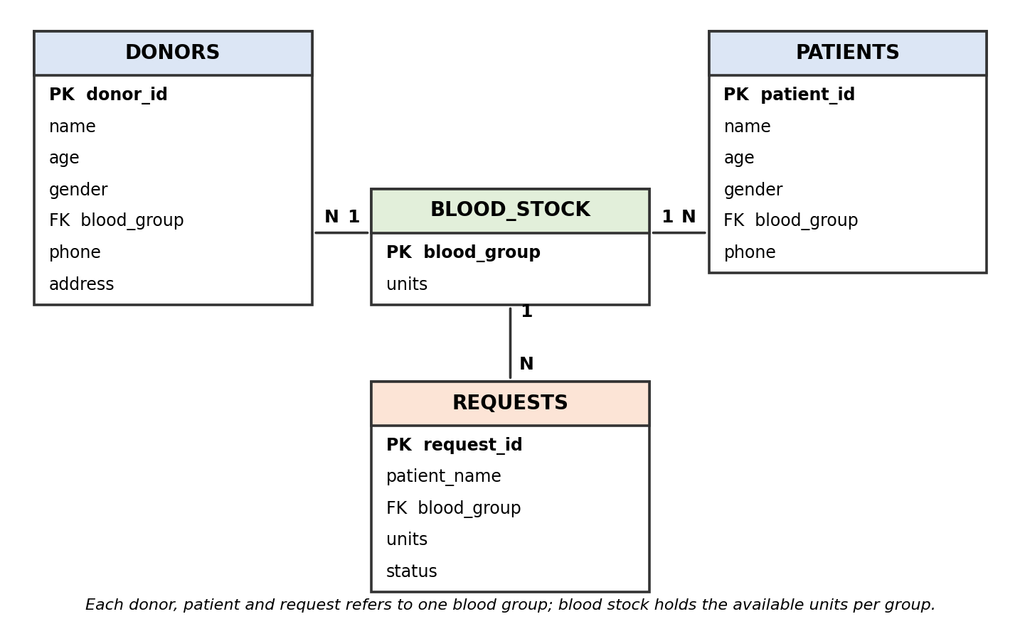
Figure 5.1: Entity-relationship diagram of the Blood Bank database
Table 5.1: Database schema
Table | Fields
Donors | ID, Name, Age, Gender, Blood Group, Phone, Address
Patients | ID, Name, Age, Gender, Blood Group, Phone
Blood Stock | Blood Group, Units
Requests | ID, Patient Name, Blood Group, Units, Status

5.3 Design Decisions and Assumptions
    - Each donor and patient has a unique ID generated automatically by the database.
    - Blood stock is maintained by blood group, with one row for each of the eight groups (A+, A-, B+, B-, AB+, AB-, O+, O-).
    - A request contains a blood group and the number of units required.
    - Stock is increased after a donation and decreased only after a request is approved and fulfilled.
    - A request with a status such as Pending, Approved or Rejected allows the progress of every request to be tracked.
    - The number of units in stock can never become negative.

CHAPTER 6: IMPLEMENTATION

6.1 Module-wise Implementation
The application is divided into five modules. Each module has its own routes, controller logic and database queries, which keeps the code organized and makes each part easy to test separately.
Table 6.1: Modules of the system
Module | Responsibility
Donor Module | Registers new donors, stores their details and lists existing donors.
Patient Module | Registers patients and lists patient records.
Blood Stock Module | Maintains the available units for each blood group and updates them after donations and approved requests.
Blood Request Module | Creates requests, checks availability of the required group and updates the request status.
Admin Module | Handles administrator login and protects management operations.

6.2 Front-end Logic
The frontend consists of simple pages, each connected to one backend resource:
    - Donor form – collects donor details and sends them to the server.
    - Patient form – collects patient details.
    - Blood-stock page – shows the available units of every blood group.
    - Blood-request form – lets the user enter the patient, blood group and units needed.
    - Request-status page – shows whether each request is pending, approved or rejected.
JavaScript validates the fields before they are sent (for example, age must be a number and the blood group must be one of the valid groups), and then uses the Fetch API to call the backend and display the response on the page.

6.3 API Integration
All communication between the frontend and the backend takes place through REST endpoints that exchange data in JSON format. Table 6.2 lists the endpoints.
Table 6.2: REST API endpoints
Method | Endpoint | Purpose
GET | /donors | Retrieve all donor records
POST | /donors | Add a new donor
GET | /patients | Retrieve all patient records
POST | /patients | Add a new patient
GET | /stock | View blood stock by blood group
GET | /requests | Retrieve all blood requests
POST | /requests | Create a new blood request

6.4 Authentication and Authorization
Authentication verifies the identity of a user before protected operations are allowed. An administrator logs in with a username and password; the password is compared with the stored bcrypt hash, and on success a signed token is returned. Authorization then checks this token on every protected route, so that only authorized administrators can manage records, stock and requests.

CHAPTER 7: FEATURES

7.1 List of Main Features
    - Donor registration
    - Patient registration
    - Blood-group management
    - Blood-stock management
    - Blood availability search
    - Blood-request management
    - Request status tracking
    - Centralized database storage
    - Administrator login and management

7.2 How Each Feature Works
Table 7.1: Working of the main features
Feature | How It Works
Donor Registration | Staff enters the donor’s information and saves it; the record is stored in the Donors table and can be viewed later.
Blood Stock | The system displays the available units for each blood group.
Blood Availability Search | The user selects a blood group and the system shows how many units are available.
Blood Request | The user enters patient details, the required blood group and the number of units; a request is created with the status Pending.
Stock Update | Donated blood increases the stock, and fulfilled requests decrease the available stock.
Request Status Tracking | Every request carries a status so that staff and users can see whether it is pending, approved or rejected.

CHAPTER 8: TESTING

8.1 Postman API Testing
Every REST endpoint was tested with Postman. For each endpoint, requests were sent with valid data, with missing fields and with invalid values, and the status codes and JSON responses were compared with the expected behaviour. Postman also served as living documentation of the API, because each saved request shows the URL, method and sample body.

8.2 Integration Testing
Each module was first tested separately, and then the complete application was tested together – frontend, backend and database – to verify that records are stored correctly, stock updates follow donations and approved requests, and requests for unavailable blood are handled properly.

8.3 Tools Used for Testing
    - Web browser – testing the pages and forms.
    - Postman – testing the API endpoints.
    - Visual Studio Code – inspecting code and console output.
    - Database tools – checking table contents directly.
    - Manual testing – walking through complete user scenarios.

8.4 Test Cases and Results
Table 8.1 lists the main test cases used and the result expected from each.
Table 8.1: Test cases
# | Test Case | Expected Result
1 | Add donor | Donor record stored
2 | Add patient | Patient record stored
3 | View stock | Stock displayed
4 | Add request | Request created
5 | Request available blood | Request processed
6 | Request unavailable blood | Insufficient stock shown
7 | Update stock | Correct quantity displayed

CHAPTER 9: DEPLOYMENT

9.1 Steps to Deploy
The application can be deployed on any computer that has Node.js and MySQL installed. The steps are:
    - Install Node.js.
    - Install the project packages with npm install.
    - Configure the database (create the database and tables).
    - Start the backend server.
    - Start the frontend.
    - Open the application in a browser.

9.2 Environment Configuration
Database connection details and server settings are kept in a single environment file (.env) and are set according to the development environment. This file contains the database host, user, password and database name, the port on which the server listens, and the secret used to sign login tokens. It is never committed to version control.

9.3 Hosting of Frontend and Backend
For this submission the system runs locally for development and demonstration. It can later be deployed to a suitable hosting environment, with the frontend served as static files, the Node.js backend running on a server or cloud platform, and the database hosted on a managed MySQL service.

CHAPTER 10: CHALLENGES & LIMITATIONS

10.1 Issues Faced During Development
    - Managing different blood groups consistently across donors, patients, requests and stock.
    - Keeping the stock figures updated after every donation and request.
    - Maintaining accurate records and avoiding duplicate or invalid entries.
    - Handling multiple requests for the same blood group.
    - Connecting the frontend, the backend and the database correctly.

10.2 Solutions Applied
    - A centralized database so that every module reads the same data.
    - Separate modules for donors, patients, stock and requests.
    - Input validation on both the frontend and the backend.
    - Stock updates performed together with the donation or approval, so the figures stay correct.
    - API-based communication between the frontend and the backend.

10.3 Current Limitations or Known Bugs
    - No automatic SMS or email notifications.
    - No automatic donor reminders.
    - No integration with hospital systems.
    - Reporting is limited.
    - Some records may require manual verification.

CHAPTER 11: FUTURE ENHANCEMENTS

11.1 Planned Features
    - SMS / email notifications.
    - Donor reminders for the next eligible donation date.
    - Low-stock alerts.
    - Blood expiry monitoring.
    - Hospital integration.
    - Mobile application.
    - Advanced reports.
    - Blood compatibility checking.
    - Cloud deployment.

11.2 Possible Integrations or Optimizations
    - Hospital database integration.
    - Notification services.
    - Cloud database.
    - Mobile application.
    - Dashboard and reporting.

CHAPTER 12: CONCLUSION

12.1 Summary of the Project
The Blood Bank Management System provides a computerized way to manage donor information, patient information, blood stock and blood requests. It replaces manual registers with an organized, database-based approach and gives staff quick access to the information they need, especially the availability of each blood group.

12.2 What Was Achieved
    - Donor management.
    - Patient management.
    - Blood-stock management.
    - Blood-request management.
    - Blood availability checking.
    - Centralized record storage.

12.3 Skills Learned
    - Database design and management.
    - Frontend development.
    - Backend development.
    - REST API creation.
    - CRUD operations.
    - Database connectivity.
    - Testing and debugging.
    - Project documentation.

CHAPTER 13: REFERENCES
    - Node.js – Official Documentation, https://nodejs.org/en/docs
    - Express.js – Official Documentation, https://expressjs.com
    - MySQL 8.0 Reference Manual, https://dev.mysql.com/doc/refman/8.0/en/
    - mysql2 (Node.js MySQL driver) – npm documentation, https://www.npmjs.com/package/mysql2
    - jsonwebtoken – npm documentation, https://www.npmjs.com/package/jsonwebtoken
    - bcrypt – npm documentation, https://www.npmjs.com/package/bcrypt
    - Postman Learning Center, https://learning.postman.com
    - MDN Web Docs – HTML, CSS, JavaScript and Web APIs, https://developer.mozilla.org

CHAPTER 14: APPENDICES

Appendix A: Sample Code Snippet
The SQL statements that create the Blood Stock and Requests tables, and the query that reduces stock when a request is approved:
CREATE TABLE blood_stock (
blood_group VARCHAR(3) PRIMARY KEY,
units INT NOT NULL CHECK (units >= 0)
);

CREATE TABLE requests (
request_id INT AUTO_INCREMENT PRIMARY KEY,
patient_name VARCHAR(100) NOT NULL,
blood_group VARCHAR(3) NOT NULL,
units INT NOT NULL CHECK (units > 0),
status VARCHAR(20) DEFAULT 'Pending',
FOREIGN KEY (blood_group) REFERENCES blood_stock(blood_group)
);

-- reduce stock when a request is approved
UPDATE blood_stock
SET units = units - ?
WHERE blood_group = ? AND units >= ?;

Appendix B: Installation and Setup Instructions
    - Install Node.js and MySQL.
    - Create the database and tables using the SQL script.
    - Open the server folder and run: npm install
    - Create the .env file with the database details.
    - Start the backend: npm start
    - Open the frontend pages in a browser.

Appendix C: API Reference Summary
Table 14.1: API summary
Resource | Endpoints
Donors | GET /donors, POST /donors
Patients | GET /patients, POST /patients
Blood Stock | GET /stock
Requests | GET /requests, POST /requests

Appendix D: Database Tables
Table 14.2: Database tables
Table | Description
Donor table | Stores ID, name, age, gender, blood group, phone and address of each donor.
Patient table | Stores ID, name, age, gender, blood group and phone of each patient.
Blood stock table | Stores the number of units available for each blood group.
Request table | Stores ID, patient name, blood group, units required and status of each request.

Appendix E: Screenshots
Insert the screenshots of the running application in the frames below.
    - Login Page
[ Insert scree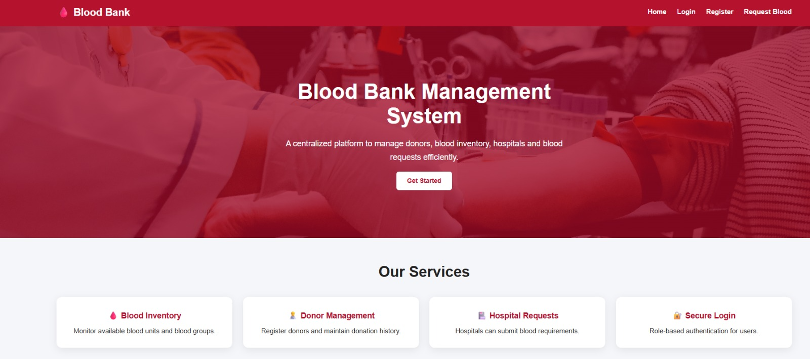nshot of Login Page here ]

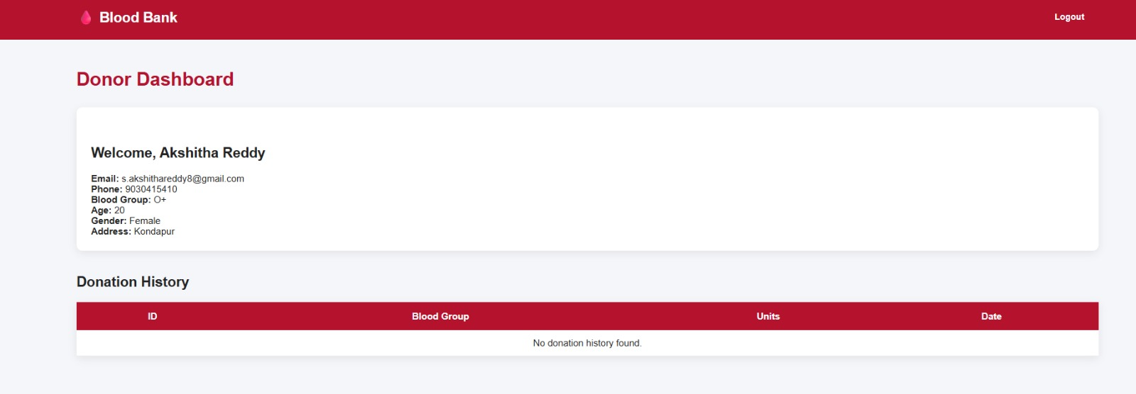
    - Dashboard
[ Insert screenshot of Dashboard here ]

    - Donor Registration
[ Insert scre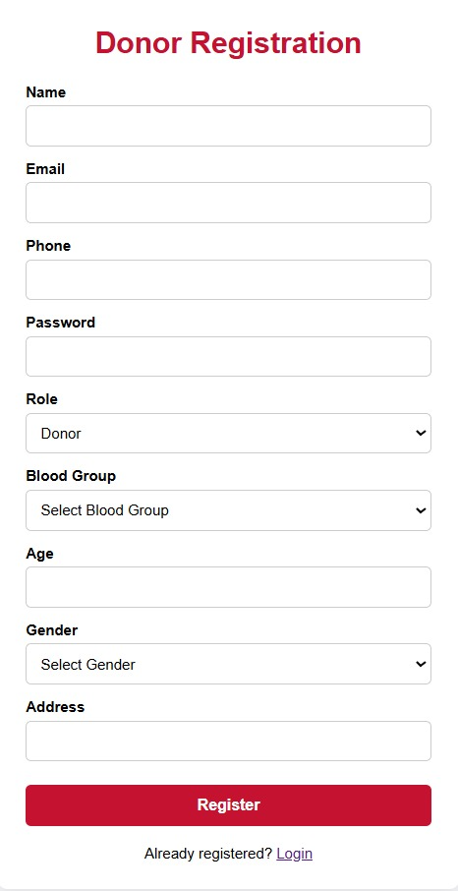enshot of Donor Registration here ]

    - Blood Bank
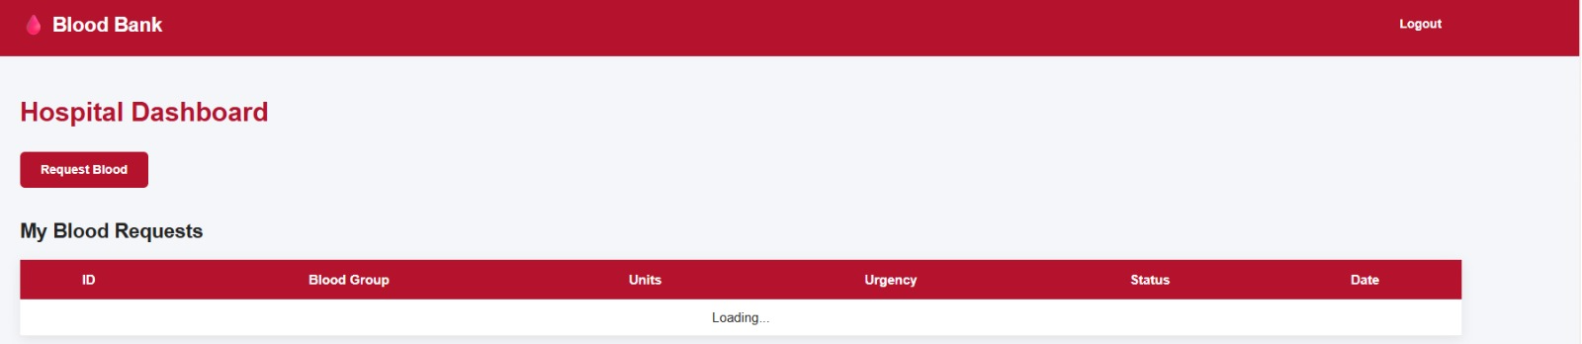[ Insert screenshot of Blood Stock here ]

    - Blood Request
[ Insert screensho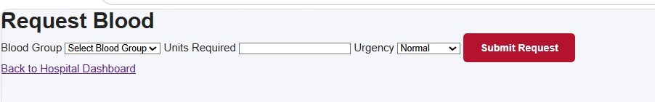t of Blood Request here ]

