“Shared Memory Based Data Exchange System”
A Project Report Submitted in the partial fulfillment of the requirements for the award of the degree of

BACHELOR OF TECHNOLOGY
In

DEPARTMENT OF COMPUTER SCIENCE ENGINEERING

By

[STUDENT NAME 1] [ROLL NO. 1]

[STUDENT NAME 2] [ROLL NO. 2]

Under the Esteemed Guidance of

[Guide Name]
Assistant Professor
Department of Computer Science and Information Technology




K L (Deemed to be) University DEPARTMENT OF COMPUTER SCIENCE ENGINEERING
&

DEPARTMENT OF COMPUTER SCIENCE AND INFORMATION TECHNOLOGY

Declaration

The Project Report entitled “Shared Memory Based Data Exchange System” is a record of Bonafide work of [STUDENT NAME 1] - [ROLL NO. 1], [STUDENT NAME 2] - [ROLL NO. 2], submitted in partial fulfillment for the award of B. Tech in Computer Science and Engineering (or) Computer Science and Information Technology to the K L University. The results embodied in this report have not been copied from any other departments/University/Institute.

[STUDENT NAME 1]-[ROLL NO. 1]

[STUDENT NAME 2]-[ROLL NO. 2]

K L (Deemed to be) University

DEPARTMENT OF COMPUTER SCIENCE ENGINEERING

CERTIFICATE

This is to certify that the mini project based report entitled “Shared Memory Based Data Exchange System” is a bonafide work done and submitted by [STUDENT NAME 1] - [ROLL NO. 1], [STUDENT NAME 2] - [ROLL NO. 2], in partial fulfillment of the requirements for the award of the degree of BACHELOR OF TECHNOLOGY in Department of Computer Science Engineering, K L (Deemed to be University), during the academic year [ACADEMIC YEAR].

Signature of the Guide

Signature of the Course Coordinator Signature of the HOD

ACKNOWLEDGEMENT
The success in this project would not have been possible but for the timely help and guidance rendered by many people. Our wish to express my sincere thanks to all those who has assisted us in one way or the other for the completion of my project.

Our greatest appreciation to my Course Coordinator [Course Coordinator Name], and my guide [Guide Name], Department of Computer Science which cannot be expressed in words for his/her tremendous support, encouragement and guidance for this project.

We express our gratitude to [HOD Name], Head of the Department for Computer Science Engineering for providing us with adequate facilities, ways and means by which we are able to complete this project-based Lab.

We thank all the members of teaching and non-teaching staff members, and also who have assisted me directly or indirectly for successful completion of this project. Finally, I sincerely thank my parents, friends and classmates for their kind help and cooperation during my work.

[STUDENT NAME 1]-[ROLL NO. 1]

[STUDENT NAME 2]-[ROLL NO. 2]

Abstract

The Shared Memory Based Data Exchange System is an operating systems project that allows multiple independent processes to exchange data quickly and safely through a common region of memory. In Linux, every process has its own private address space, so processes normally communicate through pipes, sockets or message queues. These mechanisms copy data between user space and the kernel, which adds overhead. Shared memory removes this copying by mapping one memory segment into the address space of several processes, but it also removes the protection that the operating system normally provides. When many processes read and write the same memory at the same time, race conditions can lose, duplicate or corrupt data. To address this problem, our project implements a shared-memory exchange mechanism that keeps data consistent using standard synchronization primitives.
The system is developed using C programming, POSIX shared memory and Linux system calls. A parent process creates the shared memory segment with shm_open(), ftruncate() and mmap(), and then creates several producer and consumer processes using fork(). The segment holds a bounded ring buffer of fixed-size messages. A process-shared robust mutex protects the head and tail positions of the buffer, while two counting semaphores, empty and full, make producers wait when the buffer is full and consumers wait when it is empty.
Every message carries a sequence number and a checksum, so a consumer can detect corrupted data. The parent also maintains a receive table that records how many times each message from each producer was received. After all the processes finish, the parent checks this table and reports the number of lost messages, duplicated messages and checksum failures. A command-line option can disable the mutex to demonstrate what happens without synchronization.
In our tests with up to eight producers, six consumers and 160,000 messages, the synchronized system delivered every message exactly once with no checksum errors. Without the mutex, the same program lost and duplicated tens of thousands of messages. This project demonstrates important operating system concepts, including inter-process communication, shared memory, process creation, semaphores, mutual exclusion, the producer-consumer problem and resource cleanup. It is intended for educational and demonstration purposes and provides a foundation for more advanced IPC systems.

Index

S. No. | Chapter | Topics / Subtopics | Page No.
 | Acknowledgement |  | i
 | Abstract |  | ii
1 | Introduction |  | 7
 |  | 1.1 Background of the Project
 |  | 1.2 Problem Statement
 |  | 1.3 Objectives of the Project
2 | OS Concepts and Background Study |  | 8
 |  | 2.1 Operating System Concepts Related to the Project
3 | Technologies Used |  | 9
4 | System Architecture and Design |  | 10–11
 |  | 4.1 Shared Memory Segment
 |  | 4.2 Producer Processes
 |  | 4.3 Consumer Processes
 |  | 4.4 Working Methodology
 |  | 4.5 Implementation Modules
5 | Testing and Validation |  | 12–13
 |  | 5.1 Screenshots of Test Execution
6 | Results |  | 14
7 | Limitations |  | 15
8 | Future Enhancements |  | 16
9 | Team Contributions |  | 17
10 | Conclusion |  | 18

CHAPTER -1 INTRODUCTION
1.1 Background of the Project
Processes in Linux run in separate address spaces, so they cannot directly read or write each other's memory. When processes must cooperate, the operating system provides inter-process communication (IPC) mechanisms such as pipes, message queues, sockets and shared memory. Shared memory is the fastest of these because the processes access the same physical memory directly, without copying data through the kernel for every message. However, the operating system does not coordinate access to shared memory, so the programmer must provide synchronization.
This project builds a data exchange system on POSIX shared memory. A parent process creates the shared segment and starts several producer and consumer processes. Producers place messages in a bounded ring buffer and consumers remove them. A mutex and semaphores control access, and the system verifies after every run that each message was delivered exactly once.
1.2 Problem Statement
To design and implement a Linux application in which multiple processes exchange data through shared memory while maintaining data consistency, so that no message is lost, duplicated or corrupted even when many processes access the shared region at the same time.
1.3 Objectives of the Project
- Create a shared memory segment that can be accessed by multiple processes.
- Support several producer and consumer processes running at the same time.
- Prevent race conditions using a mutex and semaphores.
- Handle full and empty buffer conditions without losing data.
- Detect corrupted messages using a checksum.
- Verify that every message is delivered exactly once.
- Demonstrate operating-system IPC and synchronization concepts.

CHAPTER -2 OS CONCEPTS AND BACKGROUND STUDY
2.1 Operating System Concepts Related to the Project
- Shared memory: shm_open() and mmap() map one memory region into the address space of several processes.
- Process creation: fork() creates the producer and consumer processes, and waitpid() lets the parent wait for them.
- Semaphores: sem_wait() and sem_post() block a process when the buffer is full or empty.
- Mutual exclusion: a process-shared mutex lets only one process update the buffer indices at a time.
- Producer-consumer problem: a bounded ring buffer lets producers and consumers work at different speeds.
- Resource cleanup: shm_unlink() removes the segment, and a robust mutex recovers if a process dies while holding the lock.

CHAPTER -3 TECHNOLOGIES USED
- Programming language: C
- IPC mechanism: POSIX shared memory (shm_open, mmap)
- Synchronization: POSIX semaphores and pthread robust mutex
- Operating system: Ubuntu Linux / Ubuntu on WSL
- Compiler: GCC with Make
- Development environment: Visual Studio Code
- Version control: Git and GitHub

CHAPTER -4 SYSTEM ARCHITECTURE AND DESIGN
The system consists of three main components, which are coordinated by a parent process.
4.1 Shared Memory Segment
The shared memory segment is created by the parent process and mapped by every worker. It contains the process-shared mutex, the empty and full semaphores, the head and tail indices of the ring buffer, an array of fixed-size messages, the counters used for verification, and a receive table that records every (producer, sequence number) pair that arrives.
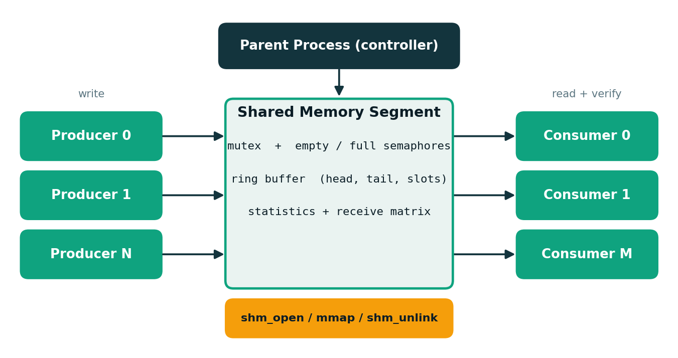
Figure 4.1: System architecture
4.2 Producer Processes
Each producer builds a message containing its producer id, a sequence number, a text payload and an FNV-1a checksum. It waits on the empty semaphore for a free slot, locks the mutex, copies the message into the slot at the head index, advances the head, unlocks the mutex and signals the full semaphore.
4.3 Consumer Processes
Each consumer waits on the full semaphore for a filled slot, locks the mutex, copies the message from the slot at the tail index, advances the tail, unlocks the mutex and signals the empty semaphore. It then verifies the checksum and records the message in the receive table. A special poison message tells the consumer to stop.
4.4 Working Methodology
- The parent process creates the shared memory segment using shm_open(), ftruncate() and mmap().
- The parent initializes the mutex and the empty and full semaphores.
- The parent creates the consumer processes and then the producer processes using fork().
- Each producer waits for a free slot, writes a checksummed message and signals the consumers.
- Each consumer waits for a filled slot, reads the message and signals the producers.
- Consumers verify the checksum and record each received message in the receive table.
- After all producers finish, the parent sends one poison message for each consumer.
- The parent waits for the consumers and checks for lost, duplicated and corrupted messages.
- The parent prints the result (PASS or FAIL) and removes the segment with shm_unlink().
4.5 Implementation Modules
- Shared memory manager (create, map, initialize, unlink)
- Producer processes
- Consumer processes
- Synchronization (mutex and semaphores)
- Verification and reporting

CHAPTER -5 TESTING AND VALIDATION
The following tests were performed to evaluate the system.
Test | Expected result
Build and start | The program compiles without warnings and the shared segment is created
Default run (4 producers, 3 consumers) | All 20,000 messages are delivered with no loss or duplication
Stress run (8 producers, 6 consumers) | All 160,000 messages are delivered; result is PASS
Single-slot buffer | Processes block and resume correctly; no message is lost
Unsafe mode (no mutex) | Inconsistency is detected (lost and duplicated messages)
Shutdown and cleanup | Consumers exit and the shared segment is removed

5.1 Screenshots of Test Execution
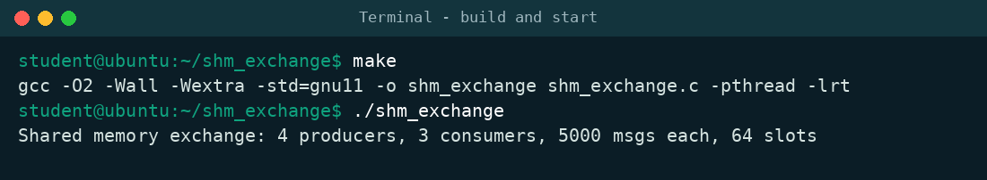
Figure 5.1: Build and start: the program compiles and the shared segment is created
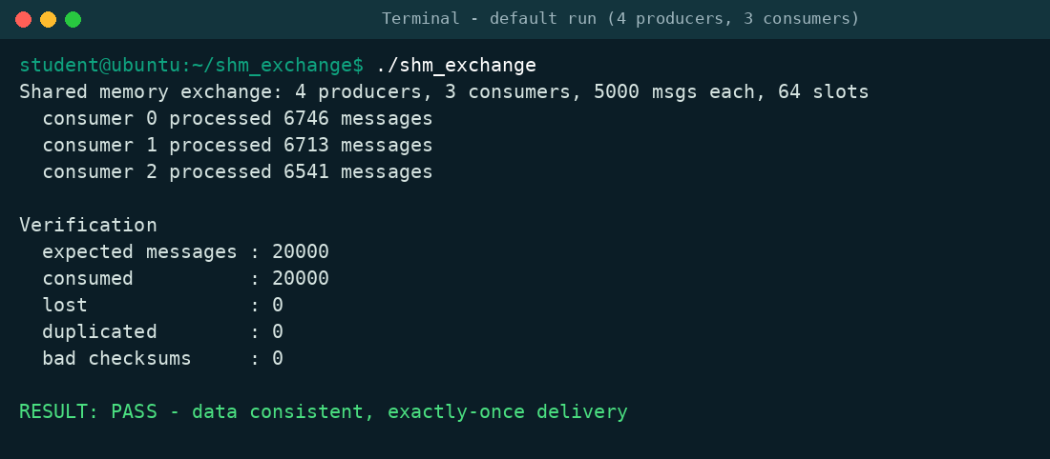
Figure 5.2: Default run: all 20,000 messages are delivered exactly once
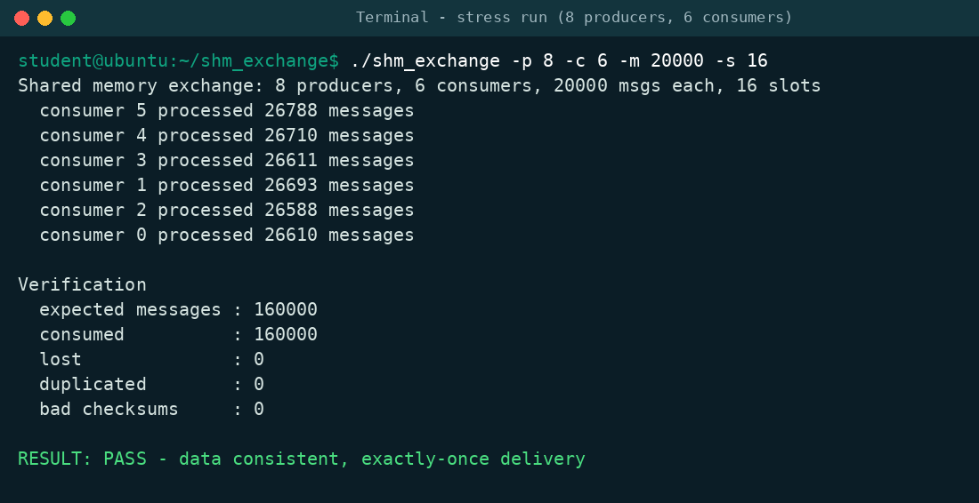
Figure 5.3: Stress run: 160,000 messages with 8 producers and 6 consumers
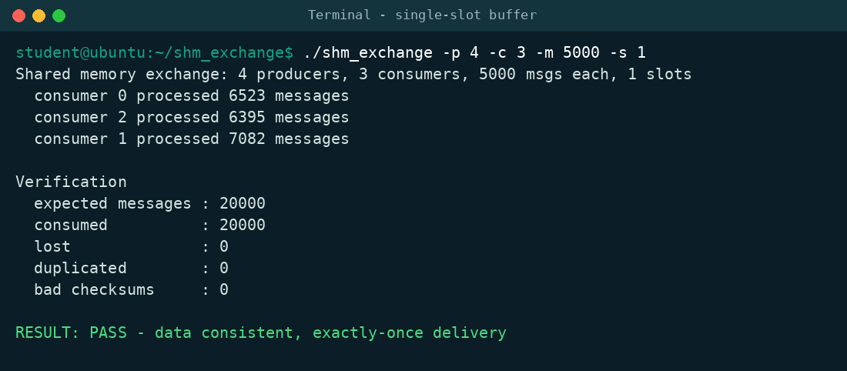
Figure 5.4: Single-slot buffer: processes block and resume without losing messages
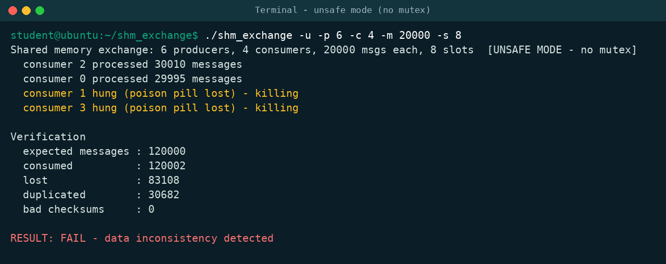
Figure 5.5: Unsafe mode: removing the mutex causes lost and duplicated messages

CHAPTER -6 RESULTS
The system delivered every message exactly once in all synchronized runs, including a stress run with 8 producers, 6 consumers and 160,000 messages and a run with a buffer of only one slot. No checksum errors were found. In unsafe mode, where the mutex was removed, a run of 120,000 messages lost 83,108 messages and duplicated 30,682, and consumers hung because a stop message was overwritten. This shows that synchronization is essential. The exact numbers in unsafe mode vary from run to run because they depend on process scheduling. After every run the program exits with code 0 for PASS or 1 for FAIL, and the shared memory segment is removed.
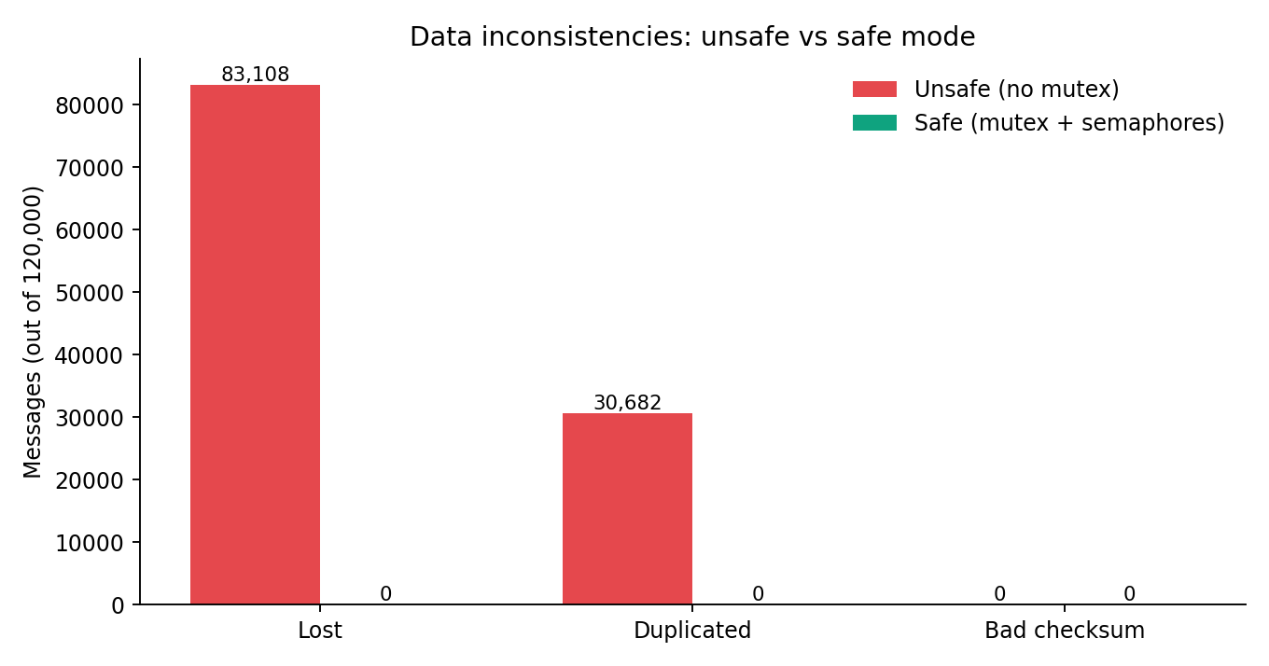
Figure 6.1: Data inconsistencies in unsafe mode compared with safe mode
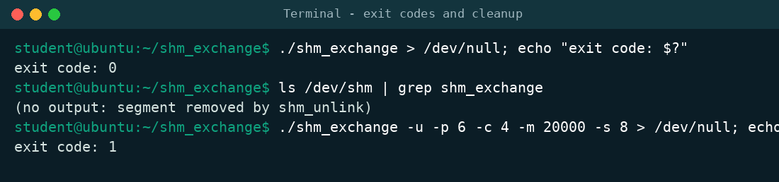
Figure 6.2: Exit codes and cleanup of the shared memory segment

CHAPTER -7 LIMITATIONS
- The system works only between processes running on the same machine.
- Messages have a fixed size, so large or variable-size data is not supported.
- The ring buffer uses a single lock, which can limit performance with very many processes.
- The project is a demonstration system and not a production-grade messaging service.

CHAPTER -8 FUTURE ENHANCEMENTS
- Use a lock-free ring buffer to reduce contention.
- Support variable-size messages and multiple channels.
- Add a graphical dashboard to show buffer usage and throughput.
- Measure and compare performance with pipes, message queues and sockets.
- Add message priorities and message types.
- Add configuration files and additional automated tests.

CHAPTER -9 TEAM CONTRIBUTIONS
- Team Member 1: Shared memory design, ring buffer, and synchronization with mutex and semaphores.
- Team Member 2: Producer and consumer processes, verification logic, testing, documentation, and presentation.

CHAPTER -10 CONCLUSION
The Shared Memory Based Data Exchange System demonstrates how multiple processes can exchange data quickly through shared memory while keeping the data consistent. By combining a bounded ring buffer with a process-shared mutex, counting semaphores and message checksums, the project achieves exactly-once delivery, and the verification step shows that removing synchronization immediately causes lost and duplicated data. The project provides a practical demonstration of inter-process communication, process creation, synchronization and resource cleanup.

