Skill Week-12
Session-23
Task 1: To Execute Large Pipelines, Launch Multiple Jobs, Measure Stability, Monitor Resources, Detect Failures, Analyze Performance.
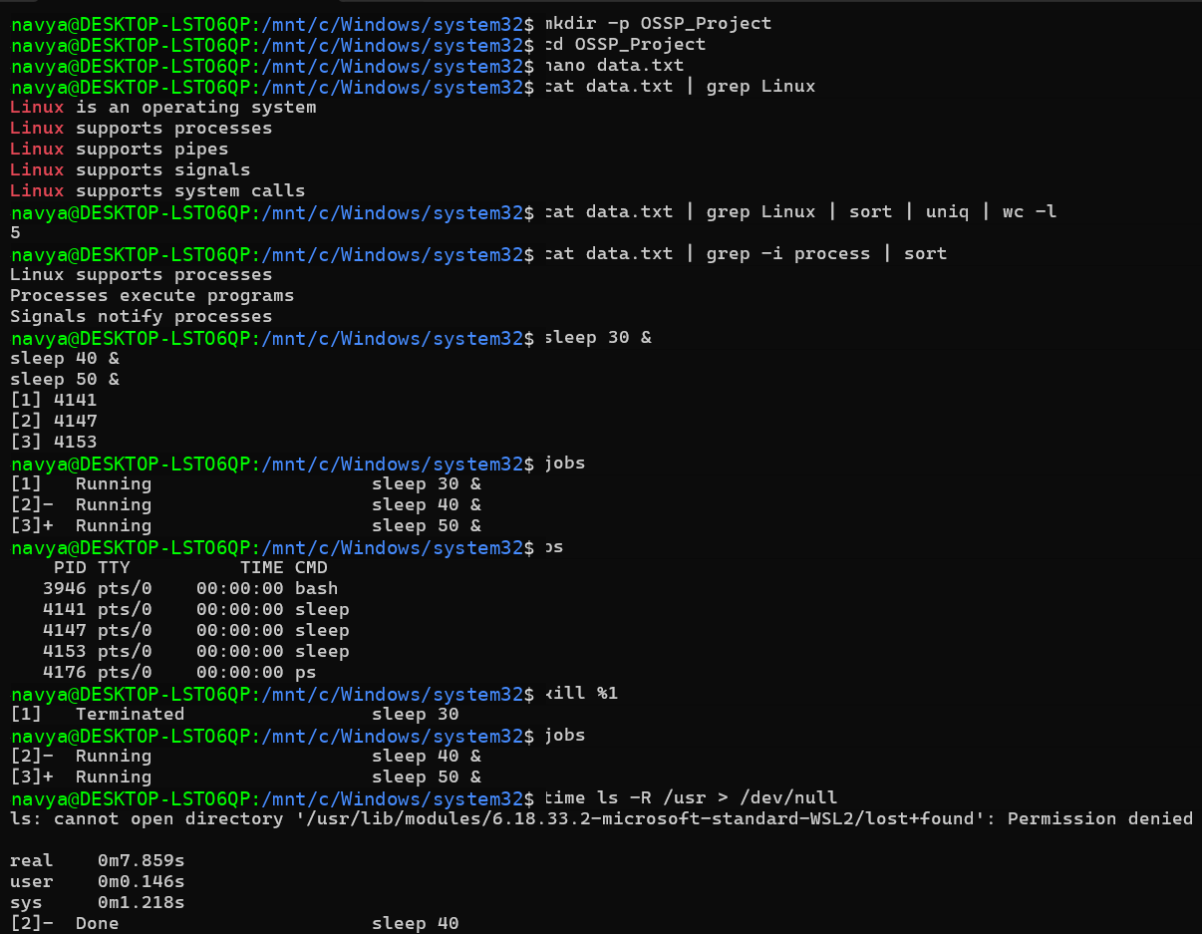
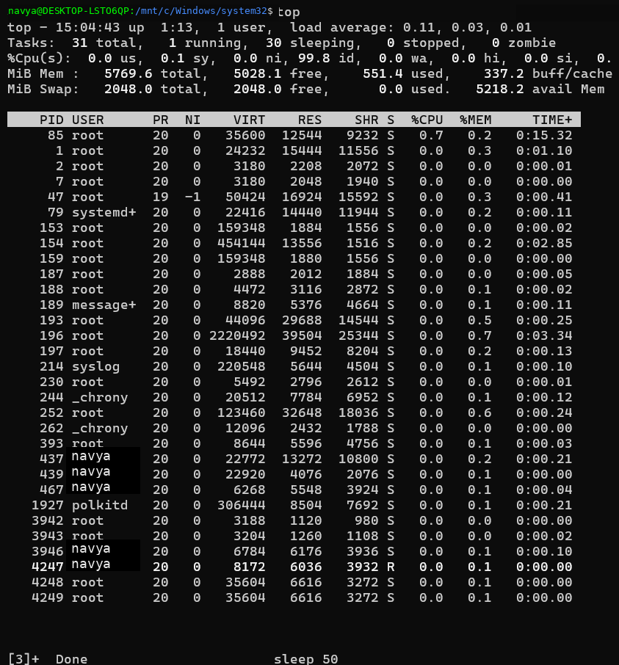
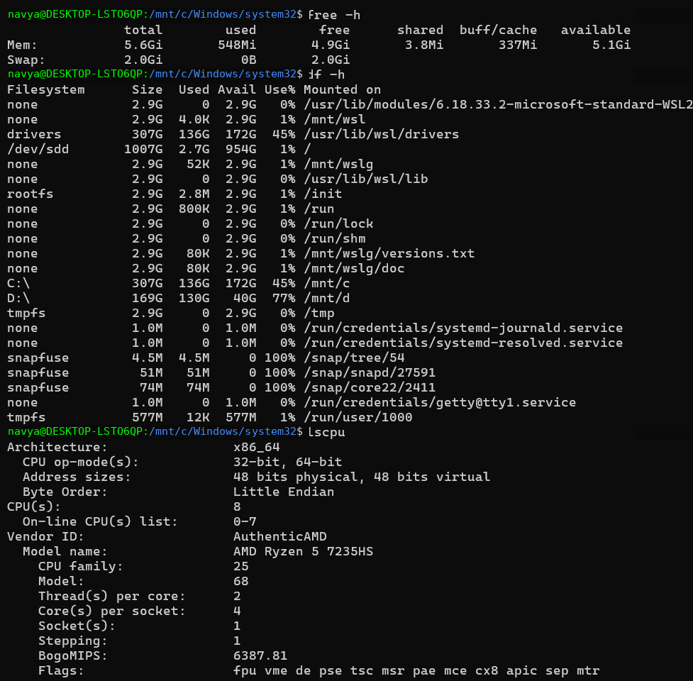
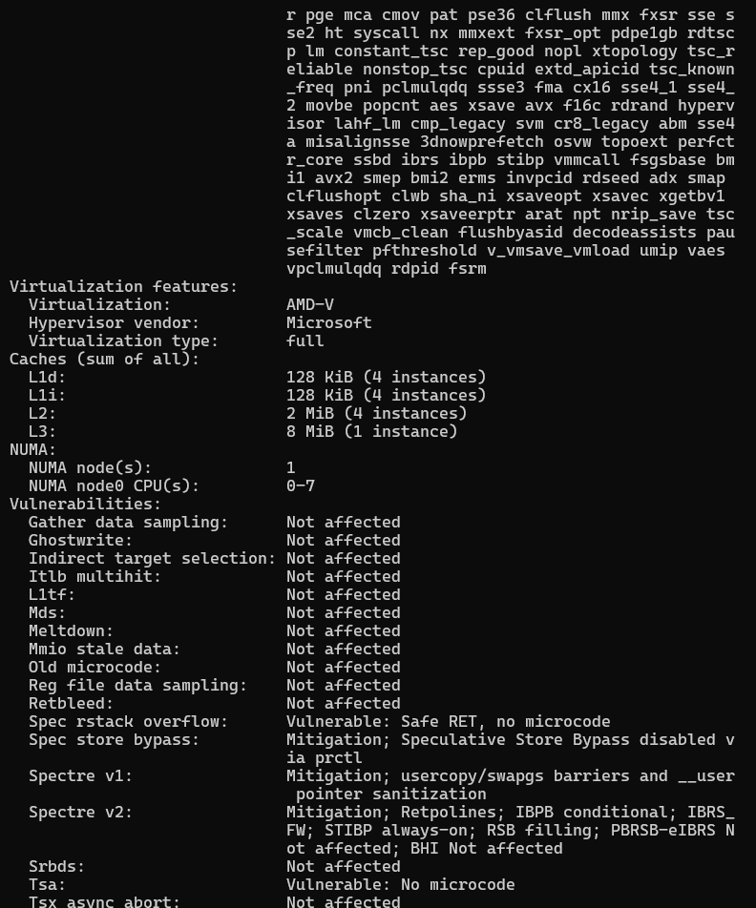
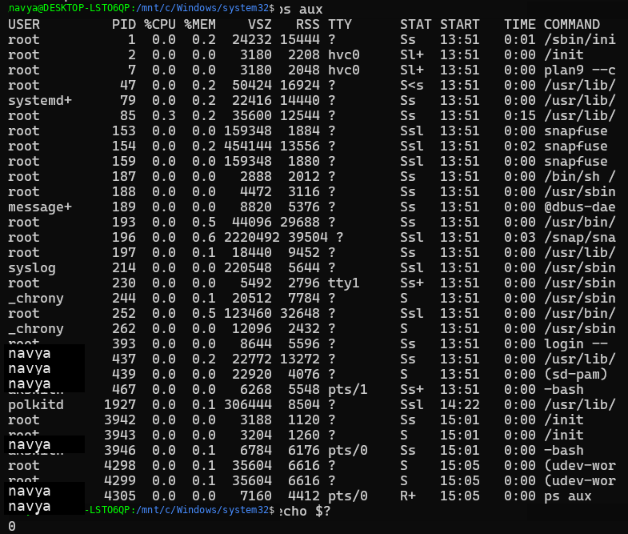
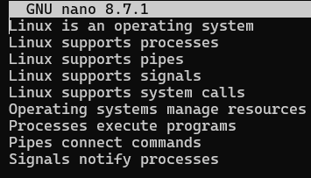

Task 2: To Document Architecture, Create Flow Diagrams, Explain Execution Paths, Describe Syscalls, Record Design Decisions, Review Documentation.
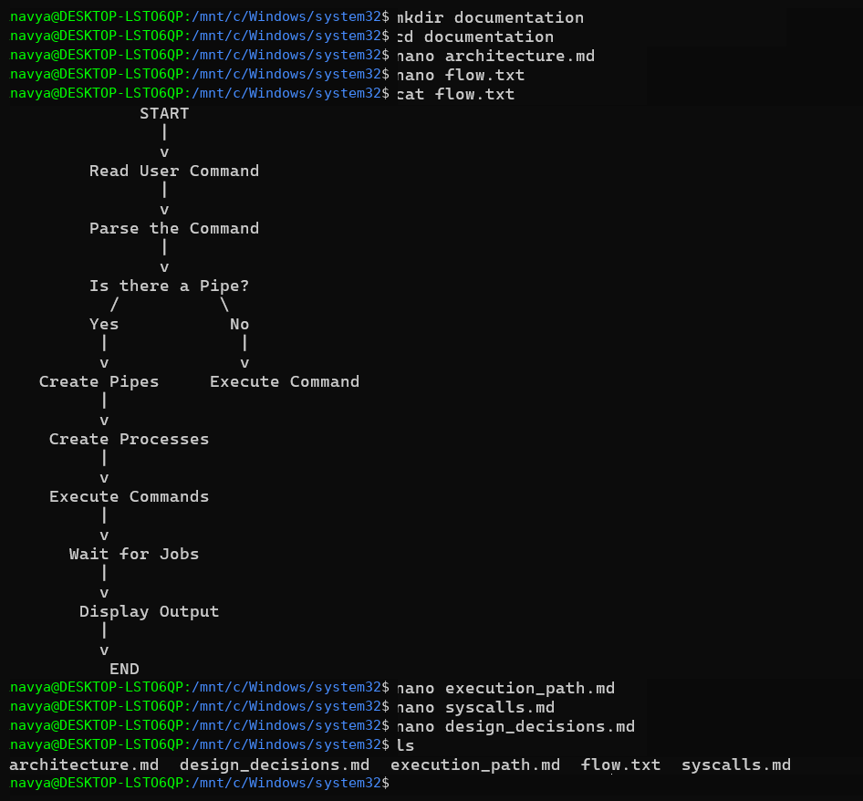
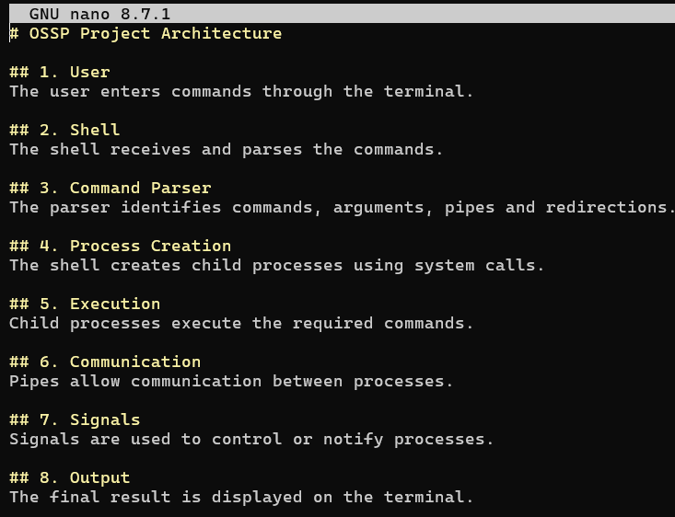
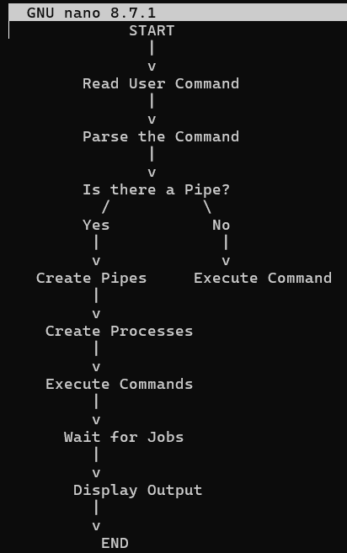
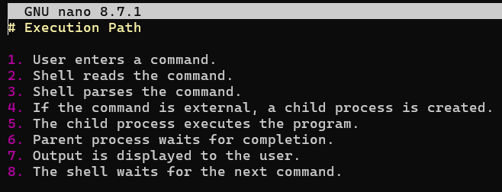
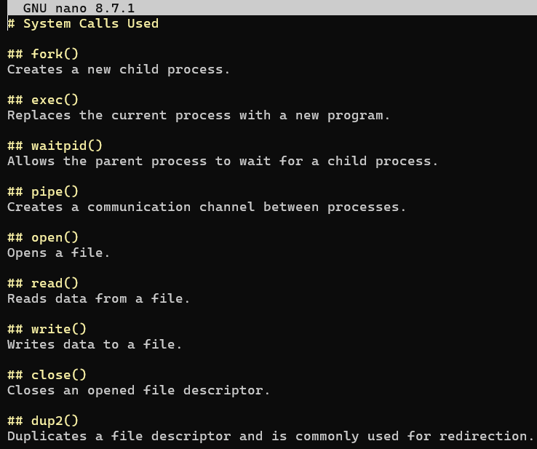
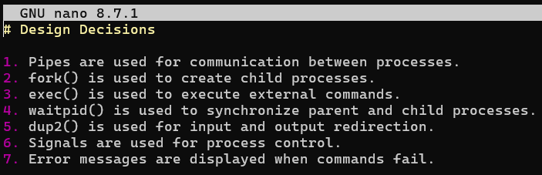

Session-24
Task 1: To Organize Source Code, Improve Build Scripts, Add README, Verify Repository Structure, Tag Releases, Validate Deliverables.
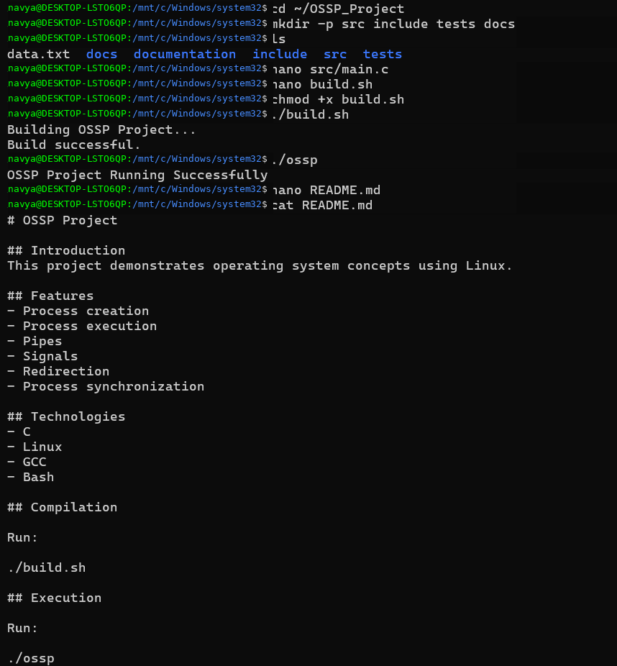
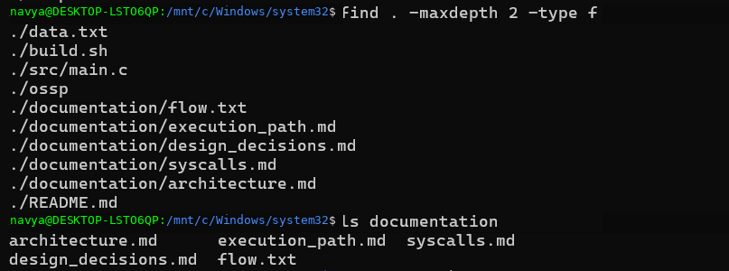
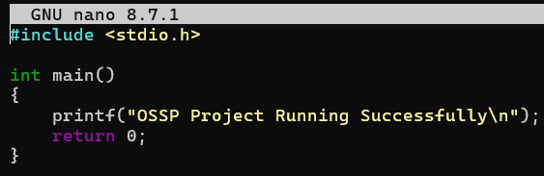

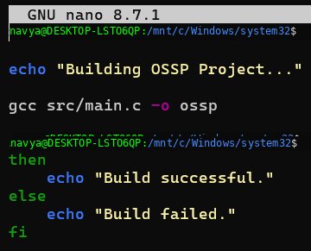
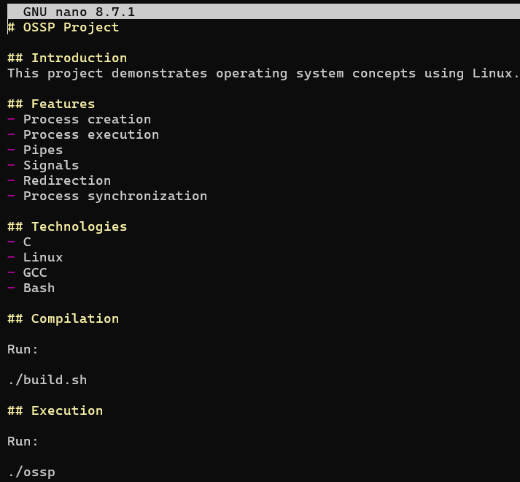

Task2:To Create Demo Scenarios, Validate Features, Rehearse Presentation, Demonstrate Pipelines, Demonstrate Signals, Final Project Review.
