Skill Week-11
Session-21
Task 1: To Connect Modules, Validate Interfaces, Test End-to-End Execution, Handle Errors, Improve Reliability, Refactor Components.
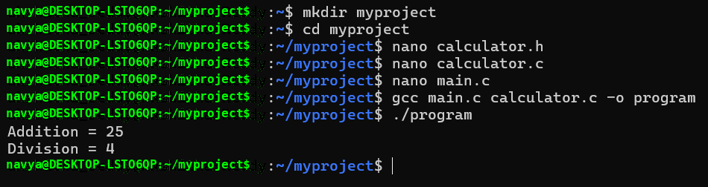
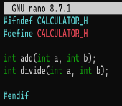
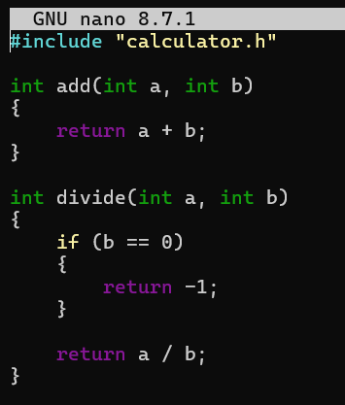
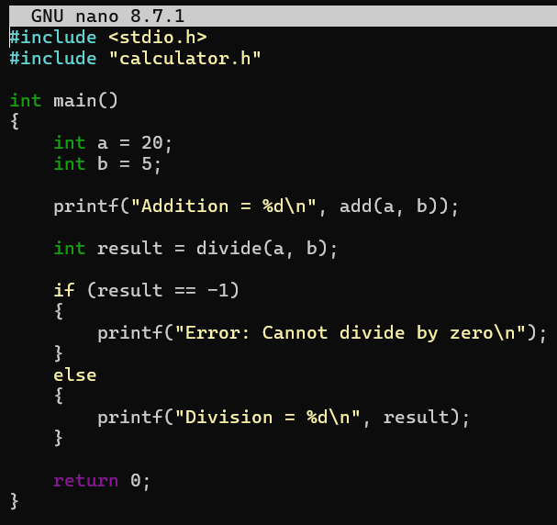

Task 2: To Detect Runtime Errors, Generate Messages, Log Failures, Handle Invalid Syntax, Recover Gracefully, Test Error Scenarios.
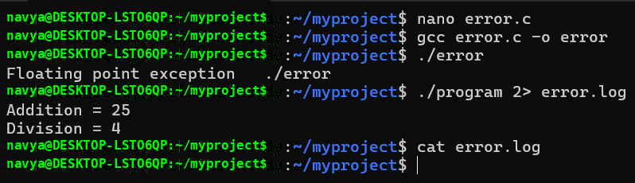
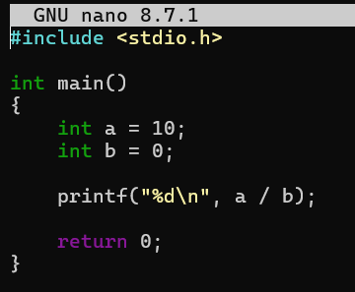

Session-22
Task 1:To Run Valgrind, Identify Leaks, Fix Memory Errors, Release Resources, Verify Cleanup, Document Findings.
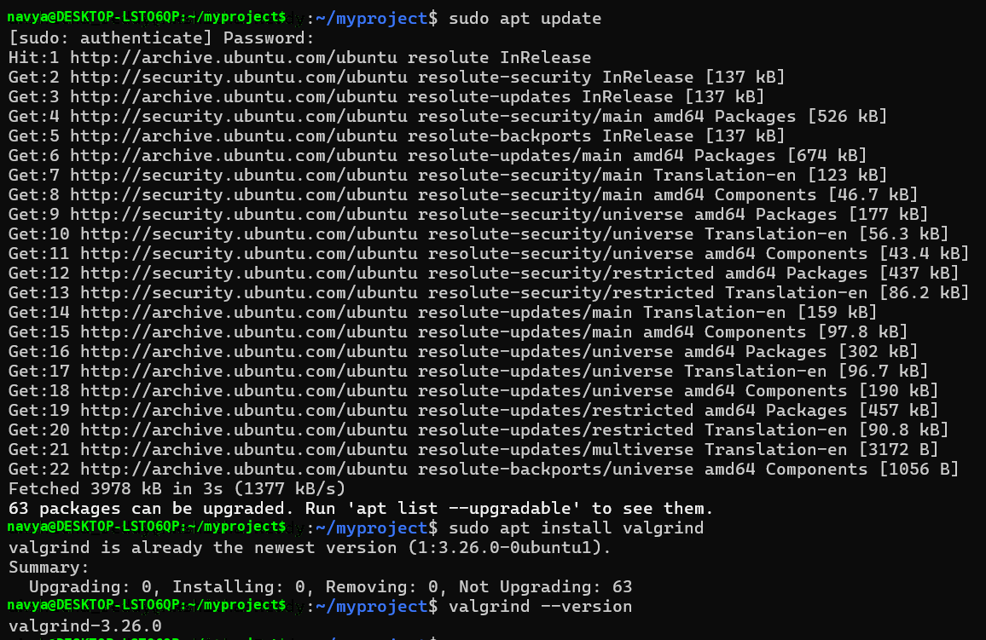
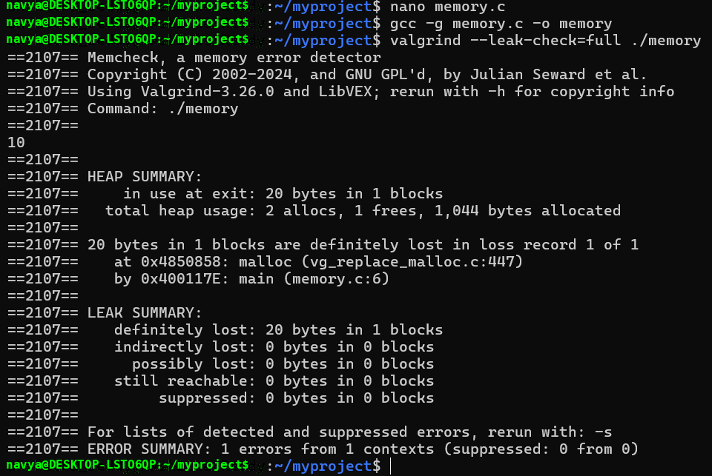
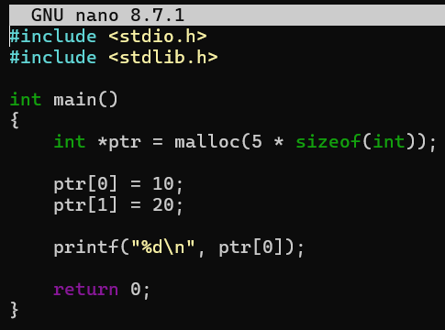
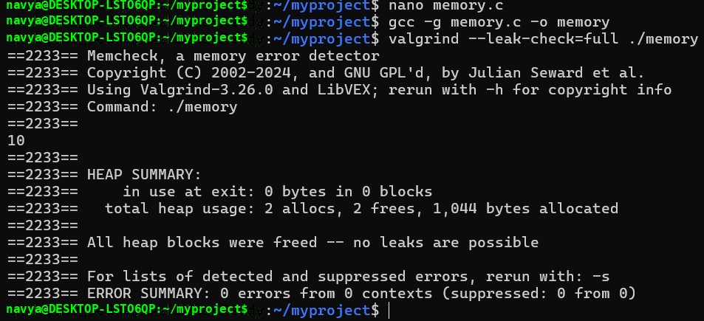
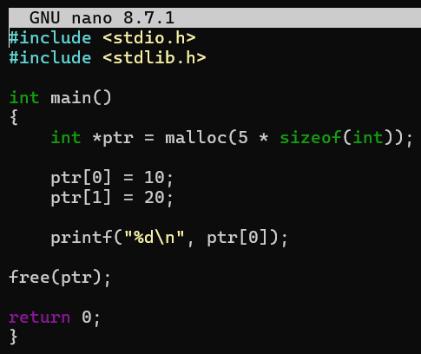

Task 2: To Design Test Cases, Create Test Scripts, Automate Execution, Verify Outputs, Compare Results, Generate Reports.
