Skill Week-10
Session-19
Task 1: To Register Handlers, Configure Signal Actions, Handle Interrupts, Manage Signal Context, Verify Stability, Test Signal Events.
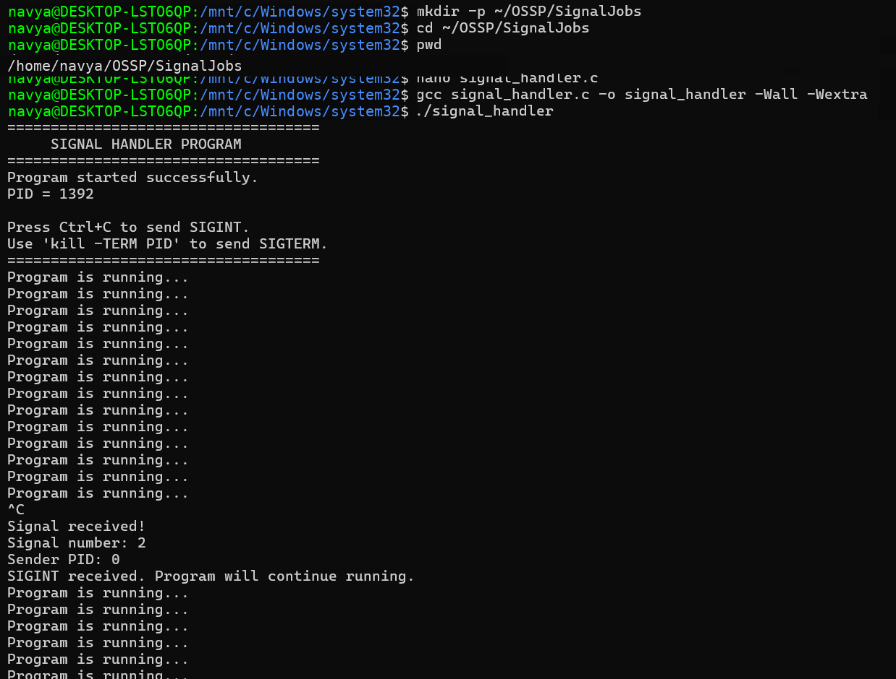
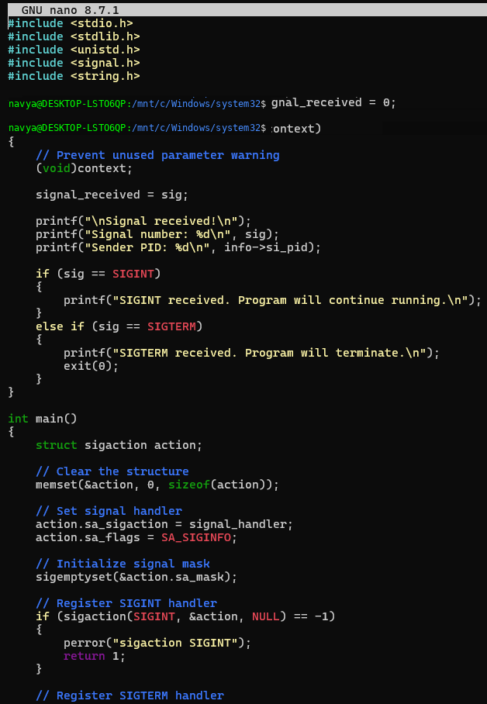
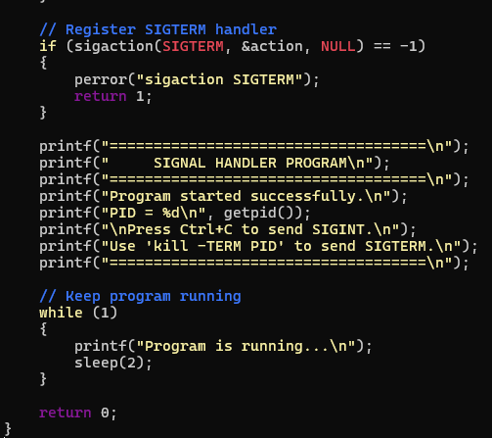

Task 2: To Capture SIGINT, Forward Signals, Protect Shell Process, Terminate Foreground Jobs, Update Job States, Test Interrupt Handling.
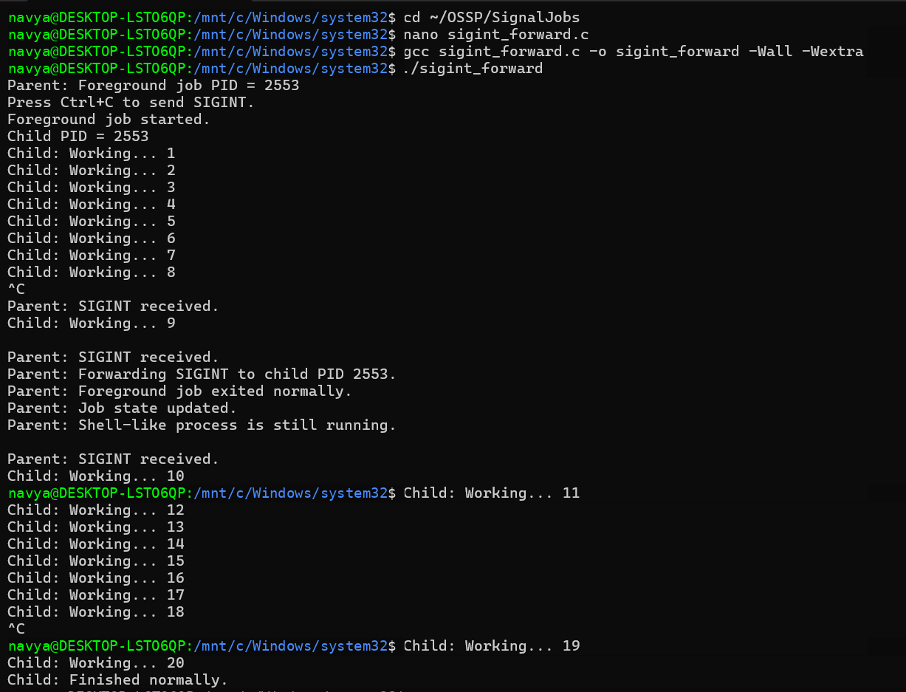
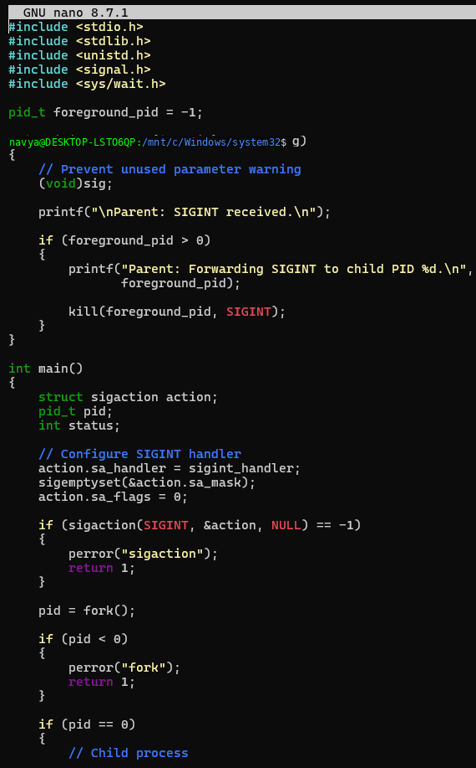
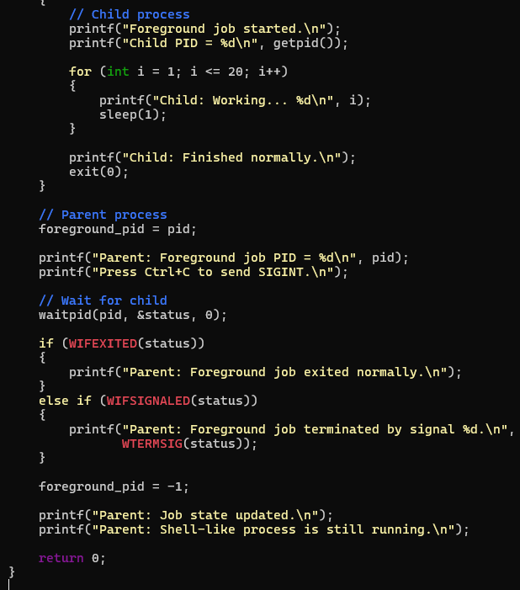

Session-20
Task 1: To Capture SIGTSTP, Suspend Processes, Update Job Table, Preserve State, Resume Later, Test Suspension Workflow.
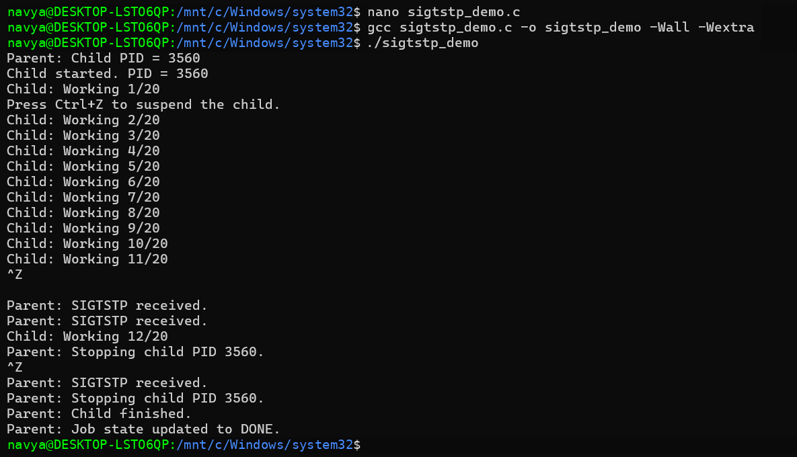
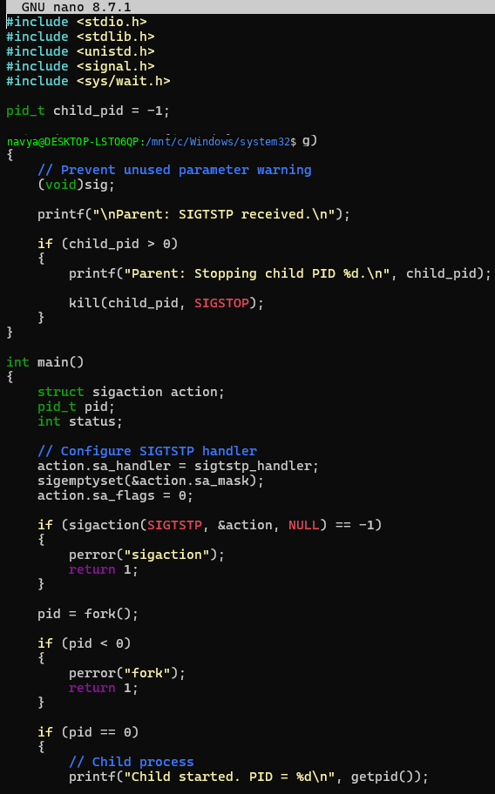
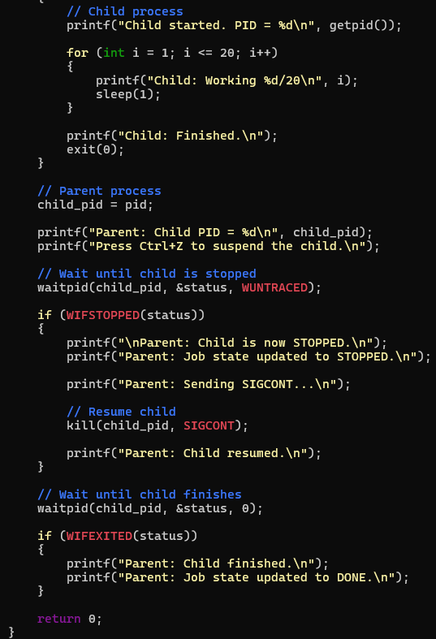

Task 2: To Create Process Groups, Assign Group IDs, Transfer Terminal Control, Restore Ownership, Coordinate Signals, Validate Behavior.
