Skill Week-9
Session-17
Task 1: To implement how to List Active Jobs, Display Status Information, Retrieve Job IDs, Format Output, Update State Information, Test Job Listings.
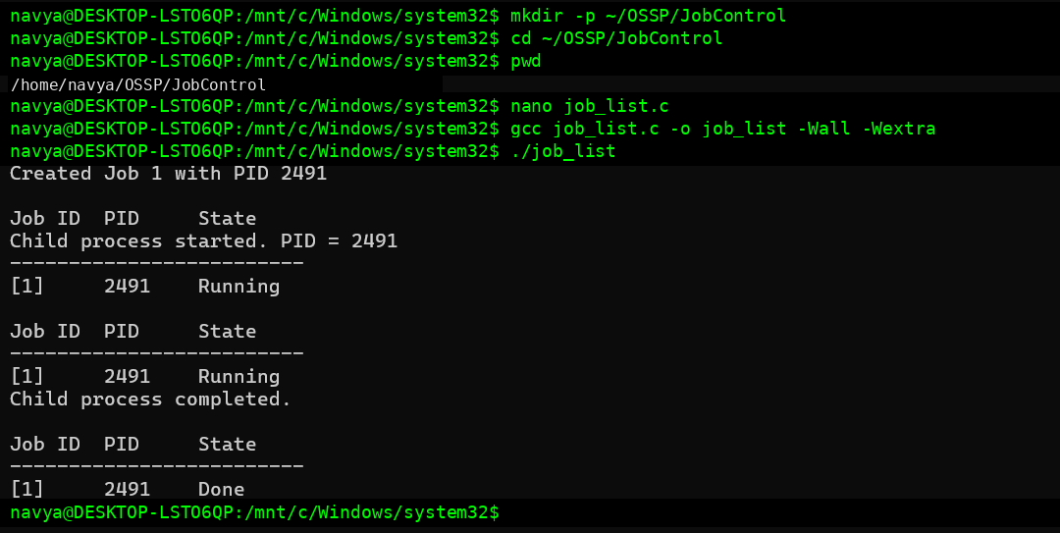
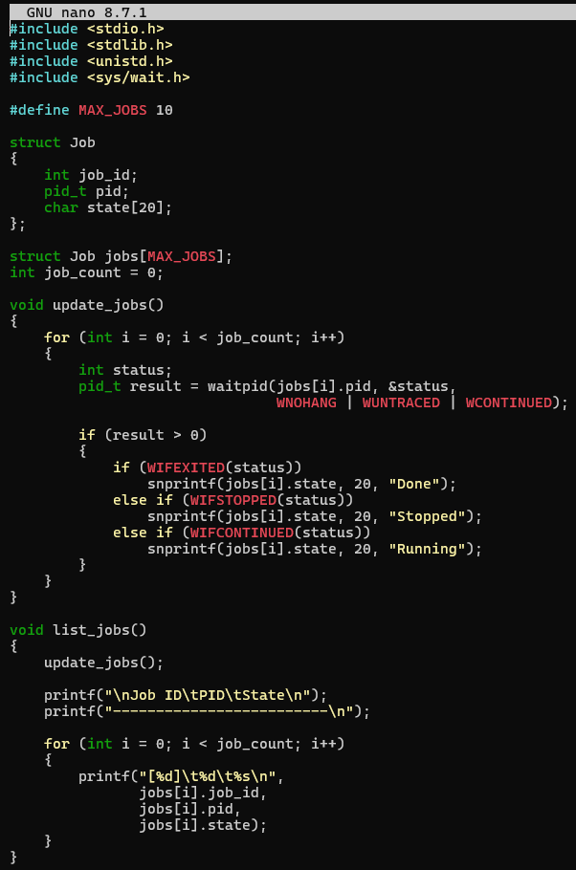
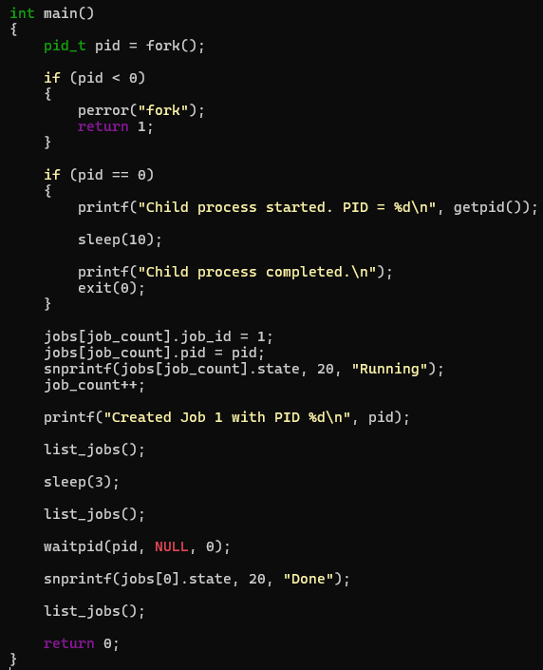

Task 2: To design how to Identify Target Job, Transfer Terminal Control, Resume Processes, Wait for Completion, Update Job State, Test Foreground Switching.
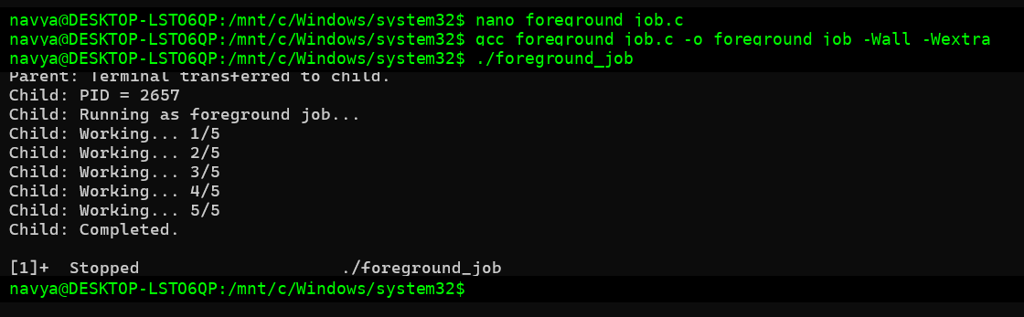
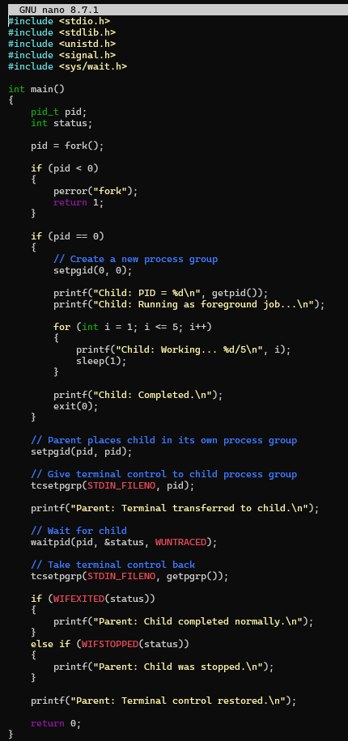

Session-18
Task 1: To Analyze Signal Delivery, Understand Signal Masks, Review Process Groups, Explore Terminal Signals, Test Signal Behavior.
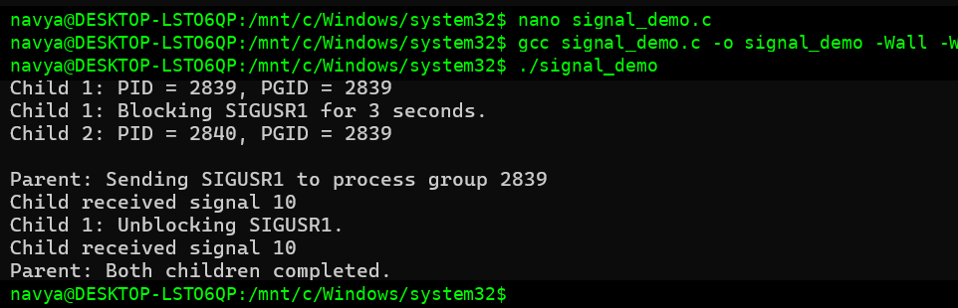
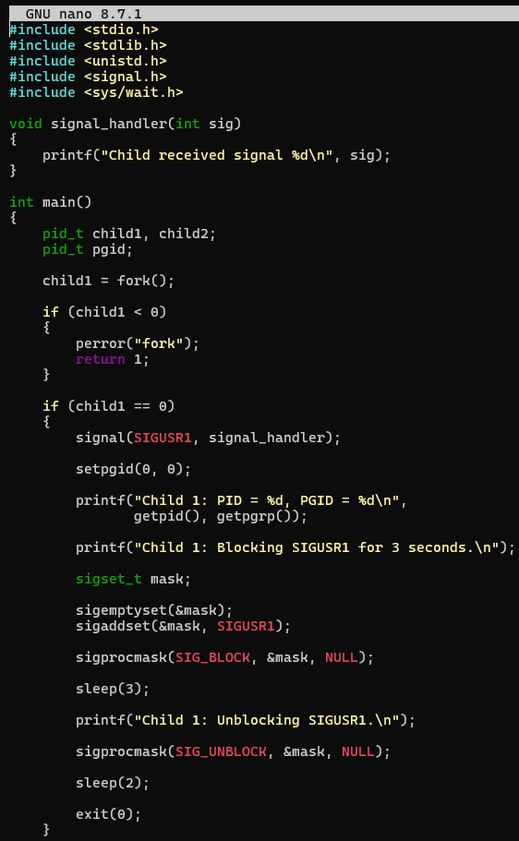
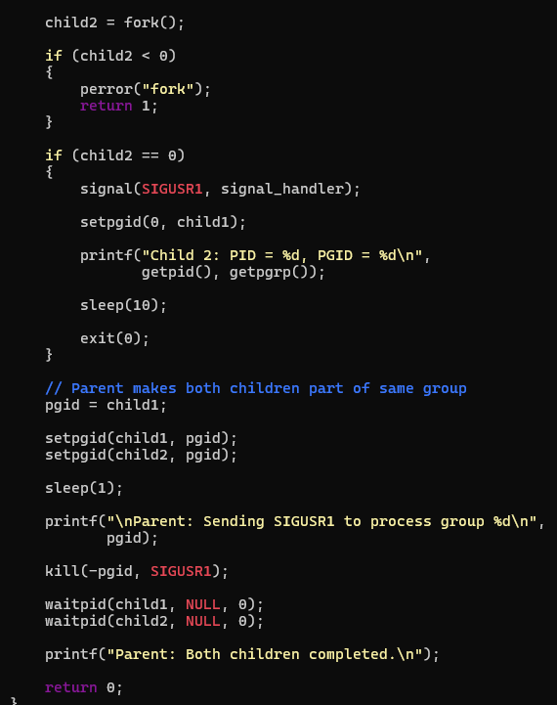

Task 2: To implement how to resume stopped jobs, send continue signals, update job status, maintain job table, verify execution, test background recovery.
