Skill Week-1
Task 1: To Install Linux VM, Configure GCC, Setup Git Repository, Create Project Structure, Understand Shell Architecture, Build Initial Makefile.
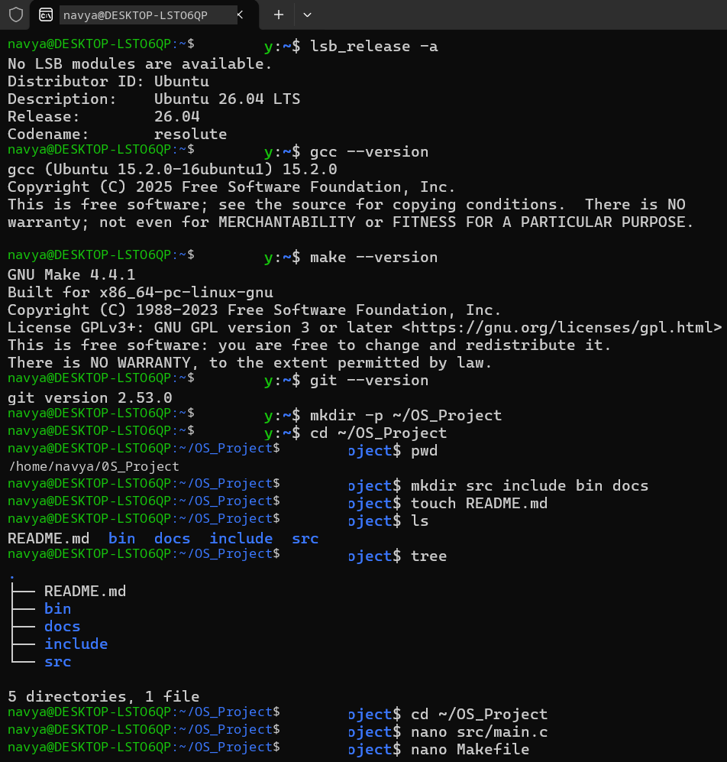
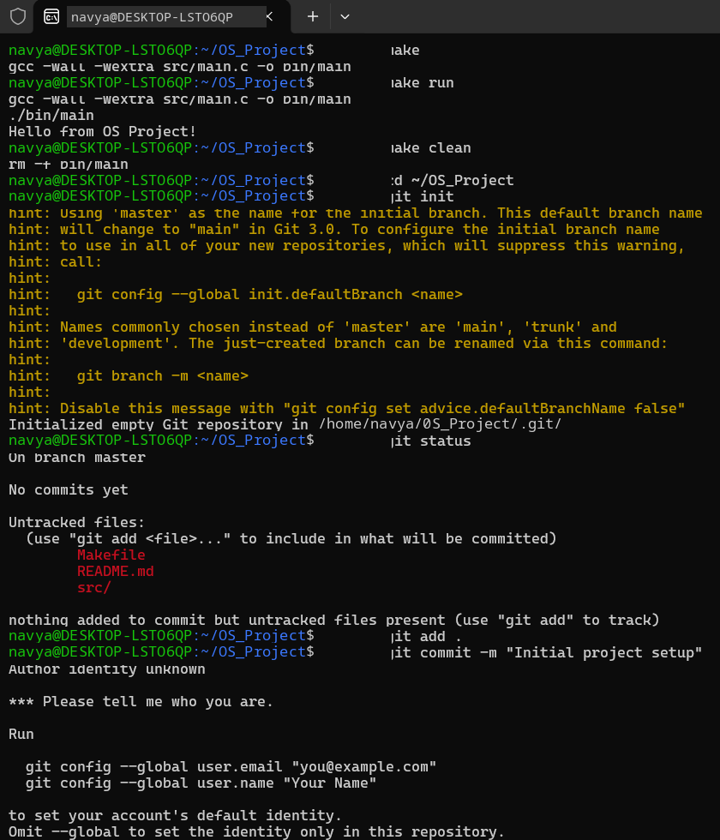
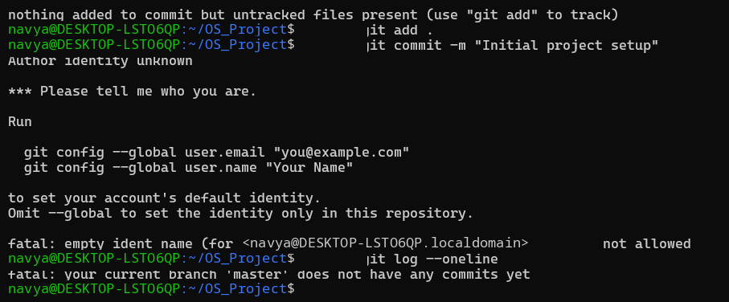
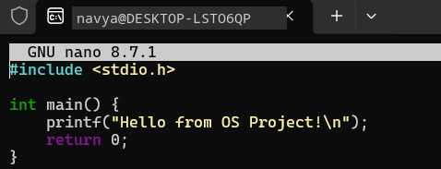
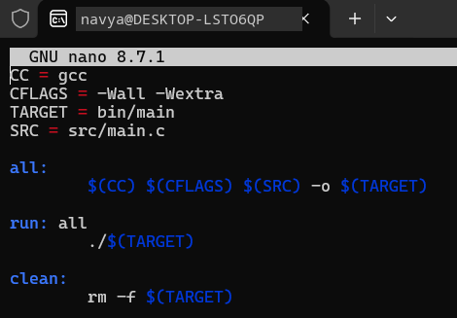

Task 2: To Analyze process abstraction, execute fork(), understand exec() family, analyze parent-child relationships, inspect process tree, practice system call tracing.
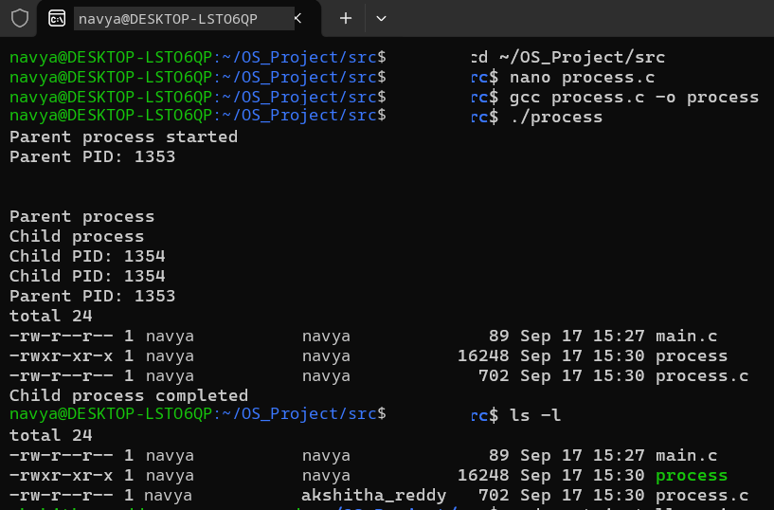
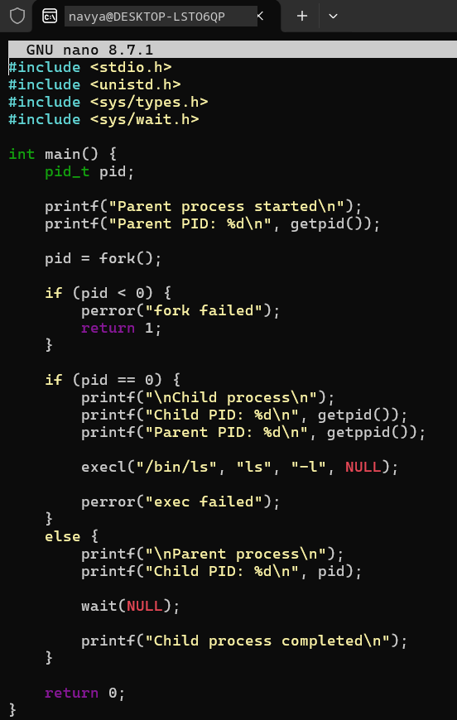

Task 3: To Create Main Loop, Display Prompt, Read User Input, Handle Exit Conditions, Design Control Flow Diagram, Test Interactive Loop.
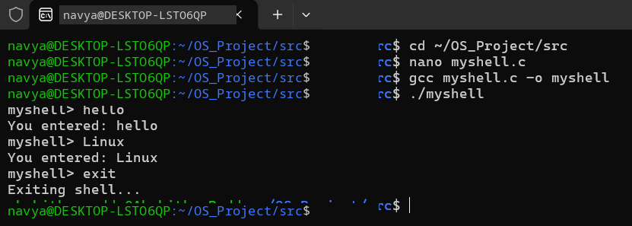
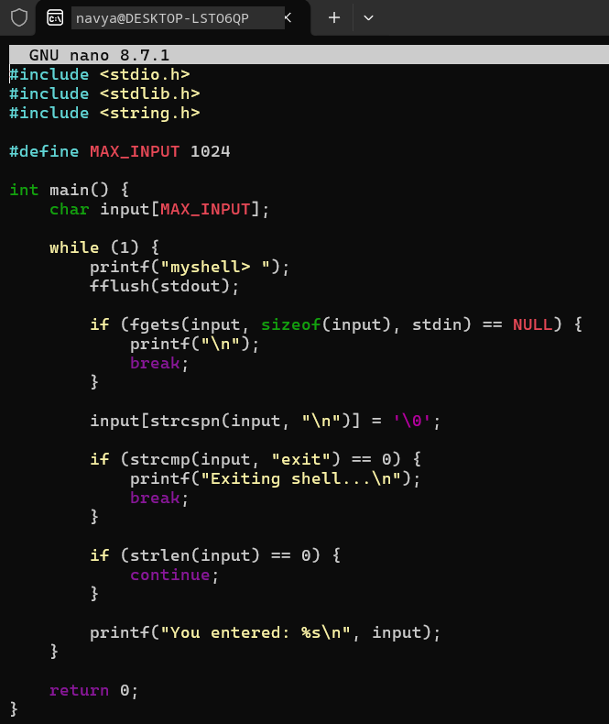

Task 4: To Capture Keyboard Input, Handle Backspace, Process Enter Key, Manage Input Buffer, Support Multi-Character Commands, Test User Interaction.
