Punto de partida: https://maps.google.com/maps?q=43.28288269042969%2C-2.8658719062805176&z=17&hl=es
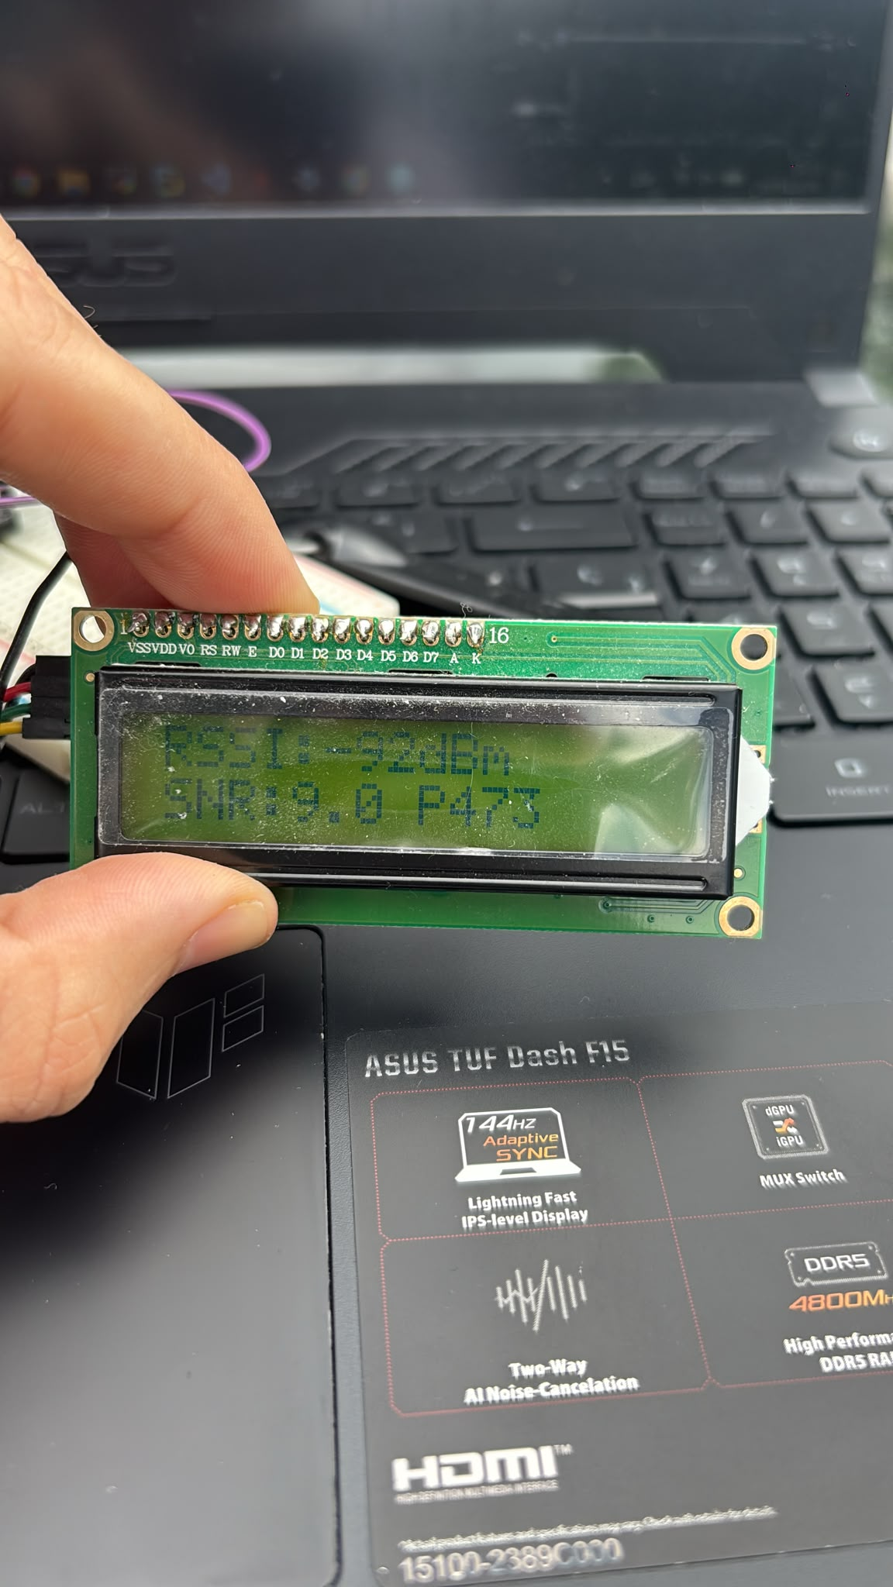

2. punto: https://maps.google.com/maps?q=43.283206939697266%2C-2.8664095401763916&z=17&hl=es

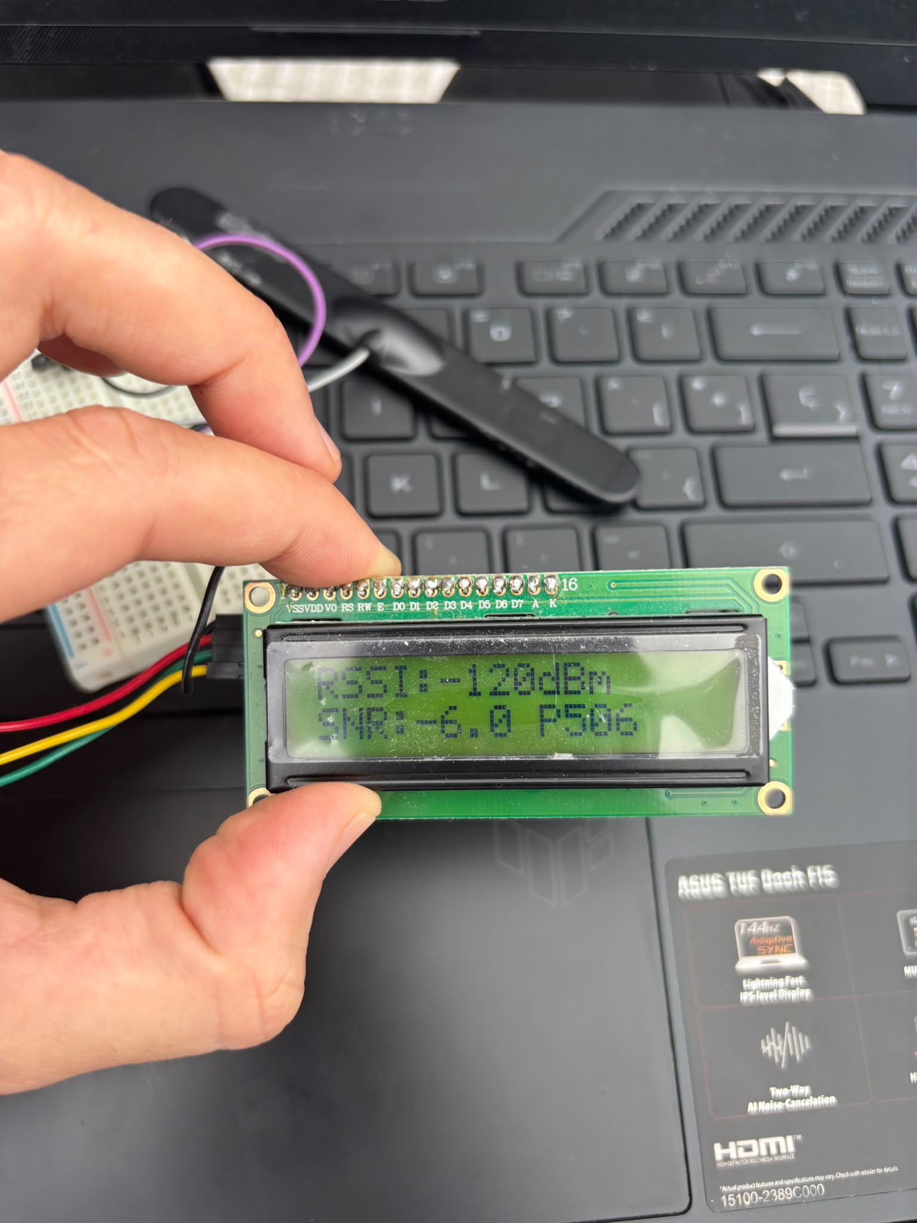

3. punto: https://maps.google.com/maps?q=43.28364944458008%2C-2.867128610610962&z=17&hl=es

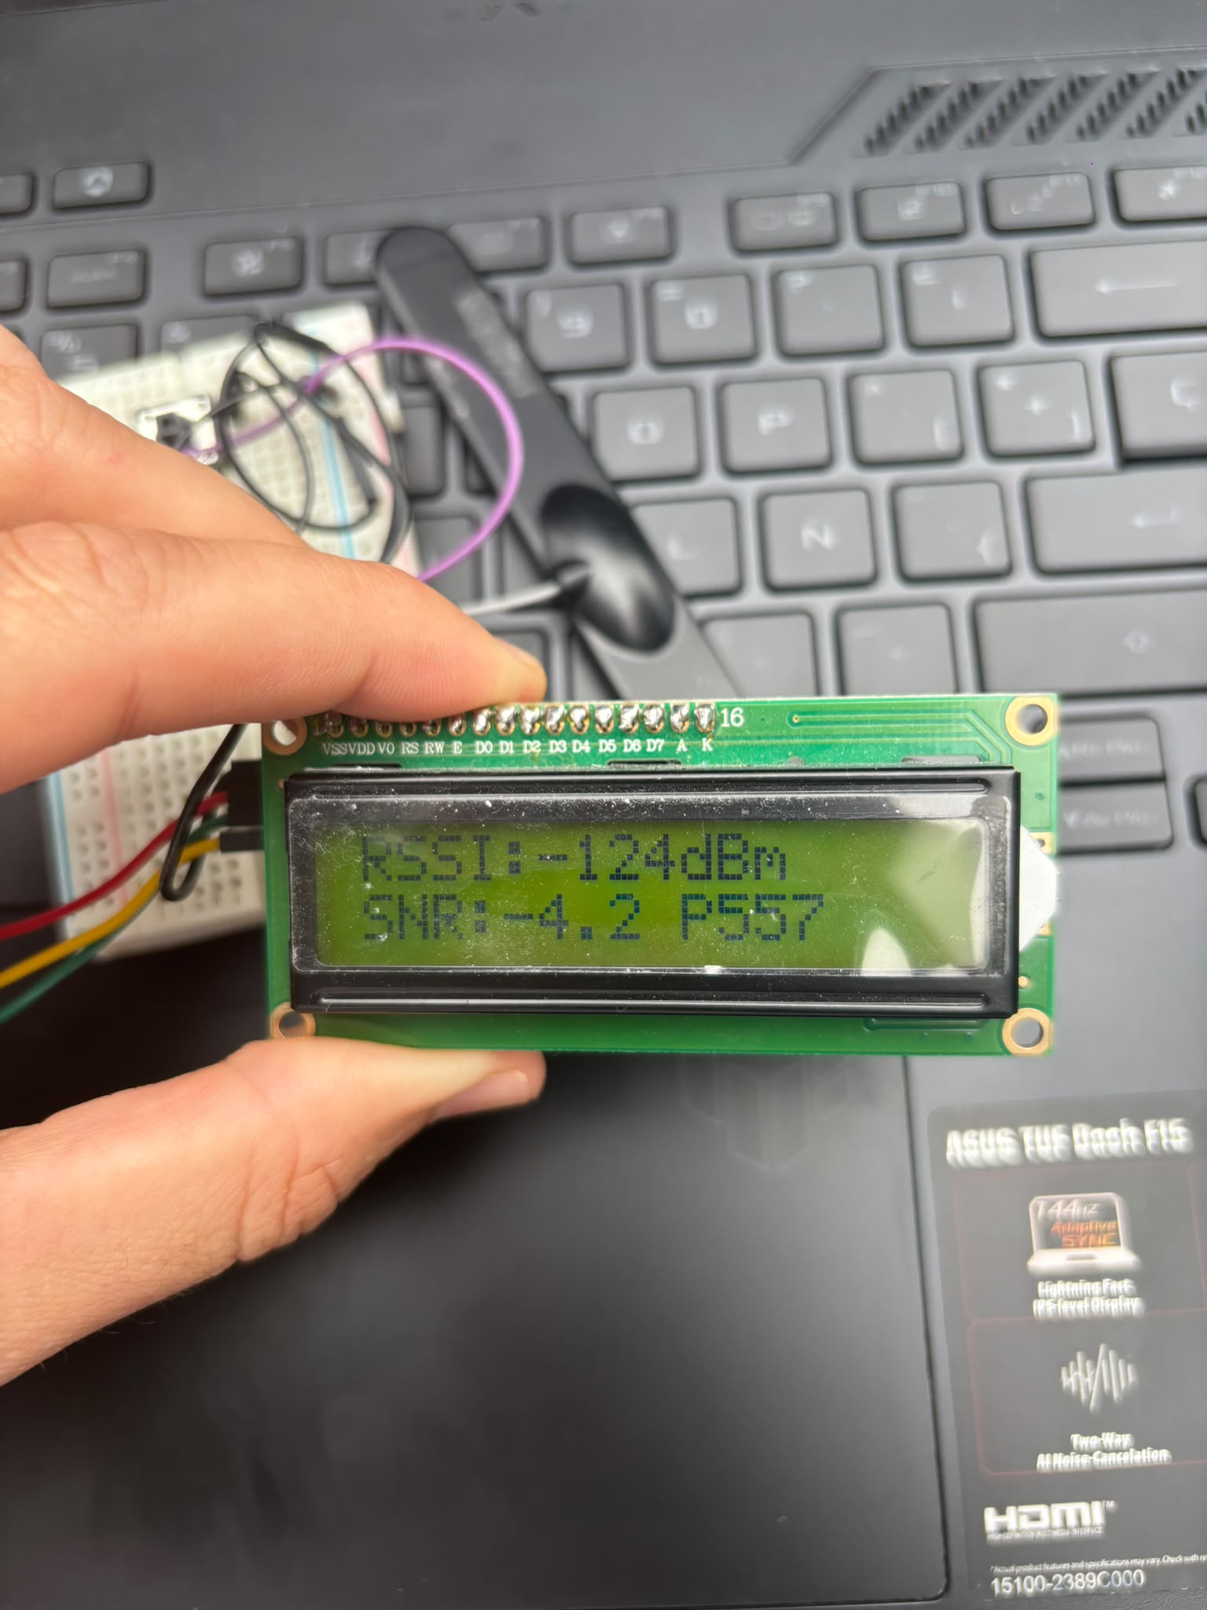

Siguiente: https://maps.google.com/maps?q=43.284149169921875%2C-2.8678932189941406&z=17&hl=es

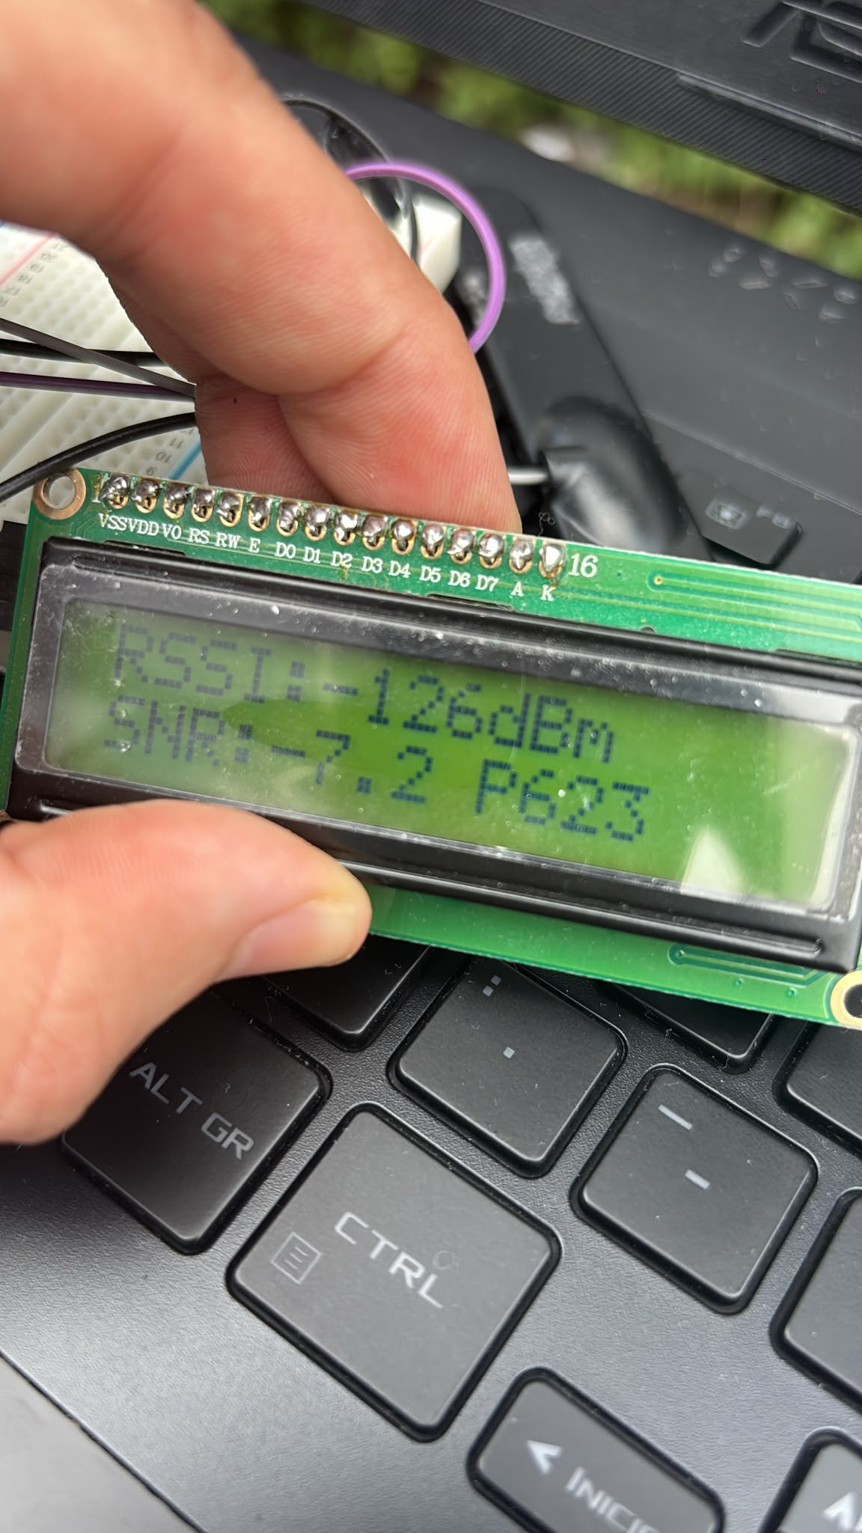

Siguiente:
https://maps.google.com/maps?q=43.2843132019043%2C-2.868394374847412&z=17&hl=es
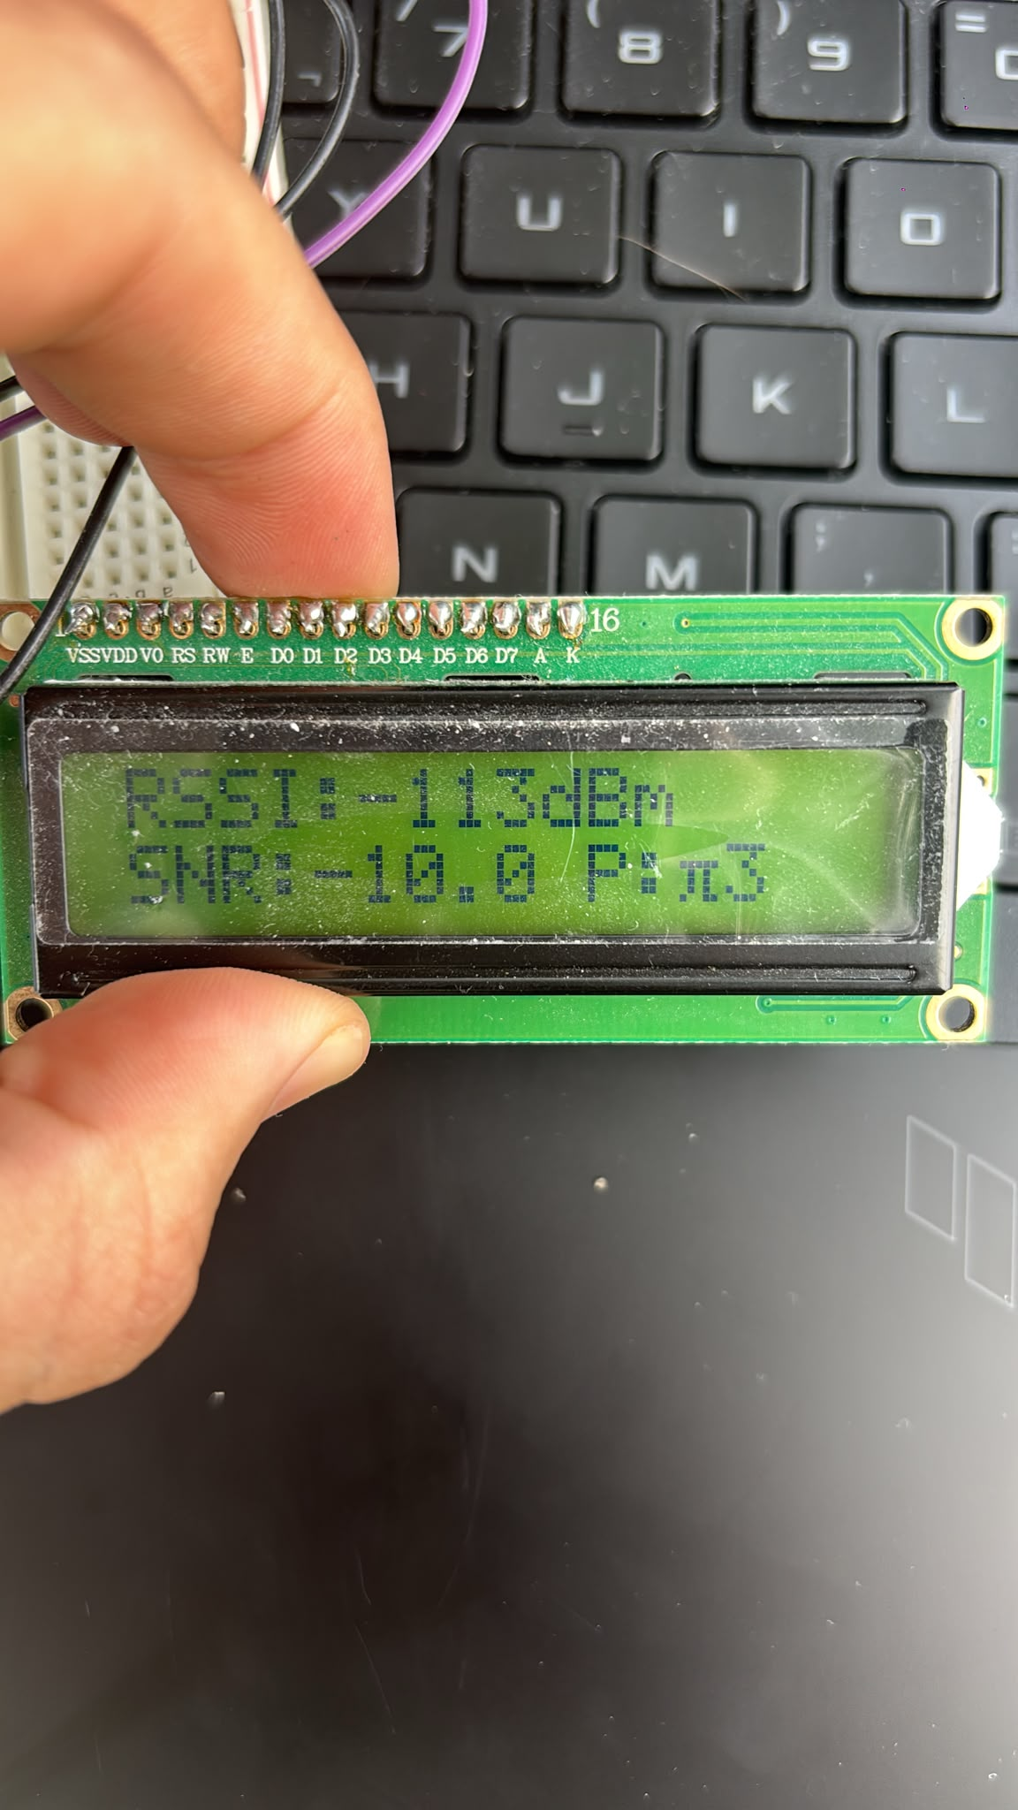

Siguiente: https://maps.google.com/maps?q=43.28481674194336%2C-2.8693037033081055&z=17&hl=es
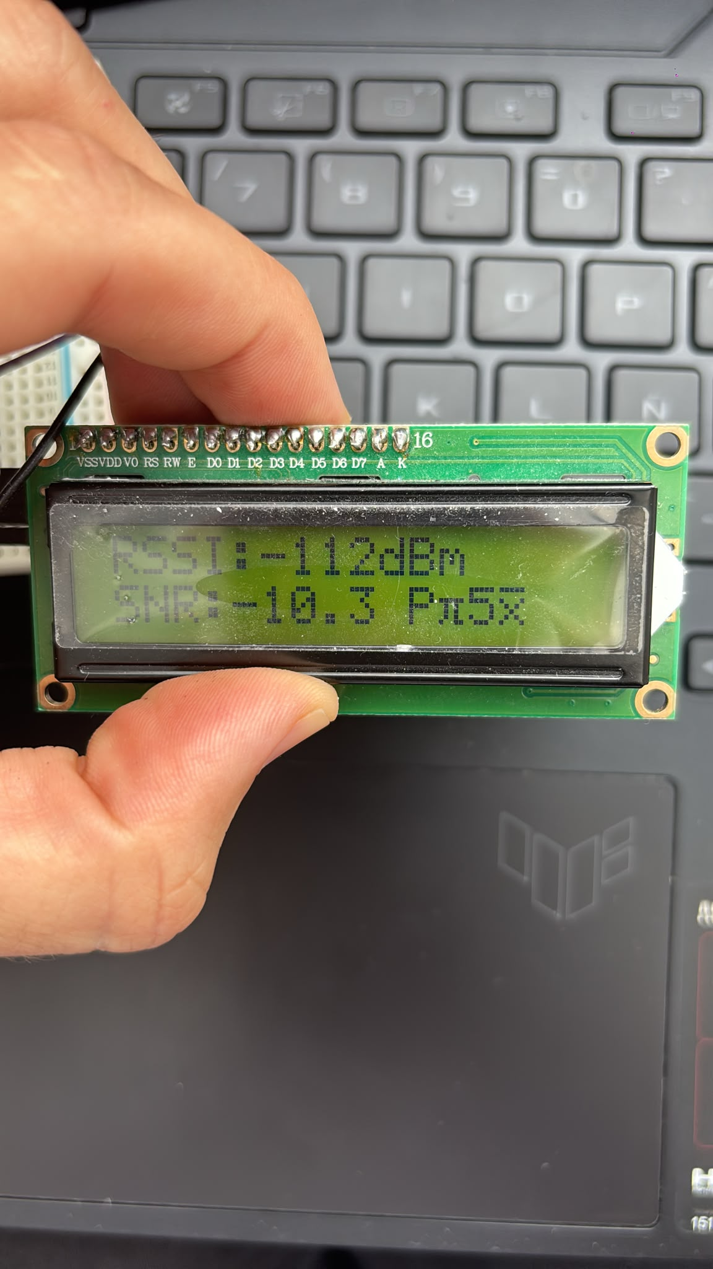

Siguiente:
maps.google.com/maps?q=43.28501892089844%2C-2.8698008060455322&z=17&hl=es
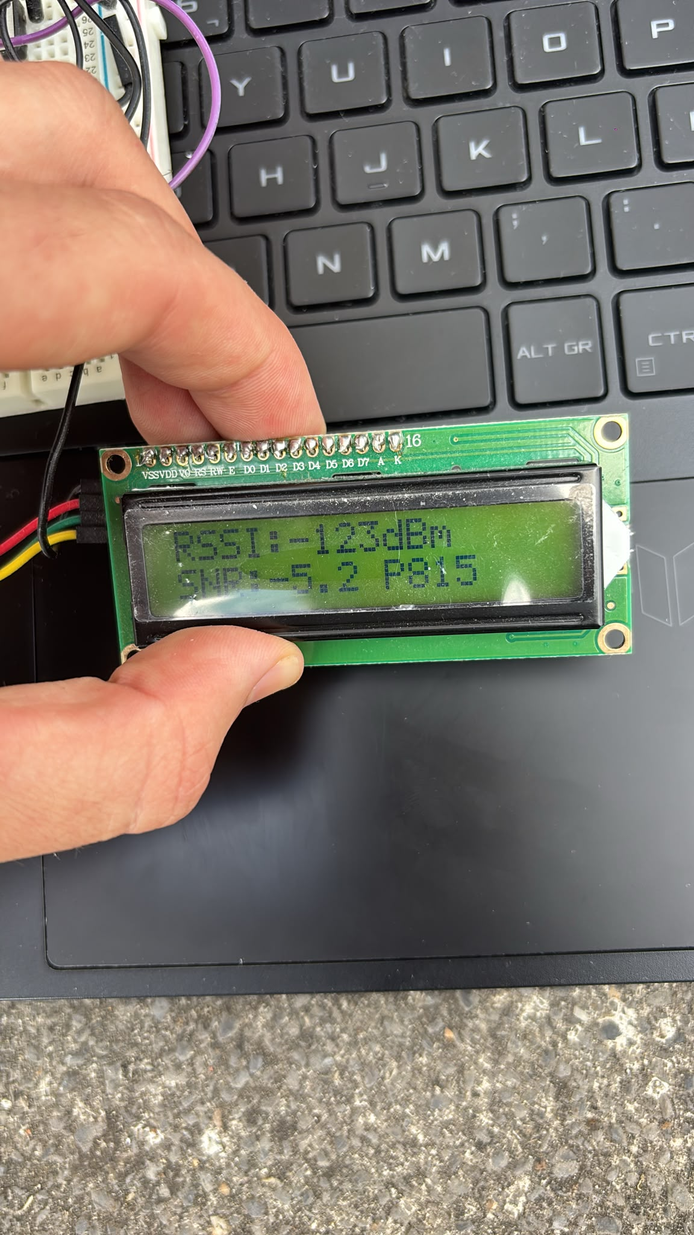

Aquí hemos perdido la conexión:

https://maps.google.com/maps?q=43.2852783203125%2C-2.8703465461730957&z=17&hl=es

historico de datos (capturas de pantalla del serial monitor de arduino):

