VEGAS: a Simple Tool for Modeling Reactor Fleet Dynamics
Erich Schneider, Los Alamos National Laboratory

VEGAS is a JAVA-based computational tool for simulating a time-dependent reactor fleet consisting of an evolving technology mix. Although the original motivation for VEGAS was to generate realistic reactor deployment schedules to be used as inputs to more detailed simulation models, it can be used as a stand-alone package. VEGAS accepts the following inputs:

Table. Input Categories for the VEGAS Model
Economic and financial parameters, i.e., discount rates | Any number of reactor types, characterized by user-supplied input and output heavy metal compositions
Reactor power levels, construction times, lifetimes, and costs; fuel cycle unit costs | Material flow pathways through the fuel cycle, i.e., reactor types that demand reprocessed material, SNF types from which the material may be drawn
A time-dependent demand function for nuclear energy | Availability dates for reactor technologies
Initial conditions reflecting a ‘present-day’ fleet plus a stockpile of ‘Legacy SNF’ | Time-dependent capacity of reprocessing facilities
Starting and ending dates, dates to perform detailed cost breakdowns | Residence and minimum cooling times, thermal efficiency, average load factor, discharge burnup, and other performance characteristics for each reactor type

VEGAS propagates the reactors, material flows and costs through time, adding new facilities in accordance with the scenario rules specified by the user. In most cases, the evolving fleet will not exactly reflect the user’s wishes as specified in the input file. For instance, the user might tell VEGAS to build only breeder reactors using plutonium and DU feed after, say, 2050. Depending on the amount and plutonium content of the SNF existing in the system, VEGAS may find that plutonium supply limits the rate at which the breeders may be brought online. Therefore, VEGAS might, depending on user preferences, meet the demand for nuclear energy by building as many breeders as it can but falling back on advanced LWRs when Pu is temporarily unavailable. In fact, the user’s desire or guess for the reactor mix might not be achieved whenever a reactor type that takes feed from reprocessed SNF is to be deployed. Reprocessing plant capacity limitations could also have this effect.

VEGAS uses traditional present-value and levelized-cost analyses to calculate reactor and fuel cycle costs. The economic model for reactor construction is adapted from the method documented in the 2003 MIT study. VEGAS can also compute ‘cost maps’ showing the sensitivity of electricity costs to variations in inputs. These cost maps can reflect a single year, or they can be obtained from discount-weighted averages. The maps can depict a single scenario but are more often used to compare multiple strategies, such that simultaneous plotting can provide a depiction of ‘break-even’ between various options.

Reactors in VEGAS are treated discretely: each reactor type is assigned a capacity (MW(e)) and lifetime, and new reactors always serve out their complete lifetime operating at their full capacity. VEGAS tracks materials differently. They are treated in a continuous fashion: VEGAS computes annual input and output mass flow rates for each reactor type. This approximation, reasonable when applied to many reactors over the long term, avoids the computational overhead stemming from tracking thousands of individual fuel batches. Materials are tracked as they progress through the fuel cycle: nuclear fuel, for instance, might be in reactors being irradiated; out of pile but in cooling storage; or out of pile and in ‘long term’ storage (i.e., it has cooled long enough to be considered available for reprocessing).

The numerical tables constituting the output of VEGAS may be plotted in MATLAB using utilities included with the code. Two examples of such plots are shown below; the VEGAS input files that produced the first of these are also included. The ‘cost map’ plots referred to above are not shown; specimens of these are available in the literature.

Version of June 2012

Automatic plotting. Now as long as MATLAB is installed, after successfully completing a simulation MATLAB will automatically be run and graphs will be plotted.

Reprocessing capacity limits. When a limit is set, if the current scenario gets to a point where throughput exceeds this limit it will also fall back to the other type of reactors. The capacity limits can be left unset and will then default to the unlimited case.

The U_{nat} Usage graph now displays the total natural Uranium usage based on the consumption during the simulation which is added to the user specified ReferenceAmount from the U Mining & Milling parameters in the NFC_parameters.txt file.

Front end prices can now change with consumption and time. Fixed by default. If a reference year, amount and amount exponent are set, follows the equation
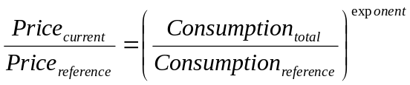,
as described in http://web.mit.edu/mitei/research/studies/nuclear-fuel-cycle.shtml
If a reference year, price and time exponent are set, price changes with time as described by the equation
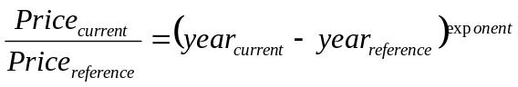.
Both, any or none of these price change modifiers can be used for any of the front end technologies independently thus affecting the plotted electricity and front end costs.

The user can now choose whether to run the simulation based on preset reactor construction ratios (as in the earlier version) or the cost driven automated decision version. In the latter case the electricity costs are evaluated every year of the simulation for every possible equilibrium nuclear fuel cycle consisting of no more than one reactor from each tier. Reactor availability dates can be specified with the YearAvailable parameter in the Reactor_parameters.txt file (it is ignored for the user scenario simulations but should not be omitted). Best effort is taken to follow the equilibrium ratio and will fall back to the reactors specified by the IfCausesTiltReplaceWithType parameter in the case of insufficient amount of fuel due to not enough spent fuel to be reprocessed or reprocessing throughput caps.
The way the simulation is run can be selected with the ScenarioSet parameter in the NFC_parameters.txt file. Set to true for user specified scenarios and false for cost-driven simulations.
Examples of both cases are provided below. Please note the only difference is the value of the ScenarioSet parameter.
- VEGAS Transmutation Sample Run: ScenarioSet=false
(Input files for this run listed below)
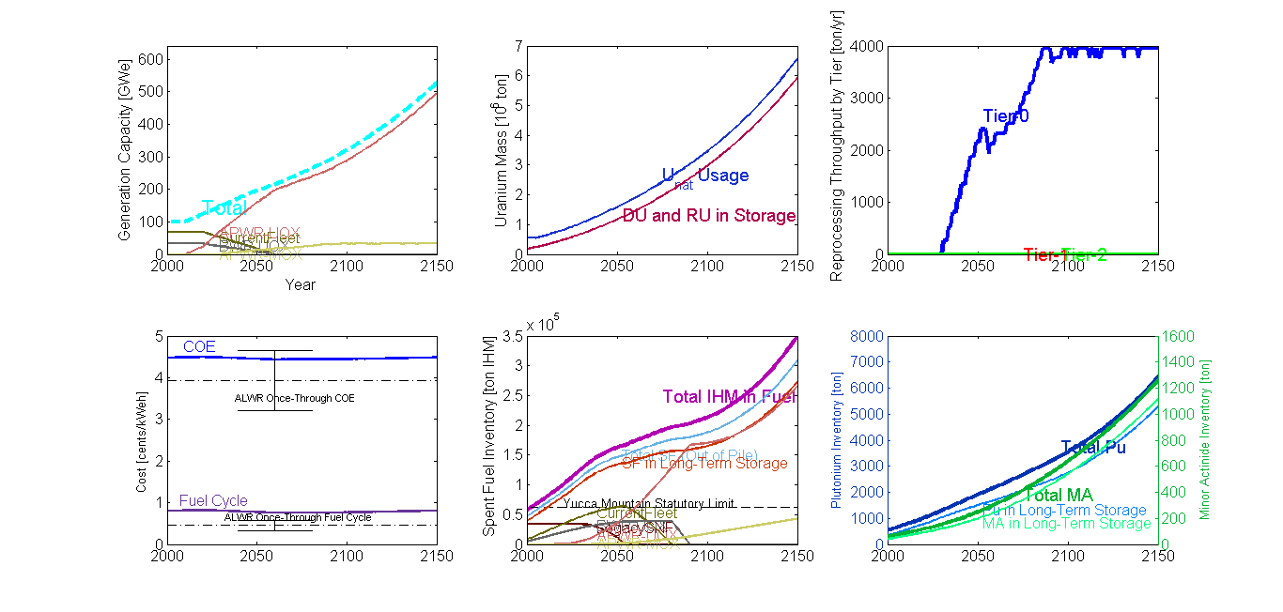
2. VEGAS Transmutation Sample Run: ScenarioSet=true
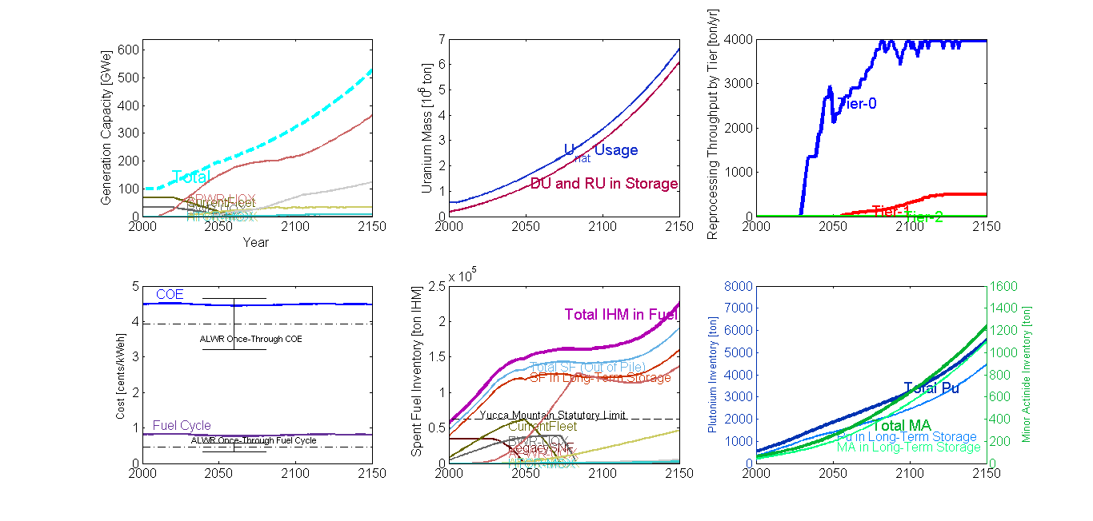
VEGAS Input File: NFC_parameters.txt

##### GENERAL ECONOMIC INPUTS #####
SocialDiscountRate=2.0 # percent
FinancialDiscountRate=7.0 # percent
RequiredReturnOnEquity=10.0 # percent
EquityFractionForNewCapacity=50. # percent
RiskFreeRateOfReturn=2.0 # percent

##### FUEL CYCLE INPUTS #####
NewReactorLifetime=60.0 # years
ReactorConstructionTime=4.0 # years
NaturalUEnrichment=0.71 # percent U-235 in U
TailsUEnrichment=0.25 # percent U-235 in U
SeparatedActinideStorageCost=500 # $ / kg / yr
SeparatedActinideVitDisposalCost=6000 # $ / kg
SeparatedActinideRepositorySpace=10.0 # kg repository space used / kg actinide
StartYear=1990 # integer
EndYear=2160 # integer
AssessEquilibriumCostsAtYear=2050 # integer: equilibrium cost data will not be written if this is not in [StartYear,EndYear]
# choose a date late in the simulation when near-equilibrium behavior is expected
# however, choosing a date too close to EndYear will reflect undesirable 'end effects':
# e.g., SNF going unreprocessed since no reactor demands it prior to EndYear
LegacySNF=34000. # metric tons IHM
LegacySNFIsOfType=0 # reactor type from which SNF composition obtained

##### EXOGENOUS DEMAND FOR NUCLEAR ENERGY #####
InitialGenerationCapacity=100. # GW(e): existing at StartYear
YearInitialFleetBeginsRetiring=2020
YearInitialFleetFinishesRetiring=2060 # initial fleet retires at constant rate during this interval
InitialCapacityData[0]={
Type=1
Percentage=68. # sum of percentages for initial capacity by type must add to 100.
}
InitialCapacityData[1]={
Type=2
Percentage=32. # sum of percentages for initial capacity by type must add to 100.
}
GrowthSpecified[0]={ # Use GrowthSpecified to define the demand for nuclear energy.
Year=2010 # Demand growth may be specified by a fixed capacity target at a given year, or a (%/year) growth rate:
GrowthRate=0.0 # zero growth through 2010, then...
}
GrowthSpecified[1]={
Year=2050 # integer Year for GrowthSpecified[i] should be > StartYear and < Year of GrowthSpecified[i+1]
Capacity=200. # capacity reaches this level (GW(e)) by Year 2050, starting from InitialGenerationCapacity=97 GWe in 2010
} # Linear growth from previous Year of GrowthSpecified (or from StartYear if this is the first GrowthSpecified) is assumed.
GrowthSpecified[2]={
Year=2051
GrowthRate=1.0 # percent/year demand growth rate applied to this and subsequent years
}

##### REPROCESSING PLANT CAPACITIES #####
ReprocessingCapacity[0]={ # tier 0 reprocessing capacity
AddCapacity[0]={
Year=1900
Capacity=0. # if left unspecified will default to infinite reprocessing
}
AddCapacity[1]={
Year=2030 # year this reprocessing capacity takes effect, superceding the previous setting
Capacity=1500.
}
AddCapacity[2]={
Year=2040
Capacity=4000.
}
}
ReprocessingCapacity[1]={ # tier 1 reprocessing capacity
AddCapacity[0]={
Year=1900
Capacity=500.
}
}
ReprocessingCapacity[2]={ # tier 2 reprocessing capacity
AddCapacity[0]={
Year=1900
Capacity=1200.
}
}

##### SCENARIO RULES #####
ScenarioSet=true # Change manual or dynamic building orders
ScenarioRules[0]={
Year=1900 # first set of rules should always be imposed at Year <= StartYear
TryToBuild[0]={ # VEGAS will meet nuclear energy demand by building the facility types given below
FacilityNumber=1 # This is referenced to the FacilityNumber in Reactor_parameters.txt
Percentage=68. # target percentage of new plant builds by net electric generation capacity
}
TryToBuild[1]={
FacilityNumber=2
Percentage=32.
}
}
ScenarioRules[1]={
Year=2010 # year this ScenarioRule takes effect, superceding the previous Rule
TryToBuild[0]={
FacilityNumber=3
Percentage=100.
}
}
ScenarioRules[2]={
Year=2020
TryToBuild[0]={
FacilityNumber=3
Percentage=75.
}
TryToBuild[1]={
FacilityNumber=4
Percentage=25. # sets target of 25% PWR-MOX, 75% PWR-UOX for new builds between 2020 and 2045
} # VEGAS will only build this much MOX-burning capacity, though, if enough Pu is available
}
ScenarioRules[3]={
Year=2045
TryToBuild[0]={
FacilityNumber=3
Percentage=65.
}
TryToBuild[1]={
FacilityNumber=4
Percentage=10.
}
TryToBuild[2]={
FacilityNumber=5 # FacilityNumbers 5 and 6 are fast-spectrum burners in low- and high-MA loadings, respectively
Percentage=3.
}
TryToBuild[3]={
FacilityNumber=6
Percentage=22. # again, VEGAS will try to deploy this percentage of FR capacity,
} # but will default to lower-tier facilities if feed is unavailable.
}

##### FRONT END FUEL CYCLE PROCESSES #####
# The number and function of the technologies is hard-coded into VEGAS.
# One may use these commands to set scheduling and default cost data
FrontEndTech[0]={
Name="U Mining & Milling"
DefaultLeadTime=2.0 # years prior to fuel charge
DefaultCost=106.0 # Dollars / kg U as U3O8
ReferenceYear=2005 # reference year for price growth; any consumption or time after this year will increase price according to exponents
ReferenceAmount=540000000. # total amount consumed before reference year
AmountExponent=0.11 # the rate of price increase due to amount consumed, defaults to 0 if unset
TimeExponent=0. # the rate of price increase due to time passed, defaults to 0 if unset
}
FrontEndTech[1]={
Name="Conversion to UF6 "
DefaultLeadTime=2.0 # years prior to fuel charge
DefaultCost=10.0 # Dollars / kg U as U3O8
}
FrontEndTech[2]={
Name="Enrichment "
DefaultLeadTime=1.5 # years prior to fuel charge
DefaultCost=155.0 # Dollars / SWU
}
FrontEndTech[3]={
Name="Fuel Fabrication "
DefaultLeadTime=1.0 # years prior to fuel charge
DefaultCost=250.0 # Dollars / kg IHM
}
FrontEndTech[4]={
Name="Transportation->RX"
DefaultLeadTime=0.5 # years prior to fuel charge
DefaultCost=50.0 # Dollars / kg IHM
}

##### BACK END FUEL CYCLE PROCESSES #####
BackEndTech[0]={
Name="SNF Storage "
DefaultLagTime=0.0 # years after fuel discharge
DefaultCost=300.0 # Dollars / kg IHM
}
BackEndTech[1]={
Name="SNF Transportation"
DefaultLagTime=8.0 # years after fuel discharge
DefaultCost=50.0 # Dollars / kg IHM
}
BackEndTech[2]={
Name="Reprocessing "
DefaultLagTime=8.0 # years after fuel discharge
DefaultCost=1120.0 # Dollars / kg IHM
PercentOfFeedLost=0.2
}
BackEndTech[3]={
Name="SNF Disposal "
DefaultLagTime=10.0 # years after fuel discharge
usesRepositorySpace=1.0 # default kg repository space used / kg of material
DefaultCost=500.0 # Dollars / kg IHM
}
BackEndTech[4]={
Name="HLW Vitrification "
DefaultLagTime=10.0 # years after fuel discharge
DefaultCost=480.0 # Dollars / kg IHM in HLW
}
BackEndTech[5]={
Name="HLW Storage "
DefaultLagTime=10.0 # years after fuel discharge
DefaultCost=100.0 # Dollars / kg IHM in HLW
}
BackEndTech[6]={
Name="HLW Disposal "
DefaultLagTime=50.0 # years after fuel discharge
usesRepositorySpace=4.0 # default kg repository space used / kg of material
DefaultCost=1600.0 # Dollars / kg IHM in HLW
}
VEGAS Input File: Reactor_parameters.txt

%%%%%% REACTOR TYPES %%%%%% SEE COMMENTS BELOW %%%%%%
FacilityNumber 0 1 2 3 4 5 6 7 8
Name LegacySNF CurrentFleet BWR-UOX APWR-UOX APWR-MOX HTGR-UOX HTGR-MOX HTGR-TRU SFR
BelongsToTier 0 0 0 0 1 1 2 2 2
YearAvailable 1900 1900 1970 2000 2000 2030 2040 2070 2035
AllowedToUseSeparatedActinides false false false false false false false true true
PlantSize 1000. 900. 900. 1450. 1450. 300. 300. 300. 600.
DischargeBurnup 30. 50. 40. 60. 60. 121. 121. 470. 140.
ThermalEfficiency 33. 35. 35. 35. 35. 48. 48. 48. 45.
RecirculatingPower 2.0 2. 2. 2. 2. 2. 2. 2. 2.
Availability 80. 90. 90. 90. 90. 90. 90. 90. 90.
CapitalCost 1700. 1700. 1700. 1700. 1700. 1700. 1700. 1700. 2100.
AnnualFixedOM 68. 68. 68. 68. 68. 68. 68. 68. 68
InputUEnrichment 3.0 4.2 3.7 4.9 0.25 15.0 0.25 0.25 0.25
InputUMass 1.0 1.0 1.0 1.0 0.90655 1.0 0.75 0.00 0.6696
InputPuMass 0.0 0.0 0.0 0.0 0.09249 0.0 0.25 0.87 0.2914
InputMAMass 0.0 0.0 0.0 0.0 0.00096 0.0 0.0 0.13 0.03989
OutputUMass 0.958 0.93595 0.94576 0.92466 0.87146 0.853 0.700 0.0 0.59917
OutputPuMass 0.008 0.01110 0.01085 0.01194 0.06148 0.023 0.160 0.47 0.2284
OutputMAMass 0.001 0.00129 0.00114 0.00160 0.00619 0.003 0.010 0.07 0.03117
MinimumCoolingTime 4 4 4 4 4 4 4 4 4
ResidenceTime 3 5 5 5 5 4 4 4 4
BatchesPerCore 3 4 4 4 4 4 4 4 4
%%% UNIT COSTS %%%
UMiningAndMillingCost D D D D D D D D D
UF6ConversionCost D D D D D D D D D
EnrichmentCost D D D D D D D D D
FuelFabricationCost D D D D D D 1100 11000 2600
TransportationToRXCost D D D D D D D D D
SFStorageCost D D D D D D D D D
SFTransportationCost D D D D D D D D D
ReprocessingCost D D D D D 1600 2700 7000 2000
SFDisposalCost D D D D D D D D D
HLWVitrificationCost D D D D D D D D D
HLWStorageCost D D D D D D D D D
HLWDisposalCost D D D D D D D D D
%%% REPROCESSING HIERARCHY %%% SEE COMMENTS BELOW %%%
Members X X X X 0,1,2,3 X 5 7,6,5 8,4,0,1,2,3
IfCausesTiltReplaceWithType 0 1 2 3 3 3 5 6 3

%%%%%% COMMENTS & SAMPLE INPUTS %%%%%%
Name="PWR" # Keep this short as it appears on the plots; no spaces allowed
BelongsToTier=0 # 0=Uses virgin feed only, 1=thermal-spectrum, at least some feed comes from Tier-0 or 1 discharges, 2=fast-spectrum, at least some feed comes from Tier-0 or 1 discharges
YearAvailable=2030 # Reactor availability year for the price driven simulation. Can be set to before simulation dates for a fully availavle reactor or after for an unused reactor
AllowedToUseSeparatedActinides false # can this facility draw upon separated, stored Pu and/or MA? (Will be irrelevant if feed is exclusively uranium)
PlantSize=1000. # MW(e): all new facilities of this type have this capacity
DischargeBurnup=45. # Equilibrium average discharge burnup [MWd/kgIHM]
ThermalEfficiency=35. # percentage of thermal energy (MW(t)) converted to electricity (MW(e))(gross)
RecirculatingPower=2.0 # percentage of gross electric power recirculated to plant systems
Availability=85. # load factor, probability that reactor is operating and producing power
CapitalCost=1700. # overnight construction cost, $/kW(e)
AnnualFixedOM=68. # yearly fixed (non fuel cycle) operations and maintenance, $/kW(e)/yr
InputUEnrichment=3.8 # percent U-235 in U. If this is > NaturalUEnrichment, separative work will be used and the NU consumption will be appropriately incremented.
# If this is <= NaturalUEnrichment but > TailsUEnrichment, no SW will be used but the NU consumption will be incremented.
# If this is <= TailsUEnrichment, no SW will be applied and the NU consumption will not be incremented (DU not currently tracked)
InputUMass=1.0 # fractional composition of fresh fuel, kg/kgIHM: [0] = U, [1]=Pu, [2]=MA
InputPuMass=0.0 # [0]+[1]+[2] usually, but not always, sums to 1.0. Example: breeder with 2 kgIHM blanket per 1kgIHM in active core
InputMAMass=0.0 # Then the sum would be 3.0, of which most would be uranium
OutputUMass=0.956 # Again [0]=U, [1]=Pu, [2]=MA.
OutputPuMass=0.00942 # FP fraction in output is obtained from (InputMass)-(OutputMass)
OutputMAMass=0.00140
MinimumCoolingTime=5 # (integer) minimum number of years that must elapse before this SNF can be reprocessed
ResidenceTime=4.0 # years fuel is resident in reactor (including down- as well as up-time)
BatchesPerCore=4 # Generic fuel management strategy
%%%% COMMENTS ON COST DATA %%%%
# Costs below are one-time costs, $/kg of input feed stream, unless noted otherwise
# Costs are assessed at 'DefaultLeadTime' or 'DefaultLagTime' as given in NFC_parameters.txt
# *Exception* Closed-cycle back-end processes (transportation, reprocessing, HLW vitrification, storage and disposal) are applied when the Pu or MA content of the SNF is demanded
# Entries of 'D' indicate that the default cost from NFC_parameters.txt is to be used. Numerical entries will override those values.
# Units are $/kgIHM with these exceptions: mining&milling and conversion: $/kg U as U308, enrichment: $/SWU, HLW vitrification, storage, disp: $/kg HLW (fission products, actinide losses, unused separated Pu and MA)

UMiningAndMillingCost
UF6ConversionCost
EnrichmentCost
FuelFabricationCost
TransportationToRXCost
SFStorageCost
SFStorageAnnualCost
SFTransportationCost
ReprocessingCost
SFDisposalCost
HLWVitrificationCost
HLWStorageCost
HLWStorageAnnualCost
HLWDisposalCost
%%%% COMMENTS ON REPROCESSING HIERARCHY %%%%
ReprocessHierarchy=0,1,2,3 # when looking for Pu and MA feed, the facility will first use separated Pu and/or MA if it's AllowedToUseSeparatedActinides
# if it's not, or if not enough separated actinides are available, this list dictates the order in which SNF stockpiles will
# be searched to find the necessary Pu and MA. In this example, the reactors will search first for SNF from reactors of type 0 to be reprocessed.
# if not enough of this SNF is available, SNF discharged from reactors of type 1 will be interrogated, and so on.
# No SPACES between entries, please! If reactors of this type do not demand any recovered Pu or MA feed, enter 'X'.

IfCausesTiltReplaceWithType=3 # VEGAS attempts to build reactors according to the ScenarioRules in NFC_parameters.txt.
# if VEGAS tries to build a reactor of this type and 'Tilts' (finds that not enough Pu and/or feed is available to provide its lifetime supply),
# the facility build will be cancelled. This integer specifies which facility type VEGAS should build in its place.
# note that IfCausesTiltReplaceWithType may specify a reactor type that might *also* 'Tilt'.
# therefore, the chain of 'backup' facility types should eventually lead back to one that will definitely not 'Tilt' (i.e., only demands uranium feed).

