Computer programming

Final Project

Report

I.E.S. San Vicente
San Vicente del Raspeig (Alicante)
2017/2018

Teachers:
José Ignacio Cabanes / Ignacio Iborra

Student:
Gonzalo Martínez Font

1. Introduction
Project name
The Last Jumper

Made by
Gonzalo Martínez Font

Short description of the project
This is a platformer where you have to try to get to the end of each level avoiding your death while moving and jumping. It is a graphical application that uses the SDL graphics library.

2. Functionality of the project
After entering the program, a welcome screen will we displayed, where the user can choose between:

• Play.
• Load level.
• Scores.
• Credits.
• Quit.

If the player chooses the first option, the first level of the game will be loaded.
This first level will act as a tutorial so the player can learn the basics of the movement and the game itself. Then the real game will begin. The player will have to avoid all kind of deadly traps and reach the end without dying, or he/she will have to start from the beginning.

With “Load level” option, the player can choose the level that he wants to play and only the ones cleared will be unlocked.

The credits option will lead the player to a screen where all the people involved in the project and additional information will be showed.

Before quitting the game, the levels cleared will be saved, and they will be retrieved in the next session.

The images and spritesheet of the character and scene will be loaded from a file when the level is selected.

3. Screen prototype
The game screen will look like this:

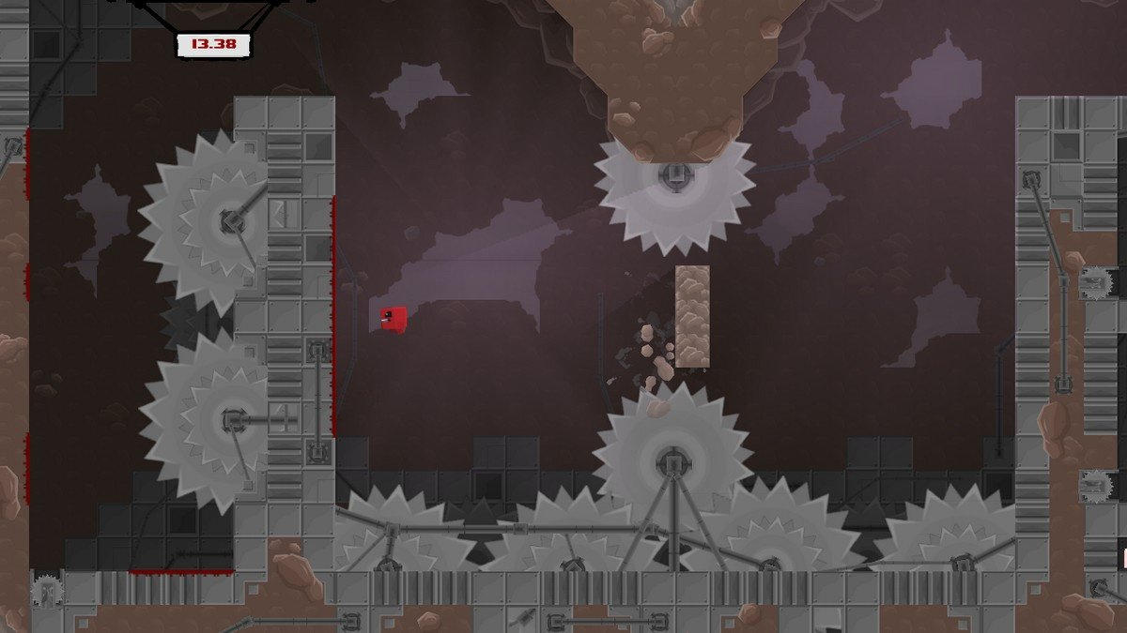

4.Analysis

4a. Requisites
Requisite | Date achieved
Movement and jump fully functional. | X
Collisions between the character, enemies and obstacles of the level.
Ability to do the walljumping. | X
Different playable levels. | X
Scroll in the levels. | X
Traps that kill the character. | X
Saving progression. | X
Load levels. | X
Enemies that patrol an area and other enemies that follow the character. | X
Scoreboard functional with the possibility to save own scores. | X
All screens completed. | X
Music inclusion in the intro screen, menu and levels.
Collectibles across each level. | X

4b. Basic pseudocode

4c. Classes diagram
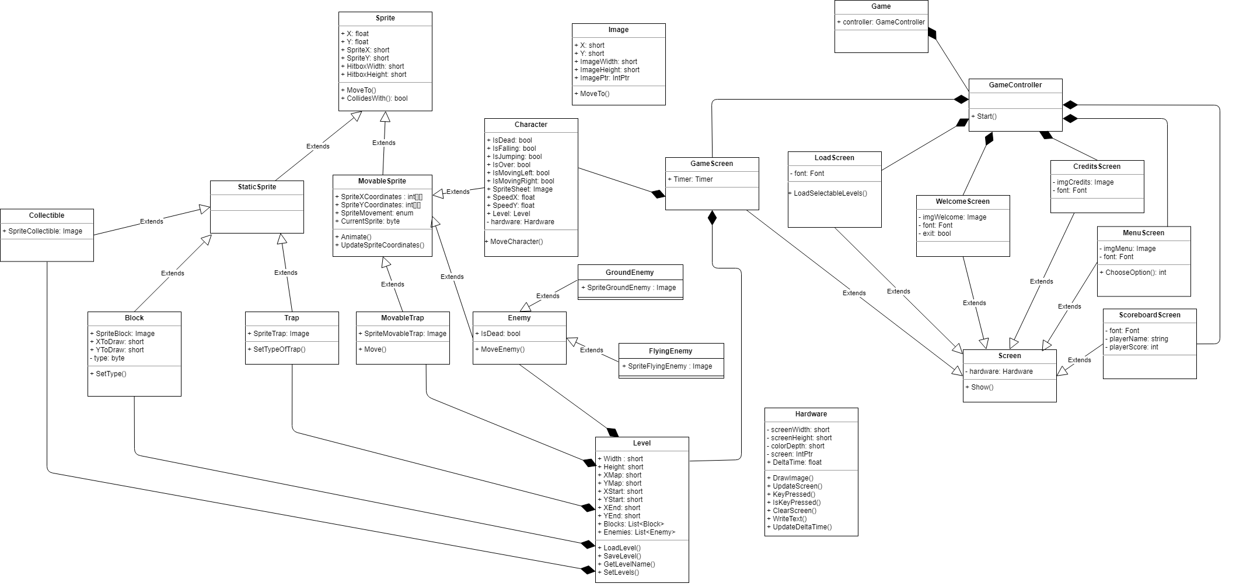

5. Initial planning and expected deliveries

5a. Expected deliveries

- Version 1: Basic approach of all the classes so they are ready for future versions. Main loop of the game that will load basic sprites and the spritesheet of the character along with the movement and jump.

- Version 2: Improving the game mechanics and movement with the addition of gravity with delta time, speed and acceleration of the character.

- Version 3: Loading and creating levels from txt files: ability to set a letter on the file and add this to the blocks list and display it on the game screen, and setting the start and end of the level so the character appears on that position.

- Version 4: Collision system with static objects based on a character array. Once done implementation of walljumping using the collisions with the blocks.

- Version 5: Implementation of the scroll with the screen and character and its adjustments. Transitioning between screens and death addition.

- Version 6: Addition of simple traps (spikes or deadly floor) and making the character die when getting in contact with them. These traps are static and have regular shapes.

- Version 7: Ability to save and load the progression of the levels cleared by writing and reading data from a file.

- Version 8: Load Level Screen fully functional: the levels completed can be selected, the others are locked and not selectable.

- Version 9: Addition of enemies with fixed movement patterns that can kill the character as well as displaying them in game and setting its hitbox.

- Version 10: Implementation of a timer to tell the time left to finish each level and the inclusion of the Credits screen.

- Version 11: Implementation of the intro screen and menu screen, creation of the tutorial level to show the mechanics of the game. Adding an extra difficulty that changes the speed of the enemies and the time necessary to finish the levels.

- Version 12: Scoreboard screen implementation for each level and displaying the records saved after finishing them.

- Version 13: Different kind of enemies with characteristic movement styles and speed: two types of enemies. One of these can fly and follow you around and the others are on the floor all time patrolling certain coordinates.

- Version 14: Different kind of blocks: blocks that disappear after having touched or stepped in one, with a different sprite than the normal ones. Creation of more levels including this new type of block.

- Version 15: Advanced collision and “complex traps” addition: these kind of traps are constantly moving and its collision must be calculated for each movement.

- Version 16: Collectibles: coins that add more points to the score. Music: playable in the intro, menu and game screens. And controller support using Tao Sdl mapping.

- Version 17: Addition of the double jump and the slide skills to the character and creation of a new set of levels to test them.

5b. Real deliveries

- Version 1: Basic approach of almost all the classes (skeleton for most of them). Main loop of the game that loads basic sprites, the sprites of the character along with its movement(not the final one) and test of loading an image. Also writing a text for testing purposes.

- Version 2: Inclusion of a new method to the Hardware class to calculate the delta time and use it on the movement and jump. Calling this method on the game loop and changes in Sprite attributes to calculate better the movement of the character and added speed to character in x and y axis and improved the code of the movement itself. Used gravity and delta time with these speeds.

- Version 3: Loading and creating levels from txt files: ability to set a letter on the file and add this to the blocks list and display it on the game screen, and setting the start and end of the level so the character appears on that position. [As expected]. Inclusion of some changes in the Block class to create them better and in the GameScreen to display them.

- Version 4 (The expected version 11): Implementation of the intro screen and menu screen, creation of the tutorial level to show the mechanics of the game. Adding an extra difficulty that changes the speed of the enemies and the time necessary to finish the levels.

- Version 5: Changes in some classes to implement the collision system and beginning of the collision system between the character and the list of blocks loaded from the level.

- Version 6: Implementation of the scroll with the screen and character and its adjustments but not accurate yet. Transitioning between screens and death addition.

- Version 7: As expected, addition of simple traps (spikes or deadly floor) and making the character die when getting in contact with them. These traps are static and have regular shapes. Also, started the implementation of the way to save levels.

- Version 8: Finished the ability to save and load the progression of the levels cleared by writing and reading data from a file. Started the implementation of the Load Level Screen.

- Version 9: As expected, Load Level Screen fully functional: the levels completed can be selected because this screen only loads the ones from the save file.

- Version 10: Almost finished the addition of enemies with fixed movement patterns that can kill the character as well as displaying them in game and setting its hitbox. And implemented all the visual screens and things left that will be visible in game.

- Version 11: As expected, implementation of a timer to tell the time left to finish each level and the inclusion of the Credits screen. Fixed the movement, added walljumping, added points and time in game and changed some screens.

- Version 12: Scoreboard screen implementation with new methods to load, save and check the input of the player after completing a level to save his name.

- Version 13: Different kind of enemies with characteristic movement styles and speed: two types of enemies. One of these can fly and follow you around and the others are on the floor all time patrolling certain coordinates, but the enemies aren’t drawn in game yet.

- Version 14: Added translation of the game in different languages pressing a key in the menu screen.

- Version 15: Bug fixes and little changes.

6. File formats

6a. Plain files format
The levels are loaded from txt files which contain characters of the game like ‘B’ to draw and obtain simple blocks or ‘T’ for traps, separated by commas to read them when loading a level. Just like this:

B,B,B,B,B,B,B,B,B
B, , , , , , , , , , , ,B
B, , , , ,B,B,B, , ,B
B,B,B,B,B,B,B,T,B

Also to save the progress of the player there is a txt file that writes the name of the level cleared so in the Load Level Screen this file can be read and display the levels that can be selected to load:

00_Tutorial
01_Level 1
02_Level 2
03_Level 3

And another file with “txt” format that is used to save and load the score of the players, so the game will display it in the Scoreboard Screen:

VCH;125;level1
GMF;241;level1

7. Problems found and solutions

One of the problems found was the implementation of the collision system correctly and is pending of being fixed.

Also, in the expected version 4, I had to implement the walljumping after the collision system was finished, but this was added in the version 11.

Another problem is the loading and change of the sprites of the enemies with its movement, not fixed yet.

