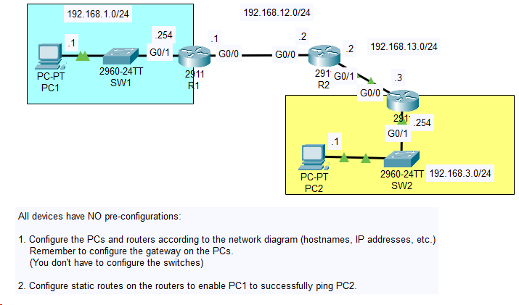

The following is the configs for the middle router:

This router has the routes built in statically->

!

version 15.1

no service timestamps log datetime msec

no service timestamps debug datetime msec

no service password-encryption

!

hostname R2

!

!

!

!

!

!

!

!

ip cef

no ipv6 cef

!

!

!

!

license udi pid CISCO2911/K9 sn FTX1524WL74-

!

!

!

!

!

!

!

!

!

!

!

spanning-tree mode pvst

!

!

!

!

!

!

interface GigabitEthernet0/0

description ## to R1 ##

ip address 192.168.12.2 255.255.255.0

duplex auto

speed auto

!

interface GigabitEthernet0/1

description ## to R3 ##

ip address 192.168.13.2 255.255.255.0

duplex auto

speed auto

!

interface GigabitEthernet0/2

no ip address

duplex auto

speed auto

shutdown

!

interface Vlan1

no ip address

shutdown

!

ip classless

ip route 192.168.1.0 255.255.255.0 GigabitEthernet0/0

ip route 192.168.3.0 255.255.255.0 192.168.13.3

!

ip flow-export version 9

!

!

!

no cdp run

!

!

!

!

!

line con 0

!

line aux 0

!

line vty 0 4

login

!

!

!

end

The following is the router 3 config:

!

version 15.1

no service timestamps log datetime msec

no service timestamps debug datetime msec

no service password-encryption

!

hostname R3

!

!

!

!

!

!

!

!

ip cef

no ipv6 cef

!

!

!

!

license udi pid CISCO2911/K9 sn FTX1524BUD8-

!

!

!

!

!

!

!

!

!

!

!

spanning-tree mode pvst

!

!

!

!

!

!

interface GigabitEthernet0/0

description ## to R2 ##

ip address 192.168.13.3 255.255.255.0

duplex auto

speed auto

!

interface GigabitEthernet0/1

description ## to SW2 ##

ip address 192.168.3.254 255.255.255.0

duplex auto

speed auto

!

interface GigabitEthernet0/2

no ip address

duplex auto

speed auto

shutdown

!

interface Vlan1

no ip address

shutdown

!

ip classless

ip route 192.168.1.0 255.255.255.0 192.168.13.2

!

ip flow-export version 9

!

!

!

no cdp run

!

!

!

!

!

line con 0

!

line aux 0

!

line vty 0 4

login

!

!

!

end