Question 1:

Question 2:

Question 3:



Notes:

https://www.pubconcierge.com/blog/subnetting-101-free-ipv4-cheat-sheet/

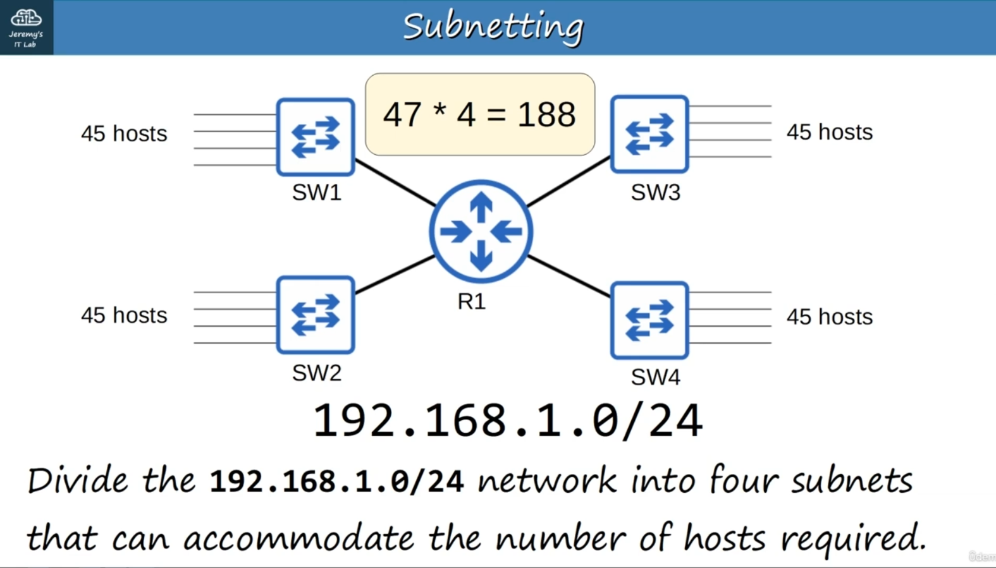

These are not point to point so we start at /30

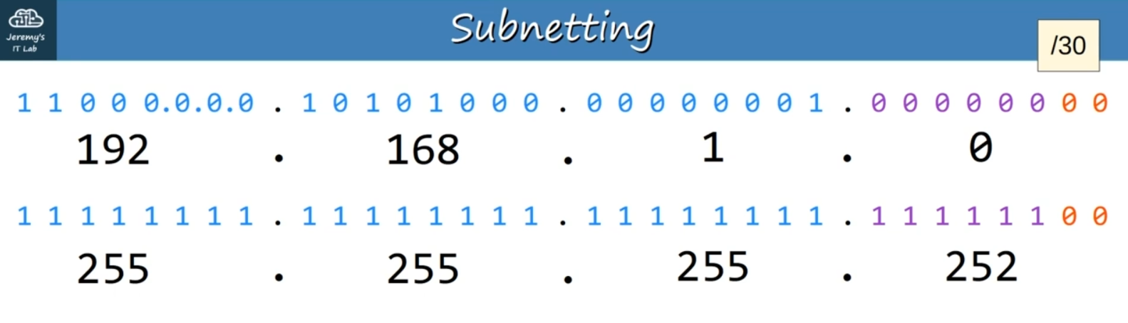

/29 is also too small for the number of hosts for each network

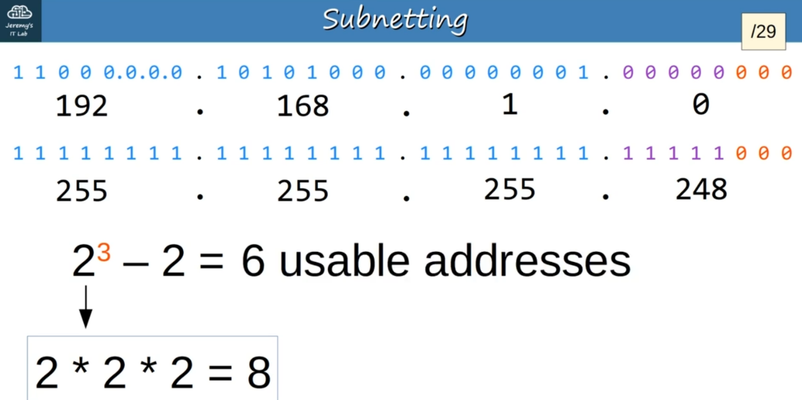

/28 is also too small:

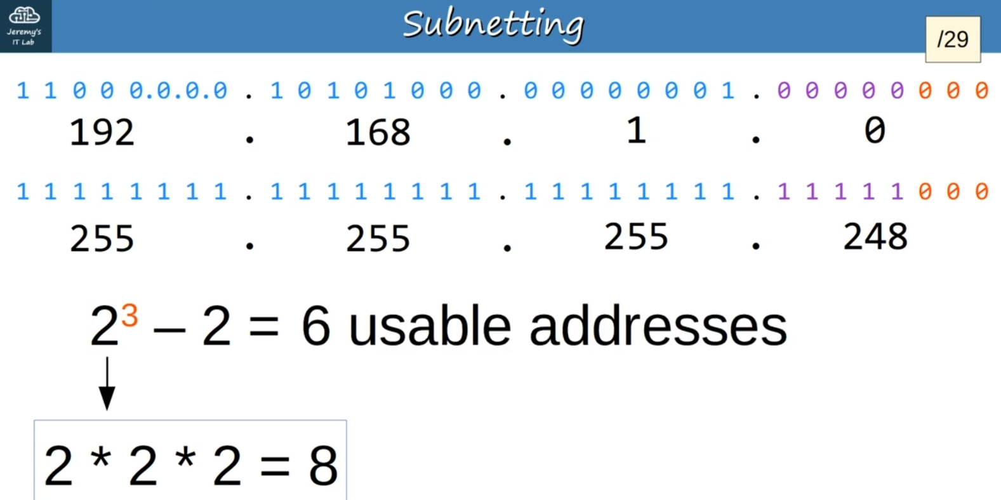

/27 is also too small

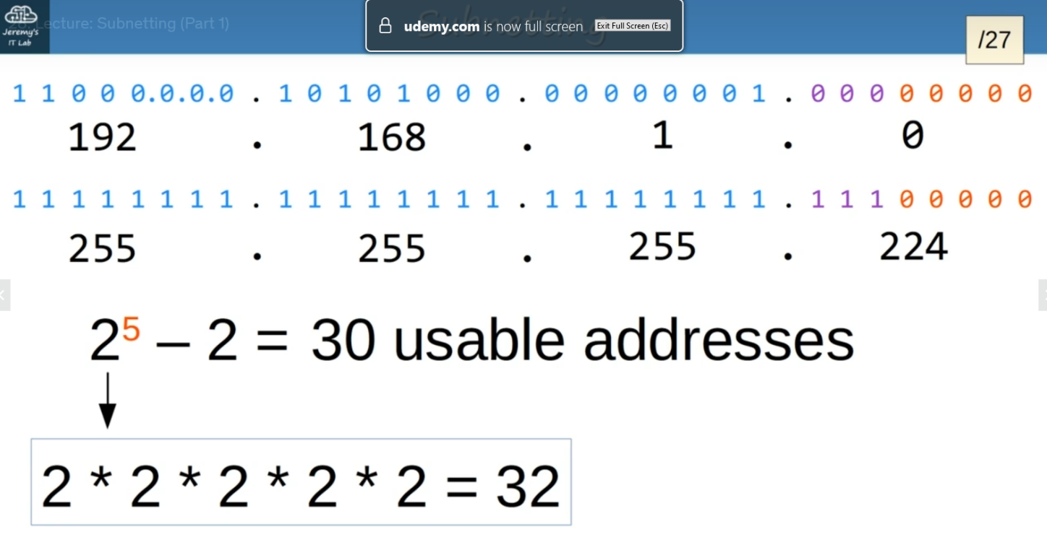

/26 is the smallest we can go:

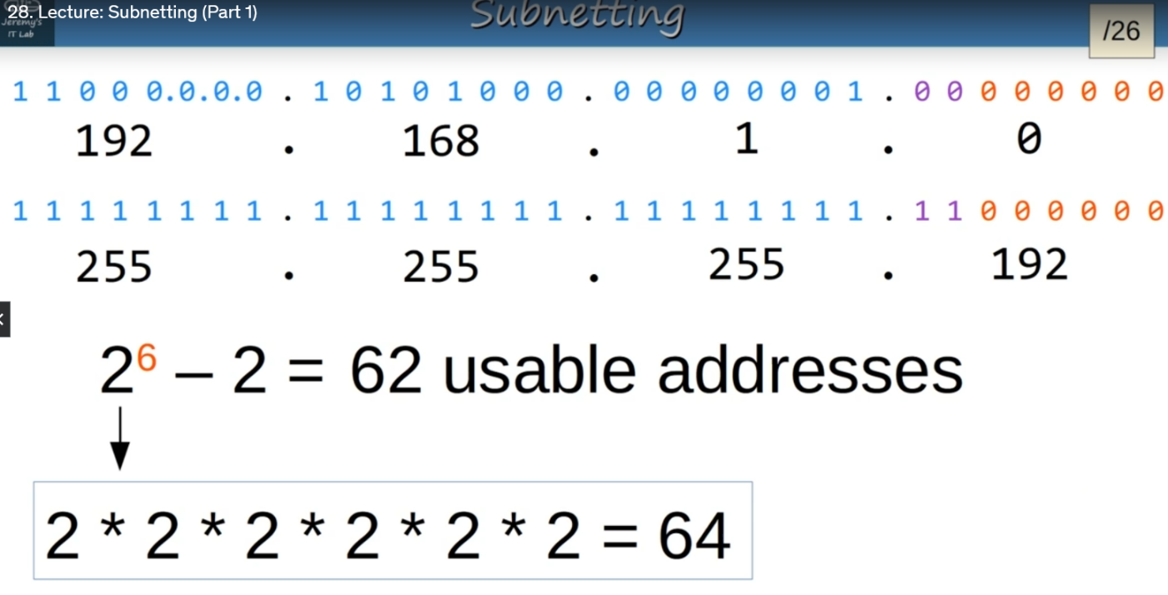

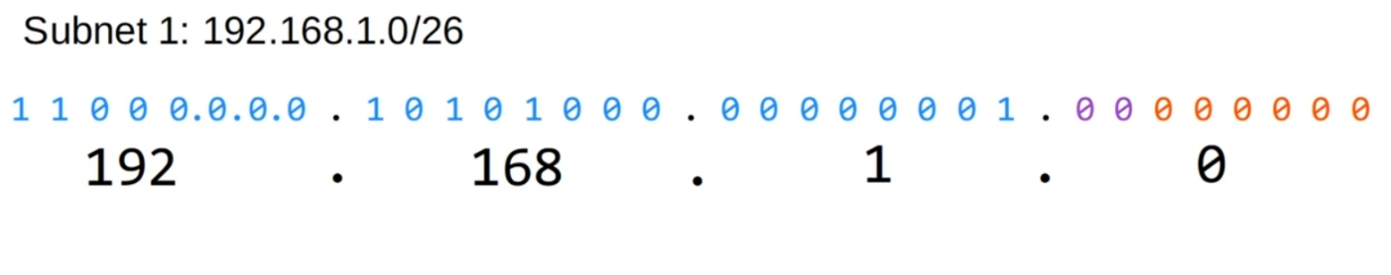Purple is what we borrowed from the network portion:

The broadcast address is the last address in the range and it is when all the host bits are set to 1:

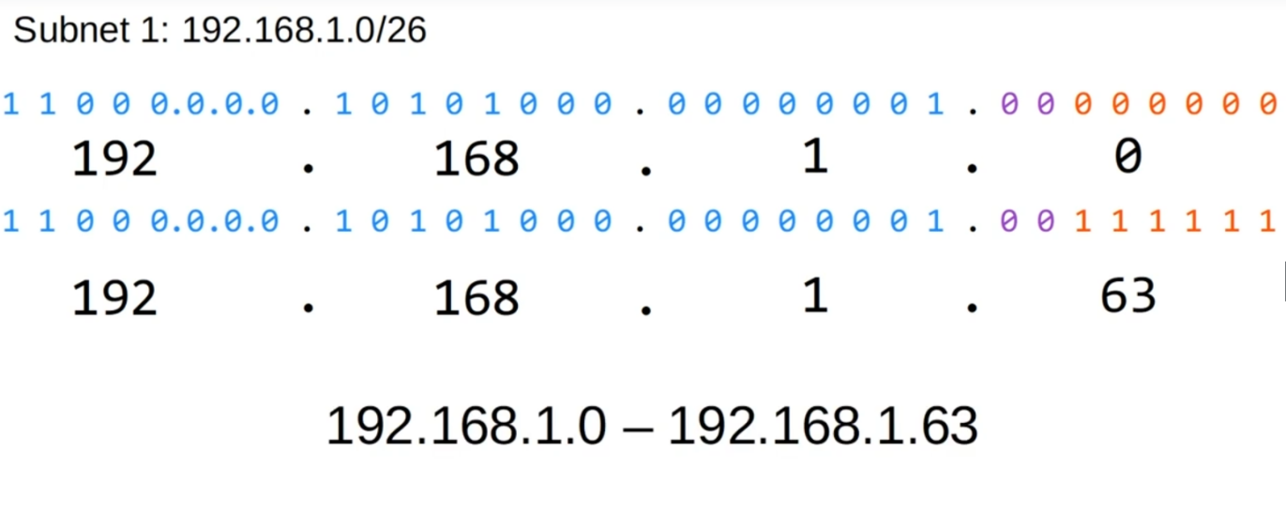

Subnet 2 will be one higher than the broadcast of the last subnet

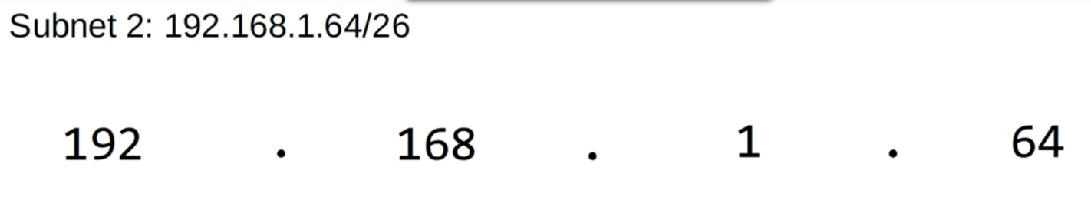

Change all the host bits to 1 to get the broadcast address:

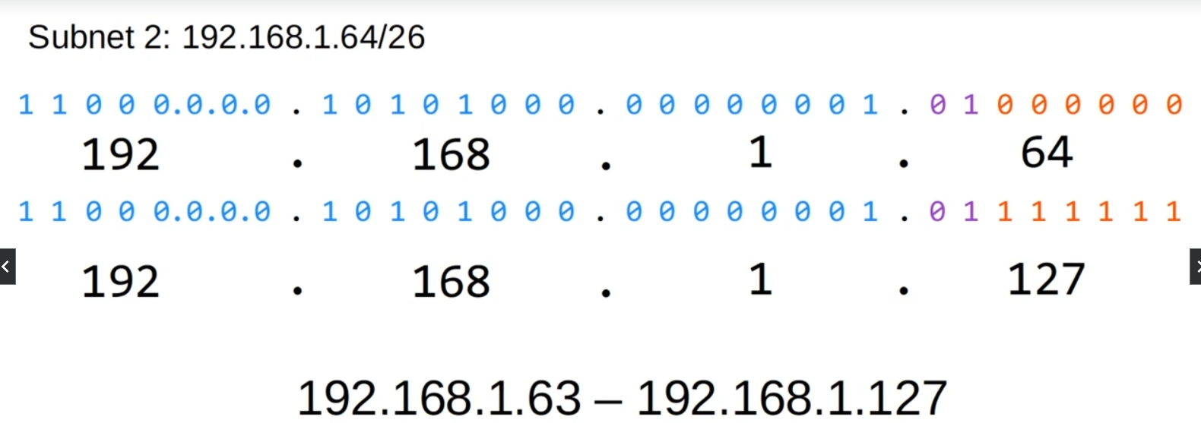

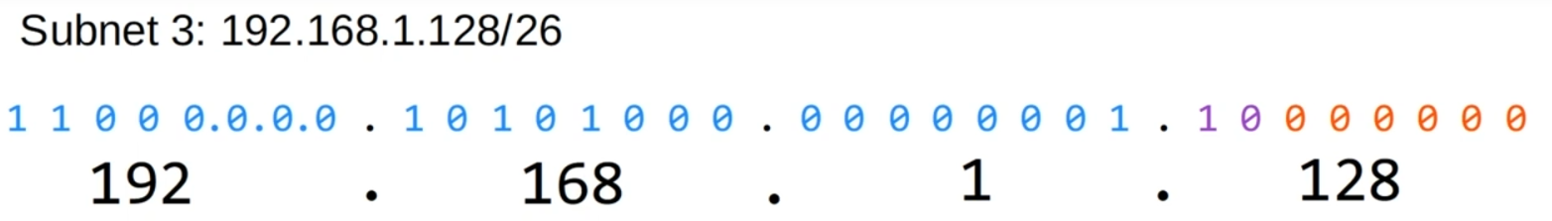Add 1 to the broadcast to get the next subnet:

Change all the host bits to 1:

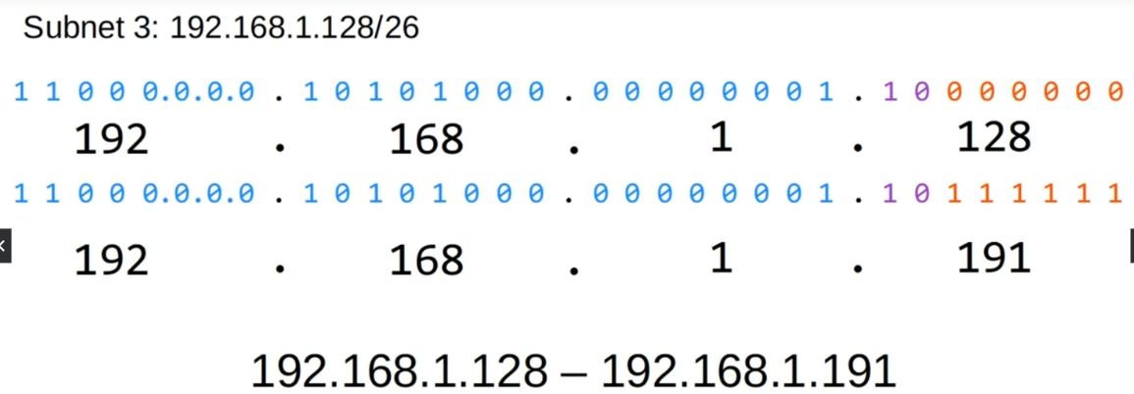

To find the next subnet all the borrowed bits are changed to 1

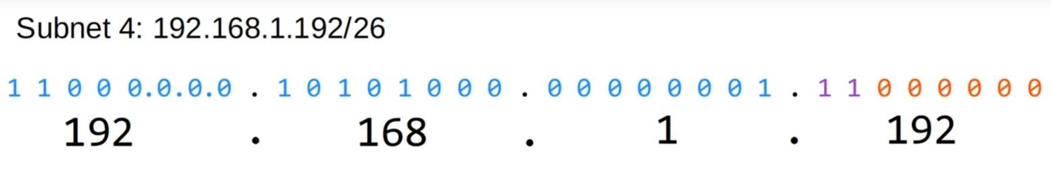

Change all the host bits to 1 now:

