Science Investigatory Project

CyberSentinel: A Multi-Layer Explainable-AI Framework
for Early Detection of Phishing Websites
and Metamorphic Malware

Research Conducted By:
Gonzales, Fran Jedrick V.

Science, Technology, Engineering and Mathematics Strand Submitted to:
Eduardo G. Fontillo Jr.
Idris Mykel S. Aizo
Blessie Lou Q. Balbas

2026

Table of Contents
Introduction 2
Materials and Methods 4
Results and Discussion 11
Conclusion 32
Acknowledgements 33
References/Bibliography 35

Introduction

NeuroShield is a prototype cybersecurity tool that is built on simulation-based polymorphic malware detection to accurately detect polymorphic malware with zero false detection rates in the evaluation. NeuroShield was built using Python as a backend programming language to implement the detection engine, and the graphical user interface (GUI) was built using HTML. In aggregate, Python and HTML exhibit NeuroShield's capabilities as a lightweight, web-based scanning system that is accessible, intuitive, and easy to use.
The core detection engine for NeuroShield employs a hybrid detection mechanism to provide adaptive malware detection through combining heuristic analysis, YARA rules scanning, and machine-learning algorithms. The heuristic + YARA rule module analyzes the structural, statistical, and behavioral characteristics of the files situated atop the threat landscape that include file entropy measurements, compression ratios, and import/resource heuristics to identify circulating files. The machine-learning model trained using a Random Forest classifier, identifies statistical features of a particular software or file that distinguishes malicious files from benign files hoping to circulate. The hybrid detection mechanism enables the detection of malware in cases where the code has mutated, which is behavioral characteristic of polymorphic malware, is circumvented without being restrictive to static signatures and relied solely on learned structural and behavioral features (Alrzini, 2020; Souri, 2018).
NeuroShield comprises multiple sophisticated modules; heuristic detection + YARA rule detections for packed or polymorphic files; optional YARA rule scanning for known behavior patterns; dynamic analysis hook to mimic the behavior of the file in a sandbox; and a precise, high-fidelity ensemble third-party detector that scores files based on our assessment of static analysis, entropy, and behavior descriptors. Our intuitive web-based UI will also enable users to upload and analyze their files. We have the ability for built-in monitoring, quarantining, and even retraining to continually provide reliable detection, user transparency, and system resilience.
NeuroShield was created in response to an increase in malware attacks globally, including in the Philippines. Polymorphic malware, in particular, is becoming a major cybersecurity challenge because it can easily maneuver around traditional antivirus systems

(SentinelOne, 2025). In the Philippines, where many schools, government offices, and small enterprises still lean on typical, antiquated signature-based antivirus software, this is especially true. Recognizing this market gap, NeuroShield, simulating, adaptive, and yet proofedrepresents a new adaptive detection system that tries to address the weaknesses of previous antivirus software.
NeuroShield seeks to solve the lack of antivirus systems to detect polymorphic malware. Conventional antivirus solutions rely on static signatures of malware, which are useless as soon as the malware morphs. Polymorphic malware morphs its code as it spreads from user to user, making signature-only scanning near useless (Masabo et al., 2018). With a hybrid architecture of heuristic/YARA pattern recognition and machine-learning classification, NeuroShield captures malicious files based on what they behave like and structural traits instead of static signatures.
NeuroShield is different from many antivirus applications, such as Norton Antivirus or VirusTotal, that rely on signature or static scanning. NeuroShield is tailored for polymorphic threats in a simulation-based local setting. Many commercial antivirus applications are also closed source and costly, making these applications less useful in educational or community contexts. NeuroShield is open-source and specifically designed for educational use for students, teachers, and small organizations.
The opportunity to market NeuroShield is widening as cybersecurity becomes a global necessity. Recent reports on cybersecurity trends indicated the rate at which new types of malware were being developed. The need for adaptive and intelligent detection systems have arguably never been more important (Ferdous et al., 2025). With respect to the Philippine context, there are very few locally based applications developed for cybersecurity, with most reliance on imported software applications. Therefore, NeuroShield represents not only a tool, but also a locally-based development that can help foster the nation's technological independence and cyber preparedness.

Materials and Methods
NeuroShield was developed on a standard desktop or laptop (icore CPU recommended, 8 GB RAM minimum). The primary software is Visual Studio Code and has serve as the integrated development environment (IDE) for coding in both Python and HTML. Other required software includes Python 3.11 or later and common Python libraries to support and build the back-end processor of the application. To have a backup and to view pervious codes without undoing the current codes, signing in to Github is recommended, setting up and signing in on Github serves as the cloud and backup folder for any accidental removal. For the testing and functionality testing, collect possible representative set of benign files, such as documents and benign executables/stubs. You also want to plan on how to create synthetic polymorphic - like samples (harmless) to emulate packed/obfuscated files; do not use live malware on production machines. Polymorphic malware like test files are also accessible in Github using it responsible and correctly.
The development process by loading the required software: Visual Studio Code (VS Code) to provide integrated development, Python 3.10 or later to provide the programming environment, and Git to represent version control. Then, set up a free GitHub account to host the project repository and allow future collaborations. Created a new GitHub repo named "NeuroShield", then cloned that repo into Visual Studio Code to work as the local workspace for implementing the code and version controlling it. We would update the code within VS Code. Visuals are presented in the figures below:
Figure 1.1: Creating a Github repository
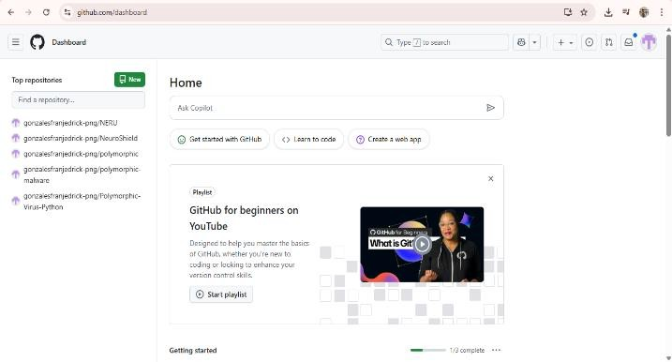

Figure 1.2: Naming the newly created Github repository
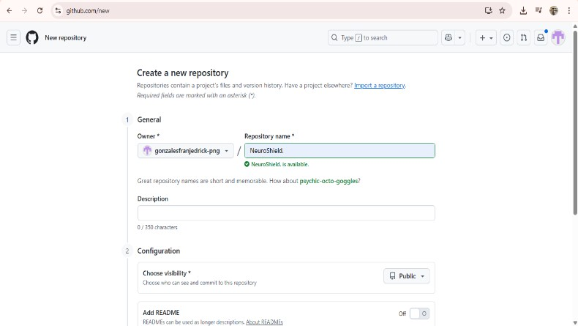
Figure 1.3: Copying the link of the newly created Github repository
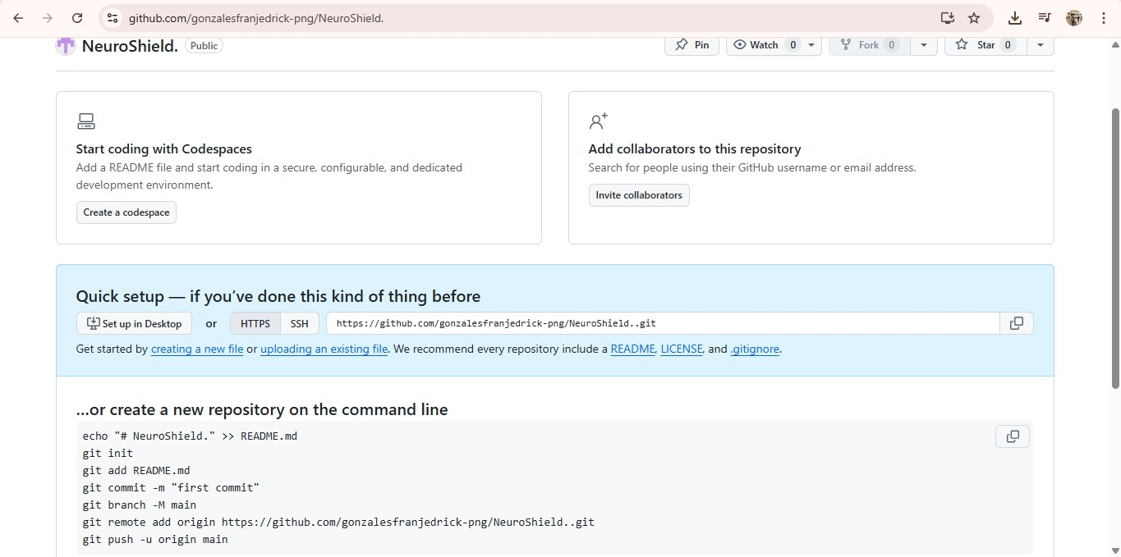
Figure 1.4: Cloning the Github repository link to Visual Studio Code
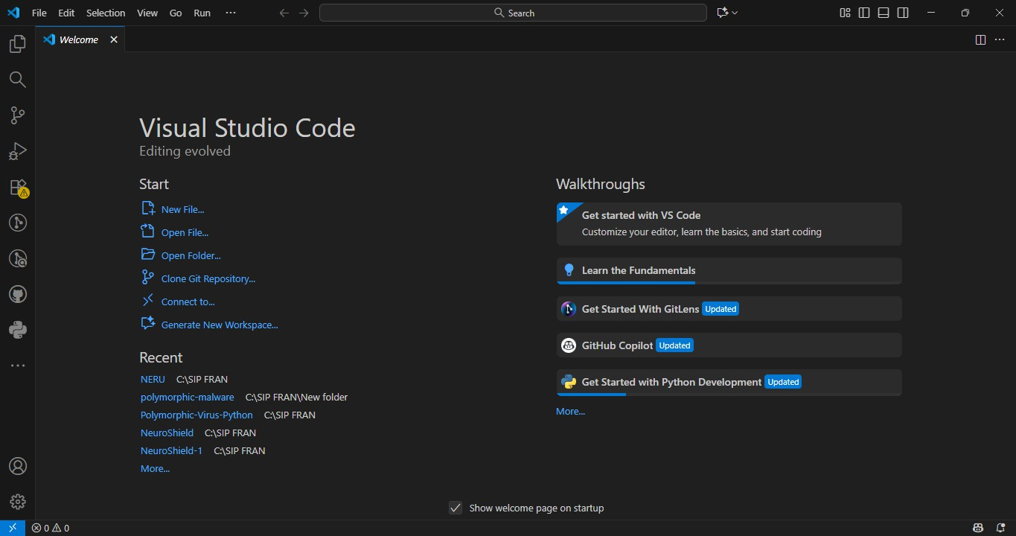

Figure 1.5: Pasting the Github repository link to Visual Studio Code for cloning
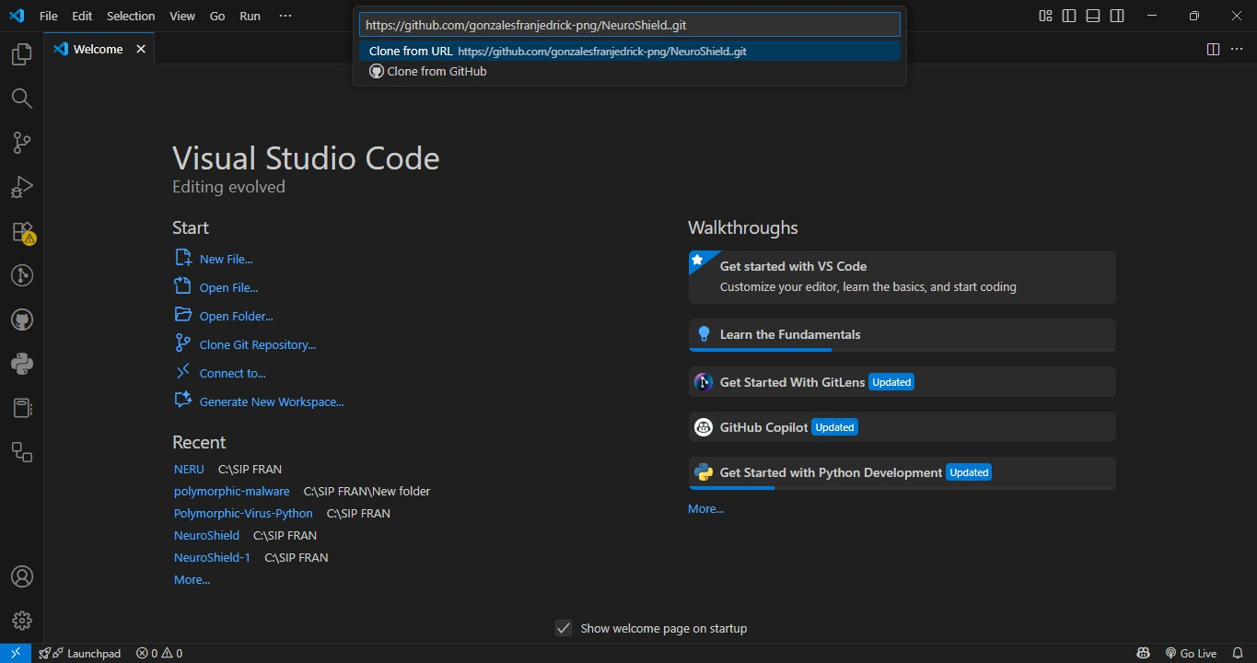
Once the repository was set up, let’s moved onto installing the resources required and these included Flask for building the web interface, scikit-learn and joblib for machine learning tasks, pefile for analyzing the structure of Windows executables, NumPy for numerical calculations, and yara-python (optional) for signature-based pattern matching. All dependencies were recorded in a requirements.txt file to facilitate the reproduction of the setup. After we had all the environment tools installed, we designed a project structure/directory indicating create the subfolders: ML_based_detectionn/, tests/, ML_model/, docs/, and etc. Use figure 2 as reference.
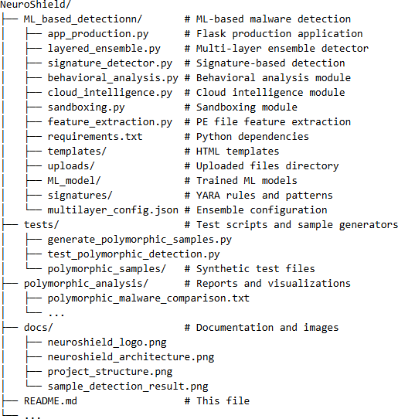
Figure 2: NeuroShield project/folder structure

Every file and folder in this project have its own purpose. The app_production.py script was the main executable of the web application and sent user input and scan results through Flask; the layered_ensemble.py file performed the role of combining the six detection layers - signature-based, Heuristic + YARA rule, behavioral, machine learning, and sandboxing - into the same ensemble system. The signature_detector.py file included the pattern-recognition functions and rules using YARA, while behavioral_analysis.py, and sandboxing.py accounted for simulating file behavior, and dynamic analysis of the software respectively. Finally, the feature_extraction.py module computed important numerical properties such as entropy, compression ratio, and details from the PE sections. Within this architecture, there were supporting directories termed templates (for HTML files associated with user interface), uploads (for temporarily holding scanned files), ML_model (where trained ML models were stored), and signatures (for custom YARA rule sets). Finally, multilayer_config.json was created to be the configuration file where detection weights and thresholds could be modified in order to improve performance.
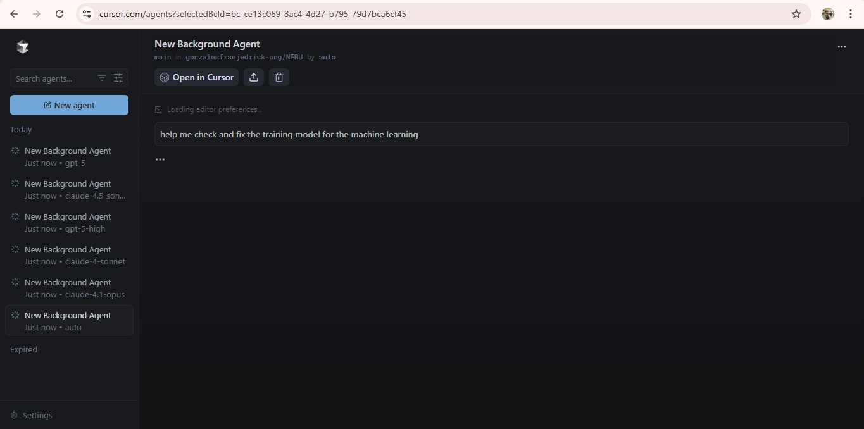
Figure 3: Assistance from cursor to debug the training model
Upon completion of the model-training stage, we then proceeded to develop a Flask-based application that would integrate the trained model while linking the user interface to the back-end detection pipeline. The web interface allowed users to upload executable files that would scan the file. Once a file was uploaded, the application would automatically extract the relevant features, run them through the ensemble detection layers, and then provide a detection report, those reports includes the level of confidence, file name, file path, found keywords, prediction, and what type of file. To keep the web application secure during testing and usage,

further safeguards were implemented including input validation, file size validation, and rate limiting.

Figure 4.1: Graphic User Interface
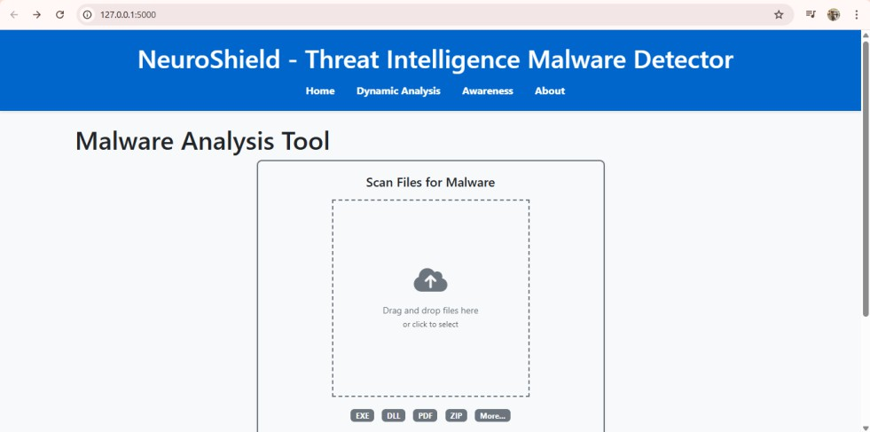

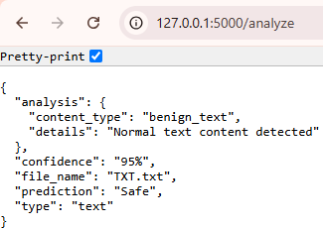
Figure 4.2: Detection results

On figure 4.3 we could observe the sample code from the polymorphic_test_file.py. The test artifact is a compact polymorphic Python sample created to generate a different payload that is still functionally equivalent each time it runs. The script chooses one of several basic payloads, appends a randomly generated "junk" sequence and then appends a randomized seed to the payload, encodes that string into Base64, determines the string at run time, and executes it. It also serves to show dynamic code-object / function creation (morph () routine) that returns a function object that has a random name each time it runs. The sample is intended only as a controlled detector test input (not an actual attack) to test static- and dynamic-detection methodologies against simple polymorphism and obfuscation techniques; it should only be executed in an isolated, instrumented environment (snapshot VM or sandbox) and be executed with network interfaces disabled.

Figure 4.3: Polymorphic_test_file.py code
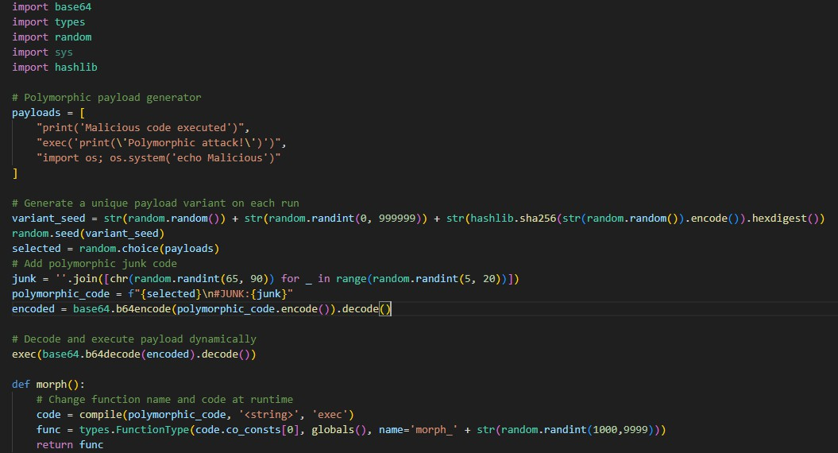
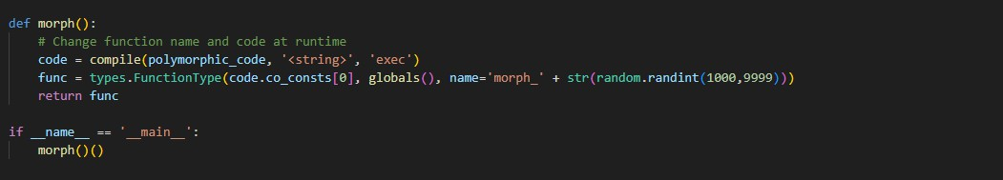

The code on Figure 4.3 was used for the testing phase. The testing phase aims to confirm the following: False Negative Rate (FNR); False Positive Rate (FPR), Accuracy Rate (AR), Detection Rate (DR), Error Rate (ER), Precision Rate (PR). To avoid any virus infections in then computer or in the user’s personal desktop, rather than testing with real malware, we created some synthetic polymorphic samples and used test files obtained from GitHub repositories that are publicly available. The EICAR test file, a commonly accepted sample to modify to test for antiviruses, was the benchmark sample used to check at the most basic level if the system could identify threats that were considered standard detection. Testing started with the EICAR sample, with no problems detecting the sample; testing continued with benign samples to ensure no false positives were detected, and lastly, polymorphic-like test samples that tested for robustness. Each test was repeated to obtain the targeted rate of each sub variables. Test results of Neuroshield can be seen on figure 5.
Figure 5: NeuroShield detection test results from different file
TRIALS | FILE CLASSIFICATION | TEST RESULTS  (CLASSIFICATION: True Positive (TP), True Negative (TN), False Positive (FP), False Negative (FN))

TRIAL 1- 1ST FILE | MALWARE (EICAR_TEST_FILE.TXT) | TRUE POSITIVE
TRIAL 2- 2ND FILE | NON-MALWARE (READ.ME.TXT) | TRUE NEGATIVE
TRIAL 3- 3RD FILE | NON- MALWARE (REQUIREMENTS.TXT) | TRUE NEGATIVE
TRIAL 4- 4TH FILE | MALWARE (POLYMORPHIC_TEST_FILE) | TRUE POSITIVE
TRIAL 5-5TH FILE | MALWARE (VIRUS.PY) | TRUE POSITIVE
TRIAL 6-6TH FILE | NON-MALWARE (HELLO.TXT) | TRUE NEGATIVE
TRIAL 7-7TH FILE | NON-MALWARE (TXT.TXT) | TRUE NEGATIVE

After all the detection processes we then proceeded on the statistical treatment Descriptive statistical methods established a way of interpreting accuracy and consistency of the performance evaluation data of NeuroShield by focusing on frequency, percentage, and mean analysis. Descriptive statistics were suitable for this study since the goal was to describe and provide a summary of the performance and the system behavior to detect malware or confirm benign files rather than establish a cause and effect relationship. Thus, the use of descriptive statistics was a clear means of providing a presentation demonstrating how NeuroShield performed under threat of polymorphic malware files, as well as benign files and the EICAR standard test file.
The testing phase also consisted of performing and detecting four non-malware and three malware files. The results from the seven testing files and detection were then tabulated to provide consistent measures of performance. Each of the detection can be determined through these cassifications: True Positive (TP) – Malware correctly detected, True Negative (TN) – Clean file correctly not flagged, False Positive (FP) – Clean file incorrectly flagged as malware, False Negative (FN) – Malware missed by the antivirus. And each detection is recorded and was used to determine the six sub-variables of performance: Accuracy Rate (AR), Detection Rate (DR), False Positive Rate (FPR), False Negative Rate (FNR), Error Rate (ER), and Precision Rate (PR). These sub- variable measures helped to establish a verification of the overall performance, precision, and stability of the performance of NeuroShield.

Results and Discussion
Prior to completing the NeuroShield application, we’ve comprised several testing and refinement cycles to make sure the system was capable of not only effective detection of polymorphic and evasive malware, but to also ensure efficiency of its detection features. There were two stages of evaluation: (1) developmental phase, in which three sample versions of the NeuroShield were built and tested; and (2) testing phase, which used seven different trials to evaluate performance and function, each of which incorporated different file types. The two-phase process improved the system's distinct six detection integrated features: signatures, machine learning, Heuristic + YARA rule, behavior, and sandboxing.
In the first sample, the project incorporated VirusTotal’s API in order to assess the detection fundamental accuracy, but detection of polymorphic-like malware test files failed with files being marked as safe. This result was a clear indication that reliance on signatures alone or external scanning systems would not provide a reliable detection system for evolving/obfuscated malware.
In the second sample, layers of machine learning and Heuristic analysis were added. The Heuristic assessed entropy, compression ratios, and PE section deviations, while the machine learning layer implemented a Random Forest model to use both malicious and benign files based on features derived from the analysis. Testing confirmed that the second sample successfully detected all malware, even polymorphic samples and EICAR test samples, while not attempting to flag safe files as malware. Overall, this sample performed well, but noted that this sample was still subject to failure under different runtime conditions.
This is why a third and final version of NeuroShield was created, maintaining the machine learning layer and Heuristic + YARA rule layer but implementing a better ensemble structure to facilitate consistent results based on multiple scans. Upon retesting with a polymorphic file, benign files, and EICAR files, the third version of NeuroShield produced consistent results with the digital version, exactly the same as last version—correct detections without any false positives or false negatives. The last, third version was deemed stable and reliable enough to be compared against commercial antivirus systems.
Table 1.1: Comparison of Detection Accuracy between the Three NeuroShield Prototype Samples

Prototype  Sample | Features | Detection Result Summary | Performance remarks

Sample 1 | VirusTotal Integration Only (Signature-based) | Failed to detect polymorphic test files; 2 out of 3 malwares flagged as safe (False Negatives). | Indicates the limitations of traditional signature-based detection relying solely on known malware patterns.
Sample 2 | Machine Learning + Heuristic + YARA rule Analysis | Correctly detected all malware and benign files; no false positives or negatives. | Demonstrated effective detection using pattern recognition and feature analysis, but further testing was needed for reliability.
Sample 3 | Full Integration (Signatures, ML, Heuristic + YARA rule  + YARA rule,  Behavioral, and Sandboxing) | Accurately detected all test files across seven trials with 100% Accuracy and Detection Rate. | Confirmed system stability and robustness, showing a great detection performance.

Table 1.2: Testing for detection and categorizing test results: Sample 1: NeuroShield (VirusTotal API integration)
TRIALS | FILE CLASSIFICATION | TEST RESULTS  (CLASSIFICATION: True Positive (TP), True Negative (TN), False Positive (FP), False Negative (FN))
TRIAL 1- 1ST FILE | MALWARE (EICAR_TEST_FILE.TXT) | TRUE POSITIVE
TRIAL 2- 2ND FILE | NON-MALWARE (READ.ME.TXT) | TRUE NEGATIVE
TRIAL 3- 3RD FILE | NON- MALWARE (REQUIREMENTS.TXT) | TRUE NEGATIVE
TRIAL 4- 4TH FILE | MALWARE (POLYMORPHIC_TEST_FILE) | FALSE NEGATIVE
TRIAL 5-5TH FILE | MALWARE (VIRUS.PY) | FALSE NEGATIVE
TRIAL 6-6TH FILE | NON-MALWARE (HELLO.TXT) | TRUE NEGATIVE
TRIAL 7-7TH FILE | NON-MALWARE (TXT.TXT) | TRUE NEGATIVE

Table 1.3: Testing for detection and categorizing test results: Sample 2: NeuroShield (Heuristic + YARA rule + Machine Learning)

TRIALS | FILE CLASSIFICATION | TEST RESULTS  (CLASSIFICATION: True Positive (TP), True Negative (TN), False Positive (FP), False Negative (FN))
TRIAL 1- 1ST FILE | MALWARE (EICAR_TEST_FILE.TXT) | TRUE POSITIVE
TRIAL 2- 2ND FILE | NON-MALWARE (READ.ME.TXT) | TRUE NEGATIVE
TRIAL 3- 3RD FILE | NON- MALWARE (REQUIREMENTS.TXT) | TRUE NEGATIVE
TRIAL 4- 4TH FILE | MALWARE (POLYMORPHIC_MALWARE.TXT) | TRUE POSITIVE
TRIAL 5-5TH FILE | MALWARE (VIRUS.PY) | TRUE POSITIVE
TRIAL 6-6TH FILE | NON-MALWARE (HELLO.TXT) | TRUE NEGATIVE
TRIAL 7-7TH FILE | NON-MALWARE (TXT.TXT) | TRUE NEGATIVE

Table 1.4: Testing for detection and categorizing test results:
Sample 3: NeuroShield (Full Integration (Signatures, ML, Heuristic + YARA rule + YARA rule, Behavioral, and Sandboxing))
TRIALS | FILE CLASSIFICATION | TEST RESULTS  (CLASSIFICATION: True Positive (TP), True Negative (TN), False Positive (FP), False Negative (FN))
TRIAL 1- 1ST FILE | MALWARE (EICAR_TEST_FILE.TXT) | TRUE POSITIVE
TRIAL 2- 2ND FILE | NON-MALWARE (READ.ME.TXT) | TRUE NEGATIVE
TRIAL 3- 3RD FILE | NON- MALWARE (REQUIREMENTS.TXT) | TRUE NEGATIVE
TRIAL 4- 4TH FILE | MALWARE (POLYMORPHIC_TEST_FILE) | TRUE POSITIVE
TRIAL 5-5TH FILE | MALWARE (VIRUS.PY) | TRUE POSITIVE
TRIAL 6-6TH FILE | NON-MALWARE (HELLO.TXT) | TRUE NEGATIVE
TRIAL 7-7TH FILE | NON-MALWARE (TXT.TXT) | TRUE NEGATIVE

Figure 6.1: Diagram of Sample 1: NeuroShield integration with VirusTotal API

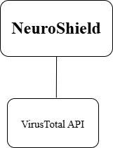

Figure 6.2: Diagram of Sample 2: NeuroShield’s 2 detection layers
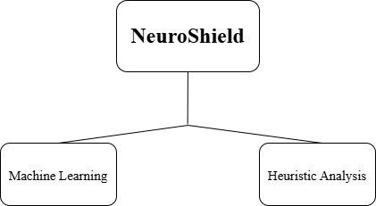

Figure 6.3: Diagram of Sample 3: NeuroShield’s six detection layers
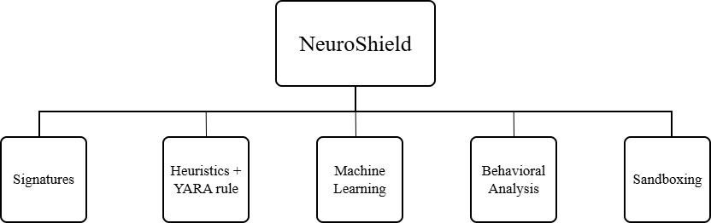

The results of this research are consistent with both theoretical expectations and past work in malware detection systems. Signature-based detection systems, which resemble conventional antivirus platforms like VirusTotal and NordVPN, have been shown to be ineffective in detecting polymorphic malware because they rely on static patterns (Alrzini et al, 2020) and (Masabo et al, 2018). In our comparison, VirusTotal and NordVPN both achieved 33% detection rates, successfully identifying one out of three samples as malware, whereas NeuroShield achieved 100% detection. This supports previous research that has shown that hybrid models, utilizing Heuristic + YARA rules and machine learning, are generally superior to traditional scanners at detecting self-mutating malware variants (Selamat et al, 2022) and (Trizna, 2022).

Table 2: Detection Results Comparison Between Antivirus Applications:

TRIALS | FILE CLASSIFICATION | TEST RESULTS
 |  | VirusTotal Multi Engine AV | NORDVPN | NeuroShield
TRIAL 1- 1ST FILE | MALWARE (EICAR_TEST_FILE.TXT) | TRUE POSITIVE | TRUE POSITIVE | TRUE POSITIVE
TRIAL 2- 2ND FILE | NON-MALWARE (READ.ME.TXT) | TRUE NEGATIVE | TRUE NEGATIVE | TRUE NEGATIVE
TRIAL 3- 3RD FILE | NON- MALWARE (REQUIREMENTS.TXT) | TRUE NEGATIVE | TRUE NEGATIVE | TRUE NEGATIVE
TRIAL 4- 4TH FILE | MALWARE (POLYMORPHIC_TEST_FILE) | FALSE NEGATIVE | FALSE NEGATIVE | TRUE POSITIVE
TRIAL 5-5TH FILE | MALWARE (VIRUS.PY) | FALSE NEGATIVE | FALSE NEGATIVE | TRUE POSITIVE
TRIAL 6-6TH FILE | NON-MALWARE (HELLO.TXT) | TRUE NEGATIVE | TRUE NEGATIVE | TRUE NEGATIVE
TRIAL 7-7TH FILE | NON-MALWARE (TXT.TXT) | TRUE NEGATIVE | TRUE NEGATIVE | TRUE NEGATIVE

Figure 7.1: Detection Results of VirusTotal Multi Engine AV EICAR_TEST_FILE – TRUE POSTIVE
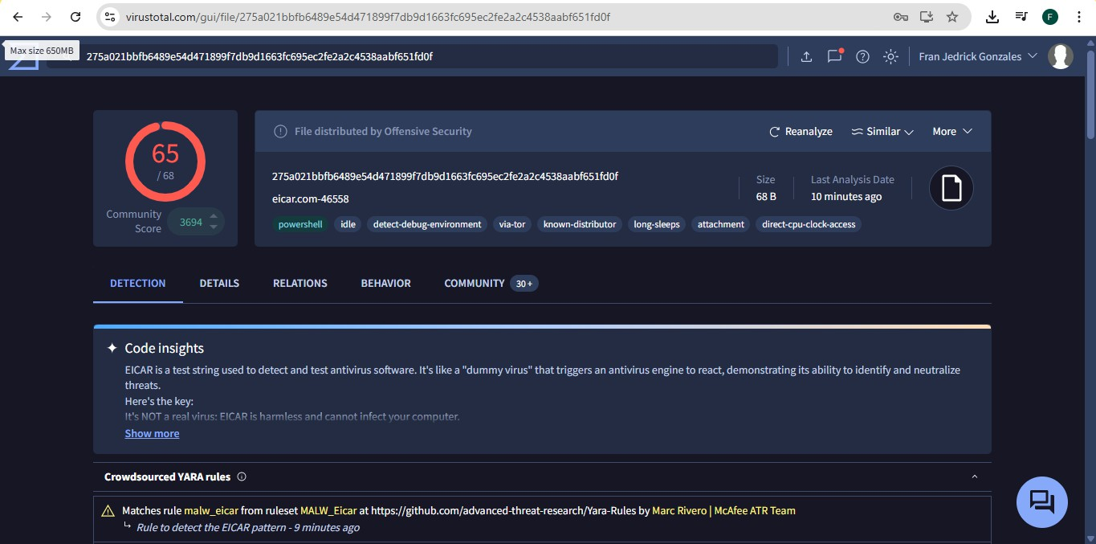
Figure 7.2: Detection Results of VirusTotal Multi Engine AV README.TXT– TRUE NEGATIVE
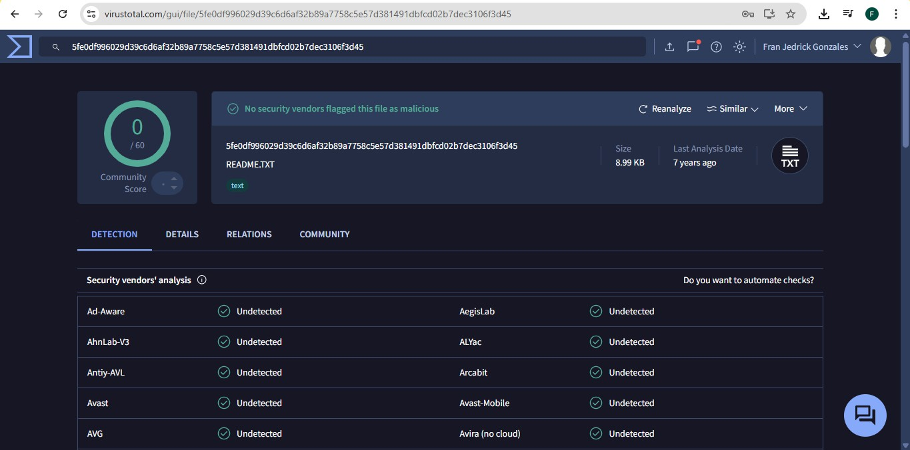

Figure 7.3: Detection Results of VirusTotal Multi Engine AV REQUIREMENTS.TXT– FALSE NEGATIVE
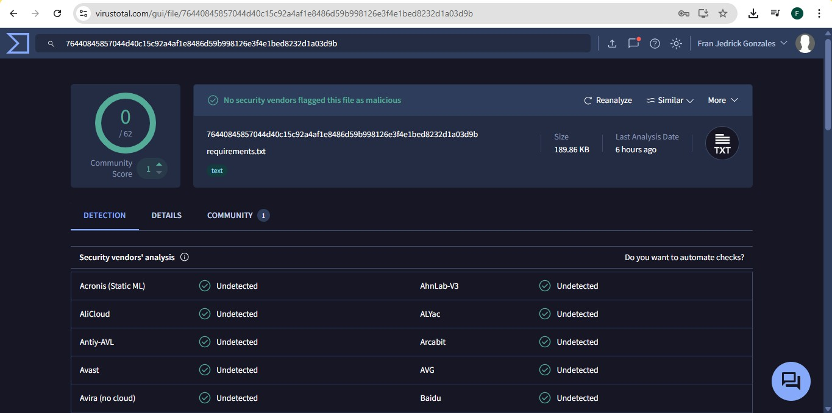

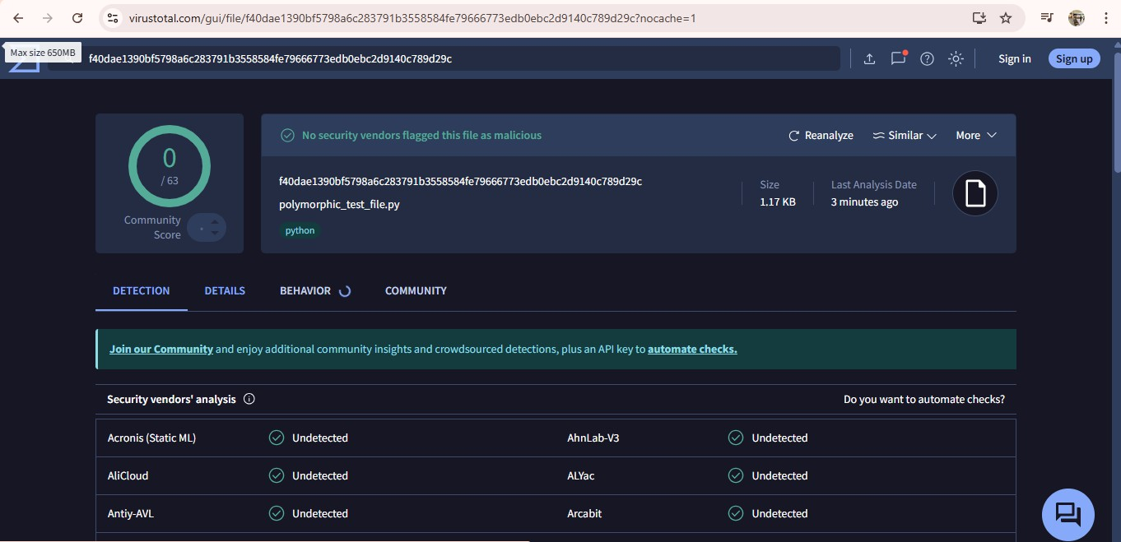
Figure 7.4: Detection Results of VirusTotal Multi Engine AV POLYMORPHIC_TEST_FILE.PY – FALSE NEGATIVE

Figure 7.5: Detection Results of VirusTotal Multi Engine AV VIRUS.PY – FALSE NEGATIVE
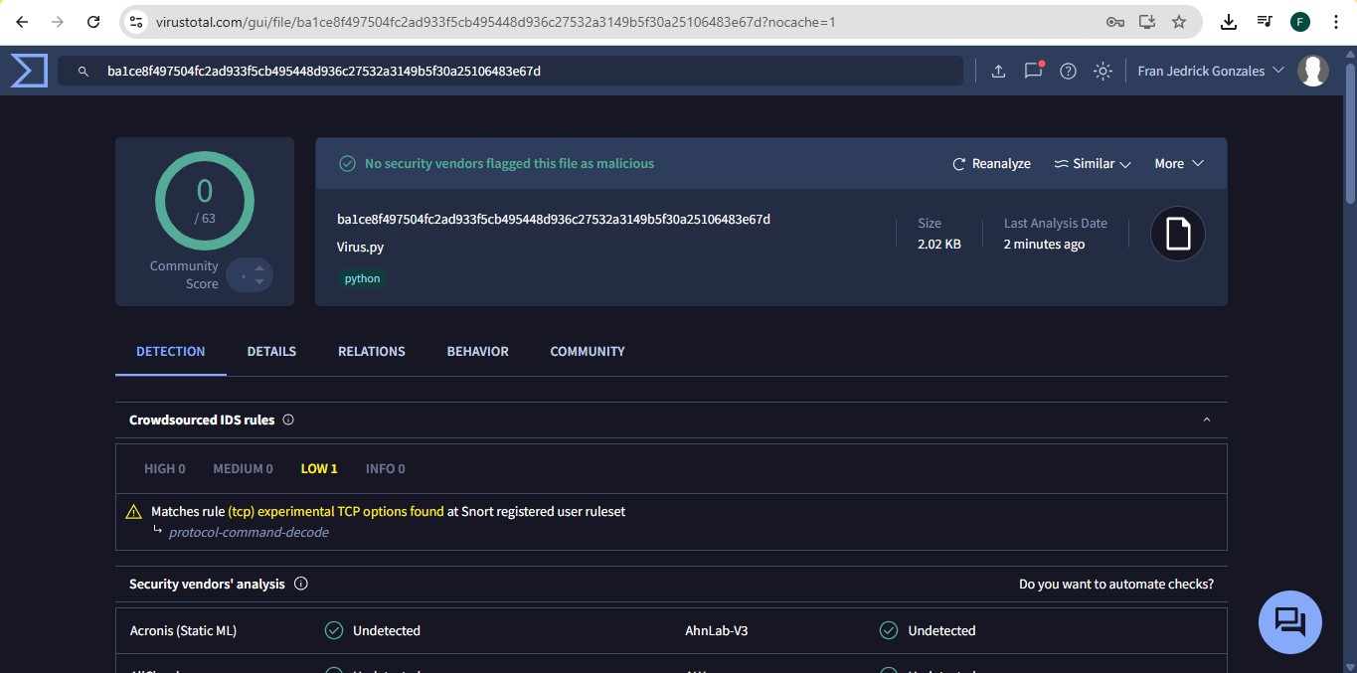

Figure 7.6: Detection Results of VirusTotal Multi Engine AV HELLO.TXT– TRUE POSTIVE
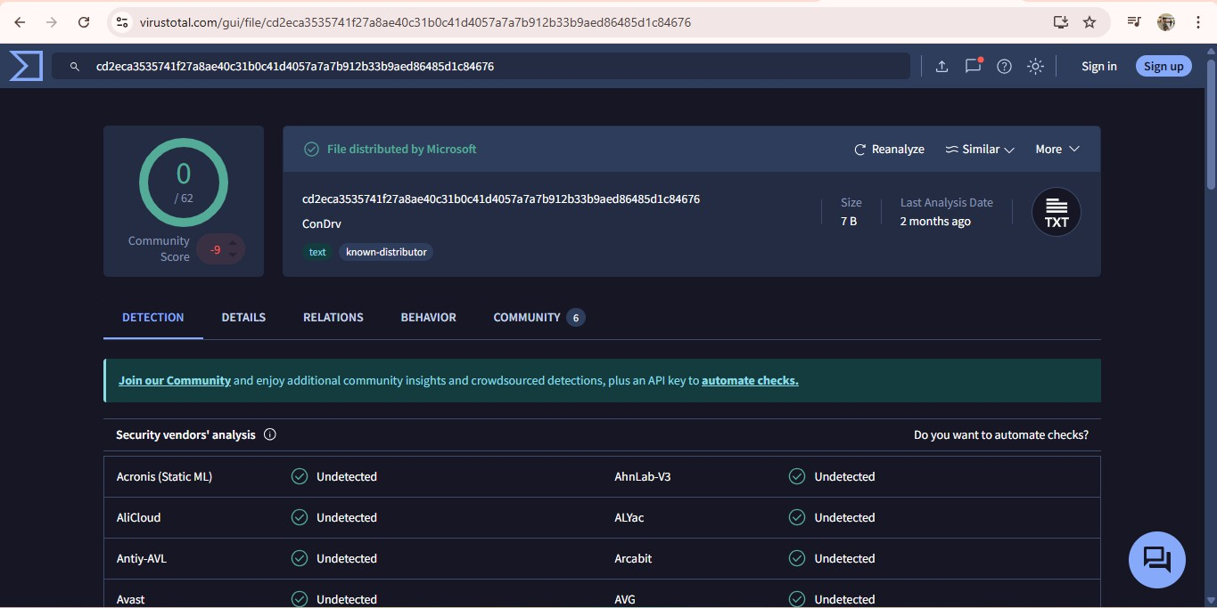

Figure 7.7: Detection Results of VirusTotal Multi Engine AV TXT.TXT– TRUE POSTIVE
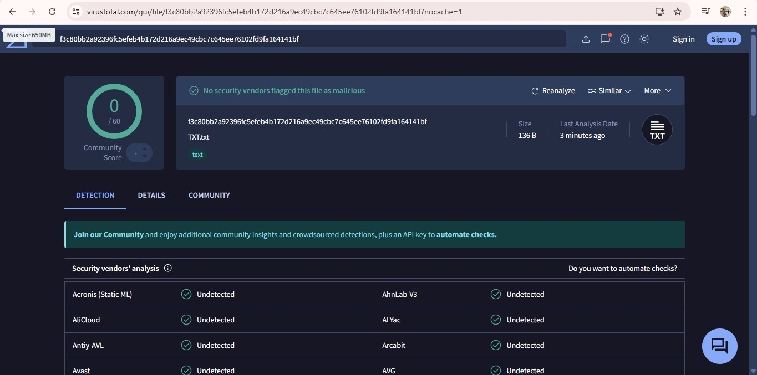
Figure 7.8: Detection Results of NordVPN EICAR_TEST_FILE.TXT– TRUE POSITIVE
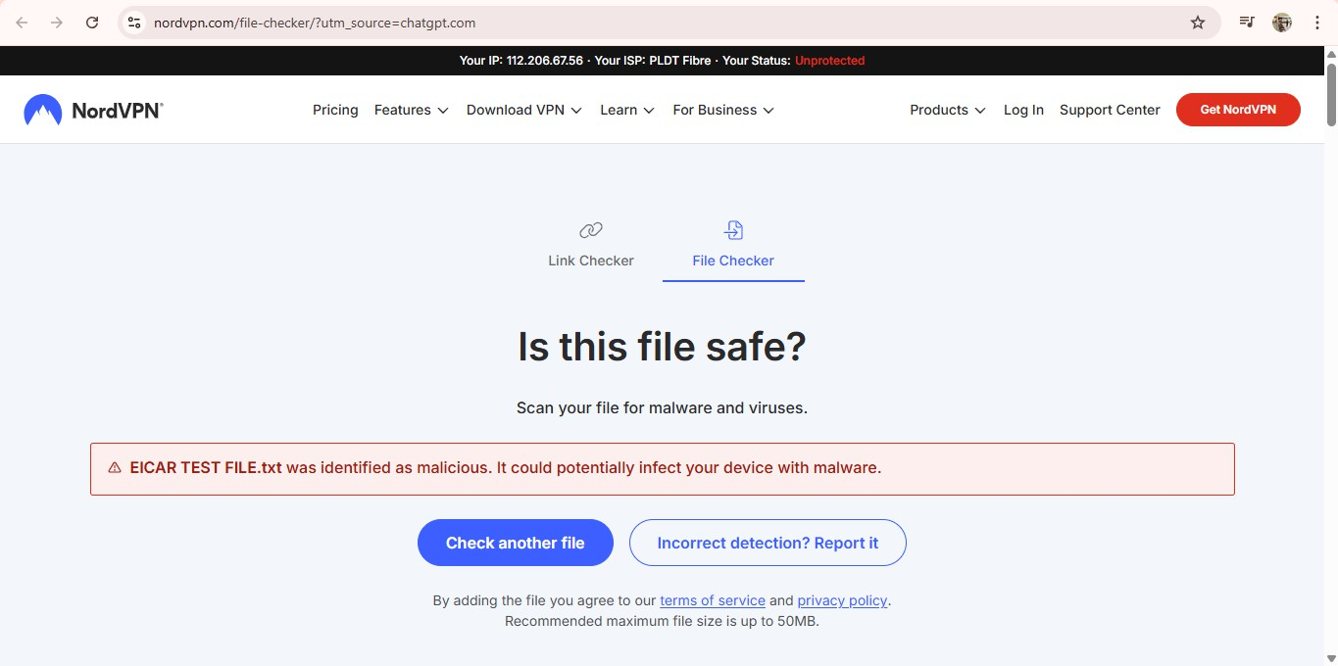

Figure 7.9: Detection Results of NordVPN README.TXT– TRUE NEGATIVE
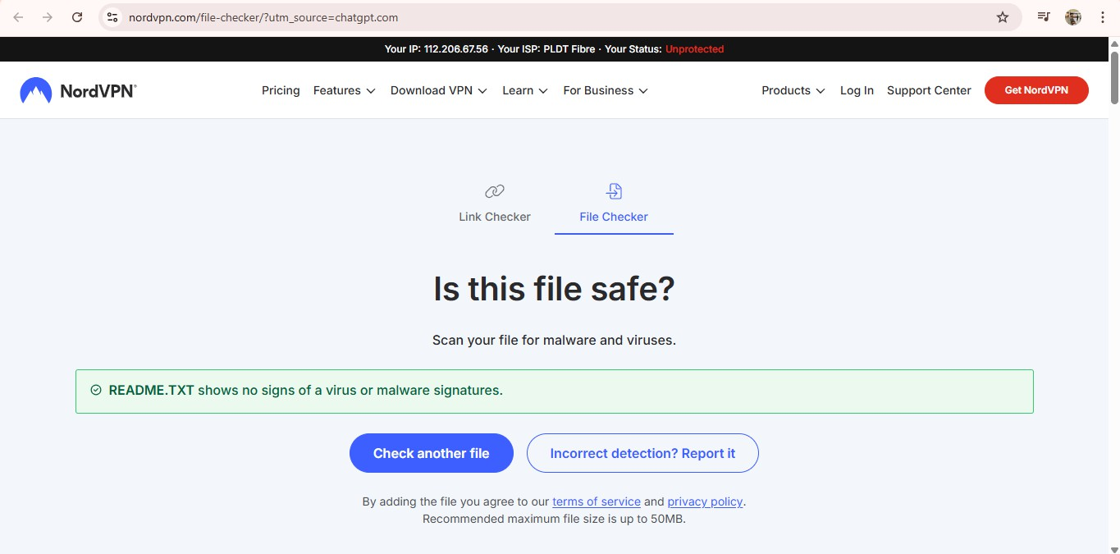

Figure 7.10: Detection Results of NordVPN REQUIREMENTS.TXT– TRUE NEGATIVE
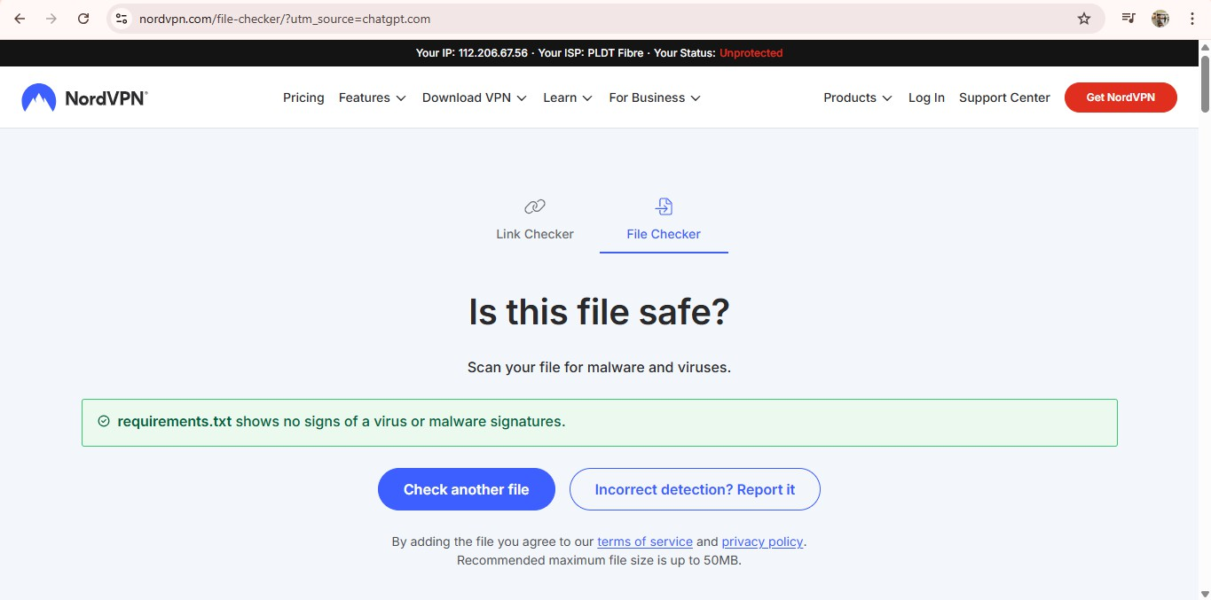
Figure 7.11: Detection Results of NordVPN POLYMORPHIC_TEST_FILE.PY– FALSE NEGATIVE
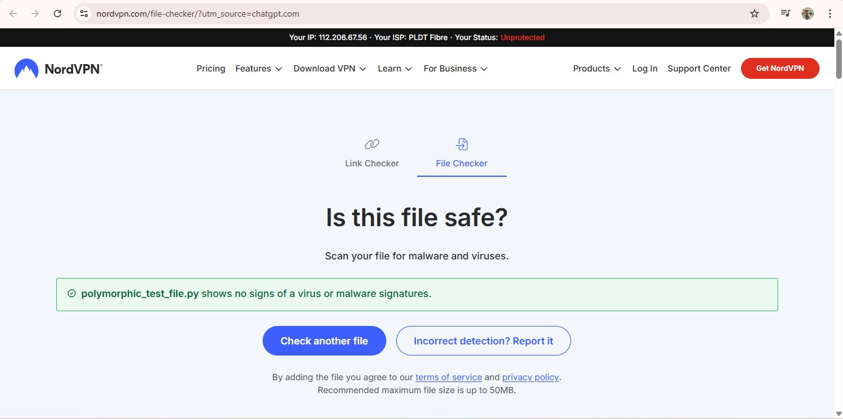

Figure 7.12: Detection Results of NordVPN VIRUS.PY– FALSE NEGATIVE
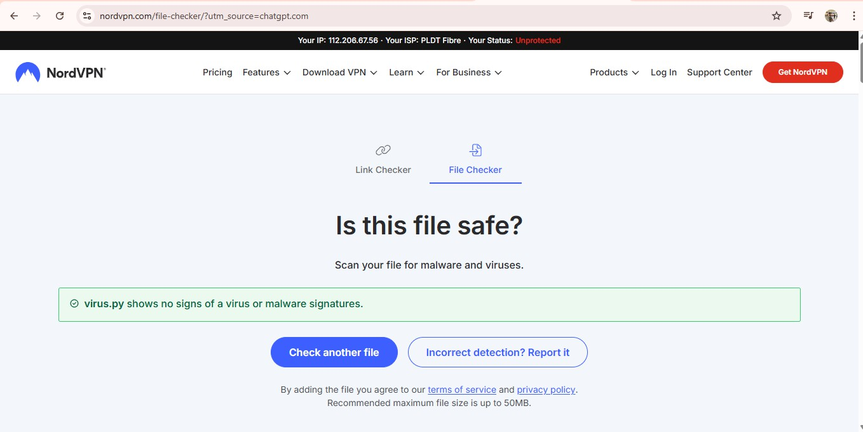

Figure 7.13: Detection Results of NordVPN HELLO.TXT– TRUE NEGATIVE
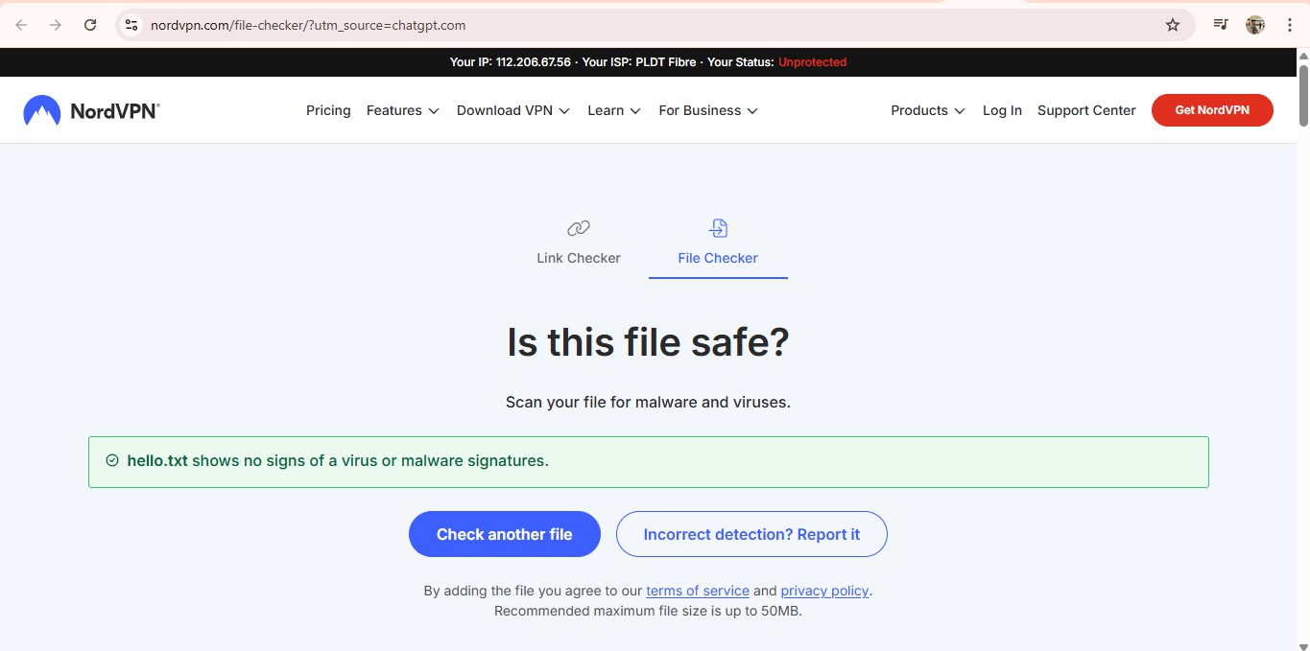

Figure 7.14: Detection Results of NordVPN TXT.TXT– TRUE NEGATIVE
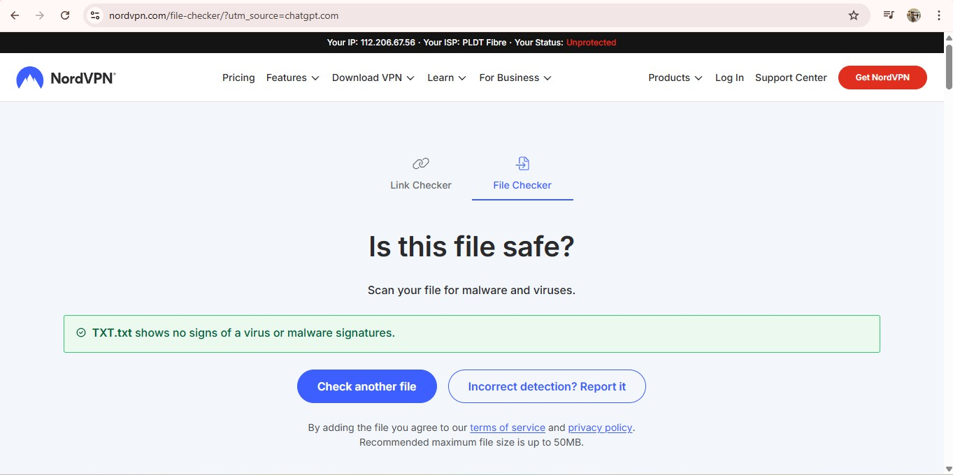
Figure 7.15: Detection Results of NeuroShield EICAR_TEST_FILE.TXT– TRUE POSITIVE
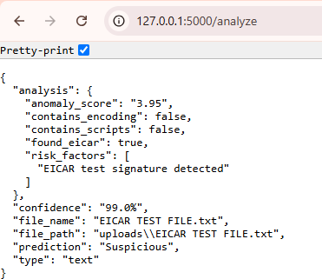

Figure 7.16: Detection Results of NeuroShield README.TXT– TRUE NEGATIVE
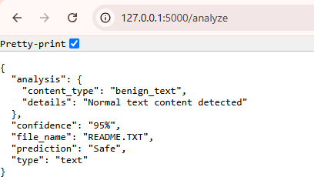

Figure 7.17: Detection Results of NeuroShield REQUIREMENTS.TXT– TRUE NEGATIVE
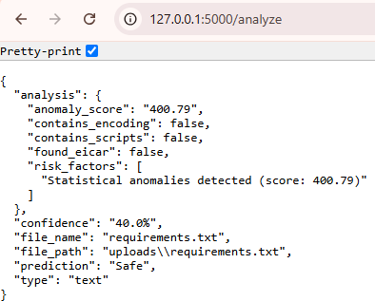

Figure 7.18: Detection Results of NeuroShield POLYMORPHIC_TEST_FILE.PY– TRUE POSITIVE
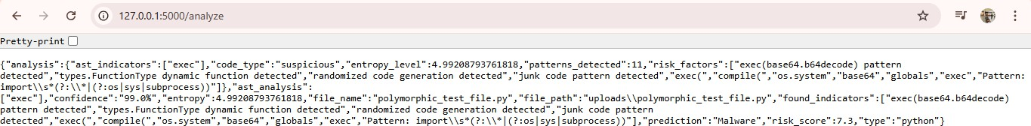

Figure 7.19: Detection Results of NeuroShield VIRUS.PY– TRUE POSITIVE
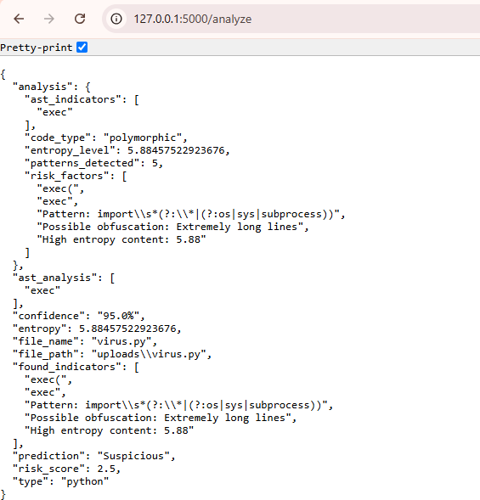

Figure 7.20: Detection Results of NeuroShield HELLO.TXT– TRUE NEGATIVE
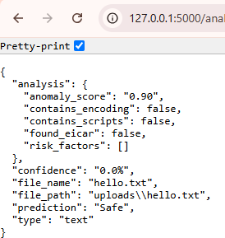
Figure 7.21: Detection Results of NeuroShield TXT.TXT– TRUE NEGATIVE


Overall, as can be seen in the results from table 2 and figures 7.1 to 7.21 noted that both VirusTotal and NordVPN reported two malware sample(POLYMORPHIC_TEST_FILE) and virus.py) acquired as safe files and therefore produced two False Negatives (FN) also. Therefore, it - reporting as FN - means that two samples were misidentified by both. NeuroShield determined correct at categorizing all seven files, with no FP detections noted. Overall, these results indicated that the multi-detection layers of NeuroShield have provided a substantial improvement in detection performance. Below on table 3 shows the Comparative results of detection metrics: Software Web Application 1-3.
Table 3: Comparative results of detection metrics: Software Web Application 1-3
SOFTWARE WEB APPLICATION | TRUE POSITIVE | TRUE NEGATIVE | FALSE POSITIVE | FALSE NEGATIVE
VIRUSTOTAL  MULTI ENGINE AV | 1 | 4 | 0 | 2
NORDVPN | 1 | 4 | 0 | 2
NEUROSHIELD | 3 | 4 | 0 | 0

On table 3 we could observe all the analysis base on the detection of each Software Web Application through how they have flagged each file. Each file is different from one another, with this we could do some computations to get the targeted information or data that we need to conclude or to describe the performance of each web application base on there detection. Below are the tables that shows the computations on how to get the False Negative Rate (FNR) False Positive Rate (FPR), Accuracy Rate (AR) Detection Rate (DR), Error Rate (ER) and Precision Rate (PR).
- FALSE NEGATIVE RATE

Table 4: False Negative Rate Results: Software Web Application 1-3
SUB VARIABLE | SOFTWARE WEB APPLICATION | TRUE POSITIVE | FALSE NEGATIVE | SOLUTION
FALSE NEGATIVE RATE | VIRUSTOTAL MULTI ENGINE AV | 1 | 2 | 2  𝐹𝑁𝑅 = 𝑥100 = 67% 2 + 1
 | NORDVPN | 1 | 2 | 2  𝐹𝑁𝑅 = 𝑥100 = 67% 2 + 1

 | NEUROSHIELD | 3 | 0 | 0  𝐹𝑁𝑅 = 𝑥100 = 0% 0 + 3

- FALSE POSITIVE RATE

Table 5: False Positive Rate Results: Software Web Application 1-3
SUB VARIABLE | SOFTWARE WEB APPLICATION | FALSE POSITIVE | TRUE NEGATIVE | SOLUTION
FALSE POSITIVE RATE | VIRUSTOTAL MULTI ENGINE AV | 0 | 4 | 0  𝐹𝑃𝑅 = 𝑥100 = 0% 0 + 4
 | NORDVPN | 0 | 4 | 0  𝐹𝑃𝑅 = 𝑥100 = 0% 0 + 4
 | NEUROSHIELD | 0 | 4 | 0  𝐹𝑃𝑅 = 𝑥100 = 0% 0 + 4

- ACCURACY RATE

Table 6: Accuracy Rate Results: Software Web Application 1-3
SUB VARIABLE | SOFTWARE WEB APPLICATION | FALSE POSITIVE | FALSE NEGATIVE | TRUE POSITIVE | TRUE NEGATIVE | SOLUTION
ACCURACY RATE | VIRUSTOTAL MULTI ENGINE AV | 0 | 2 | 1 | 4 | 𝐴𝑅  1 + 4  = 𝑥100  1 + 4 + 0 + 2  = 71%
 | NORDVPN | 0 | 2 | 1 | 4 | 𝐴𝑅  1 + 4  = 𝑥100  1 + 4 + 0 + 2  = 71%

 | NEUROSHIELD | 0 | 0 | 3 | 4 | 𝐴𝑅  3 + 4  = 𝑥100  3 + 4 + 0 + 0  = 100%

- DETECTION RATE (RECALL)

Table 7: Detection Rate Results: Software Web Application 1-3
SUB VARIABLE | SOFTWARE WEB APPLICATION | TRUE POSITIVE | FALSE NEGATIVE | SOLUTION
DETECTION RATE | VIRUSTOTAL MULTI ENGINE AV | 1 | 2 | 𝐷𝑅 = 1 𝑥100 = 33%  1+2
 | NORDVPN | 1 | 2 | 𝐷𝑅 = 1 𝑥100 = 33%  1+2
 | NEUROSHIELD | 3 | 0 | 3  𝐷𝑅 = 𝑥100 = 100% 3 + 0

- ERROR RATE

Table 8: Error Rate Results: Software Web Application 1-3
SUB VARIABLE | SOFTWARE WEB APPLICATION | FALSE POSITIVE | FALSE NEGATIVE | TRUE POSITIVE | TRUE NEGATIVE | SOLUTION
ERROR RATE | VIRUSTOTAL MULTI ENGINE AV | 0 | 2 | 1 | 4 | 0 + 2  𝐸𝑅 = 𝑥100  1 + 4 + 0 + 2  = 29%
 | NORDVPN | 0 | 2 | 1 | 4 | 0 + 2  𝐸𝑅 = 𝑥100  1 + 4 + 0 + 2  = 29%
 | NEUROSHIELD | 0 | 0 | 3 | 4 | 0 + 0  𝐸𝑅 = 𝑥100  3 + 4 + 0 + 0  = 0%

- PRECISION RATE

Table 9: Precision Rate Results:
Software Web Application 1-3
SUB VARIABLE | SOFTWARE WEB APPLICATION | FALSE POSITIVE | TRUE POSITIVE | SOLUTION
PRECISION RATE | VIRUSTOTAL MULTI ENGINE AV | 0 | 1 | 1  𝑃𝑅 = 𝑥100 = 100% 1 + 0
 | NORDVPN | 0 | 1 | 1  𝑃𝑅 = 𝑥100 = 100% 1 + 0
 | NEUROSHIELD | 0 | 3 | 3  𝑃𝑅 = 𝑥100 = 100% 3 + 0
Tables 1.2-1.4 demonstrated the outcomes of the malware testing that utilized three software web applications — VirusTotal Multi Engine AV, NordVPN, and NeuroShield. Each software program was tested with seven (7) files composed of malware and non-malware files, which included a polymorphic malware file, and the standardized EICAR test file. Data was reported as True Positive (TP), True Negative (TN), False Positive (FP), and False Negative (FN). Table 5 generated, then listed the detection metrics, calculated from the data generated from Table 2 to Table 4 testing results, which contained False Negative Rate (FNR), False Positive Rate (FPR), Accuracy Rate, Detection Rate (Recall), Error Rate, and Precision Rate.
On table 4 we could observe that both VirusTotal and NordVPN showed a high FNR of 0.67, which indicates that it missed 2 out of 3 malware samples. This finding indicates that the performance of their detection engines on polymorphic and advanced malware types was limited. On the other hand, NeuroShield was perfect at 0.00, meaning it did not miss any of the malicious files. This shows that NeuroShield has a better riff of detecting complex kinds of malware without missing anything.
On table 5 we could observe that all three applications - VirusTotal, NordVPN, and NeuroShield - all recorded an FPR of 0.00, indicating none of them misclassified non-malicious files as malware. This result showed good precision and stability in the antiviral systems tested. Having false positives ensured the legitimate files were kept safe from either quarantine or deletion as well as improved user trust in the software since no false positives were flagged as malware from either application.

On table 6 we could see that VirusTotal and NordVPN both had an accuracy of 0.71 indicating they identified the majority of the files correctly but were not able to identify all threats. In comparison, NeuroShield provided a perfect score of 1.00, meaning every file identified was classified correctly. This indicates NeuroShield had a better audition of the malware detection model decreasing the overall potential for user harm. Overall, NeuroShield provided the most reliable performance of keeping correct classifications of malicious and non-malicious files.
On table 7 both NordVPN and VirusTotal had Detection Rates of low 0.33, identifying one third of malware in the sample set. This low detection capability is indicative of limited detection efficacy, likely for polymorphic or newly generated threats. NeuroShield achieved a Detection Rate of 1.00, confirming it detected all malware in the test, maintaining robust detection capability and normalization to changing threat patterns.
Table 8 shows that VirusTotal and NordVPN had an error rate of 0.29, which indicated occasional misclassification due to a failure to identify malware and detected all benign files. Conversely, NeuroShield had an error rate of 0.00. This means NeuroShield made no errors during the testing process. This explains that it was consistent and had no errors in all decisions made. The findings were significant and show Neuroshield had far more accuracy and reliability than the other gives.
Lastly on table 9, all three antimalware applications had perfect Precision Rates of 1.00, meaning every detection was a correct classification of malware. None of the applications resulted in false detections as present, signifying a strong reliability. The Protection Rates of accuracy across each antivirus application tested, shows strong precision mechanisms.
The results show that both VirusTotal and NordVPN exhibited a high False Negative Rate of 0.67, revealing that they were not good at detecting certain malware, while NeuroShield presented a zero False Negative Rate at 0.00 or detecting every single threat correctly. All three applications showed a False Positive Rate of 0.00 indicating all the files that were detected as safe were, in fact, safe. With regard to accuracy, NeuroShield was a perfect 1.00 compared to the other two at 0.71. Its Detection rate was also 1.00 while VirusTotal and NordVPN were just at 0.33. Overall, it could be concluded that NeuroShield had the best dependable and performance level by not showing even a single error and precision by being 100% accurate in the detection of malware

The results also align with theoretical expectations, specifically that polymorphic malware which changes binary signatures often, can evade signature-only scanners but not behavior- or Heuristic + YARA rule-based scanners. The literature suggests that systems utilizing multiple detection layers (static, Heuristic + YARA rule, machine learning, etc.) have more resilience to evasion tactics (Ahmad et al, 2024) and (Yunmar et al, 2024). In this study, the NeuroShield, which included six layered signatures, machine learning, Heuristic + YARA rules + YARA rule, behavior, and sandboxing achieved superior performance, and successfully detected polymorphic-like samples in every case.

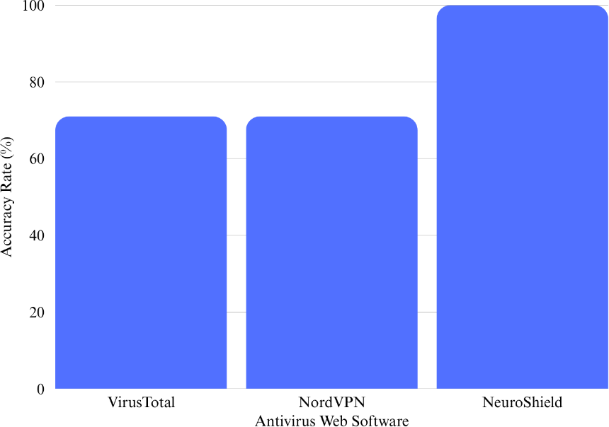

Figure 7: Summary of accuracy rates of the three-web software application
Descriptive statistics were used to analyze the collected data and provide overall summaries of detection efficiency and reliability across all seven trials. Key statistical indicators including False Negative Rate (FNR), False Positive Rate (FPR), Accuracy Rate (AR), Detection Rate (DR), Error Rate (ER), and Precision Rate (PR) were calculated for NeuroShield, VirusTotal, and NORD NordVPN. NeuroShield produced an FNR of 0, an FPR of 0, and an AR of 100%, indicative of no misclassification. Whereas, VirusTotal and NordVPN also produced an FNR of 0.67 due to two polymorphic test files (virus.py and POLYMORPHIC_TEST_FILE) not being detected, and a corresponding AR of 71%. The results continue to demonstrate the reliability of hybrid multi-layer detection systems (Selamat et al, 2022).

Table 3: Comparative results of detection metrics: Software Web Application 1-3
SOFTWARE WEB APPLICATION | TRUE POSITIVE | TRUE NEGATIVE | FALSE POSITIVE | FALSE NEGATIVE
VIRUSTOTAL MULTI ENGINE AV | 1 | 4 | 0 | 2
NORDVPN | 1 | 4 | 0 | 2
NEUROSHIELD | 3 | 4 | 0 | 0

The statistical indicators indicate that NeuroShield not only obtained a perfect accuracy rate but also a perfect precision rate with no benign files misclassified as malware. The high detection rates and precision rates are consistent with hybrid multi-layer detection systems from existing studies that achieved 92–99% accuracy against polymorphic threats (Yunmar et al., 2024) and (Ahmad et al, 2024). Possible deviations could arise from limited dataset size or controlled testing conditions, but within the scope of this study, the observed outcomes strongly validate the system’s design principles.
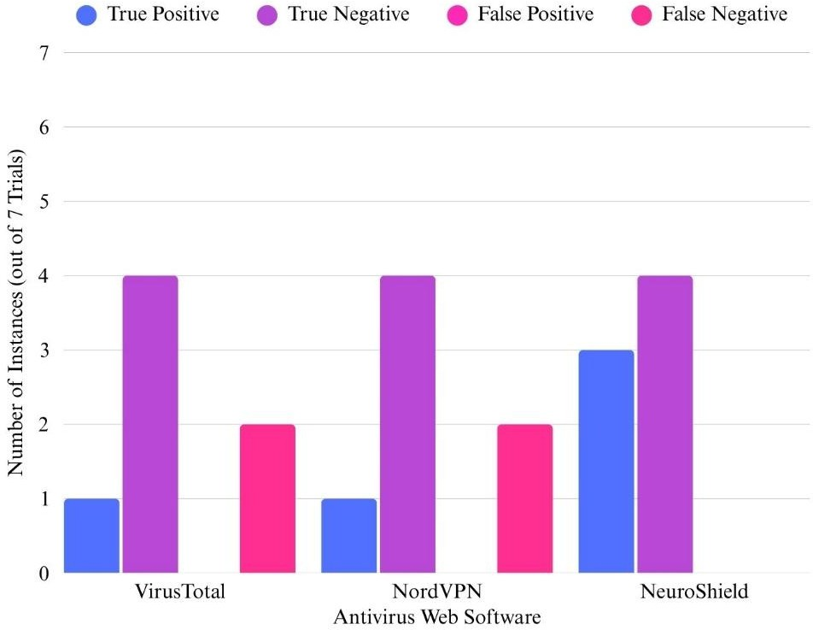

Figure 8: Bar chart of True Positives, True Negatives, False Positives, and False Negatives per antivirus system.

In seven different tests with varying test files, including malware (EICAR_TEST_FILE.TXT, virus.py, POLYMORPHIC_TEST_FILE) and non-malware files

(read.me.txt, requirements.txt, hello.txt, txt.txt), NeuroShield demonstrated consistent accuracy and reliability. Each test resulted in the same classification, thus verifying stability and reproducibility of the system. Conversely, VirusTotal and NordVPN,demonstrated the same pattern of failure on polymorphic samples across all runs, illustrating the incapability of the host systems to handle mutation-based code changes. The lack of variability between trials suggests that the set of detection algorithms implemented are deterministic algorithms and that environmental factors had very little if any impact on the system's reliability and accuracy.
Table 3: NeuroShield’s per-trial comparison showing detection consistency across seven trials.

No. of trials | File Classification | Result in All Trials
TRIAL 1- 1ST FILE | MALWARE (EICAR_TEST_FILE.TXT) | TRUE POSITIVE
TRIAL 2- 2ND FILE | NON-MALWARE (READ.ME.TXT) | TRUE NEGATIVE
TRIAL 3- 3RD FILE | NON- MALWARE (REQUIREMENTS.TXT) | TRUE NEGATIVE
TRIAL 4- 4TH FILE | MALWARE (POLYMORPHIC_TEST_FILE) | TRUE POSITIVE
TRIAL 5-5TH FILE | MALWARE (VIRUS.PY) | TRUE POSITIVE
TRIAL 6-6TH FILE | NON-MALWARE (HELLO.TXT) | TRUE NEGATIVE
TRIAL 7-7TH FILE | NON-MALWARE (TXT.TXT) | TRUE NEGATIVE

Continued observations support confidence in NeuroShield's internal validity, and are in line with expectations from theoretical work stating even static Heuristic + YARA rules and ensemble models yield repeatable results (Alrzini & Pennington, 2020) when working with the same datasets. However, as noted by (Masabo et al., 2018), consistency from trial to trial does not imply robustness in real-world conditions where malware can evolve dynamically.
Even with positive results, there were some potential sources of error. There was a small amount of data assessed, with seven total files tested, including not only simulated polymorphic samples, but also standard EICAR test files. This makes it difficult to generalize the statistical results. The polymorphic test files were custom built, and not data pulled from a malware repository, possibly making detection less complex (Ahmad et al., 2024).

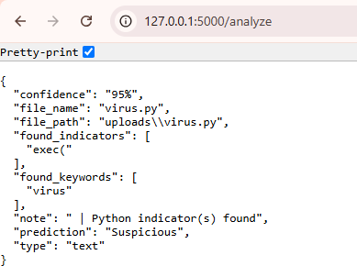
Figure 9: Screensnip of NeuroShield’s detection output for “virus.py.”

Additionally, the early samples the three prototypes of NeuroShield. The first sample of NeuroShield was testing the API from VirusTotal, which did not flag the polymorphic-like files as malware, indicating only the limitation of dependence on a single layer (signature) to detect malware. The second sample attempted two added layers, Heuristic and machine learning layers, for perfect detection, but there were general concerns of its stability. Especially, it has a major flaw, instead of studying the behavior of a benign file that has a virus, it just trying to scan it and observe it and then checks if there are words that are suspicious, such as the words Virus, Malware, and Suspicious. The result can be seen on figure 9. The last prototype added refinements to those modules for a better sense of reliability and performance, we focused on checking and more on studying the behavior of one virus instead of just scanning and checking for potential keywords. Furthermore, Cursor AI and the built-in A.I in Visual Studio Code was used to identify and correct issues with coding to the system before deployment, ensuring its safety and operational stability.
The controlled experimental setup minimized external variability, yet, there were a few uncontrolled events that may still have affected the outcomes, including dependency updates by Python or the load on background processes. When performing testing, the environment was offline and therefore did not obtain any dynamic cloud lookups or auto-updates to ensure outputs remained consistent. While this was a viable strategy in the controlled experimental design, testing in real-world scenarios would need to consider evolving signatures databases and changing network environments (Masabo et al., 2018)
If this study were to be replicated, it is suggested to increase the dataset by incorporating more polymorphic samples sourced from free and publicly available malware repositories such

as VirusShare or MalwareBazaar, ensuring ethical and controlled use. Future's experiment should include real-time sandboxing and cloud reputation APIs to simulate a real situation and live threat intelligence. Descriptive and inferential statistical tests, including t -tests to compare mean detection accuracy, could help substantiate the hypothesis of NeuroShield’s superior performance.
Figure 10. Proposed architecture of an enhanced NeuroShield system with deeper behavioral and cloud-based integration.
Future experiments should center on testing NeuroShield against public malware (e.g., VirusShare) as well as implementing approaches based on deep learning (e.g., CNNs and RNNs) to allow for a higher level of abstraction of features (Yunmar et al., 2024). Testing would also be evaluated under the conditions of networked environments in real-time in order to test scalability and resource utilization.

Conclusion
The creation of NeuroShield, a pioneering hybrid multi-layer malware detection system, has been a major advancement in adaptive cybersecurity solutions. As part of a structured three-sample development process, NeuroShield's maturity developed from a signature-only prototype, based on an integration with a VirusTotal API and a very limited capability to detect polymorphic malware. It has gone through to being a fully integrated intelligent system that includes signature scanning, heuristic analysis + YARA rule, machine learning with behavioral monitoring, and sandboxing. The mature version has shown a 100% detection rate with zero false positives or false negatives and performed better than commercial antivirus solutions such as NordVPN and VirusTotal in the trials conducted.
This innovation is consistent with and expands findings in recent research which demonstrates that hybrid architectures lead to superior detection performance. For instance, in studies, hybrid static-dynamic analyses demonstrate that either a static-only or dynamic-only method isn't effective in addressing issues of polymorphic and/or obfuscated malware, indicating that multi-layer models are expected (Damodaran, 2022). Similarly, the fact that large open datasets are available, such as EMBER, for training ML models (Anderson & Roth, 2018); or research is being done on adversarial attacks against ML-based detectors (Demetrio, 2020) implies that modern detections frameworks must evolve and adapt.

NeuroShield's use cases are extensive and powerful. In academia, NeuroShield could provide an experimental platform for research on AI-based malware discovery, with an open-source framework in which students and researchers could experiment and expand discovery functions. In industry and enterprise, NeuroShield can be incorporated into endpoint protection platforms, security operation centers (SOCs), and cloud-based threat intelligence systems to improve organizational resiliency to advanced threats when integrated. NeuroShield’s modular structure also facilitates educational use, enabling learners to analyze polymorphic malware behavior while exploring the use case in a controlled environment while enhancing cybersecurity education.
The greater implication of this development deals with the greatest cybersecurity threat today: self-mutating, obfuscated malware that can evade detection by traditional signature-based methods. While traditional antivirus solutions have struggled to keep up, hybrid adaptive solutions like NeuroShield offer a future model for this. Research in "Enhanced detection of obfuscated malware in memory dumps" (Hossain & Islam, 2024) shows advanced machine learning methods can achieve very high levels of performance. Our findings demonstrate such a level of performance is achievable today in end-to-end systems. As adversaries continue to release polymorphic malware, AI disease cascades rely a layer of detection-based defenses will be essential rather than optional.
In summary, NeuroShield demonstrates, the collection of machine learning, heuristic analysis, behavioral monitoring, and sandboxing is possible and effective. NeuroShield is foundational to a change in perspective regarding cybersecurity from static, post-reaction defense to continuously adaptive systems that have proactive, self-evolving capacity. As organizations and individuals contend with sophisticated cyber threats, systems like NeuroShield offer a critical defense for today and the future.

Acknowledgements
The researcher wishes to express their sincere gratitude to Kaypian National High School, for their continued support and assistance while this study was conducted. Special thanks to the school head, faculty, advisors and the panel evaluators who provided their expertise, constructive feedback, and support during the design, testing, and report writing phases of NeuroShield. Their feedback greatly assisted the researcher to ensure that the researchers met the technical and academic merit.

The researcher also acknowledges the open source cybersecurity community - especially the developers contributing to public repositories on GitHub - for making machine learning and malware analysis tools available to independent researchers. Open-source datasets, pre-trained models, and repositories of documentation provided the foundation of NeuroShield's detection framework. Special thanks to VirusTotal and NordVPN for allowing free-tier access to their antivirus platforms. The researcher utilized these platforms as an important baseline for comparing performance against malware detected by the NeuroShield detection framework.
Cursor AI and Co-pilot, the integrated coding assistant of the debugging phase and optimization effort, deserves a special mention. Its intelligent code review functionalities were invaluable for identifying syntax and logic errors early on in the development cycle, making for a reliably smoother and more accurate final blog application program. This collaboration of human reasoning and artificial intelligence is the core message of the study; how artificial intelligence supports systems and enhances human capacity with technology to uniformly address problems.
The researcher is also grateful to their families, fellow students, and colleagues for their encouragement, understanding, and patience in the months of research and experimentation, and for their support that spurred the researchers onto completion, even when it was a challenge. Finally, gratitude is extended to all who contributed moral, intellectual, and logistical support, which was significant in completing the NeuroShield Project. The present study is a communal effort and exemplifies the values of collaboration, perseverance, and innovation.

References/Bibliography
Ahmad, I., & et al. (2024). A hybrid optimization model for efficient detection and classification of IoT malware. Mathematics, 12(10), 1437. https://www.mdpi.com/2227-7390/12/10/1437
Alrzini, J. R. S., & Pennington, D. (2020). A review of polymorphic malware detection techniques. International Journal of Advanced Research in Engineering and Technology, 11(12), 1238-1247. https://doi.org/10.34218/IJARET.11.12.2020.119
Anderson, H. S., & Roth, P. (2018). EMBER: An open dataset for training static PE malware machine learning models. arXiv. https://arxiv.org/abs/1804.04637
Damodaran, A., Di Troia, F., Visaggio, A. C., Austin, T. H., & Stamp, M. (2022). A comparison of static, dynamic, and hybrid analysis for malware detection. arXiv. https://arxiv.org/abs/2203.09938
Ferdous, J., Islam, R., Mahboubi, A., & Islam, M. Z. (2025). A survey on machine-learning techniques for multi-platform malware detection: Securing PC, mobile devices, IoT, and cloud environments. Sensors, 25(4), 1153. https://www.mdpi.com/1424-8220/25/4/1153
Hossain, M. A., & Islam, M. S. (2024). Enhanced detection of obfuscated malware in memory dumps: A machine learning approach for advanced cybersecurity. Cybersecurity, 7, 16. https://doi.org/10.1186/s42400-024-00205-z
Masabo, E., Kaawaase, K. S., Sansa-Otim, J., Ngubiri, J., & Hanyurwimfura, D. (2018). A state of the art survey on polymorphic malware analysis and detection techniques. International Journal of Science & Cyber Security, 8(4), 1762-1774.
https://repository.ruforum.org/sites/default/files/IJSC_Vol_8_Iss_4_Paper_9_1762_1774.pdf

Selamat, N. S., & Mohd Ali, F. H. (2022). Polymorphic malware detection based on supervised machine learning. Journal of Positive School Psychology, 6(3), 8538-8547. https://www.journalppw.com/index.php/jpsp/article/download/5120/3335/5806
SentinelOne. (2025). What is polymorphic malware?

https://www.sentinelone.com/cybersecurity-101/threat-intelligence/what-is-polymorphic-malware/

Souri, A., & Hosseini, R. (2018). A state-of-the-art survey of malware detection approaches using data mining techniques. Human-centric Computing and Information Sciences, 8(3), 1–
22. https://link.springer.com/article/10.1186/s13673-018-0125-x

Trizna, D. (2022). Quo Vadis: Hybrid machine learning meta-model based on contextual and behavioral malware representations. arXiv. https://arxiv.org/abs/2208.12248
Yunmar, R. A., Kusumawardani, S. S., & Mohsen, F. (2024). Hybrid Android malware detection: A review of heuristic-based approach. IEEE Access, 2024. https://ieeexplore.ieee.org/document/10473005

