Uriel Gonzalez
Dr. Zhang
Advanced Artificial Intelligence
October 15, 2019

n-Puzzle Project

A general overview of the problem
Defining a search algororithm for this problem is challenging. The search space can be represented by a directed graph, where each node is a state and each edge is a transition. The main issue is that it is possible to return to a previous state: that is, some actions can be undone. For example if you move right and then you move left you end up in the same place as where you started. Most search algorithms are used for a search space that is a tree, but not for one that is a directed graph that has cycles. One way of tackling this issue is to remember the previous transition and choose a successor that does not cancel it. This only prevents some of the cycles, but there are others that will not be prevented, like going up, left,down, right, up, left,down, right for the 8-puzzle instance. In general, it would take an infinite amount of memory and an infinite amount of conditionals to determine to preevent any repretitions. The only way to handle cycles in a directed graph with cycles search space is to keep track of which states have beeen traversed already. I found this website and used the pseudo code to implement my solution: https://sandipanweb.wordpress.com/2017/03/16/using-uninformed-informed-search-algorithms-to-solve-8-puzzle-n-puzzle/ . I did my implementation on Java. To represent the k by k grid I decided to use a one dimensional array. I defined functions to implement moving the tiles around. I wrapped the array in a class called State. When a node is expanded, I needed to store the move being made and the state that results from applying that move. Each successor node could be the goal, so I decided to wrap the move and the state as the class Candidate. As you can see, State does wrap functionality while candidade is just a container. All the search algorithms are the same, but they use different data structures.
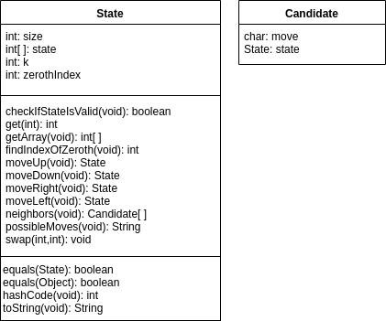

Depth First Search implementation
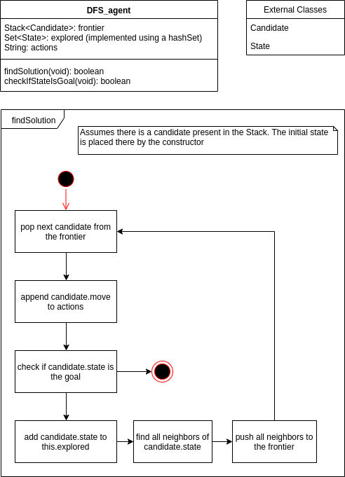

Breadth First Search implementation
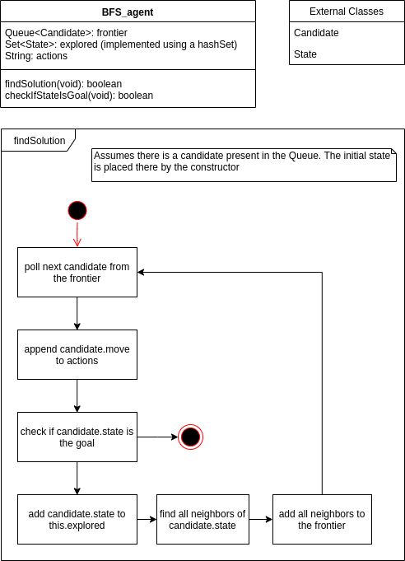

A* Search implementation
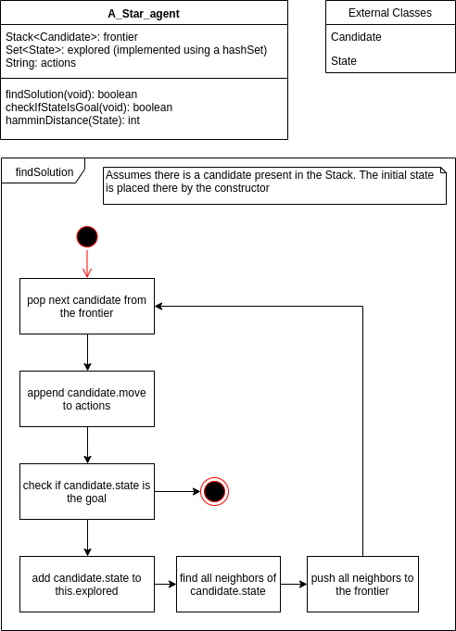

Even the modified A* algorithm has trouble handling a directed graph. If the algorithm selects to move from state A to state B and then once in B it selects to move to A again, then the algorithm loops forever. To solve this, for the first candidate, we add all the successors to the stack (ignoring the heuristic). If at any point the algorithm selects a successor that has already been explored, it ignores the heuristic and add all non-explored successors. This adds variability to the algorithm and prevents it from getting stuck, but I was not able to write a proof for it; it just works.

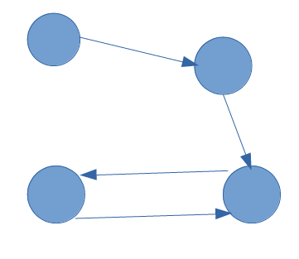
A cycle showing when A* would get stuck

Results
All search algorithms perform the same operations. They both have a hash set, which takes constant time to check if an element is in the set. I am assuming that the operations of adding and removing candidates from a stack or a queue take the same time. Based on all these, I decided to use the number of states visited as a metric of performance. Thus, an algorithm that visites more states is more inefficient than one that takes less steps. I found some unsolvable instacesFor the benckmark I used the following instances of the 8-puzzle problem: {1,0,2,3,4,5,6,7,8}, {2,0,1,4,3,5,6,7,8}, {2,0,1,4,3,6,5,8,7}, {2,7,1,4,3,6,5,0,8}, {8,7,5,4,3,6,1,0,2}. I was not expecting DFS or BFS to be more efficient than the other, but I was expecting A* to be significanlty more efficient. The modifications made to the A* algorithm caused it to perform the same as DFS, which is unusual. The only way for this to be possible is if the graph under the heuristic contains many cycles, such that it always performs DFS.

