Software Project Management Plan (SPMP)
Distributed Team Collaboration Processes II
Ivan Dontsov, Andy Phenix, Maureen Rottschaefer
Version 1.4
2/19/2012
Note: This template has been adapted from IEEE Std 1058-1998 for SPMPs. You should follow the general format and guidance in this template. How you break pagers and use fonts, capitalization, spacing, figures, tables, illustrations etc. is up to you. You might save time by using the “styles” provided in this template.

This document describes the processes and tools to be used in planning, developing, monitoring and controlling the activities and assignments of the Distributed Team Collaboration Processes II team.

Revision History
Version | Description of Versions / Changes | Responsible Party | Date
1.0 | Initial version of SPMP for comment by team | Maureen | 1/31/12
1.1 | First revised draft post OMSE 555 recalibration meeting | Andy | 2/8/12
1.2 | Second revised draft | Andy | 2/12/12
1.3 | Incorporated feedback from Maureen | Andy | 2/16/12
1.4 | Additional feedback from team incorporated prior to submission to Stuart for review | Andy | 2/19/12

Approval Block
Version | Comments | Responsible Party | Date
1.0

Table of Comments
Introduction 3
1.1 Overview and Objectives 3
1.2 Deliverables and Internal Project Documents (TBC) 4
1.3 Priorities, Assumptions, Constraints, Risks 4
1.3.1 Priorities 4
1.3.2 Assumptions, Constraints and Dependencies 4
1.3.3 Risks 4
1.4 Evolution of the SPMP 5
1.5 Reference Materials 5
1.6 Definitions and Acronyms 5
2 Development Process 6
2.1 Process Model 6
2.1.1 Phased Delivery 6
2.1.2 Key Deliverables (by Phase) 7
2.1.3 Key Milestones (by Phase) (TBC) 8
2.2 Project Organization 9
2.3 Activities, Tasks, Resources (TBC) 10
2.3.1 Work Breakdown and Tasks 10
2.3.2 Dependencies 11
2.3.3 Resources (TBC) 11
2.4 Schedule (TBC) 11
3 Managerial Process 11
3.1 Risk Management 11
3.2 Requirements Management (Scope Control) 12
3.3 Monitoring and Control 12
3.4 Configuration Management 13
3.5 Quality Assurance (TBC) 13
4 Technical Processes 14
4.1 Processes and Methods (TBC) 14
4.2 Development Tools / Development Environment (TBC) 14
4.3 Technical Product and Process Metrics (TBC) 14
5 Additional Supporting Plans (TBC) 15
Appendices 15

Introduction

Overview and Objectives
The Oregon Master of Software Engineering (OMSE) 2010 Practicum Project focused on developing a software engineering process specification specifically tailored to distributed teams – the Distributed Software Engineering Process Specification (DSEPS). As part of that project the team also developed a process specification tool which, while used in subsequent OMSE courses, has some opportunities for improvement which are outlined in the 2012 OMSE 555 course syllabus:
“Based on our 551 experiences, the current tool implementation provides a simple interface but is not particularly user friendly. The tool also lacks any support for collaborative review, analysis, explicit support for process families, or other things we might wish to do with processes and process models.
A useful project would extend the existing process tool. The most obvious extension would be to provide a more user-friendly interface and easier administrative support. Further extensions that would add capabilities to the tool might include:
- Collaborative Review: support for distributed, collaborative review of process models. This would define review processes and provide supporting tools or infrastructure.
- Modeling and analysis: support for formally modeling processes, simulating process execution, or analyzing key process properties.
- Improved support for defining families of processes and creating family members.”
The primary objective of this OMSE 2012 Practicum Project is to extend and refine the process specification tool and address some of its limitations. In particular, the project will address the ‘most obvious extension’ to provide a more user-friendly interface and easier administrative support.

As a secondary objective, should bandwidth permit, the project will also extend the tool to provide support for defining families of processes and creating family members, and / or collaborative review of process models. It is not intended to address the proposed modeling and analysis extension during this project.

In order to demonstrate the effectiveness and features of the redesigned process specification tool, the DSEPS will be modeled using the new tool.

The project will be executed over two semesters as the curriculum for OMSE 555 / 556, and the project team will consist of the following students - Ivan Dontsov, Andy Phenix, and Maureen Rottschaefer. Stuart Faulk, the OMSE 555 / 556 instructor, will act as the primary customer for the project.

Deliverables and Internal Project Documents (TBC)
The following deliverables will be provided for the project (to all stakeholders):
- Plans
  - Software Project Management Plan (SPMP)
  - Software Test Plan (STP)
  - Software Quality Assurance Plan (SQAP)
- Technical Documents and Software
  - Software Requirements Specification (SRS)
  - Software Architecture Document (SAD)
  - Software User Documentation
  - Source Code (including installation and configuration instructions).

Priorities, Assumptions, Constraints, Risks

Priorities
Given the fairly high-level requirements that have been identified for the project to-date, it is likely that some tradeoffs will need to be made to meet the fixed-resource and schedule constraints. It is assumed that the course instructor will act in the interests of the OMSE program, and provide the project team with guidance on the project scope and relative priority of each identified requirement.
As such, one of the key deliverables in the first phase of the project will be a baseline set of requirements (via the SRS) that clearly identify the scope of the core functionality required to meet the primary project objective. The SRS will be extended in the second and subsequent phases of the project to cover requirements to meet the secondary project objectives.
Another key deliverable will be to define a base architecture that can be extended in the second and subsequent phases to accommodate whatever subset of extensions the project team has capacity to develop. Indeed, if well executed, the base architecture should accommodate additional extensions provided by subsequent OMSE practicum project teams.

Assumptions, Constraints and Dependencies
It is assumed that the process specification tool developed by the project team will be hosted by PSU’s existing IT infrastructure provided by the Computer Action Team (CAT). Each project team member will be responsible for provisioning their own development environment in accordance with the toolset identified in section 4.2.

Risks
The following key risks have been identified for the project:-
- Limited resources – there are insufficient team members to cover all project activities (leading to secondary issues – for example, independent validation & verification of project artifacts).
- Unavailability of main stakeholder – it is likely that many competing demands will be made of the course instructor (across multiple practicum teams, multiple OMSE courses, etc.). Additionally, given the dual role played by the instructor (course lecturer vs project customer) there is potential for confusion in intra-team communications.
- Confusion around practicum project process – recent changes to the OMSE program (including the departure of key staff members and loss of course materials) has created confusion between the participants and delayed project activities.
- New development process / project team – the project team intends to leverage the distributed software engineering process that resulted from the prior 2010 practicum project. However, the documented process specification does not cover all project activities, the most notable absence being quality assurance. Additionally, the project team has no past shared working experience to draw upon (for example, when estimating team capacity).
Section 3.1 details how the project team will address these risks and any additional risks that arise during the course of the project.

Evolution of the SPMP
This initial draft of the Software Project Management Plan (SPMP) will be placed under change control upon publication (see section 3.3 for details). During each subsequent phase of the project, the project team will meet periodically (frequency TBD) to review any proposed changes to the plan, assess the impact of making those changes and recommend accordingly (approve, reject, defer). If necessary, an updated version of the SPMP will be published at the conclusion of each phase of the project.

Reference Materials
This Software Project Management Plan (SPMP) references the following existing project documentation:
- OMSE 555 course syllabus
- 2012 Practicum Project Proposal
- Distributed Software Engineering Process Specification (DSEPS)
- DSEPS Process to SDLC Mapping (PSM)
- 2010 Practicum Project Team Materials

Definitions and Acronyms
DTCPII is an acronym that stands for Distributed Team Collaboration Processes II.

Development Process

Process Model
The project will use a hybrid development process, with a bias towards Waterfall in the first project term (OMSE 555), switching to a more iterative process model in the second project term (OMSE 556). This will allow the project team to:
- Focus on understanding the core desired functionality for the process specification tool
- Conservatively manage project scope based on team member availability
- Establish a working relationship within the project team, and clarify roles and responsibilities

Phased Delivery
The project will be delivered in a phased manner with three major phases:
- Phase 1 – base-lining
- Phase 2 – core functionality
- Phase 3 – desired functionality
For the first phase of the project, it is anticipated that two main streams of work will be scheduled – one focusing on requirements elicitation and specification, and the second focused on establishing a candidate architecture for the system. Phase 2 will focus on the implementation activities required to deliver the core functionality identified for the process specification tool. Phase 3 will focus on delivering the functionality required to meet the secondary objectives for the project – the scope of which will be adjusted based upon the project schedule and capacity at that time. For the second and third phases of the project, it is hoped that the project team can switch to using a more iterative development methodology, delivering incremental functionality on bi-weekly iterations.
The following chart provides an overview of how the project is broken down into each phase across the proposed schedule:

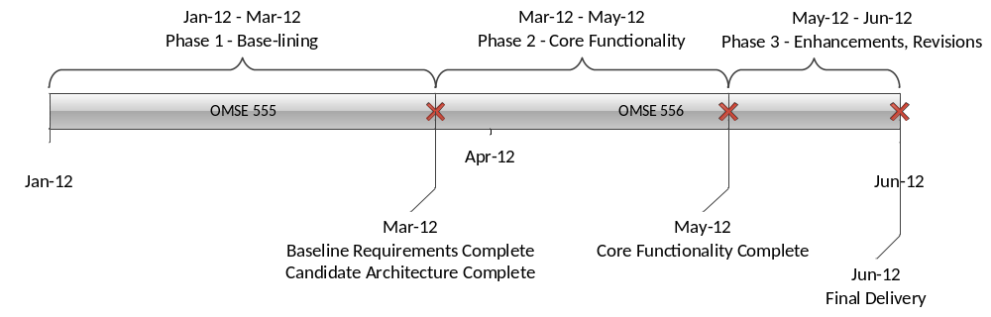

Key Deliverables (by Phase)
Based on the process model outlined above, it is expected that the key deliverables for each phase will be as follows:
- Phase 1 – Initial base-lining phase
  - Project plan (SPMP)
    - Team member roles and responsibilities
    - Project size & schedule estimates
    - Agreement on how project scope will be managed
    - Risk management plan – key project risks documented and mitigation plan provided
  - Base-lined requirements
    - Requirements (in the form of use cases & scenarios) for core (essential) functionality (SRS)
    - ‘Paper’ prototypes – wireframe diagrams for proposed tool user interface
  - Candidate architecture
    - Establish the technical landscape, identify major sub-systems and the key system interfaces between them (SAD)
    - Identify hosting platform and development environment
  - Quality management plan
    - Define how quality will be built-into each phase of the project
  - Communication plan
    - Establish standards for team communication
    - Provision document repository for managing key deliverables
- Phase 2 – Core functionality build out
  - Design artifacts
  - Working software
  - Testing artifacts (test plans, test output)
  - User documentation
- Phase 3 – Desired functionality, enhancements, revisions, etc.
  - Additional Requirements (in the form of use cases & scenarios for secondary (non-essential) functionality (SRS)
  - Design artifacts
  - Working software
  - Testing artifacts (test plans, test output)
  - Amendments to user documentation (if required)

Key Milestones (by Phase) (TBC)
What is the process model you plan to follow (Waterfall, Evolutionary, XP)? You should clearly identify your main phases, activities and milestones. You should clearly show what you expect to achieve and produce by each milestone, and by what date (a milestone every 2 weeks is reasonable). You should also show which deliverables identified in 1.2 (both internal and external) your team will produce by each milestone. At a minimum, your activities should include those for establishing the customer’s requirements, setting up your development environment, your architecture and design activities, coding, integration, and testing, packaging of your customer deliverables, and your customer demonstrations. Don’t forget activities and milestones for getting the customer’s approval of the requirements and for presenting your SPMP to your management. Also, you should show all progress reviews and presentations.

Phase | Deliverable | Milestone Date | Comments
1 – Base-lining | Draft SPMP | 2/23/12 | Mid-term pushed out 1 week (from original class schedule)
 | Draft SRS | 2/23/12
 | PPT (progress report) | 2/23/12
 | Draft Candidate Architecture | TBD | Format TBD
 | Draft Prototype | TBD | Paper-based mockups
 | SPMP (final) | 3/22/12
 | SRS (final) | 3/22/12
 | PPT (end of term status + demo) | 3/15/12 | Demo TBD
 | Candidate Architecture | TBD | Format TBD
 | Prototype | TBD | Paper-based mockups
2 – Core Functionality | TBD | TBD
 | PPT (progress report) | 5/3/12
3 – Desired Functionality | TBD | TBD
 | PPT (end of term status + demo) | 6/7/12

Project Organization
For the initial phase of the project, each team member will assume a primary role that maps back to the key phase 1 deliverables – the project plan (SPMP), requirements specification (SRS) and candidate architecture (SAD). Each team member will also assume a secondary role, providing support for quality assurance on each of the phase 1 deliverables. Additionally, it is tentatively planned that the project team will interact with other OMSE project teams, trading SQA tasks between individual practicum projects. It is assumed that the course instructor will act as the primary customer for both phases of the project. The proposed organizational structure for Phase 1 is:

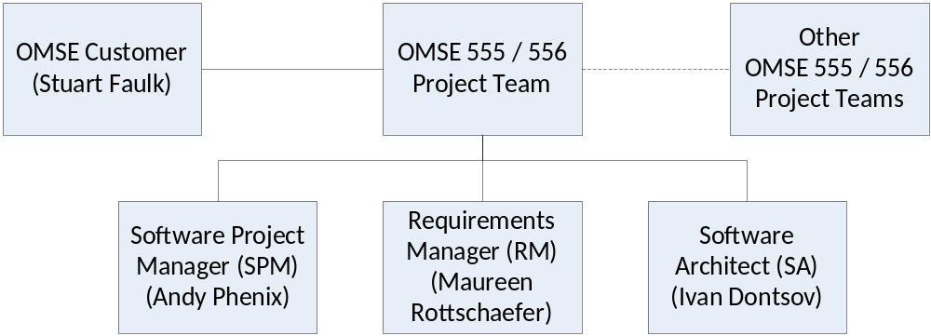

For the second and subsequent phases of the project, it is expected that each of the project team members will switch their primary role to that of software developer or tester, while continuing their phase 1 focus (project management, requirements, architecture) as a secondary role. Again, it is tentatively planned that the project team will interact with other OMSE project teams, trading SQA tasks between individual practicum projects. The proposed organizational structure for Phase 2 is:

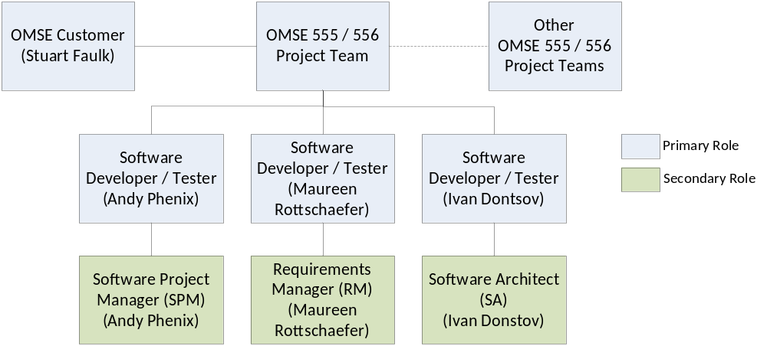

Activities, Tasks, Resources (TBC)
Your SPMP should clearly show the assignment of team members to activities and tasks. To do this, you need to identify all the activities and tasks for the project, in other words, develop a “work breakdown structure”.
A straight forward approach is to list the activities and tasks you have already identified in 2.1 and add to these general effort tasks like project planning, project tracking, documentation, development environment support, and quality assurance.
You can construct a table that identifies all of these activities, briefly describes each activity, lists the team roles supporting each, and the individual team member(s) assigned to each activity / task. Finally, you should estimate the number of person days in the last column and find the total estimated resources to complete all project tasks.
Caution: This is a critical table that both supports your estimate to complete the project and the control your work. You should get everyone’s buy-in to ensure that no critical activities are missing, the allocations are balanced, and the estimates are reasonable. Be prepared to re-visit this table periodically.

Work Breakdown and Tasks
An initial Work Breakdown Structure (WBS) for the project is provided below. This reflects the current high-level understanding of the tasks required to complete the Project, and will be used in subsequent sections for dependency planning, resource allocation & schedule estimation. It is expected that this WBS will be periodically refined throughout the project life cycle.

- Project Management
  - Develop Project Plan
  - Establish Project Site
  - Phase Task Planning, Breakdown & Estimation
  - Progress Reporting and Audits

- System Analysis
  - Develop Requirements
  - Analyze Existing Process Specification Tool
  - User Interface Design

- Software Engineering
  - Develop Quality Attribute ('ilities') Requirements
  - Design Candidate Architecture
  - Build Technical Prototypes
  - Design System Interfaces
  - Develop & Unit Test Software

- Software Quality Assurance
  - Develop SQA Plan
  - Acceptance Testing

- Configuration Management
  - Build Development & Testing Environments
  - Deployment

- Technical Publications
  - Develop User Documentation

Dependencies
For the initial phase of the Project the primary focus is on (a) requirements elicitation and specification, and (b) candidate architecture definition. As such, the main dependency is on these two efforts.

Resources (TBC)
WBS Task | Description | Predecessor | Estimated Duration (Weeks) | Staff Allocated

Schedule (TBC)
Create a schedule, preferably in the form of a Gantt chart. This should show a bar for every activity and task identified above over the project time line (this works out to about 16 weeks). Annotate the chart with all major milestones as well as weekly progress reviews.

Managerial Process

Risk Management
The project team will maintain a risk management plan that lays out both the risks identified for the project, as well as the mitigation plan for each of those risks. Each risk will be classified in terms of probability of occurrence, and the degree of impact to the project schedule, on a scale of low (L), medium (M) or high (H). Any risk identified as having a probability of occurrence or degree of impact greater than low will be reviewed during a periodic review meeting with the primary stakeholder (see section 3.3 below).

For the currently identified risks, the mitigation plan is as follows:
Risk | Probability  (L/M/H) | Impact  (L/M/H) | Mitigation Plan
Limited resources | H | M | Project team will manage scope accordingly (see section 3.2 below), and each team member will assume multiple project roles (see section 2.2 above)
Unavailability of main stakeholder | M | L | Project team will assume the role if main stakeholder is unavailable, and document any assumed requirements for review at a later meeting
Confusion around practicum project process | H | H | Addressed by week 4 recalibration meeting
New development process / project team | M | M | Project team will review DSEPS

Requirements Management (Scope Control)
Given that the project is highly constrained with respect to staffing and schedule, it is critical that the scope of requirements is flexible yet closely managed. As outlined above in section 2, the project team will limit the scope of requirements under consideration in Phase 1 of the project to the core functionality that meets the primary objectives of the project.
During Phase 2 of the project, the project team will adopt an iterative development process and as the project team better understands the team capacity, additional requirements will be considered for inclusion.

Monitoring and Control
The project team will provide weekly status reports (via the project site wiki) that detail:
- Summary of weekly activities
  - Major accomplishments and / or Milestones reached
  - New problem areas and / or hurdles identified
- Changes to Scope
  - New / Removed Requirements
- Task Status + Status of Each Major Deliverable (roll-up)
- Testing Status
  - Defect Counts (by functional area)
  - Defect Trends.
- Updated Risk Plan – specifically calling out risks to scope and / or schedule

In addition to the above monitoring and reporting mechanisms, the project team will also meet periodically (frequency TBD) with the primary stakeholder, to review any (possibly) schedule-impactful changes to the project. This control mechanism will weigh the pros and cons of proposed changes, and decide whether each change should be accepted, rejected or deferred.

Configuration Management
Redmine has been provided as the preferred configuration management tool for the 2012 OMSE practicum projects. A project site (https://projects.cecs.pdx.edu/projects/omse-dtcp2) will be maintained and will provide the following capabilities:
- Document repository – for all non-software artifacts (such as this SPMP document, meeting minutes, progress reports, etc.)
- Document lifecycle management – from draft through review, publication and subsequent revisions
- Central point of communication & document distribution
- Issue and defect tracking
Redmine also provides Subversion for Source Code Management (SCM), which will provide the following key capabilities: -
- Source code repository – for all developed software components
- Versioning of all software components
- Labeling – tagging of key milestones / software releases, traceability to requirements, defect #s, etc.
- Management of configuration settings (per environment)

In addition to the above, the project team will also leverage Skype, email and the OMSE 555 / 556 D2L website to communicate with the course instructor and other practicum project teams.

Quality Assurance (TBC)
How will you ensure that your documents and code have been independently reviewed by someone on your team?
[TBC – team members will assume multiple roles including SQA on artifacts delivered by other team members; possibly farm out reviewer role to other OMSE teams]

Technical Processes

Processes and Methods (TBC)
The following software development methods, tools and techniques will be employed during the project:
- Architecture / design – Candidate Architecture, User Interface Design (via wireframes), Design Reviews
- Code Development – Unit Testing, Code Reviews
- Testing – Usability testing
- Deployment – Install Scripts

Development Tools / Development Environment (TBC)
Based on the outlined system constraints and the project team’s technical expertise, it is proposed that the following software development environment (tools, languages, operating systems and utilities) will be adopted for this project:
- OS – Linux
- Platforms
  - Database – MySQL
  - Web Server / Application Framework – Mono
- Development
  - Languages – C#, HTML, Javascript
  - Development IDE – Microsoft Visual Studio
- Testing
  - Unit Testing – TBD
- Configuration Management
  - Source Code Management (SCM) – Subversion
  - Build Automation – TBD
  - Continuous Integration – TBD
  - Defect Tracking – Redmine
  - Code Review – TBD
It is anticipated that revisions to this standard toolset may be required after the candidate architecture for the project has been developed in Phase 1.

Technical Product and Process Metrics (TBC)
Identify the metrics that you plan to use to provide assurances that your solution will meet the quality, performance and other non-functional requirements for the project.

Additional Supporting Plans (TBC)
If required, additional plans can be inserted here.

Appendices
Appendices should include details that would clutter the main sections. All items in the appendices should be references from somewhere in the main body of the document.

