Final Project

The first possibility for a final project is to build a space fighter game. “Who doesn’t love games”!? The reason for the specific game is because there is some documentation out there that I can refer to incase I get stuck. I will be using the openFrameworks toolkit to code my space fighter game. Ultimately, I will have a single ship where one controls the ship with the left and right keys. While simultaneously using either the “a” key or “spacebar” key to shoot bullets from the spaceship. The enemies will fall from the top of the screen towards the ship. The image below is the first mockup of what the game looks like.

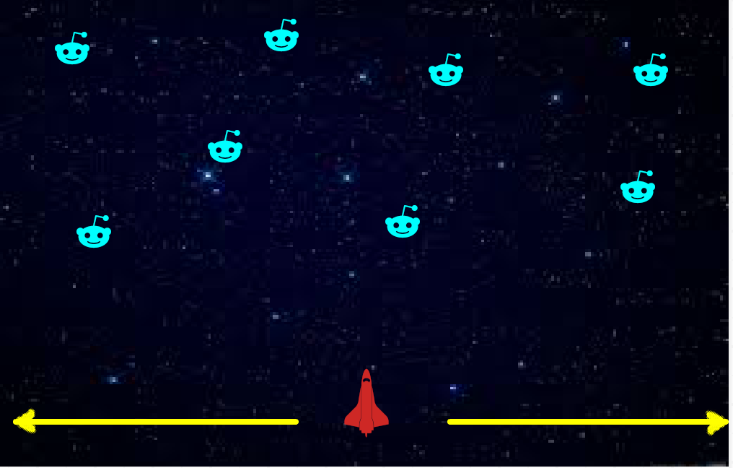

My second idea for a final project would just be to recreate a tic tac toe game. I am not sure how difficult it will start implementing a 3d tic tac toe game in openFrameworks. So, for now to not set myself up for failure I would like just to get a functioning graphical tic tac toe game. Drawing a single board and having the user click on available spaces and draw the corresponding ‘X’ or ‘O’. I also thought it would be interesting for users to drag and drop X’s or O’s to the available spaces. The picture displays the drag and drop method. Where the X’s and O’s are just scattered around on each side.

