**Singly Constrained vs Doubly Constrained Model Results**

**SINGLY CONSTRAINED:**

**FAMILY**

V_i **=** B_Enroll ***\**** Enroll_i **+** B_Dist ***\**** Dist_i

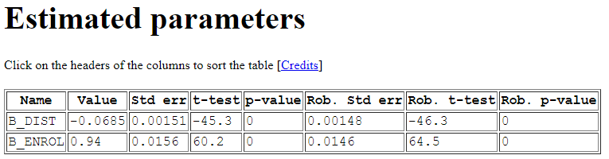

APO = 25.7%

**NON-FAMILY**

V_i **=** B_Enroll ***\**** Enroll_i **+** B_Dist ***\**** Dist_i

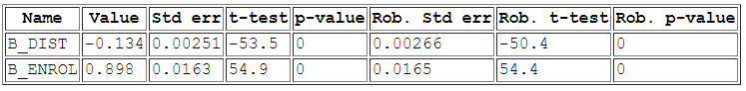

APO = 43.9%

**COMBINED (FAMILY + NON-FAMILY)**

V_i **=** B_Enroll ***\**** Enroll_i **+** B_Dist ***\**** Dist_i **+** B_Fam_Dist ***\**** Family ***\**** Dist_i

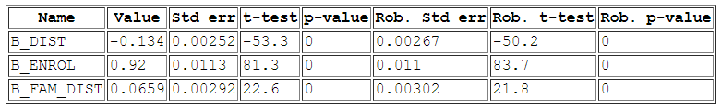

APO = 33.6%

**DOUBLY CONSTRAINED (“Eric Model”):**

**FAMILY**

V_i **=** ASC_i **+** B_Enroll ***\**** Enroll_i **+** B_Dist ***\**** Dist_i, where B_Enroll = 1

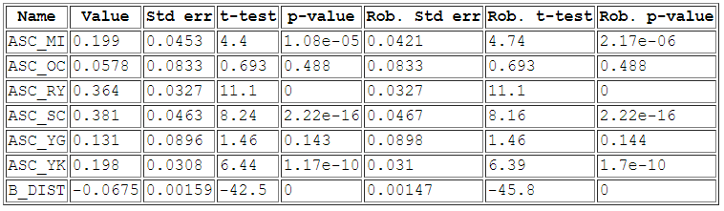

APO = 25.4%

**NON-FAMILY**

V_i **=** ASC_i **+** B_Enroll ***\**** Enroll_i **+** B_Dist ***\**** Dist_i, where B_Enroll = 1

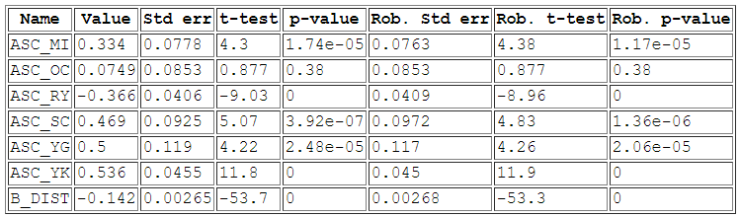

APO = 46.6%

**COMBINED (FAMILY + NON-FAMILY)**

V_i **=** ASC_i **+** B_Enroll ***\**** Enroll_i **+** B_Dist ***\**** Dist_i **+** B_Fam_Dist ***\**** Family ***\**** Dist_i, where B_Enroll = 1

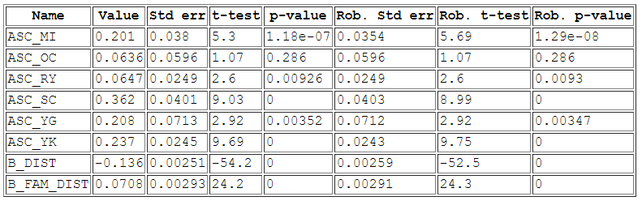

APO = 33.6%