How do people understand inequality in Chile? A study of attitudes through network analysis.

# Abstract

This article constitutes the first application of the attitude network approach to peoples' views on inequality. We adopt a network model in which nodes represent survey variables, and edges their conditional associations. This allows us to conceptualise perceptions, beliefs and judgments about inequality as a network of connected evaluative reactions. We analyse 2019 ISSP Social Inequality Module data from Chile, since this country is one of the most unequal in the world. Relying on a network approach, we provide a systematic analysis of the wide-ranging indicators measuring subjective inequality. Results show that conceptions regarding inequality, redistribution, taxation and wages form a unified belief system that is moderately connected and displays a small-world structure. Second, we stratify the sample by educational level, household income, and social class, obtaining six attitude networks. We compare the structures of these networks investigating differences in community membership, node centrality and network connectivity, evidencing that people in lower socioeconomic positions have a more multidimensional understanding of inequality. We contribute to social justice research by proposing an innovative conceptualization of these attitudes, and by providing evidence of their structural variation across different social status groups.

Keywords: attitudes towards inequality, social justice research, attitude networks, network analysis, Chile.

# 1 Introduction

Chile is one of the most unequal countries in the world [(Keeley, 2015)](https://app.readcube.com/library/0a3c846c-7570-4913-bd72-3afd46468081/all?uuid=34871736551204024&item_ids=0a3c846c-7570-4913-bd72-3afd46468081:4dec1e2f-b58b-4966-88d4-ef58733e8a40). Besides examining indicators of objective inequality at the country level, it is also important to investigate how people understand inequality, since their support is required to maintain an unequal social order. Interestingly, social justice research has highlighted a paradox according to which legitimation of inequality is stronger in more unequal countries [(Castillo, 2011)](https://app.readcube.com/library/0a3c846c-7570-4913-bd72-3afd46468081/all?uuid=5619736767725445&item_ids=0a3c846c-7570-4913-bd72-3afd46468081:43645f59-bc3b-48b3-a793-a551a57165bc) where people express higher support for meritocratic beliefs [(Mijs, 2019)](https://app.readcube.com/library/8841a519-4b57-4192-9afd-0d3b615bff40/all?uuid=9672999758477103&item_ids=8841a519-4b57-4192-9afd-0d3b615bff40:3bb0d41a-59ed-42d8-a80d-9438afbec138). These factors make Chile a relevant case study.

One of the main shortcomings of empirical social justice research is the lack of a systematic examination of these attitudes, since perceptions, beliefs and judgments about inequality are usually not studied simultaneously [(Janmaat, 2013)](https://app.readcube.com/library/0a3c846c-7570-4913-bd72-3afd46468081/all?uuid=6919719111130185&item_ids=0a3c846c-7570-4913-bd72-3afd46468081:a5fe0957-21b3-4f66-991b-a1b55320ca5a). Moreover, it is difficult to interpret their relationships hierarchically [(Trump, 2023)](https://app.readcube.com/library/0a3c846c-7570-4913-bd72-3afd46468081/all?uuid=2515132356430031&item_ids=0a3c846c-7570-4913-bd72-3afd46468081:548f8074-084b-410b-816d-44ea49789c66). This requires studying these conceptions as part of an integrated belief system. Therefore, we provide the first contribution adopting a network approach to the study of attitudes towards inequality. Within this framework, these attitudes are conceptualised and measured as a network of interacting evaluative reactions, where nodes represent survey variables and edges their conditional associations.

This article is structured as follows. First, we present a theoretical framework for a systematic inquiry of attitudes towards inequality, and we discuss the evidence that the literature shows for the Chilean case. Then, we describe the theory underlying the network approach. Second, we expose the research design and the network estimation methods adopted in this research. Third, we present results regarding the network of attitudes towards inequality at the population level, and we compare the attitudes networks of individuals with different education, household income and social class. Then, we discuss our results in light of the social justice and attitude network theories. Finally, in the conclusion, we stress limitations and contributions of our research.

# 2 Theory

## 2.1 Attitudes towards inequality

### 2.1.1. Attitudes towards inequality: a theoretical framework

The empirical study of people’s attitudes towards inequality constitutes a broad field of research, developed by work in two main areas: principles justice research and rewards justice research (Wegener, 1999). The former seeks to understand the support towards general distributional norms, while the latter addresses individual evaluations on specific distributions [(Castillo, 2012)](https://app.readcube.com/library/72f7b9ef-f289-4244-a0ee-52ad6777d0e5/all?uuid=3561768532017363&item_ids=72f7b9ef-f289-4244-a0ee-52ad6777d0e5:dfc55849-b695-481e-bbf0-e0f0143940a6). However, the fact that both areas are closely related and that the indicators used by the literature are varied, makes it necessary to use a global framework to analyze and order the different aspects of how people understand inequality.

In this line, Janmaat’s operationalization [(2013)](https://app.readcube.com/library/0a3c846c-7570-4913-bd72-3afd46468081/all?uuid=4724733487559969&item_ids=0a3c846c-7570-4913-bd72-3afd46468081:a5fe0957-21b3-4f66-991b-a1b55320ca5a&options=%7B%22items%22%3A%7B%220a3c846c-7570-4913-bd72-3afd46468081%3Aa5fe0957-21b3-4f66-991b-a1b55320ca5a%22%3A%7B%22suppressAuthor%22%3Atrue%7D%7D%7D) is of great importance, as it highlights the multidimensionality of attitudes towards inequality, while systematising the scientific production on the topic. The author argues that views on inequality vary in their *conception* and in their *dimension.* Conceptions of inequality involve individual perceptions, beliefs, and judgments. Perceptions correspond to subjective estimations about existing social inequalities; beliefs refer to normative ideas about how people think inequality should be; judgments represent evaluations on thedesirability of a given distributional asset. Secondly, views on inequality are structured in two dimensions. In fact, attitudes towards inequality are either referred to the magnitude of inequality or to the moral principles that govern the distribution of resources in a society. Thus, this operationalization can be visualised as a typology with six cells, that are obtained by crossing the three types of conceptions and the two dimensions of the views on inequality (See Table 1[1]).

These notions have been widely addressed in social justice literature, often using other nomenclatures. For example, what under Jaanmat's scheme is classified as perceptions on principles regarding inequality refer to what other authors label as *stratification beliefs* [*(Kluegel & Smith, 1981)*](https://app.readcube.com/library/0a3c846c-7570-4913-bd72-3afd46468081/all?uuid=04375106187447264&item_ids=0a3c846c-7570-4913-bd72-3afd46468081:7ef40926-f133-44c1-a745-d26fb8eb1d2a) or *inequality beliefs* [(Mijs, 2018)](https://app.readcube.com/library/0a3c846c-7570-4913-bd72-3afd46468081/all?uuid=30555780139816635&item_ids=0a3c846c-7570-4913-bd72-3afd46468081:57d7bb69-7f39-427c-8623-0f8e8cbbb790). Although the term “beliefs” is used, in reality they correspond to the determinants of inequality perceived by subjects, traditionally differentiated between individualistic -factors linked to the individuals themselves, such as their hard work or education- and structuralist -societal determinants beyond individual control, such as race [(Kluegel & Smith, 1986)](https://app.readcube.com/library/0a3c846c-7570-4913-bd72-3afd46468081/all?uuid=17032313512702424&item_ids=0a3c846c-7570-4913-bd72-3afd46468081:5cc6cd8e-9784-4936-b989-e74ab81455d3). Likewise, Janmaat’s beliefs on principles are also known as *justice ideologies* [(Wegener & Liebig, 1995)](https://app.readcube.com/library/0a3c846c-7570-4913-bd72-3afd46468081/all?uuid=8006039309727607&item_ids=0a3c846c-7570-4913-bd72-3afd46468081:64f73899-78ec-422e-b47b-539b9670e30f). These include merit, need, equity or equality, among others principles [(Deutsch, 1975)](https://app.readcube.com/library/0a3c846c-7570-4913-bd72-3afd46468081/all?uuid=04454265816106384&item_ids=0a3c846c-7570-4913-bd72-3afd46468081:58670b37-6695-45f3-a2c7-64c950fb52df). Researchers usually divide them in two major areas: egalitarianism, which calls for an equal distribution of resources, and individualism, where distribution is guided by individual performance [(Castillo, 2011)](https://app.readcube.com/library/0a3c846c-7570-4913-bd72-3afd46468081/all?uuid=3858031672196338&item_ids=0a3c846c-7570-4913-bd72-3afd46468081:43645f59-bc3b-48b3-a793-a551a57165bc).

Although Janmaat's work is limited to measurements exclusively on economic inequality, the evidence shows that subjective evaluations on redistribution, taxation and wages, are essential to comprehend how people understand the distribution of resources. It has been shown in a variety of contexts that beliefs about redistribution are closely related to people's perceptions of inequality [(Choi, 2021; Fatke, 2018; García‐Sánchez et al., 2020)](https://app.readcube.com/library/0a3c846c-7570-4913-bd72-3afd46468081/all?uuid=9375798723153361&item_ids=0a3c846c-7570-4913-bd72-3afd46468081:2d93587f-9510-4e10-b201-fde8c4b1b3a7,0a3c846c-7570-4913-bd72-3afd46468081:9aab537e-96b0-4c30-9d67-7516a018194f,0a3c846c-7570-4913-bd72-3afd46468081:421437b9-406d-4b60-b96d-48904371aa9e). Also, several studies have focused on people's preferences regarding taxation and their concerns about reducing inequalities [(Alm & Torgler, 2006; Barnes, 2015; Franko et al., 2013)](https://app.readcube.com/library/0a3c846c-7570-4913-bd72-3afd46468081/all?uuid=69504339673912&item_ids=0a3c846c-7570-4913-bd72-3afd46468081:e1cf7dce-708e-4e17-a6bb-d392a6e4a512,0a3c846c-7570-4913-bd72-3afd46468081:388b5c1b-5698-4a4b-812f-405b41b205e2,0a3c846c-7570-4913-bd72-3afd46468081:79269b17-8860-441d-bb9e-2ad14c4a7142). In the same vein, research on perceptions and beliefs regarding the magnitude and principles governing wage allocation constitute an important subfield in the study of inequality [(Castillo, 2009; Evans et al., 2010; Frank et al., 2015; Osberg & Smeeding, 2006)](https://app.readcube.com/library/0a3c846c-7570-4913-bd72-3afd46468081/all?uuid=5062265773555624&item_ids=0a3c846c-7570-4913-bd72-3afd46468081:82038a60-7e56-4476-bf1f-5e139deb9d12,0a3c846c-7570-4913-bd72-3afd46468081:f8444d46-f0f4-42a3-8bcc-c1bbe7c96906,0a3c846c-7570-4913-bd72-3afd46468081:f387503d-0e65-4ed0-991a-035ad167d616,0a3c846c-7570-4913-bd72-3afd46468081:67539644-af05-4052-92bc-bc84bfea1294).

### 2.1.2. Understanding attitudes towards inequality in Latin America and Chile

Research on attitudes towards inequality has mainly been conducted, paradoxically, in developed countries with lower levels of disparities in the distribution of resources. However, in recent years a significant amount of academic work has focused on understanding how people address inequality within Latin America, one of the regions with the highest inequality indexes in the world [(Keeley, 2015)](https://app.readcube.com/library/0a3c846c-7570-4913-bd72-3afd46468081/all?uuid=34871736551204024&item_ids=0a3c846c-7570-4913-bd72-3afd46468081:4dec1e2f-b58b-4966-88d4-ef58733e8a40). This literature has allowed us to understand the local particularities of the phenomenon and how various evidence in developed nations holds or not to the Latin American context.

Moreover, an important avenue of research on social justice focuses on identifying how sociodemographic characteristics are related to variations in people's attitudes towards inequality. Among these, one of the most studied questions refers to differences according to the social status of individuals, based on measures such as educational level, income and social class. Several studies show that higher socioeconomic positions are related to lower levels of perception of inequality [(Bobzien & Kalleitner, 2020; Evans et al., 1992; Evans & Kelley, 2017)](https://app.readcube.com/library/0a3c846c-7570-4913-bd72-3afd46468081/all?uuid=7877589205907024&item_ids=0a3c846c-7570-4913-bd72-3afd46468081:1df5fc7d-c219-4474-9bef-8f683cb55137,0a3c846c-7570-4913-bd72-3afd46468081:9297d250-e90d-4296-9925-17128c243ce4,0a3c846c-7570-4913-bd72-3afd46468081:d2a297e8-988d-46ab-bc51-15088fd4c4f4), a lower belief in public redistribution [(Franko et al., 2013)](https://app.readcube.com/library/0a3c846c-7570-4913-bd72-3afd46468081/all?uuid=6831266329904127&item_ids=0a3c846c-7570-4913-bd72-3afd46468081:79269b17-8860-441d-bb9e-2ad14c4a7142), and lower concerns towards the actual distribution of resources [(Hadler, 2005)](https://app.readcube.com/library/0a3c846c-7570-4913-bd72-3afd46468081/all?uuid=2686909684203773&item_ids=0a3c846c-7570-4913-bd72-3afd46468081:df71c568-b7b3-4b63-9890-002737dce3b5). These differences would be guided by status-related variations in experiences of relative deprivation [(Edmiston, 2018)](https://app.readcube.com/library/0a3c846c-7570-4913-bd72-3afd46468081/all?uuid=024485597711594642&item_ids=0a3c846c-7570-4913-bd72-3afd46468081:585d621f-2b40-4a8d-8b91-e01bf236f334) and by the lack of information lower-status individuals have to correctly estimate the resources held by different social groups [(Aalberg, 2008; Clark & D’Ambrosio, 2015)](https://app.readcube.com/library/0a3c846c-7570-4913-bd72-3afd46468081/all?uuid=35479648334671743&item_ids=0a3c846c-7570-4913-bd72-3afd46468081:d4367e94-a9ee-4abf-86c7-5f7befcbeb10,0a3c846c-7570-4913-bd72-3afd46468081:a9d67438-55f6-449c-ab11-7c29e8bea035). However, other research destabilise the link between status positions and attitudes towards inequality, highlighting the importance of cultural norms and normative values that go beyond mere self-interest [(Etzioni, 1988; Feldman & Zaller, 1992)](https://app.readcube.com/library/0a3c846c-7570-4913-bd72-3afd46468081/all?uuid=2308823528887355&item_ids=0a3c846c-7570-4913-bd72-3afd46468081:78dae9cd-0f4f-4f20-8fc3-db26ab186804,0a3c846c-7570-4913-bd72-3afd46468081:e6c5b150-35ab-4508-bb15-329cc4a14435)). Indeed, it has found that unlike in European countries [(Schmidt-Catran, 2016)](https://app.readcube.com/library/0a3c846c-7570-4913-bd72-3afd46468081/all?uuid=7443445448721774&item_ids=0a3c846c-7570-4913-bd72-3afd46468081:4b427cf2-1f59-4193-bc61-e455047de368) in Latin America support for attitudes such as public redistribution are not primarily determined by the objective socioeconomic position of individuals [(Berens, 2015; Franetovic & Castillo, 2021)](https://app.readcube.com/library/0a3c846c-7570-4913-bd72-3afd46468081/all?uuid=882600511382189&item_ids=0a3c846c-7570-4913-bd72-3afd46468081:f8983209-47e6-42dd-9f21-1f84856762c4,0a3c846c-7570-4913-bd72-3afd46468081:290609b6-aa67-4638-80dd-a01d30041199), questioning the applicability and universality of a self-interest approach, grounded in a utility-oriented social actor [(Franko et al., 2013; Meltzer & Richard, 1981; Wegener & Liebig, 1995)](https://app.readcube.com/library/0a3c846c-7570-4913-bd72-3afd46468081/all?uuid=5257263093877701&item_ids=0a3c846c-7570-4913-bd72-3afd46468081:a8efa3d4-401b-4655-8e9e-b343941697e6,0a3c846c-7570-4913-bd72-3afd46468081:64f73899-78ec-422e-b47b-539b9670e30f,0a3c846c-7570-4913-bd72-3afd46468081:79269b17-8860-441d-bb9e-2ad14c4a7142).

In particular, Chile is a country with vast research on attitudes towards inequality. Its high levels of economic disparities and its inclusion in 1998 in the International Social Survey Program (ISSP) have promoted a significant amount of academic work in the field. In this regard, it has been seen that in Chile people's education plays an important role, increasing perception of inequality [(Castillo et al., 2012)](https://app.readcube.com/library/0a3c846c-7570-4913-bd72-3afd46468081/all?uuid=29252465591923327&item_ids=0a3c846c-7570-4913-bd72-3afd46468081:10305cb5-888d-4e51-876f-11cc0593f8c8). However, there is evidence that belief in public redistribution is not explained by income [(Franetovic & Castillo, 2021)](https://app.readcube.com/library/0a3c846c-7570-4913-bd72-3afd46468081/all?uuid=2655121143974696&item_ids=0a3c846c-7570-4913-bd72-3afd46468081:f8983209-47e6-42dd-9f21-1f84856762c4) or political preferences [(Castillo et al., 2013)](https://app.readcube.com/library/0a3c846c-7570-4913-bd72-3afd46468081/all?uuid=9696042503395136&item_ids=0a3c846c-7570-4913-bd72-3afd46468081:5839deff-6753-41aa-b537-65e53c973424). The literature has also shown that in Chile most people critically judge the tax system [(Atria, 2022)](https://app.readcube.com/library/0a3c846c-7570-4913-bd72-3afd46468081/all?uuid=9174087098437864&item_ids=0a3c846c-7570-4913-bd72-3afd46468081:a0b5844b-739b-4db8-a978-68070bc52d00) and that the perception of tax regressivity and the belief in its progressivity are positively associated with the perception of inequality and the belief in public redistribution [(Castillo & Olivos, 2014)](https://app.readcube.com/library/0a3c846c-7570-4913-bd72-3afd46468081/all?uuid=1489557818592302&item_ids=0a3c846c-7570-4913-bd72-3afd46468081:058f8dc0-59d9-4642-b32a-847339849372). However, none of these efforts have incorporated a holistic approach capable of understanding how the wide range of attitudes towards inequality relate to one another and how these associations differ according to individuals’ position in social structure. The present research responds precisely to this gap in the field.

## 2.2 Attitudes networks

As anticipated above, attitudes towards inequality are usually measured through perceptions, beliefs and judgments about magnitude and principles about inequality [(Janmaat, 2013)](https://app.readcube.com/library/0a3c846c-7570-4913-bd72-3afd46468081/all?uuid=0550601070114457&item_ids=0a3c846c-7570-4913-bd72-3afd46468081:a5fe0957-21b3-4f66-991b-a1b55320ca5a). Researchers tend to aggregate variables that tap these dimensions into indices [(e.g. Kluegel & Smith, 1986)](https://app.readcube.com/library/0a3c846c-7570-4913-bd72-3afd46468081/all?uuid=12405919009234356&item_ids=0a3c846c-7570-4913-bd72-3afd46468081:5cc6cd8e-9784-4936-b989-e74ab81455d3&options=%7B%22items%22%3A%7B%220a3c846c-7570-4913-bd72-3afd46468081%3A5cc6cd8e-9784-4936-b989-e74ab81455d3%22%3A%7B%22prefix%22%3A%22e.g.%22%7D%7D%7D), conforming at least implicitly to a latent variable measurement approach. The critical flaw in this operationalization is that relationships among indicators of the same dimensions are cancelled out, flattening the multidimensionality of the concept. To overcome this limitation, we propose to study attitudes towards inequality through the lens of the CAN model [(Dalege et al., 2016)](https://app.readcube.com/library/c61b91da-fa6e-4348-80b6-c2428280b16a/all?uuid=7750609497223262&item_ids=c61b91da-fa6e-4348-80b6-c2428280b16a:a2c9eb4c-32c5-4fe3-9d5b-27c5022c4699). In this framework, attitudes are conceptualised and measured as networks of interacting evaluative reactions. These lower-order reactions are the individual survey items, thus the set of perceptions, beliefs, and judgments about inequality. These are graphically represented as nodes forming a network whose weighted, undirected edges can be estimated from real data [(Dalege et al., 2017)](https://app.readcube.com/library/c61b91da-fa6e-4348-80b6-c2428280b16a/all?uuid=10305090434413755&item_ids=c61b91da-fa6e-4348-80b6-c2428280b16a:5b2491db-b30c-4f58-ab39-c2c7471d3c9c). In this paper, these edges are interpretable as regularised partial correlations between survey items (see Methods section). Importantly, this approach qualifies between-item correlations as indicative of direct causal influence between the components of attitudes towards inequality. This constitutes the main difference between the CAN and latent variable measurement approaches, as the latter assumes that between-item correlations are spurious, being caused by an antecedent, unobservable variable [(Dalege et al., 2018)](https://app.readcube.com/library/c61b91da-fa6e-4348-80b6-c2428280b16a/all?uuid=05727287349164689&item_ids=c61b91da-fa6e-4348-80b6-c2428280b16a:12564573-44ed-454b-a58b-80c7e2932eec).

Scholars who have applied the CAN model to sociopolitical attitudes have shown that relevant nodes in the attitude network are important predictors of attitude change [(Carter et al., 2020; Chambon et al., 2022; Zwicker et al., 2020)](https://app.readcube.com/library/c61b91da-fa6e-4348-80b6-c2428280b16a/all?uuid=4348723439876657&item_ids=c61b91da-fa6e-4348-80b6-c2428280b16a:cbee107f-f476-44cf-ac6c-c76e7fb5ee99,c61b91da-fa6e-4348-80b6-c2428280b16a:d318829d-ff0c-465e-bc63-02415fe27799,c61b91da-fa6e-4348-80b6-c2428280b16a:8c732dff-5588-4161-b313-520864427349). The prominence of a node in a network is usually captured through the centrality metric [(Borsboom et al., 2021)](https://app.readcube.com/library/c61b91da-fa6e-4348-80b6-c2428280b16a/all?uuid=1072153559325204&item_ids=c61b91da-fa6e-4348-80b6-c2428280b16a:77902d13-3eed-470a-a4fc-1d0e839ca6bb). Research has shown that the most suitable measure for studying attitude networks is Strength centrality [(Bringmann et al., 2019; Dablander & Hinne, 2019)](https://app.readcube.com/library/c61b91da-fa6e-4348-80b6-c2428280b16a/all?uuid=8114781050958585&item_ids=c61b91da-fa6e-4348-80b6-c2428280b16a:691c37aa-f093-419e-8e63-8282f1e41cb8,c61b91da-fa6e-4348-80b6-c2428280b16a:51ed21cc-a44d-4599-a03e-e56caf0146ea). Strength is the generalisation of Degree centrality for weighted networks, and is calculated by summing the absolute value of all edge weights with which a node is involved [(Opsahl et al., 2010)](https://app.readcube.com/library/c61b91da-fa6e-4348-80b6-c2428280b16a/all?uuid=7688387125846118&item_ids=c61b91da-fa6e-4348-80b6-c2428280b16a:f31b5001-2e73-49ee-9a91-383651b2a48e). Since edges of an attitude network represent the associations existing between the selected items, Strength centrality operationalizes the influence that each node is expected to exercise on each other. Consistently, scholars showed that changes in central -rather than peripheral nodes- trigger larger readjustment processes [(Dalege et al., 2017; Schlicht-Schmälzle et al., 2018)](https://app.readcube.com/library/c61b91da-fa6e-4348-80b6-c2428280b16a/all?uuid=8869693220076843&item_ids=c61b91da-fa6e-4348-80b6-c2428280b16a:5b2491db-b30c-4f58-ab39-c2c7471d3c9c,c61b91da-fa6e-4348-80b6-c2428280b16a:6a9141c6-6628-4444-8af4-2a3e13440629). Therefore, this paper will investigate the centrality of each evaluative reaction belonging to the network of attitudes towards inequality.

Measuring an attitude as a network allows us to apply another technique called Exploratory Graph Analysis [EGA] [(H. F. Golino et al., 2017)](https://app.readcube.com/library/c61b91da-fa6e-4348-80b6-c2428280b16a/all?uuid=2137697942083273&item_ids=c61b91da-fa6e-4348-80b6-c2428280b16a:c44c186e-58c2-421b-947c-788ff1d19e21). EGA is a dimensionality assessment technique consisting of two steps. First, EGA estimates a partial correlation network from survey data. Second, it applies a community detection algorithm, and the number of clusters in the network is equated with the number of underlying dimensions of the construct (see Method section). Simulation studies have shown that EGA performs equal to or better than other factor analytic techniques [(H. Golino et al., 2020)](https://app.readcube.com/library/c61b91da-fa6e-4348-80b6-c2428280b16a/all?uuid=28754249195863624&item_ids=c61b91da-fa6e-4348-80b6-c2428280b16a:beaa49c8-6603-48e3-8da0-cca3fd1409e2). Therefore, EGA allows us to investigate the dimensionality of attitudes toward inequality and will be applied in the following article.

# 3 Methods

## 3.1 Data and variables

We use data from the ISSP 2019 – Social Inequality V module [(ISSP Research Group, 2022)](https://app.readcube.com/library/0a3c846c-7570-4913-bd72-3afd46468081/all?uuid=4957971161410403&item_ids=0a3c846c-7570-4913-bd72-3afd46468081:55247836-2119-4954-9b7e-8624e750a156). This survey includes questions measuring perceptions, beliefs, and judgments about magnitude and principles regarding inequality and related topics, such as redistribution, taxation and wages. Data are representative of the Chilean population aged 18 years or older. Listwise deletion reduces the original sample from 1,347 to 1,040 individuals. Table 1 shows the list of selected variables and their collocation in Janmaat’s typology, whereas Table 2 reports the survey questions and their descriptive statistics. The analyses feature two perceptions about the magnitude of inequality (*ineq_p)* and progressive taxation (*reg_p*). Moreover, we include an item measuring respondents’ normative beliefs on the magnitude of the appropriate tax progressivity levels (*prog_b*). Finally, we include three variables addressing judgments on the size of existing inequality (*ineq_j*), political failure in redistribution (*redis_f*), and political disinterest in implementing redistributive policies (*redis_d*). We also analyse principles about inequality. We use ten variables tapping respondents’ perceptions of the principles that explain inequality in Chile (*family-sex*). We further include two variables regarding public and private redistribution (*redis_p, redis_m)*, and four concerning beliefs on criteria that should determine pay allocation (*resp-merit*).

**Table 1: Selected ISSP variables and their collocation in Janmaat’s typology**

|  |  |  |
| --- | --- | --- |
|  | **Magnitude** | **Principles** |
| **Perceptions** | 1. Perception of large income inequality (*ineq_p*) 2. Perception of tax regressivity (*reg_p*) | 1. Importance of wealthy family (*family*) 2. Importance of parental education (*edupar*) 3. Importance of education (*edu*) 4. Importance of hard work (*work*) 5. Importance of knowing right people (*people*) 6. Importance of political connections (*connec*) 7. Importance of giving bribes (*bribes*) 8. Importance of race (*race*) 9. Importance of religion (*relig*) 10. Importance of sex (*sex*) |
| **Beliefs** | 1. Belief in progressive taxation (*prog_b*) | 1. Belief in public redistribution (*redis_p*) 2. Belief in market redistribution (*redis_m*) 3. Pay criteria: Responsibility (*resp*) 4. Pay criteria: Training (*train*) 5. Pay criteria: Need (*need*) 6. Pay criteria: Merit (*merit*) |
| **Judgments** | 1. Judgment of unfair distribution (*ineq_j*) 2. Judgment of political disinterest in redistribution (*redis_d*) 3. Judgment of failure of public redistribution (*redis_f*) |  |

Variable names in parentheses.

**Table 2: Selected variable and their frequency distribution**

|  |  |  |  |  |  |
| --- | --- | --- | --- | --- | --- |
| **Evaluative reaction** | **Question** | **Scale** | **Mean** | **σ** | **N** |
| ineq_p | To what extent do you agree or disagree with the following statement: Differences in income in Chile are too large. | 1-5* | 4.119 | 0.935 | 1,040 |
| reg_p | Generally, how would you describe taxes in Chile today for those with high incomes? | 1-5 | 3.453 | 1.077 | 1,040 |
| prog_b | Do you think people with high incomes should pay a larger share of their income in taxes than those with low incomes, the same share, or a smaller share? | 1-5* | 3.927 | 0.884 | 1,040 |
| ineq_j | How fair or unfair do you think the income distribution is in Chile? | 1-4 | 3.259 | 0.679 | 1,040 |
| redis_d | Most politicians in Italy do not care about reducing the differences in income between people with high incomes and people with low incomes. | 1-5* | 3.902 | 1.014 | 1,040 |
| redis_f | How successful do you think the government in Italy is nowadays in reducing the differences in income between people with high incomes and people with low incomes? | 1-5 | 3.446 | 1.255 | 1,040 |
| family | How important is coming from a wealthy family for getting ahead in life? | 1-5* | 2.792 | 1.135 | 1,040 |
| edupar | How important is having well-educated parents for getting ahead in life? | 1-5* | 3.213 | 1.074 | 1,040 |
| edu | How important is having a good education yourself for getting ahead in life? | 1-5* | 3.833 | 0.883 | 1,040 |
| work | How important is hard work for getting ahead in life? | 1-5* | 3.837 | 0.974 | 1,040 |
| people | How important is knowing the right people for getting ahead in life? | 1-5* | 3.438 | 0.977 | 1,040 |
| connec | How important is having political connections for getting ahead in life? | 1-5* | 2.441 | 1.197 | 1,040 |
| bribes | How important is giving bribes for getting ahead in life? | 1-5* | 1.838 | 1.031 | 1,040 |
| race | How important is a person’s race for getting ahead in life? | 1-5* | 2.033 | 1.116 | 1,040 |
| relig | How important is a person’s religion for getting ahead in life? | 1-5* | 1.887 | 1.047 | 1,040 |
| sex | How important is being born a man or a woman for getting ahead in life? | 1-5* | 1.982 | 1.082 | 1,040 |
| redis_p | It is the responsibility of the government to reduce the differences in income between people with high incomes and those with low incomes. | 1-5* | 3.963 | 0.902 | 1,040 |
| redis_m | It is the responsibility of private companies to reduce the differences in pay between their employees with high pay and those with low pay. | 1-5* | 3.773 | 0.909 | 1,040 |
| resp | How much responsibility goes with the job – how important do you think that ought to be in deciding pay? | 1-5* | 3.984 | 0.772 | 1,040 |
| train | The number of years spent in education and training? – how important do you think that ought to be in deciding pay? | 1-5* | 3.857 | 0.811 | 1,040 |
| need | Whether the person has children to support – how important do you think that ought to be in deciding pay? | 1-5* | 3.534 | 0.892 | 1,040 |
| merit | How well he or she does the job – how important do you think that ought to be in deciding pay? | 1-5* | 3.998 | 0.743 | 1,040 |

The polarity of the variables marked with an asterisk was inverted. High values of each variable indicate large magnitudes (e.g.: high perception of inequality) or agreement on the importance of a principle (e.g.: the importance of sex for getting ahead in life).

## 3.2 Network methods

This paper is structured in two parts. In the first part of the article, we estimate the network of attitudes towards inequality from ISSP data. This will retrieve the between-person structure of this attitude network in Chile. Importantly, this first part gives us insights into how perceptions, beliefs, and judgments about inequality relate *at the population level*. Within the first part of the research, we are forced to assume that between-items associations are similar across individuals, as cross-sectional data impedes the estimation of a personalised attitude network [(Borsboom et al., 2021)](https://app.readcube.com/library/c61b91da-fa6e-4348-80b6-c2428280b16a/all?uuid=3419544903511311&item_ids=c61b91da-fa6e-4348-80b6-c2428280b16a:77902d13-3eed-470a-a4fc-1d0e839ca6bb). This is a stringent assumption we want to relax through the second part of the research design, where we investigate differences between attitude networks of different population segments. More precisely, since social status has been shown to influence attitudes towards inequality (See Theory section), we want to explore the differences in the structures of the attitude networks of people with different educational levels, household income and objective social class.

Since most of the selected variables are measured with a 1 to 5 scale, we select the Gaussian Graphical Model [GGM] as our network estimation tool [(Epskamp, Waldorp, et al., 2018)](https://app.readcube.com/library/c61b91da-fa6e-4348-80b6-c2428280b16a/all?uuid=864469152981495&item_ids=c61b91da-fa6e-4348-80b6-c2428280b16a:186fe824-a832-409a-ba25-0d8aa0ee2418). As anticipated above, this method translates the selected survey variables into network nodes and estimates their connections from ISSP data. GGMs are a subclass of Pairwise Markov Random Fields [PMRF] [(Lauritzen, 1996)](https://app.readcube.com/library/c61b91da-fa6e-4348-80b6-c2428280b16a/all?uuid=7797133527185797&item_ids=c61b91da-fa6e-4348-80b6-c2428280b16a:fb3960ee-605d-45a9-b0dd-d6bde7ff7db8). Edges of a PMRF are weighted and undirected. Indeed, the edges of a GGM are interpretable as partial correlations [(Epskamp, Waldorp, et al., 2018)](https://app.readcube.com/library/c61b91da-fa6e-4348-80b6-c2428280b16a/all?uuid=7348855248403767&item_ids=c61b91da-fa6e-4348-80b6-c2428280b16a:186fe824-a832-409a-ba25-0d8aa0ee2418), which are the correlation existing between each pair of network nodes, while controlling for each other variables in the model [(Epskamp & Fried, 2018)](https://app.readcube.com/library/c61b91da-fa6e-4348-80b6-c2428280b16a/all?uuid=849925129384999&item_ids=c61b91da-fa6e-4348-80b6-c2428280b16a:cad7131b-461c-4220-9306-fc87f3c17b11). The GGM also applies regularisation for edge estimation, in order to reduce the risk of including spurious edges in the model, increasing model parsimony and enhancing the interpretability of the network plot [(Borsboom et al., 2021)](https://app.readcube.com/library/c61b91da-fa6e-4348-80b6-c2428280b16a/all?uuid=39834875817245774&item_ids=c61b91da-fa6e-4348-80b6-c2428280b16a:77902d13-3eed-470a-a4fc-1d0e839ca6bb). A common way to apply regularisation for network models is the combination of the graphical LASSO with the Extended Bayesian Information Criteria [EBIC] [(Epskamp, Waldorp, et al., 2018)](https://app.readcube.com/library/c61b91da-fa6e-4348-80b6-c2428280b16a/all?uuid=30525300913212905&item_ids=c61b91da-fa6e-4348-80b6-c2428280b16a:186fe824-a832-409a-ba25-0d8aa0ee2418). The graphical LASSO is an efficient and well-known regularisation technique inducing sparsity in the network matrix by suppressing weak edges to exactly zero [(Friedman et al., 2008)](https://app.readcube.com/library/c61b91da-fa6e-4348-80b6-c2428280b16a/all?uuid=1775512692080482&item_ids=c61b91da-fa6e-4348-80b6-c2428280b16a:550aa465-5f0f-4470-a077-401b8c815afe). The graphical LASSO relies on a tuning parameter, which directly regulates the level of edge shrinkage [(Epskamp, Waldorp, et al., 2018)](https://app.readcube.com/library/c61b91da-fa6e-4348-80b6-c2428280b16a/all?uuid=9192213999687137&item_ids=c61b91da-fa6e-4348-80b6-c2428280b16a:186fe824-a832-409a-ba25-0d8aa0ee2418). To find its optimal value, researchers usually rely on the minimization of the EBIC [(Chen & Chen, 2008)](https://app.readcube.com/library/c61b91da-fa6e-4348-80b6-c2428280b16a/all?uuid=2480883739724158&item_ids=c61b91da-fa6e-4348-80b6-c2428280b16a:a4a20871-770b-4cbb-ba37-8545687a2fc8). This strategy has been shown to perform well in retrieving the network structure of variables surveyed in moderated-sized samples [(Foygel & Drton, 2010)](https://app.readcube.com/library/c61b91da-fa6e-4348-80b6-c2428280b16a/all?uuid=851535391795713&item_ids=c61b91da-fa6e-4348-80b6-c2428280b16a:7e9f389c-5340-492d-a5e2-3ff0bb120d9e). In addition to network estimation, we assess the number of communities in which network nodes gather, performing EGA. EGA applies the Walktrap community detection algorithm [(Pons & Latapy, 2005)](https://app.readcube.com/library/c61b91da-fa6e-4348-80b6-c2428280b16a/all?uuid=1125428550742098&item_ids=c61b91da-fa6e-4348-80b6-c2428280b16a:347321e6-c9f6-4f3e-8787-a8337843c5e0) to the GGM network. Finally, exploiting the “fundamental rule of network psychometrics” [(H. F. Golino et al., 2017)](https://app.readcube.com/library/c61b91da-fa6e-4348-80b6-c2428280b16a/all?uuid=20619109603165808&item_ids=c61b91da-fa6e-4348-80b6-c2428280b16a:c44c186e-58c2-421b-947c-788ff1d19e21), the number of detected network clusters is equated to the number of dimensions underlying the construct of attitudes towards inequality [(Christensen & Golino, 2021a, 2021b; H. Golino et al., 2020)](https://app.readcube.com/library/c61b91da-fa6e-4348-80b6-c2428280b16a/all?uuid=1433391247500294&item_ids=c61b91da-fa6e-4348-80b6-c2428280b16a:beaa49c8-6603-48e3-8da0-cca3fd1409e2,c61b91da-fa6e-4348-80b6-c2428280b16a:0d9f414f-85ed-4098-861a-8ea098347d45,c61b91da-fa6e-4348-80b6-c2428280b16a:574a0554-d381-4420-a643-6c3e698d1d13).

The second part of the article investigates structural differences in the attitude networks of different population strata. Hence, we split the original sample according to the median values of three socio-economic measures. First, we build a sample with low (versus high) educational level. We set the threshold at eleven years of education, differentiating between incomplete secondary or less (N=373), and complete secondary or more (N=660). We repeat the same process for household income setting the splitting thresholds at 448,000 CLP per month. We obtain two samples of 334 and 332 individuals. Finally, we compare manual (N=385) and non-manual workers (N=381). After this procedure, we obtain six samples on which we re-apply the GGM-based network estimation exposed in the previous paragraph. This gives us six different attitude networks, which we will statistically compare to investigate how low and high-status individuals understand inequality in Chile. To investigate their structural differences we undertake three routes. First, we observe variations at the community level, hence investigating if socioeconomic groups have a more multidimensional understanding of attitudes towards inequality. To observe these variations we apply EGA to the six attitude networks, comparing the number of dimensions retrieved in low versus high-status samples. Second, we perform a Network Comparison Test [(Borkulo et al., 2022)](https://app.readcube.com/library/c61b91da-fa6e-4348-80b6-c2428280b16a/all?uuid=25935863814607596&item_ids=c61b91da-fa6e-4348-80b6-c2428280b16a:6cdbeb0a-44c2-4e66-9bf5-1a1dd28578d7) to isolate statistical differences in the Strength centrality values of the same nodes across different attitude networks. This will allow us to observe variations in the importance of single evaluative reactions within the six attitudes networks. Third, we compare network connectivity to observe whether evaluative reactions are associated with the same intensity when stratifying the sample. To do so we calculate the Weighted Average Shortest Path Length [ASPL] of the six attitude networks [(Opsahl et al., 2010)](https://app.readcube.com/library/c61b91da-fa6e-4348-80b6-c2428280b16a/all?uuid=6468295483749602&item_ids=c61b91da-fa6e-4348-80b6-c2428280b16a:f31b5001-2e73-49ee-9a91-383651b2a48e).

# 

# 4 Results

## 4.1 Network of attitudes towards inequality (747/ 800)

Figure 1 shows the network of attitudes towards inequality in Chile. Network nodes represent the selected ISSP survey variables. Network edges represent positive (blue) and negative (red) linear relationships that are estimated from the data. Edge width is indicative of the strength of each association. Nodes are coloured according to community membership. The 22 evaluative reactions form a fully connected network, with no isolated nodes. This means that all the perceptions, beliefs and judgments about magnitudes and principles concerning inequality, redistribution, taxation and wages are part of a unified belief system in the Chilean population.

**Figure 1: Network of attitudes towards inequality**

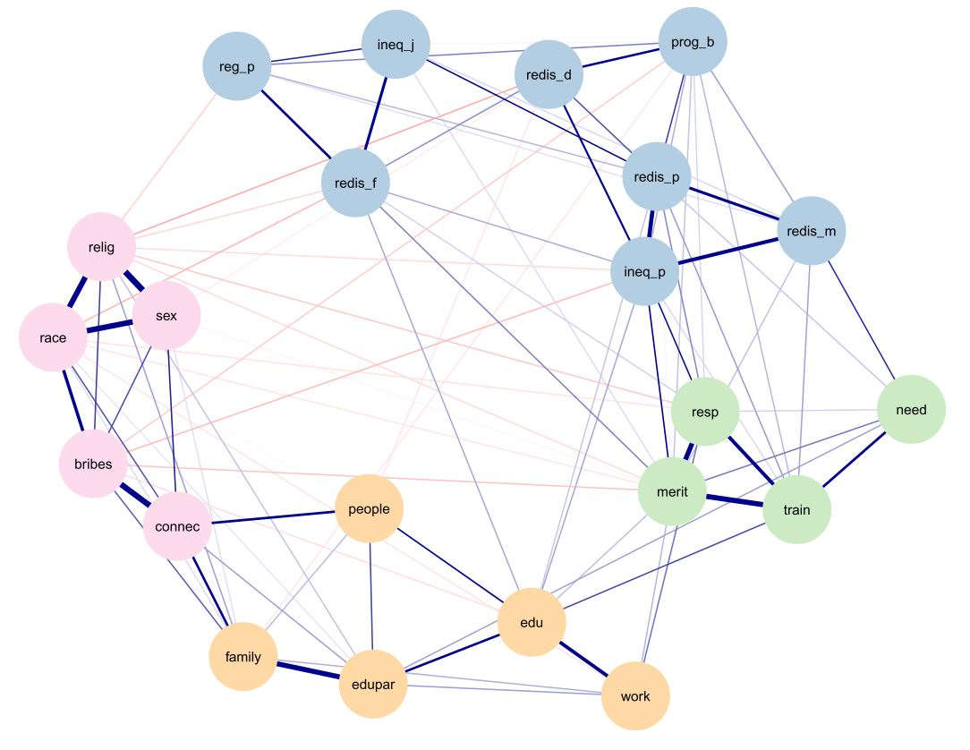

Nodes represent the 22 evaluative reactions. An edge is drawn when two variables are correlated, after having controlled for the others. The absence of an edge between two variables means that they are conditionally independent instead. Blue (red) edges represent positive (negative) associations; thicker edges represent stronger relationships. The colour of the nodes corresponds to the detected communities in the network.

EGA shows that attitudes towards inequality in Chile are grouped into four communities. The first and largest of all, in blue, concentrates all the perceptions, beliefs and judgments regarding the magnitude of inequality. In fact, it gathers the perceptions of large income inequality (*ineq_p*) and tax regressivity (*reg_p*), the belief in progressive taxation (*prog_b*), and the judgments about unfair distribution (*ineq_j*), political disinterest in redistribution (*redis_d*), and failure of public redistribution (*redis_f*). Additionally, this cluster is composed of two beliefs on principles concerning public (*redis_p*) and market redistribution (*redis_m*).

The remaining three communities deal exclusively with conceptions regarding principles about inequality. The pink cluster brings together structuralist explanations of inequality. It includes the perceived importance of the role played by people's race (*race*), sex (*sex*), religion (*relig*), bribes (*bribes*) and political connections (*connec*) in shaping inequalities. The orange one, reunites individualistic explanations, associated with individual or family actions: the importance of hard work (*work*), education (*edu*), parental education (*edupar*), coming from a wealthy family (*family*) and knowing the right people (*people*). The last and smallest community, in green, includes the totality of beliefs about the principles that should determine people's wages: responsibility (*resp*), training (*train*), need (*need*) and merit (*merit*).

This community structure reveals that the attitude network has high clustering, meaning that evaluative reactions tend to gather in enclosed communities, and to interact mainly with neighbouring variables. Moreover, this attitude network also has moderate connectivity (Weighted ASPL = 26.903). These features are usually associated with a small-world network. When compared to a random network, small-world structures are characterised by greater or equal values of connectivity, and by higher clustering coefficients [(Watts & Strogatz, 1998)](https://app.readcube.com/library/c61b91da-fa6e-4348-80b6-c2428280b16a/all?uuid=47931186881145893&item_ids=c61b91da-fa6e-4348-80b6-c2428280b16a:7a99534d-1a13-4396-a198-0e335690a73e). We investigate the small-worldness of the attitude network with a formal test that compares its connectivity and its clustering with those of a simulated random network having the same size (Humphries & Gurney, 2008). The test reveals a small-world index of 1.254, which is compatible with a small-world structure.

Most of the relationships between nodes are positive. Although there are negative associations, represented by red links, these tend to be of lower intensity if compared to the positive ones. The associations between the nodes *relig* and *sex* (edge weight = 0.36), *connec* and *bribes* (0.34), *race* and *sex* (0.33) stand out as the strongest edges. All these links correspond to intra-community associations, i.e., occurring between nodes belonging to the same cluster. However, there are weaker associations that have the particularity of bridging different communities together. Among these inter-community links, the associations of *connec* with the nodes *family* (0.16) and *people* (0.16) stand out, connecting the communities of individualistic and structuralist explanations. In addition, the communities gathering conceptions on magnitude of inequality (blue) and the one featuring principles on pay criteria (green) are mostly linked by the associations *ineq_p*-*merit* (0.10)*, ineq_p-resp* (0.10)*, and redis_m*-*need* (0.08).

Finally, we investigate the relative importance of each node in the network structure. This can be seen more clearly in Figure 2, which reports the Strength centrality for all the nodes in the network. The nodes *race*, *merit*, *ineq_p* and *relig* are those with the highest centrality. In the case of *race* and *relig*, this is explained by their triadic interaction with the node *sex*. The same occurs with *merit*, given the relevant links between *merit, resp* and *train*. In the case of *ineq_p*, a different phenomenon occurs, since its centrality is due to the multiplicity of its associations: of high intensity with nodes of its own community and of medium entity with variables of other communities. On the contrary, *reg_p, need, ineq_j* and *people* are the nodes with the lowest centrality in the network.

**Figure 2: Strength centrality of network nodes**

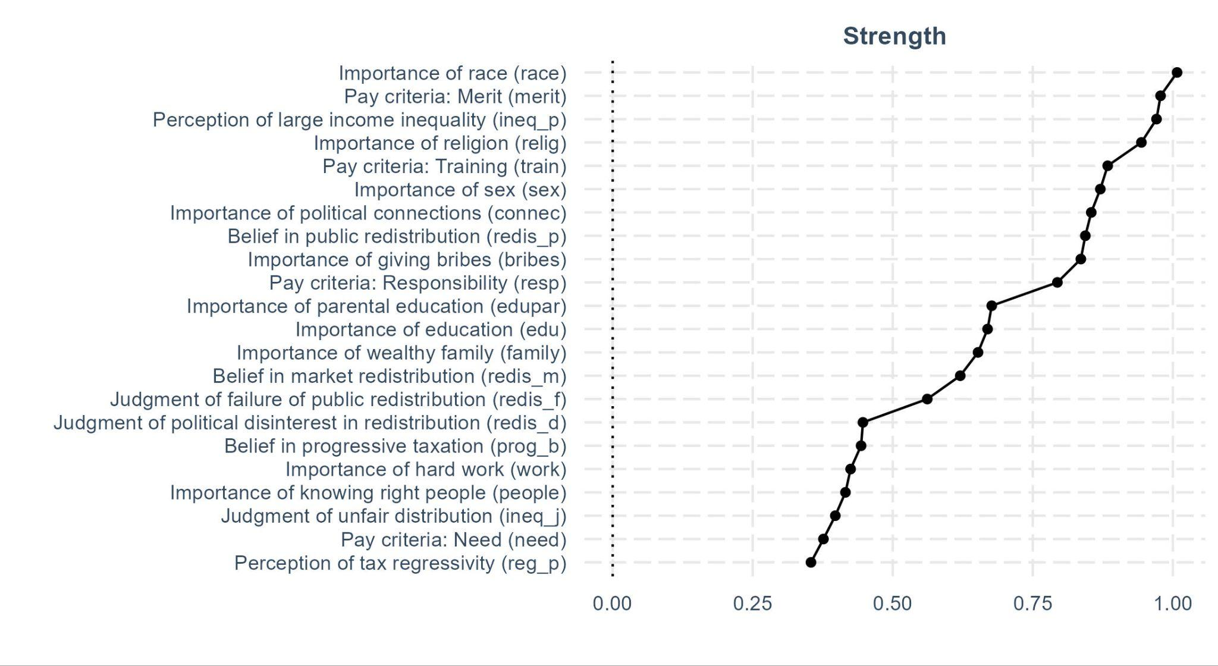

## 

## 4.2 Comparing attitude networks across socioeconomic variables

**Figure 3: Networks of attitudes towards inequality across socioeconomic variables**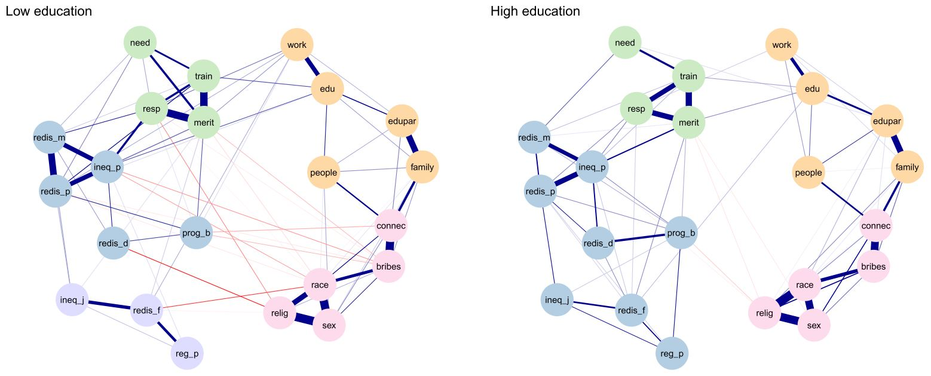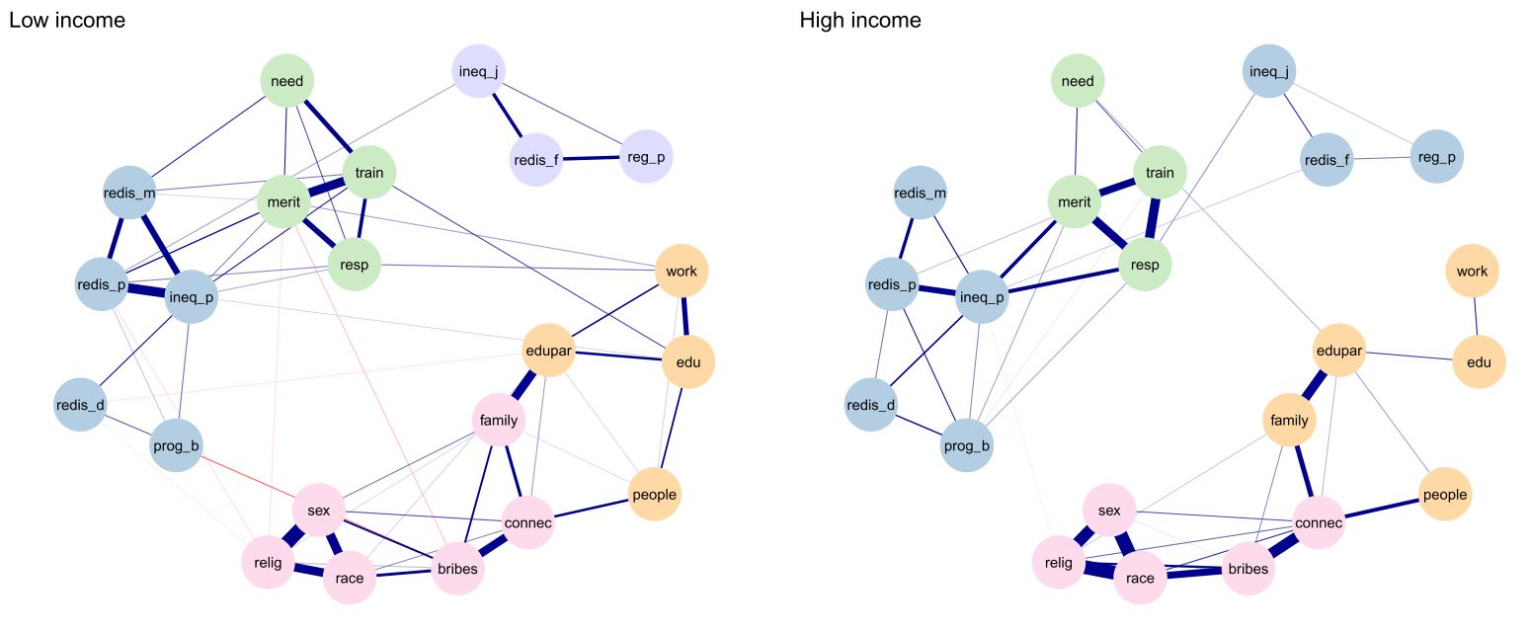

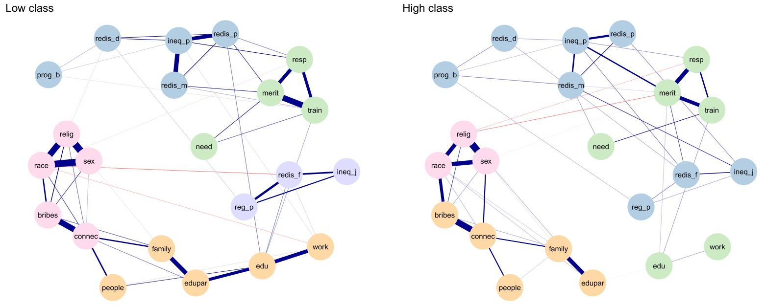Notes: Six networks of attitudes towards inequality estimated on six samples obtained splitting the original one by educational level, household income, and social class. The layout of each pair of attitude networks is obtained by averaging those of low and high-status samples.

This section presents results regarding differences between attitudes networks estimated on stratified samples. More specifically, we split the original data along three socioeconomic measures: educational level, household income and social class. As these variables can influence the levels of attitudes towards inequality, we expect to find structural network differences in terms of communities, node centrality and connectivity.

Figure 3 plots the result of six network estimations. All networks are fully connected, meaning that regardless of their socioeconomic conditions, Chileans organise their attitudes towards inequality in a single belief system. The figure highlights an important pattern regarding the dimensionality of the attitudes in question. Indeed, EGA indicates that the attitude networks of people with lower social status are systematically characterised by a greater number of network communities, thus, a more multidimensional comprehension of inequality. Indeed, the attitude networks of people with low and high educational levels show five and four clusters respectively (top panel of Figure 3). In the attitude network of the low-income sample, the perception of tax regressivity (*reg_p*) with the judgments of unfair distribution (*ineq_j*) and failure of public redistribution (*redis_f*) form a new violet cluster, gathering critical evaluations of the magnitude of Chilean inequalities. In the highly educated sample, these variables are instead part of the blue cluster. This is due to a combination of two factors. First, the partial correlations between these three items are stronger in the lower education sample. Second, in the attitude network of the most educated, these three nodes vigorously interact with the blue cluster, whereas in those of the less educated nodes of these communities weakly interact.

The pattern repeats for the income samples, where we find two attitude networks with five and four clusters. Here the main difference lies in the membership of the nodes *ineq_j*, *redis_f*, and *reg_p*. In the sample with low household income, these variables are more strongly correlated. Moreover, their judgments about the failure of public redistribution, and their perceptions about tax regressivity are almost uncorrelated with the other variables in the network. Indeed, the node *ineq_j* bridges between the violet cluster and the rest of the network. More precisely, judgments of unfair distribution (*ineq_j*) are positively correlated with stronger belief in public redistribution (*redis_p*) in the low-income sample. The structure of the attitude network of the high-income sample differs in that these three items are only loosely correlated, and in that the judgment about the failure of public redistribution (*redis_f)* is positively correlated with the perception of large income inequality (*ineq_p*).

Finally, the attitude network of manual workers displays five clusters, whereas that of the non-manual sample shows four communities. These are the networks differing the most in their community structure, as the composition of each cluster is different. In the lower-class sample, the blue cluster features five variables, since judgment of unfair distribution (*ineq_j*), those about the failure of public redistribution (*redis_f*), and the perception of tax regressivity (*reg_p*) form a separate cluster, the violet one. This mirrors the community structure of the attitude networks estimated on the low and high education samples. Indeed, among the people with lower class, these variables strongly interact, whereas in the other sample their relationships are looser, and their connections with the other nodes became stronger. Another difference is the community memberships of the nodes *edu* and *work*. In the high class sample these perceptions of principles shaping inequality are completely detached from the other explanations of inequality, belonging to the green cluster. Conversely, these variables are linked to the other inequality beliefs in the lower-class sample. Finally, the pink cluster is smaller in the higher-class sample, as the nodes *bribes* and *connec* gravitate with the yellow one. This reveals that low class individuals perceive a greater number of structural factors governing inequalities.

**Figure 4: Differences in nodes’ Strength centrality**

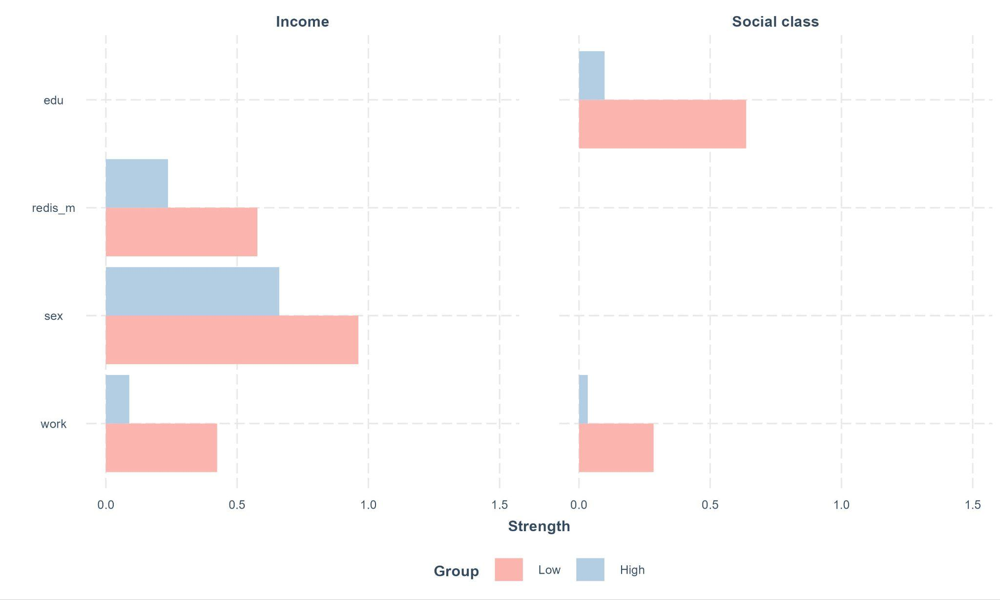

Another aspect in which the six attitude networks can structurally differ is node centrality. Therefore, we investigate the importance of each network node by comparing its values of Strength centrality scored in the network estimated on low and high-status samples. Figure 4 plots differences in the values of Strength centrality. The Network Comparison Test detects statistically significant differences by income and social class. Strength scores are higher in the low income and low social class samples. Indeed, the nodes *redis_m*, *sex*, and *work* have higher values of centrality within the attitude network of the poorer, and the nodes *edu* and *work* are more central in the attitude network of manual workers. These values are explained by the stronger connections existing in the attitude networks of lower status individuals. Moreover, it is important to highlight that the centrality metric does not describe the endorsement of each item, but only its relative importance within its attitude network. This is clear if comparing the mean values and the Strength centrality of these items. For example, the mean value of the variable *edu* is equal to 3.803 in the lower social class sample, and to 3.890 in the higher class one. Although having comparable mean values, these nodes widely differ in their centrality, as its Strength scores are 0.10 and 0.64 in the high and low sample respectively.

**Figure 5: Differences in networks’ connectivity**

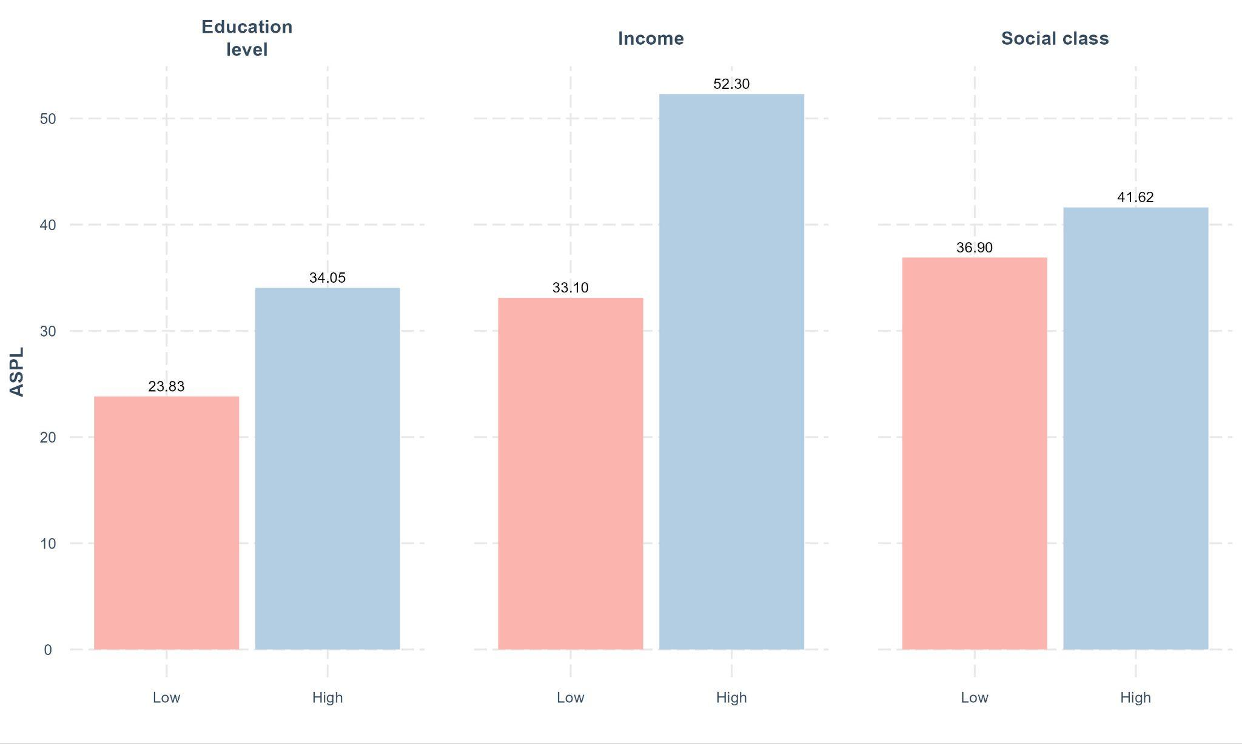

Finally, we investigate network connectivity. Figure 5 plots the six values of the weighted ASPL. Being a measure of distance, lower values indicate higher connectivity. The attitude networks of lower status groups systematically show higher connectivity. This difference is particularly striking regarding the stratification by income. These results are also intelligible from a closer inspection of Figure 3. The bottom panel of this figure shows that the attitude network estimated on the lower and higher class samples are not particularly different in this regard. Indeed, here we find a comparable number of nodes bridging between network clusters. The same is true for the social class networks. The situation is clearly different for the income networks. In the network of the high income sample the explanations of existing inequality are almost completely detached from the other variables. Here only the connections *need-edupar* and *relig-ineq_p* bridge the four network clusters.

# 5 Discussion

Our paper aimed to describe the structure of the attitudes towards inequality in a highly unequal country such as Chile. We applied a network model to 22 ISSP survey variables to examine people’s understanding of inequality. This approach allowed us to examine how perceptions, beliefs, and judgments about the magnitude and principles regarding inequality relate at the population level.

Results showed that these items form a fully connected attitude network. Hence, it is important to study the selected evaluative reactions as elements of a unified belief system. This also validates our choice to include variables tapping not only inequality but also related topics such as redistribution, taxation and wages. The attitude network is organised in four communities. One cluster gathered structuralist explanations of inequality, such as race, religion, and sex. A second one featured individualist explanations according to which unequal outcomes are mostly due to factors influenceable by individuals and their families, such as hard work and parental education. Moreover, a third cluster reunited beliefs about justice principles of wage allocations. Finally, we detected a fourth cluster, which grouped all conceptions regarding the magnitude of inequality. In fact, this community encompasses perception and judgment of income inequality (*ineq_p, ineq_j*), evaluations of the taxation system (*reg_p, prog_b*), and attitudes towards redistribution (*redis_d, redis_f, redis_m, redis_p*). Interestingly, the support for public redistribution is often adopted as an independent variable in the distributive justice literature [(Alesina & Giuliano, 2009; Franetovic & Castillo, 2021; Svallfors, 1997; Wu & Chou, 2017)](https://app.readcube.com/library/0a3c846c-7570-4913-bd72-3afd46468081/all?uuid=3169707220072062&item_ids=0a3c846c-7570-4913-bd72-3afd46468081:ebe87e67-14af-45a0-a8e2-886516edc9f6,0a3c846c-7570-4913-bd72-3afd46468081:5dbc208c-02cf-4283-97ef-14bfebf3ac22,0a3c846c-7570-4913-bd72-3afd46468081:6b117ad8-7097-4095-aa19-ad9173ced3a3,0a3c846c-7570-4913-bd72-3afd46468081:f8983209-47e6-42dd-9f21-1f84856762c4). Our results show that in Chile, contrary to prior non-network and country-level evidence [(Alesina & Angeletos, 2005)](https://app.readcube.com/library/0a3c846c-7570-4913-bd72-3afd46468081/all?uuid=23246101990806356&item_ids=0a3c846c-7570-4913-bd72-3afd46468081:1344dfec-0280-4ce1-b0eb-497c344f7a95), this belief is mostly influenced by evaluations regarding the magnitude rather than principles of inequality.

In addition to high clustering, the network of attitudes towards inequality exhibited moderate connectivity. In social network analysis, ASPL captures the extent to which network nodes are distant to each other. However, rather than measuring distances, edges of an attitude network are indicative of causal influence between evaluative reactions. Therefore, the connectivity of an attitude network correlates with the strength of the attitude in question [(Dalege et al., 2019)](https://app.readcube.com/library/c61b91da-fa6e-4348-80b6-c2428280b16a/all?uuid=6044635386436841&item_ids=c61b91da-fa6e-4348-80b6-c2428280b16a:362898b1-8cf2-4cf7-a649-7ab58198bce5). Moreover, a structure combining high clustering and high connectivity is usually described as a small-world network [(Watts & Strogatz, 1998)](https://app.readcube.com/library/c61b91da-fa6e-4348-80b6-c2428280b16a/all?uuid=6069034170605213&item_ids=c61b91da-fa6e-4348-80b6-c2428280b16a:7a99534d-1a13-4396-a198-0e335690a73e). Empirically, numerous attitude networks were observed to possess such a structure [(Carter et al., 2020; Schlicht-Schmälzle et al., 2018; Turner-Zwinkels & Brandt, 2022)](https://app.readcube.com/library/c61b91da-fa6e-4348-80b6-c2428280b16a/all?uuid=30886843230459027&item_ids=c61b91da-fa6e-4348-80b6-c2428280b16a:6a9141c6-6628-4444-8af4-2a3e13440629,c61b91da-fa6e-4348-80b6-c2428280b16a:e5df995a-5b3c-4248-922e-78ca10ebdc1d,c61b91da-fa6e-4348-80b6-c2428280b16a:cbee107f-f476-44cf-ac6c-c76e7fb5ee99), and the Chilean network of attitudes towards inequality follows this trend.

Since socioeconomic measures such as education, income, and social class influence the contents of attitudes towards inequality [(Evans & Kelley, 2017; Franko et al., 2013; Hadler, 2005)](https://app.readcube.com/library/0a3c846c-7570-4913-bd72-3afd46468081/all?uuid=9264636574959002&item_ids=0a3c846c-7570-4913-bd72-3afd46468081:d2a297e8-988d-46ab-bc51-15088fd4c4f4,0a3c846c-7570-4913-bd72-3afd46468081:79269b17-8860-441d-bb9e-2ad14c4a7142,0a3c846c-7570-4913-bd72-3afd46468081:df71c568-b7b3-4b63-9890-002737dce3b5), we stratified the sample to observe structural variations in their attitude networks. Two patterns emerge. First, the attitude networks of the lower status groups are systematically characterised by a greater number of communities. Since EGA equates the number of network clusters to the number of dimensions underlying a construct, this finding highlights that Chileans in lower socioeconomic positions have a more multidimensional comprehension of inequality. This pattern is due to an emerging community grouping critical evaluations of the magnitude of inequalities. Indeed, in the attitude networks of the high-status groups, the variables *ineq_j, reg_p, redis_f,* are part of the cluster featuring evaluative reactions on the size of existing inequality. Conversely, in low status attitude networks, the judgment of unfair distribution, the perception of tax regressivity, and the judgment of failure of public redistribution, show higher partial correlations among them, and are less related to the other variables in the other clusters. Second, we showed that attitude networks of the lower status groups are more highly connected. This result could be indicative of a greater attitude strength for these population strata.

Finally, the stratification by socioeconomic measures allowed us to relax the homogeneity assumption on which we based the first part of the research. By estimating six attitude networks we undercovered variations in the structure of the attitudes towards inequality of different individuals. Interestingly, the association between belief in public and in market redistribution is weaker in the highly educated sample, and the positive association between the allocation of wages based on need and merit disappears. In the low-income sample, the perception of giving bribes as a determinant for getting ahead in life is negatively linked to the belief on merit as a principle determining wages, whereas they are conditionally independent in the high-income sample. Moreover, low-income individuals show a stronger relationship between the perceived importance of a wealthy family and giving bribes as a source of unequal outcomes. This also accounts for the membership of the importance of coming from a wealthy family*,* which is considered a structuralist explanation of inequality in the low-income sample, and an individualist one in the high-income network. Finally, people from the high-class sample tend to detach the individualist explanations pointing at education and hard work form the rest of other inequality beliefs, whereas in the lower-class sample they are firmly integrated in the individualistic cluster. Additionally, perception of large income inequality is strongly related with belief in public and market redistribution, but only in the low-class sample. These differences are also balanced by some stable patterns. For example, the triads composed by (i) *race, relig, sex*, and (ii) *resp, merit, train* are densely connected cliques regardless of the stratification measure.

# 6 Conclusions

This article constitutes the first application of the network approach to the topic of attitudes towards inequality. We selected 22 items to investigate the understanding of inequality in Chile, one of the most unequal countries in the world. We showed that these evaluative reactions are integrated in a single beliefs system, and we emphasised their structural differences according to social status.

This paper has three main limitations. First, due to data availability we included items belonging to survey batteries. This entailed the occurrence of an instrument effect, since we observed high partial correlations between items measured jointly. However, important associations between items of different survey batteries occurred, and items measured jointly were not always part of the same community. Second, the GGM model required the inclusion of items measured in a similar scale. Therefore, we excluded variables praised by the literature, such as the perception of inequality measured by a salary gap or a diagram-based indicator [(Castillo et al., 2022)](https://app.readcube.com/library/0a3c846c-7570-4913-bd72-3afd46468081/all?uuid=18752550349727093&item_ids=0a3c846c-7570-4913-bd72-3afd46468081:9bd8c586-f281-4955-8f3c-6e51987088c3). Third, by splitting the sample according to median values of socioeconomic variables we effectively tested for a stepwise moderation. Thus, we are unable to capture all the heterogeneity existing across the social structure. However, dividing the sample in more than two groups at the time would have hindered network estimation, which requires adequate size samples to be stable [(Epskamp, Borsboom, et al., 2018)](https://app.readcube.com/library/c61b91da-fa6e-4348-80b6-c2428280b16a/all?uuid=4799201034782794&item_ids=c61b91da-fa6e-4348-80b6-c2428280b16a:1d710043-b7c6-4fa1-93a5-7aa13c36cd98).

Finally, this work provided two main contributions. By selecting a wide-ranging set of indicators, we introduced a holistic approach to the study of how people understand inequality. As highlighted by Janmaat [(2013)](https://app.readcube.com/library/0a3c846c-7570-4913-bd72-3afd46468081/all?uuid=3867172252540053&item_ids=0a3c846c-7570-4913-bd72-3afd46468081:a5fe0957-21b3-4f66-991b-a1b55320ca5a&options=%7B%22items%22%3A%7B%220a3c846c-7570-4913-bd72-3afd46468081%3Aa5fe0957-21b3-4f66-991b-a1b55320ca5a%22%3A%7B%22suppressAuthor%22%3Atrue%7D%7D%7D) social justice literature was waiting for a systematic investigation of attitudes towards inequality. Moreover, applying EGA to different social status groups, we undercovered a pattern in the dimensionality of these attitudes. Specifically, we showed that low-status individuals have a more multidimensional comprehension of inequality in Chile.

# Disclosure statement

The authors declare that there is no conflict of interest.

# Supplemental material

This article is fully reproducible. The replication code is available at the link: AFTER PUBLICATION, TO PRESERVE OUR ANONYMITY. The repository also contains the robustness analysis of the seven attitude networks.

# References

[Aalberg, T. (2008). *Achieving Justice: Comparative Public Opinion on Income Distribution* (Vol. 7).](https://app.readcube.com/library/?style=American%20Psychological%20Association%207th%20edition+%7B%22language%22:%22en-US%22%7D) <https://doi.org/10.1163/156913308x263238> [Alesina, A., & Angeletos, G.-M. (2005). Fairness and Redistribution. *American Economic Review*, *95*(4), 960–980.](https://app.readcube.com/library/?style=American%20Psychological%20Association%207th%20edition+%7B%22language%22:%22en-US%22%7D) <https://doi.org/10.1257/0002828054825655> [Alesina, A., & Giuliano, P. (2009). *Preferences for Redistribution*.](https://app.readcube.com/library/?style=American%20Psychological%20Association%207th%20edition+%7B%22language%22:%22en-US%22%7D) <http://www.nber.org/papers/w14825.pdf> [Alm, J., & Torgler, B. (2006). Culture differences and tax morale in the United States and in Europe. *Journal of Economic Psychology*, *27*(2), 224–246.](https://app.readcube.com/library/?style=American%20Psychological%20Association%207th%20edition+%7B%22language%22:%22en-US%22%7D) <https://doi.org/10.1016/j.joep.2005.09.002> [Atria, J. (2022). La sociología económica y fiscal de los impuestos: perspectivas y hallazgos para Chile. *Estudios Públicos*, *165*, 7–*3*8.](https://app.readcube.com/library/?style=American%20Psychological%20Association%207th%20edition+%7B%22language%22:%22en-US%22%7D) <https://doi.org/10.38178/07183089/0003210505> [Barnes, L. (2015). The size and shape of government: preferences over redistributive tax policy. *Socio-Economic Review*, *13*(1), 55–78.](https://app.readcube.com/library/?style=American%20Psychological%20Association%207th%20edition+%7B%22language%22:%22en-US%22%7D) <https://doi.org/10.1093/ser/mwu007>

[Berens, S. (2015). Preferences on Redistribution in Fragmented Labor Markets in Latin America and the Caribbean. *Journal of Politics in Latin America*, *7*(3), 117–156.](https://app.readcube.com/library/?style=American%20Psychological%20Association%207th%20edition+%7B%22language%22:%22en-US%22%7D) <https://doi.org/10.1177/1866802x1500700304> [Bobzien, L., & Kalleitner, F. (2020). *Attitudes towards European financial solidarity during the Covid-19 pandemic: evidence from a net-contributor country*.](https://app.readcube.com/library/?style=American%20Psychological%20Association%207th%20edition+%7B%22language%22:%22en-US%22%7D) [https://doi.org/10.1080/*14*616696.2020.1836669/suppl_file/reus_a_1836669_sm3224.docx](https://doi.org/10.1080/14616696.2020.1836669/suppl_file/reus_a_1836669_sm3224.docx) [Borkulo, C. D. van, Bork, R. van, Boschloo, L., Kossakowski, J. J., Tio, P., Schoevers, R. A., Borsboom, D., & Waldorp, L. J. (2022). Comparing network structures on three aspects: A permutation test. *Psychological Methods*.](https://app.readcube.com/library/?style=American%20Psychological%20Association%207th%20edition+%7B%22language%22:%22en-US%22%7D) <https://doi.org/10.1037/met0000476> [Borsboom, D., Deserno, M. K., Rhemtulla, M., Epskamp, S., Fried, E. I., McNally, R. J., Robinaugh, D. J., Perugini, M., Dalege, J., Costantini, G., Isvoranu, A.-M., Wysocki, A. C., Borkulo, C. D. van, Bork, R. van, & Waldorp, L. J. (2021). Network analysis of multivariate data in psychological science. *Nature Reviews Methods Primers*, *1*(1), 58.](https://app.readcube.com/library/?style=American%20Psychological%20Association%207th%20edition+%7B%22language%22:%22en-US%22%7D) <https://doi.org/10.1038/s43586-021-00055-w> [Bringmann, L. F., Elmer, T., Epskamp, S., Krause, R. W., Schoch, D., Wichers, M., Wigman, J. T. W., & Snippe, E. (2019). What do centrality measures measure in psychological networks? *Journal of Abnormal Psychology*, *128*(8), 892–903.](https://app.readcube.com/library/?style=American%20Psychological%20Association%207th%20edition+%7B%22language%22:%22en-US%22%7D) <https://doi.org/10.1037/abn0000446> [Carter, N. T., Lowery, M. R., Smith, R. W., Conley, K. M., Harris, A. M., Listyg, B., Maupin, C. K., King, R. T., & Carter, D. R. (2020). Understanding Job Satisfaction in the Causal Attitude Network (CAN) Model. *Journal of Applied Psychology*, *105*(9), 959–993.](https://app.readcube.com/library/?style=American%20Psychological%20Association%207th%20edition+%7B%22language%22:%22en-US%22%7D) <https://doi.org/10.1037/apl0000469> [Castillo, J. C. (2009). ¿Cuál es la brecha salarial justa? Opinión pública y legitimación de la desigualdad en Chile. Estudios Públicos, *113*.](https://app.readcube.com/library/?style=American%20Psychological%20Association%207th%20edition+%7B%22language%22:%22en-US%22%7D) <https://doi.org/10.38178/cep.vi113.449> [Castillo, J. C. (2011). *Legitimacy of Inequality in a Highly Unequal Context: Evidence from the Chilean Case*. *24*, 314–340.](https://app.readcube.com/library/?style=American%20Psychological%20Association%207th%20edition+%7B%22language%22:%22en-US%22%7D) <https://doi.org/10.1007/s11211-011-0144-5> [Castillo, J. C. (2012). Is Inequality Becoming Just? Changes in Public Opinion about Economic Distribution in Chile. *Bulletin of Latin American Research*, *31*(1), 1–18.](https://app.readcube.com/library/?style=American%20Psychological%20Association%207th%20edition+%7B%22language%22:%22en-US%22%7D) <https://doi.org/10.1111/j.1470-9856.2011.00605.x> [Castillo, J. C., García-Castro, J. D., & Venegas, M. (2022). *Perception of economic inequality: concepts, associated factors and prospects of a burgeoning research agenda (Percepción de desigualdad económica: conceptos, factores asociados y proyecciones de una agenda creciente de investigación)*. *37*, 180–207.](https://app.readcube.com/library/?style=American%20Psychological%20Association%207th%20edition+%7B%22language%22:%22en-US%22%7D) <https://doi.org/10.1080/02134748.2021.2009275> [Castillo, J. C., Madero-Cabib, I., & Salamovich, A. (2013). Clivajes partidarios y cambios en preferencias distributivas en Chile. *Revista de Ciencia Política (Santiago)*, *33*(2), 469–488.](https://app.readcube.com/library/?style=American%20Psychological%20Association%207th%20edition+%7B%22language%22:%22en-US%22%7D) <https://doi.org/10.4067/s0718-090x2013000200003> [Castillo, J. C., Miranda, D., & Carrasco, D. (2012). *Percepción de Desigualdad Económica en Chile: Medición, Diferencias y Determinantes*. *21*, 99–114.](https://app.readcube.com/library/?style=American%20Psychological%20Association%207th%20edition+%7B%22language%22:%22en-US%22%7D) <https://doi.org/10.4067/s0718-22282012000100007> [Castillo, J. C., & Olivos, F. (2014). Redistribución e impuestos: Un análisis desde la opinión pública. In ["Jorge Atria"] (Ed.), *Tributación en Sociedad: Impuestos y Redistribución en el Chile del Siglo XXI.* (pp. 143–166). Uqbar.](https://app.readcube.com/library/?style=American%20Psychological%20Association%207th%20edition+%7B%22language%22:%22en-US%22%7D) [https://www.researchgate.net/profile/Francisco_Olivos/publication/268810509_Redistribucion_e_impuestos_un_analisis_desde_la_opinion_publica/links/547df1200cf241dc999*25*f*23*/Redistribucion-e-impuestos-un-analisis-desde-la-opinion-publica.pdf?origin=publicati](https://www.researchgate.net/profile/Francisco_Olivos/publication/268810509_Redistribucion_e_impuestos_un_analisis_desde_la_opinion_publica/links/547df1200cf241dc99925f23/Redistribucion-e-impuestos-un-analisis-desde-la-opinion-publica.pdf?origin=publicati) [Chambon, M., Dalege, J., Waldorp, L. J., Maas, H. L. J. V. der, Borsboom, D., & Harreveld, F. van. (2022). REVIEWD Tailored interventions into broad attitude networks towards the COVID-19 pandemic. *PLOS ONE*, *17*(10), e0276439. https://doi.org/10.1371/ journal.pone.0276439  
  
Chen, J., & Chen, Z. (2008). Extended Bayesian information criteria for model selection with large model spaces. *Biometrika*, *95*(3), 759–771.](https://app.readcube.com/library/?style=American%20Psychological%20Association%207th%20edition+%7B%22language%22:%22en-US%22%7D) <https://doi.org/10.1093/biomet/asn034> [Choi, G. (2021). Individuals’ socioeconomic position, inequality perceptions, and redistributive preferences in OECD countries. *The Journal of Economic Inequality*, *19*(2), 239–264.](https://app.readcube.com/library/?style=American%20Psychological%20Association%207th%20edition+%7B%22language%22:%22en-US%22%7D) <https://doi.org/10.1007/s10888-020-09471-6> [Christensen, A. P., & Golino, H. (2021a). Estimating the Stability of Psychological Dimensions via Bootstrap Exploratory Graph Analysis: A Monte Carlo Simulation and Tutorial. Psych, 3(3), 479–500.](https://app.readcube.com/library/?style=American%20Psychological%20Association%207th%20edition+%7B%22language%22:%22en-US%22%7D) <https://doi.org/10.3390/psych3030032> [Christensen, A. P., & Golino, H. (2021b). On the equivalency of factor and network loadings. *Behavior Research Methods*, *53*(4), 1563–1580.](https://app.readcube.com/library/?style=American%20Psychological%20Association%207th%20edition+%7B%22language%22:%22en-US%22%7D) [https://doi.org/10.3758/s13428-020-01*50*0-6](https://doi.org/10.3758/s13428-020-01500-6) [Clark, A. E., & D’Ambrosio, C. (2015). *Attitudes to income inequality: Experimental and survey evidence* (1st ed., Vol. 2). Elsevier B.V.](https://app.readcube.com/library/?style=American%20Psychological%20Association%207th%20edition+%7B%22language%22:%22en-US%22%7D) <https://doi.org/10.1016/b978-0-444-59428-0.00014-x> [Dablander, F., & Hinne, M. (2019). Node centrality measures are a poor substitute for causal inference. *Scientific Reports*, *9*(1), 6846.](https://app.readcube.com/library/?style=American%20Psychological%20Association%207th%20edition+%7B%22language%22:%22en-US%22%7D) <https://doi.org/10.1038/s41598-019-43033-9> [Dalege, J., Borsboom, D., Harreveld, F. van, Berg, H. van den, Conner, M., & Maas, H. L. J. van der. (2016). Toward a formalized account of attitudes: The Causal Attitude Network (CAN) model. *Psychological Review*, *123*(1), 2–22.](https://app.readcube.com/library/?style=American%20Psychological%20Association%207th%20edition+%7B%22language%22:%22en-US%22%7D) <https://doi.org/10.1037/a0039802> [Dalege, J., Borsboom, D., Harreveld, F. van, & Maas, H. L. J. van der. (2017). Network Analysis on Attitudes: A Brief Tutorial. *Social Psychological and Personality Science*, *8*(5), 528–537.](https://app.readcube.com/library/?style=American%20Psychological%20Association%207th%20edition+%7B%22language%22:%22en-US%22%7D) [https://doi.org/*10*.1177/1948550617709827](https://doi.org/10.1177/1948550617709827) [Dalege, J., Borsboom, D., Harreveld, F. van, & Maas, H. L. J. van der. (2018). The Attitudinal Entropy (AE) Framework as a General Theory of Individual Attitudes. *Psychological Inquiry*, *29*(4), 175–193.](https://app.readcube.com/library/?style=American%20Psychological%20Association%207th%20edition+%7B%22language%22:%22en-US%22%7D) <https://doi.org/10.1080/1047840x.2018.1537246> [Dalege, J., Borsboom, D., Harreveld, F. van, & Maas, H. L. J. van der. (2019). A Network Perspective on Attitude Strength: Testing the Connectivity Hypothesis. Social Psychological and Personality Science, 10(6), 746–756.](https://app.readcube.com/library/?style=American%20Psychological%20Association%207th%20edition+%7B%22language%22:%22en-US%22%7D) <https://doi.org/10.1177/1948550618781062> [Deutsch, M. (1975). Equity, Equality, and Need: What Determines Which Value Will Be Used as the Basis of Distributive Justice? *Journal of Social Issues*, *31*(3), 137–149.](https://app.readcube.com/library/?style=American%20Psychological%20Association%207th%20edition+%7B%22language%22:%22en-US%22%7D) <https://doi.org/10.1111/j.1540-4560.1975.tb01000.x> [Edmiston, D. (2018). The poor “sociological imagination” of the rich: Explaining attitudinal divergence towards welfare, inequality, and redistribution. *Social Policy & Administration*, *52*(5), 983–997.](https://app.readcube.com/library/?style=American%20Psychological%20Association%207th%20edition+%7B%22language%22:%22en-US%22%7D) <https://doi.org/10.1111/spol.12366> [Epskamp, S., Borsboom, D., & Fried, E. I. (2018). Estimating psychological networks and their accuracy: A tutorial paper. Behavior Research Methods, 50(1), 195–212. https://doi.org/10.3758/s13428-017-0862-1  
Epskamp, S., & Fried, E. I. (2018). A Tutorial on Regularized Partial Correlation Networks. Psychological Methods, 23(4), 617–634.](https://app.readcube.com/library/?style=American%20Psychological%20Association%207th%20edition+%7B%22language%22:%22en-US%22%7D) <https://doi.org/10.1037/met0000167> [Epskamp, S., Waldorp, L. J., Mõttus, R., & Borsboom, D. (2018). The Gaussian Graphical Model in Cross-Sectional and Time-Series Data. *Multivariate Behavioral Research*, *53*(4), 453–480.](https://app.readcube.com/library/?style=American%20Psychological%20Association%207th%20edition+%7B%22language%22:%22en-US%22%7D) <https://doi.org/10.1080/00273171.2018.1454823> [Etzioni, A. (1988). *The moral dimension: Toward a new economics.* Free Press.  
  
Evans, M. D. R., & Kelley, J. (2017). Communism, Capitalism, and Images of Class: Effects of Reference Groups, Reality, and Regime in 43 Nations and 110,000 Individuals, 1987-2009. *Cross-Cultural Research*, *51*(4), 315–359.](https://app.readcube.com/library/?style=American%20Psychological%20Association%207th%20edition+%7B%22language%22:%22en-US%22%7D) <https://doi.org/10.1177/1069397116677963> [Evans, M. D. R., Kelley, J., & Kolosi, T. (1992). Images of Class: Public Perceptions in Hungary and Australia. *American Sociological Review*, *57*(4), 461.](https://app.readcube.com/library/?style=American%20Psychological%20Association%207th%20edition+%7B%22language%22:%22en-US%22%7D) <https://doi.org/10.2307/2096095> [Evans, M. D. R., Kelley, J., & Peoples, C. D. (2010). Justifications of Inequality: The Normative Basis of Pay Differentials in 31 Nations*. *Social Science Quarterly*, *91*(5), 1405–1431.](https://app.readcube.com/library/?style=American%20Psychological%20Association%207th%20edition+%7B%22language%22:%22en-US%22%7D) <https://doi.org/10.1111/j.1540-6237.2010.00738.x> [Fatke, M. (2018). Inequality Perceptions, Preferences Conducive to Redistribution, and the Conditioning Role of Social Position. *Societies*, *8*(4), 99.](https://app.readcube.com/library/?style=American%20Psychological%20Association%207th%20edition+%7B%22language%22:%22en-US%22%7D) <https://doi.org/10.3390/soc8040099> [Feldman, S., & Zaller, J. (1992). *The Political Culture of Ambivalence: Ideological Responses to the Welfare State*. *36*, 268–307.](https://app.readcube.com/library/?style=American%20Psychological%20Association%207th%20edition+%7B%22language%22:%22en-US%22%7D) <http://www.jstor.org/stable/2111433> [Foygel, R., & Drton, M. (2010). Extended Bayesian Information Criteria for Gaussian Graphical Models. *ArXiv*.](https://app.readcube.com/library/?style=American%20Psychological%20Association%207th%20edition+%7B%22language%22:%22en-US%22%7D) <https://doi.org/10.48550/arxiv.1011.6640> [Franetovic, G., & Castillo, J.-C. (2021). Preferences for Income Redistribution in Unequal Contexts: Changes in Latin America Between 2008 and 2018. *Frontiers in Sociology*, *7*, 806458.](https://app.readcube.com/library/?style=American%20Psychological%20Association%207th%20edition+%7B%22language%22:%22en-US%22%7D) <https://doi.org/10.3389/fsoc.2022.806458> [Frank, D. H., Wertenbroch, K., & Maddux, W. W. (2015). Performance pay or redistribution? Cultural differences in just-world beliefs and preferences for wage inequality. *Organizational Behavior and Human Decision Processes*, *130*, 160–170.](https://app.readcube.com/library/?style=American%20Psychological%20Association%207th%20edition+%7B%22language%22:%22en-US%22%7D) <https://doi.org/10.1016/j.obhdp.2015.04.001> [Franko, W., Tolbert, C. J., & Witko, C. (2013). Inequality, Self-Interest, and Public Support for “Robin Hood” Tax Policies. *Political Research Quarterly*, *66*(4), 923–937.](https://app.readcube.com/library/?style=American%20Psychological%20Association%207th%20edition+%7B%22language%22:%22en-US%22%7D) <https://doi.org/10.1177/1065912913485441> [Friedman, J., Hastie, T., & Tibshirani, R. (2008). Sparse inverse covariance estimation with the graphical lasso. *Biostatistics*, *9*(3), 432–441.](https://app.readcube.com/library/?style=American%20Psychological%20Association%207th%20edition+%7B%22language%22:%22en-US%22%7D) <https://doi.org/10.1093/biostatistics/kxm045> [García‐Sánchez, E., Osborne, D., Willis, G. B., & Rodríguez‐Bailón, R. (2020). Attitudes towards redistribution and the interplay between perceptions and beliefs about inequality. *British Journal of Social Psychology*, *59*(1), 111–136.](https://app.readcube.com/library/?style=American%20Psychological%20Association%207th%20edition+%7B%22language%22:%22en-US%22%7D) <https://doi.org/10.1111/bjso.12326> [Golino, H. F., Epskamp, S., & Voracek, M. (2017). Exploratory graph analysis: A new approach for estimating the number of dimensions in psychological research. PLOS ONE, 12(6), e0174035.](https://app.readcube.com/library/?style=American%20Psychological%20Association%207th%20edition+%7B%22language%22:%22en-US%22%7D) [https://doi.org/10.13*71*/journal.pone.0174035](https://doi.org/10.1371/journal.pone.0174035) [Golino, H., Shi, D., Christensen, A. P., Garrido, L. E., Nieto, M. D., Sadana, R., Thiyagarajan, J. A., & Martinez-Molina, A. (2020). Investigating the performance of exploratory graph analysis and traditional techniques to identify the number of latent factors: A simulation and tutorial. Psychological Methods, 25(3), 292–320.](https://app.readcube.com/library/?style=American%20Psychological%20Association%207th%20edition+%7B%22language%22:%22en-US%22%7D) <https://doi.org/10.1037/met0000255> [Hadler, M. (2005). *Why Do People Accept Different Income Ratios?* *48*, 131–154.](https://app.readcube.com/library/?style=American%20Psychological%20Association%207th%20edition+%7B%22language%22:%22en-US%22%7D) <https://doi.org/10.1177/0001699305053768> [ISSP Research Group. (2022). *International Social Survey Programme: Social Inequality V - ISSP 2019*.](https://app.readcube.com/library/?style=American%20Psychological%20Association%207th%20edition+%7B%22language%22:%22en-US%22%7D) <https://doi.org/10.4232/1.14009> [Janmaat, J. G. (2013). Subjective Inequality: a Review of International Comparative Studies on People’s Views about Inequality. *European Journal of Sociology*, *54*(3), 357–389.](https://app.readcube.com/library/?style=American%20Psychological%20Association%207th%20edition+%7B%22language%22:%22en-US%22%7D) <https://doi.org/10.1017/s0003975613000209> [Keeley, B. (2015). *Income inequality: The gap between rich and poor* (Vol. 75).](https://app.readcube.com/library/?style=American%20Psychological%20Association%207th%20edition+%7B%22language%22:%22en-US%22%7D) <https://doi.org/10.1787/9789264246010-en> [Kluegel, J. R., & Smith, E. R. (1981). Beliefs about Stratification. *Annual Review of Sociology*, *7*(1), 29–56.](https://app.readcube.com/library/?style=American%20Psychological%20Association%207th%20edition+%7B%22language%22:%22en-US%22%7D) <https://doi.org/10.1146/annurev.so.07.080181.000333> [Kluegel, J. R., & Smith, E. R. (1986). *Beliefs about inequality: Americans’ views of what is and what ought to be.*  
Lauritzen, S. L. (1996). *Graphical models* (Vol. 17). Clarendon Press.  
  
Meltzer, A. H., & Richard, S. F. (1981). A Rational Theory of the Size of Government. *Journal of Political Economy*, *89*(5), 914–927.](https://app.readcube.com/library/?style=American%20Psychological%20Association%207th%20edition+%7B%22language%22:%22en-US%22%7D) <https://doi.org/10.1086/261013> [Mijs, J. J. B. (2018). Inequality Is a Problem of Inference: How People Solve the Social Puzzle of Unequal Outcomes. Societies, 8(3), 64.](https://app.readcube.com/library/?style=American%20Psychological%20Association%207th%20edition+%7B%22language%22:%22en-US%22%7D) <https://doi.org/10.3390/soc8030064> [Mijs, J. J. B. (2019). The paradox of inequality: income inequality and belief in meritocracy go hand in hand. Socio-Economic Review, 19(1), 7–35.](https://app.readcube.com/library/?style=American%20Psychological%20Association%207th%20edition+%7B%22language%22:%22en-US%22%7D) <https://doi.org/10.1093/ser/mwy051> [Opsahl, T., Agneessens, F., & Skvoretz, J. (2010). Node centrality in weighted networks: Generalizing degree and shortest paths. *Social Networks*, *32*(3), 245–251.](https://app.readcube.com/library/?style=American%20Psychological%20Association%207th%20edition+%7B%22language%22:%22en-US%22%7D) <https://doi.org/10.1016/j.socnet.2010.03.006> [Osberg, L., & Smeeding, T. (2006). “Fair” Inequality? Attitudes toward Pay Differentials: The United States in Comparative Perspective. American Sociological Review, 71(3), 450–473.](https://app.readcube.com/library/?style=American%20Psychological%20Association%207th%20edition+%7B%22language%22:%22en-US%22%7D) <https://doi.org/10.1177/000312240607100305> [Pons, P., & Latapy, M. (2005). Computer and Information Sciences - ISCIS 2005, 20th International Symposium, Istanbul, Turkey, October 26-28, 2005. Proceedings. *Lecture Notes in Computer Science*, 284–293.](https://app.readcube.com/library/?style=American%20Psychological%20Association%207th%20edition+%7B%22language%22:%22en-US%22%7D) <https://doi.org/10.1007/11569596_31> [Schlicht-Schmälzle, R., Chykina, V., & Schmälzle, R. (2018). An attitude network analysis of post-national citizenship identities. *PLoS ONE*, *13*(12), e0208241.](https://app.readcube.com/library/?style=American%20Psychological%20Association%207th%20edition+%7B%22language%22:%22en-US%22%7D) <https://doi.org/10.1371/journal.pone.0208241> [Schmidt-Catran, A. W. (2016). Economic inequality and public demand for redistribution: combining cross-sectional and longitudinal evidence. Socio-Economic Review, 14(1), 119–140.](https://app.readcube.com/library/?style=American%20Psychological%20Association%207th%20edition+%7B%22language%22:%22en-US%22%7D) <https://doi.org/10.1093/ser/mwu030> [Svallfors, S. (1997). Worlds of Welfare and Attitudes to Redistribution: A Comparison of Eight Western Nations. *European Sociological Review*, *13*(3), 283–304. https://doi.org/10.1093/oxfordjournals.esr.a018219  
Trump, K. (2023). Income inequality is unrelated to perceived inequality and support for redistribution. Social Science Quarterly.](https://app.readcube.com/library/?style=American%20Psychological%20Association%207th%20edition+%7B%22language%22:%22en-US%22%7D) <https://doi.org/10.1111/ssqu.13269> [Turner-Zwinkels, F. M., & Brandt, M. J. (2022). Belief system networks can be used to predict where to expect dynamic constraint. *Journal of Experimental Social Psychology*, *100*, 104279.](https://app.readcube.com/library/?style=American%20Psychological%20Association%207th%20edition+%7B%22language%22:%22en-US%22%7D) <https://doi.org/10.1016/j.jesp.2021.104279> [Watts, D. J., & Strogatz, S. H. (1998). Collective dynamics of ‘small-world’ networks. Nature, *393*(6684), 440–442.](https://app.readcube.com/library/?style=American%20Psychological%20Association%207th%20edition+%7B%22language%22:%22en-US%22%7D) <https://doi.org/10.1038/30918>

[Wegener, B., & Liebig, S. (1995). Dominant Ideologies and the Variation of Distributive Justice Norms: A Comparison of East and West Germany, and the United States. In *Social Justice and Political Change* (pp. 240–259). DE GRUYTER.](https://app.readcube.com/library/?style=American%20Psychological%20Association%207th%20edition+%7B%22language%22:%22en-US%22%7D) <https://doi.org/10.1515/9783110868944.239> [Wu, A. M., & Chou, K. (2017). Public Attitudes towards Income Redistribution: Evidence from Hong Kong. Social Policy & Administration, 51(5), 738–754.](https://app.readcube.com/library/?style=American%20Psychological%20Association%207th%20edition+%7B%22language%22:%22en-US%22%7D) <https://doi.org/10.1111/spol.12192> [Zwicker, M. V., Nohlen, H. U., Dalege, J., Gruter, G.-J. M., & Harreveld, F. van. (2020). Applying an attitude network approach to consumer behaviour towards plastic. *Journal of Environmental Psychology*, *69*, 101433.](https://app.readcube.com/library/?style=American%20Psychological%20Association%207th%20edition+%7B%22language%22:%22en-US%22%7D) <https://doi.org/10.1016/j.jenvp.2020.101433>

1. Table 1 collocates the variables that are analysed in this article in Jaanmat’s typology. Note that this work did not include judgments on principles governing inequality, and that this cell is empty even in Jaanmat’s systematic review. This is due to the lack of survey questions and research dealing with this topic [(Janmaat, 2013)](https://app.readcube.com/library/0a3c846c-7570-4913-bd72-3afd46468081/all?uuid=09351715514098102&item_ids=0a3c846c-7570-4913-bd72-3afd46468081:a5fe0957-21b3-4f66-991b-a1b55320ca5a).