Coffee Futures & Option Valuation
QUANTITATIVE PRICING MEMO · 10 October 2026

Executive summary
Using the supplied six-month market assumptions, the estimated fair futures price is $1.21814 per pound. A European call with a $1.25 strike is worth $0.06836 per pound using the spot-based Black-Scholes formula in the training guide; for a call specifically written on coffee futures, Black-76 yields $0.07119 per pound. Risk-neutral Monte Carlo provides an independent cross-check.
VALUATION OUTPUT | USD PER LB | PURPOSE
Six-month futures - cost of carry | $1.21814 | Primary futures valuation
European call - spot Black-Scholes | $0.06836 | Training-guide convention
European call on futures - Black-76 | $0.07119 | Preferred futures-option convention
European call - Monte Carlo | $0.07141 | Simulation validation

Provided market inputs
INPUT | VALUE | INPUT | VALUE
Spot coffee price | $1.20 / lb | Risk-free rate | 2.00% p.a.
Storage cost rate | 1.00% p.a. | Maturity | 0.50 years
Call strike | $1.25 / lb | Volatility | 25.00% p.a.

1 | Cost-of-carry futures pricing
F = S × exp[(r + d) × T] = 1.20 × exp[(0.02 + 0.01) × 0.50] = $1.21813568 / lb.
Interpretation: financing and physical storage increase the six-month no-arbitrage carrying cost by approximately $0.01814 per pound. This simplified model assumes continuously compounded rates and zero convenience yield; it excludes transaction costs, delivery-grade differences, taxes and market frictions.

2 | European call option pricing
Spot Black-Scholes (as in the training guide): C = S N(d1) − K exp(−rT) N(d2). With S = $1.20, K = $1.25, r = 2%, T = 0.50, and sigma = 25%, the call is $0.06836 / lb.
Black-76 for an option on a futures contract: C = exp(−rT)[F N(h1) − K N(h2)], where h1 = [ln(F/K) + 0.5 sigma²T] / [sigma √T] and h2 = h1 − sigma √T. Substituting the cost-of-carry future gives $0.07119 / lb.

3 | Risk-neutral Monte Carlo cross-check
200,000 independent terminal-price simulations, with random seed 42, use S(T) = S(0) exp[(r + d − 0.5 sigma²)T + sigma √T × Z], Z ~ N(0,1). With zero convenience yield, the simulated terminal mean should approximate F; the discounted mean of max[S(T) − K, 0] estimates the European call value.
Results: mean simulated terminal coffee price = $1.21809 / lb (theoretical $1.21814); simulated call value = $0.07141 / lb, standard error $0.00029 / lb (approximate 95% Monte Carlo error band: $0.07084 to $0.07197).

4 | Supply, demand, weather and geopolitical scenarios
The table below is a scenario sensitivity analysis, not an empirical forecast. Spot-price shocks and volatility assumptions are hypothetical analyst choices; the task provides no observed estimates for these shocks. Carry rates and maturity remain fixed. Each option value is calculated with Black-76.
SCENARIO | SPOT | VOL. | FUTURES | CALL
Base case | $1.200 | 25% | $1.218 | $0.071
Severe drought / supply loss | $1.380 | 35% | $1.401 | $0.217
Bumper harvest | $1.080 | 28% | $1.096 | $0.035
Stronger global demand | $1.296 | 30% | $1.316 | $0.143
Demand slowdown | $1.104 | 30% | $1.121 | $0.048
Trade / geopolitical disruption | $1.344 | 38% | $1.364 | $0.202

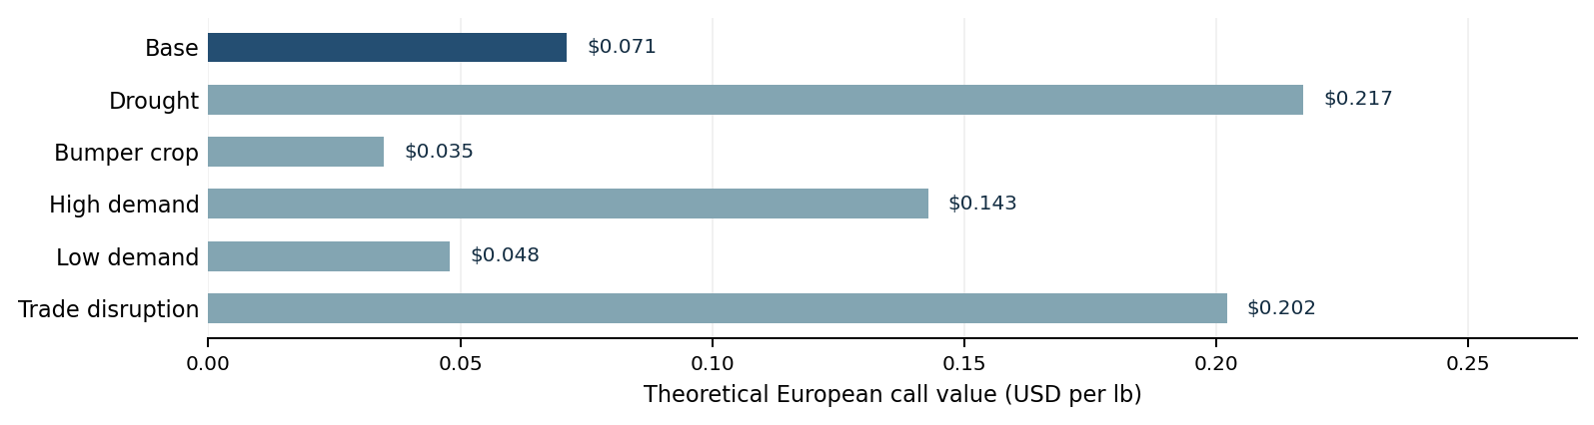

How to interpret the drivers
Supply and weather: Drought, frost, pests and shipping disruption may tighten available coffee supply, raising spot and futures prices. A bumper crop generally has the opposite effect.
Demand: Stronger consumption can lift prices and the expected call payoff; weaker consumption can reduce them, all else equal.
Geopolitics and FX: Export restrictions, political instability, freight costs and producer-currency movements can alter effective availability and risk premia.
Option sensitivity: Higher underlying futures prices and greater expected volatility usually increase a European call value, subject to other assumptions.

Pricing decision and risk controls
Use $1.21814/lb as the stylized six-month futures fair-value estimate. For the stated European call on this future, use approximately $0.07119/lb as the preferred theoretical premium; the Monte Carlo estimate provides a consistent validation. Actual tradable prices require the quoted futures curve, option conventions, current implied volatility, contract specifications, transaction costs and calibration to market data.
Risk controls: monitor price and volatility sensitivities (delta/vega), exposure limits, stress losses, basis risk, margin and liquidity. Refresh assumptions after crop reports, demand revisions, weather alerts or policy changes.

Methodological notes
The call is assumed to be European and cash-settled at maturity. Annual rates are continuously compounded. Coffee prices and premiums are expressed per pound; contract-level USD amounts require the exchange contract size. The task inputs are instructional assumptions, not verified live market quotes. Simulations under risk-neutral pricing are valuation tools, not predictive forecasts of real-world expected returns.
Reference: Citi / Forage "Pricing Commodities - Coffee" task data and the accompanying "Step by step guide" (provided with the training material).

