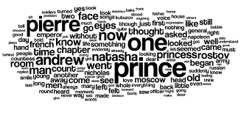

The Coding Learners’ Institute jointly with the founder of trustAI Consulting,

certifies that

«Full_Name»

Attended the **First Home-Coding Congress**

held at home, during December 9, 10 and 11, 2020.



Joe M. Doe

CEO

Coding Learner’s Institute

Gonzalo S. Trusted

Founder

trustAi Consulting