**Concept Document**

**ピンク犬 (Pinkuinu) No Signal**



**Roster**

|  |  |  |
| --- | --- | --- |
| Team Member | Role | Signature |
| **Abigail Weber** | **Technology** |  |
| **Tyler Gonzalez** | **Programming** |  |
| **Carlos Torres** | **Art** |  |

## Characters

Abigail – The young, girl, protagonist that the player controls.

TV Man – Part TV, part man. The antagonist that chases after the player and attempts to keep them from beating the game.

## Level Design

Rooms:

Child’s Room – The player’s starting point.

Mom’s Room – The final goal for the player. Located on the opposite side of the hallway, the MacGuffin, the mom’s bed, is located here.

Hallway – The connector between the two rooms, and the primary ‘adventure space’, where the TV Man will primarily be located and spawned at.

Style: Simple, early 2000’s décor.

## Mechanics

Outside of basic movement, the TV Man will roam and guard the hallway, while the player, uses their flashlight to temporarily scare him away.

## Unique Models

1. Rooms and Hallway
2. Girls Bed
3. Mom’s Bed and Mom
4. Mirror
5. Flashlight
6. Desk
7. Bookshelf

## Genre and Target Audience

*No Signal* is an adventure horror game aimed at people aged 12+ who would be interested in exploring potentially unnerving scenes or people interested in *Kimokawaii.*

Summary

*No Signal* is a first-person, interactive story game wherein players take on the role of a scared girl (Abigail) making her way to her mother’s room after having a nightmare. Players must navigate out of the girl’s room and make their way down the hall to the mother’s bedroom.

Unbeknownst to the player, a guard in the form of a TV-Headed Man patrols the halls and will attempt to prevent the player from reaching their goal. A flashlight, which is acquired in the girl’s room will allow the player to scare off the TV Man for a few seconds.

The player will have to scare the TV Man off multiple times as they make their way down the hallway towards the parents’ bedroom. A limited battery supply, however, will limit the amount of time the flashlight can be used in a single play-through, forcing the player to be selective about their flashlight usage as they progress.

The core of *No Signal*’s aesthetic impact derives from the harsh contrast between the child-like, more innocent art style and language used at the beginning of gameplay and the unsettling [words] of the TV Man and the Hallway beyond the girl’s bedroom the player initially starts in.

*No Signal*’s short gameplay centers it around casual players, while its mechanics and aesthetics make it more marketable to followers of the *Kimokawaii* trend, a Japanese culture trend.

Most Compelling Features

*No Signal* features a compelling story that is relatable to a wide audience. Waking up from a nightmare and seeking comfort from one’s parents is a common childhood occurrence for many people, and evokes strong emotions of helplessness and anxiety. The differing aesthetics of the girl and her bedroom against the hallway and guard beyond also serve to further push the emotional impact.

*Cost and Time to Develop

Student licenses were used for a majority of the programs involved in the creative process of *No Signal*: Maya 2018, Unity, and Substance Painter. Various Adobe programs were used, with all members of the ピンク犬 (PinkuInu) team using the student plan.

The project team was formed on January 16, 2019 with an original project due date of February 11th, 2019. The deadline for the project was pushed back a week for a final project deliverable date of February 18th, 2019.

Story and Setting

Set in 2008, No Signal takes place in the seemingly quiet abode of Abigail. Players guide Abigail to her mother’s room in the wake of an unsettling nightmare in order to seek her comfort. Armed with only a flashlight, she must conquer the horrors of the dark that exist beyond her bedroom doorway.

Gameplay Mechanics

### Controls

Players navigate using either Keyboard and Mouse or an Analog Joystick.

Keyboard & Mouse:

WASD - Movement

E - Pick Up Item/Use Item

Mouse - Aim/Camera Control

Joystick:

Analog - Movement

Button - Pick Up Item/Use Item

Concept Art

### Start Screen

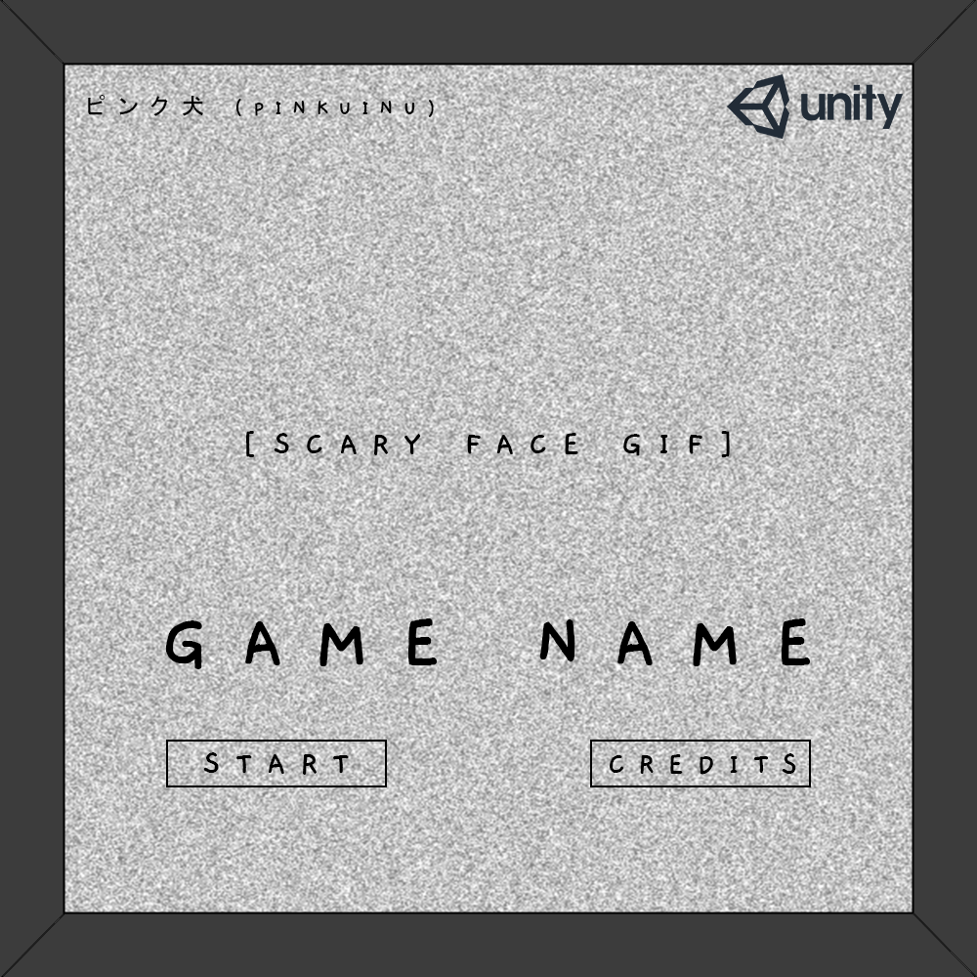

### HUD

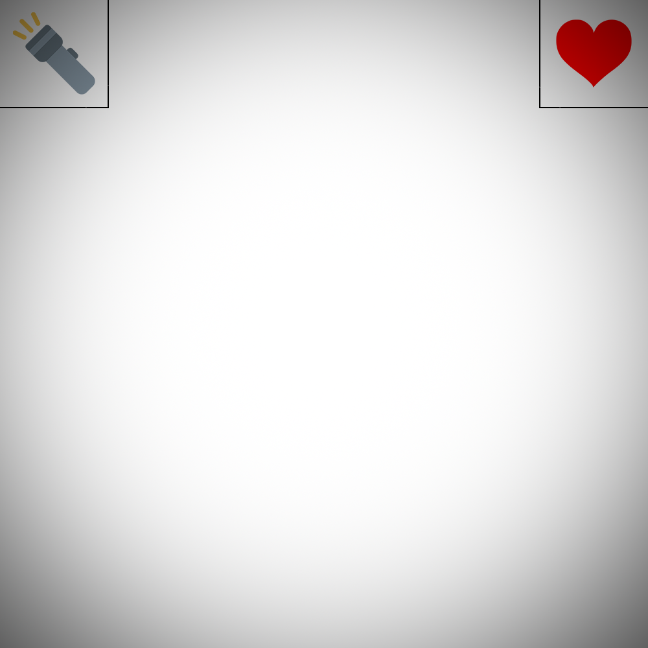

### Pause

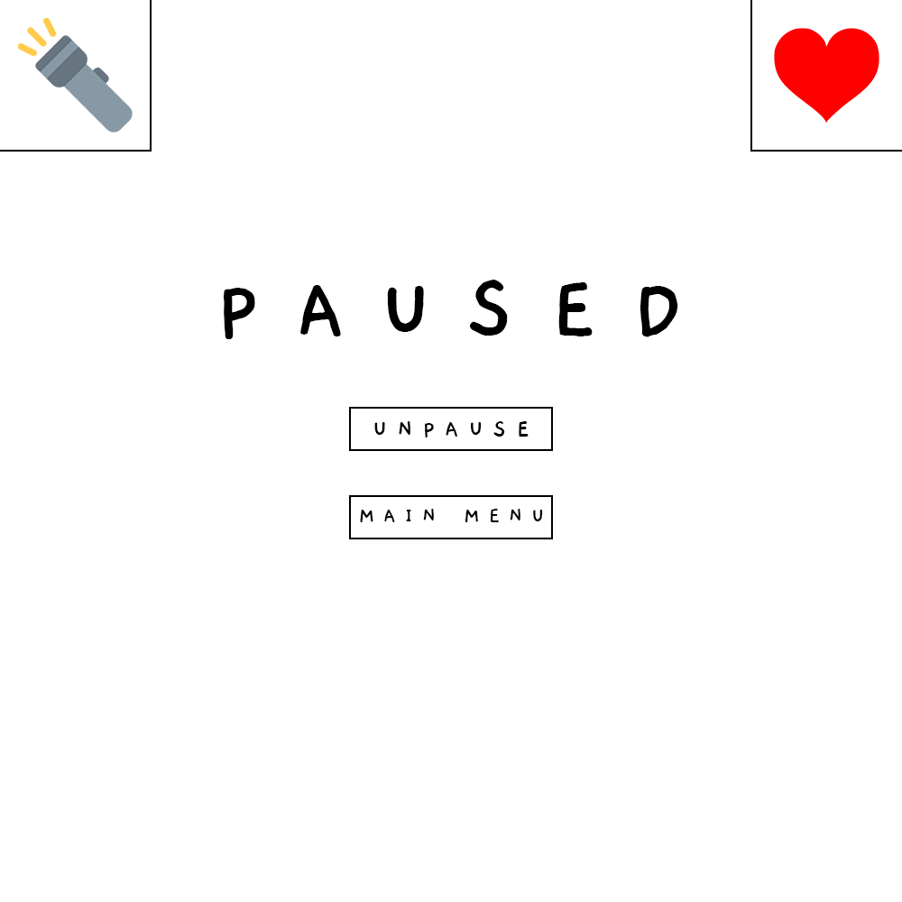

### Win Screen



### Lose Screen

