**Production Plan**

**ピンク犬 (Pinkuinu) No Signal**

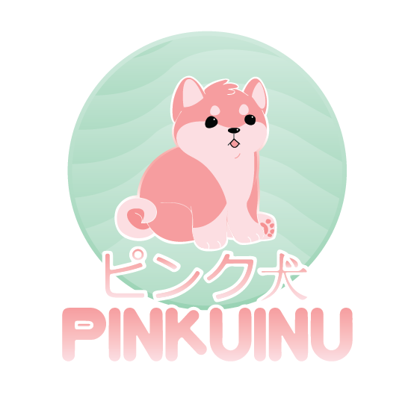

**Roster**

|  |  |  |
| --- | --- | --- |
| Team Member | Role | Signature |
| **Abigail Weber** | **Technology** |  |
| **Tyler Gonzalez** | **Programming** |  |
| **Carlos Torres** | **Art** |  |

## Week 1:

Form a team. Establish a general outline for when team members are capable of meeting up. Nail down basic game attributes such as general character and level design as well as other basic game ideas.

Project Items Worked On:

1. Team Contract
2. Concept Document
3. Production Plan
4. Concept Art
5. Wireframes

## 

## Week 2:

Create concept art and layouts. Begin moving into prototyping and initial modeling. Possibly begin documentation that has not already been started.

Project Items Worked On:

1. Concept Art
2. Functional Prototype
3. ASG (optional)
4. GDD (optional)

## 

## Week 3:

Have main character models done. Begin further modeling, especially for the rooms and hallway. Begin making 2D assets that will be implemented into final game. Have prototype scenes in Unity that match concept designs, including HUD and menus. Try to wrap-up any remaining documentation.

Project Items Worked On:

1. Wireframes with Menus and HUD in XD
2. Character 3D Models
3. 2D Assets
4. Final Unity Project
5. ASG
6. GDD

## 

## Week 4:

Finish, or update, documentation. Finish all 3D models, wrap up 2D asset production, and animations. Have a working, viable prototype with finished coding and implementation for the Unity Project. Begin testing and polishing.

Project Items Worked On:

1. 3D Models
2. 2D Assets
3. ASG
4. GDD
5. Animations
6. Final Unity Project
7. Final Working Game

## Week 5:

Finish implementing music and assets. Full game polish and testing.

Project Items Worked On:

1. Music
2. Final Unity Project
3. Final Working Game