How Do Web-Pretrained DINOv3 Features Extend to Martian Terrain? Appearance, Adaptation and Errors on AI4Mars
Gonzalo Quispe¹, Gustavo Meza¹, David Rodríguez¹
¹Pontificia Universidad Católica del Perú, Lima, Peru
Contact: gquispeo@pucp.edu.pe · meza.gustavo@pucp.edu.pe · david.rodriguezc@pucp.edu.pe

1. INTRODUCTION
Foundation vision models such as DINOv3 [1] are pretrained on web images, yet they are increasingly used on scenes that look nothing like the web, such as the surface of Mars. Rovers need to tell soil, bedrock, sand and big rock apart, and expert labels are scarce. We ask how the features of a frozen DINOv3 extend to the Martian domain (AI4Mars [2]) from three angles: (P1) is the gap one of image appearance, (P2) where in the network is it worth adapting, and (P3) where does the model fail and does it know. Supervised segmenters trained end to end reach about 0.67–0.70 mIoU on the hardest expert test set [3,4]; frozen DINO backbones have been used on Mars only on other data and tasks [5], and we found no controlled study of adaptation depth or of calibration on AI4Mars.

2. METHODOLOGY
We use the Curiosity NavCam subset of AI4Mars [2] at 512 px: 15,564 training images, 500 validation images held out by acquisition time, and the three expert test sets M1, M2 and M3 (322 images each; labels agreed by at least 1, 2 or 3 experts). The backbone is a frozen DINOv3 ViT-B/16 [1] with a linear probe (4.6 k trainable parameters), read at several layers, plus a decoder (3.5 M) and partial fine-tuning of the last blocks. For P1 we retrain the probe on images changed only in appearance (histogram equalisation, CLAHE, standardisation, Gaussian blur). For P2 we add rank-8 LoRA [6] (221 k parameters) to two consecutive blocks, early (1–2), middle (6–7) or late (11–12). For P3 we compare mIoU on pixels where three experts agree against pixels labelled by one, and measure calibration (ECE). A DeepLabV3-R50 trained end to end under the same budget (3 epochs) is the baseline. Differences use paired block-bootstrap 95 % intervals; a difference is real if the interval excludes 0 and |Δ| ≥ 0.01, equivalent if it lies inside ±0.01. Three hypotheses, one per question, and their decision rules were written down before the runs.

3. RESULTS AND DISCUSSION
Reference. The probe reaches 0.674 / 0.723 mIoU on M1 / M2, level with DeepLabV3-R50 (0.667 / 0.713; M1 difference −0.007, 95 % CI [−0.025, +0.008]) at about 8,600 times fewer trainable parameters (Table 1).
Layers and heads. On the final layer the probe reaches 0.677 / 0.725 (M1 / M2); no intermediate layer beats it, a decoder and fine-tuning the last four blocks add at most 0.012, and a random-init ViT gets 0.264.
P1, appearance. CLAHE and standardisation are equivalent to the original images on M1 (+0.001) and none of the transforms helps; blur does not hurt either (−0.002). The gap does not look photometric; the data on M2 cannot settle it.
P2, where to adapt. LoRA adds +0.005 to +0.007 mIoU in every zone and the zones do not differ (late − early: −0.000 on M1, [−0.006, +0.015]): adaptation adds little wherever it goes.
P3, errors. mIoU is 0.862 where three experts agree and 0.546 where one labelled (+0.315, [+0.180, +0.413]), so part of the ceiling is label ambiguity. Calibration is good overall (ECE 0.029) but on pixels predicted as big rock confidence exceeds accuracy by 0.674 [+0.435, +0.762], and 45 % of big-rock pixels are missed.
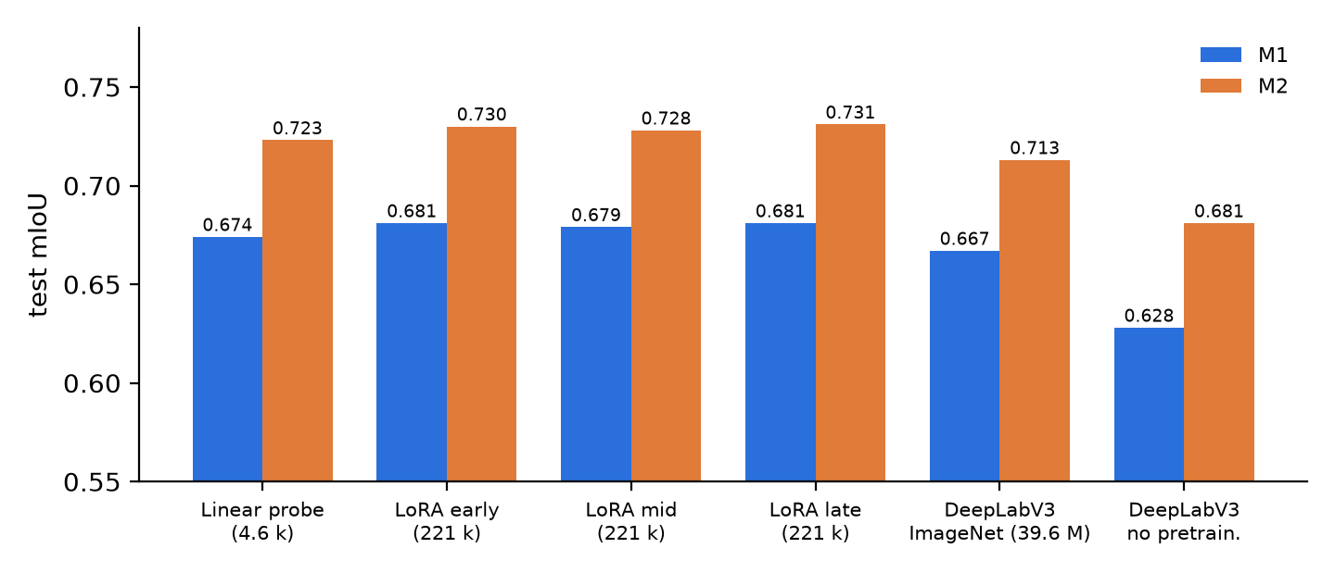
Fig. 1. Test mIoU of the probe, LoRA by zone and DeepLabV3 baselines.
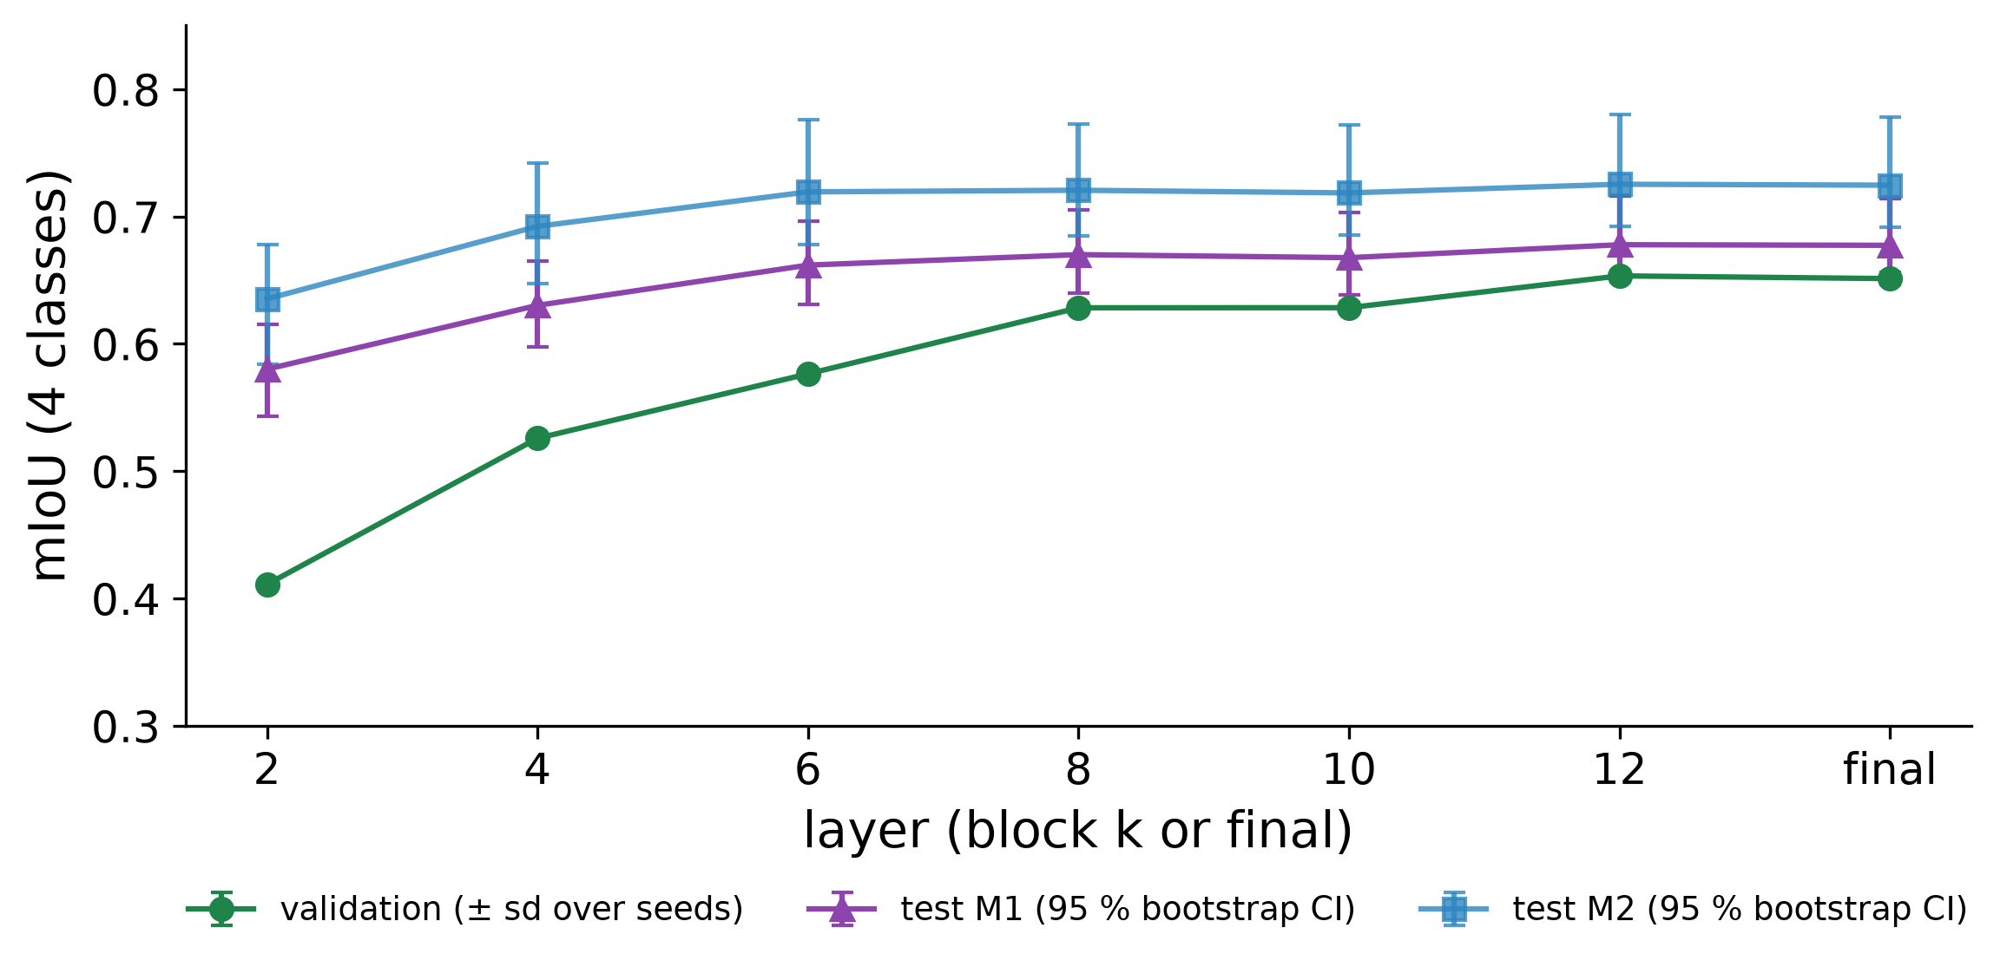
Fig. 2. mIoU of the linear probe at each layer of frozen DINOv3 (validation ± sd over 3 seeds; test sets with 95 % bootstrap CI).
Table 1. Test mIoU (4 classes), 15,564 training images. LoRA: 2 seeds; baselines: 1 seed, 3 epochs.
Model | Trainable | M1 | M2
Probe, frozen DINOv3 (3 seeds) | 4.6 k | 0.674 | 0.723
+ LoRA early (blocks 1–2) | 221 k | 0.681 | 0.730
+ LoRA middle (blocks 6–7) | 221 k | 0.679 | 0.728
+ LoRA late (blocks 11–12) | 221 k | 0.681 | 0.731
DeepLabV3-R50, ImageNet (1 seed) | 39.6 M | 0.667 | 0.713
DeepLabV3-R50, no pretraining | 39.6 M | 0.628 | 0.681

4. CONCLUSIONS
Web-pretrained DINOv3 features already work on Mars with almost no adaptation: a 4.6 k-parameter probe matches an end-to-end DeepLabV3, the gap is not one of image appearance, and adapting early, middle or late blocks adds about 0.006 mIoU. What limits the score is label ambiguity and the rare big-rock class, on which the model is confidently wrong.
Limitations. One backbone, one rover, 322 test images per set; the P1 and P2 hypotheses cannot be decided at this sample size (the P3 one is supported); LoRA uses 2 seeds and 2 epochs, the baseline 1 seed and 3 epochs; M3 holds big rock in only 5 images. These models should not be relied on for hazard detection.
Next steps. Class-aware losses for big rock, cleaner labels, other rovers. Code and results: https://github.com/gonzaquis29/DinoV3-AI4Mars.
Message for discussion. If the ceiling is in the labels, where should the next effort go?
REFERENCES
[1] O. Siméoni et al., “DINOv3,” arXiv:2508.10104, 2025.
[2] R. M. Swan et al., “AI4MARS: A dataset for terrain-aware autonomous driving on Mars,” in CVPR Workshops, 2021.
[3] F. Mohammad, Y. Li and Y. Gao, “Transformers vs CNNs: Enhancing semantic segmentation for Martian terrain classification,” in iSpaRo, 2025.
[4] F. Mohammad et al., “Deep learning based semantic segmentation for Mars rover terrain classification,” in iSpaRo, 2024.
[5] P. Durai and G. Doran, “MANTLE: a framework for adaptive in-situ planetary perception using a modular uplink principle,” arXiv:2608.28724, 2026.
[6] E. J. Hu et al., “LoRA: Low-rank adaptation of large language models,” in ICLR, 2022.

