Frozen DINOv3 Features for Martian Terrain Segmentation: Layer-wise Linear Probing on AI4Mars
Gonzalo Quispe¹, Gustavo Meza¹, David Rodríguez¹
¹Pontificia Universidad Católica del Perú, Lima, Peru
Contact: gquispeo@pucp.edu.pe · meza.gustavo@pucp.edu.pe · david.rodriguezc@pucp.edu.pe

1. INTRODUCTION
Autonomous rovers need to recognize the terrain they drive on (soil, bedrock, sand, big rock), but expert labels of Mars are scarce and costly. Self-supervised foundation models such as DINOv3 [1] are pretrained on web images and evaluated mostly on natural-image benchmarks, so it is unclear how well their frozen features transfer to a very different domain: grayscale imagery, repetitive textures and unusual illumination. We study this transfer on AI4Mars [2] with a minimal linear head and then with heavier heads, and ask (i) how well frozen DINOv3 features segment Martian terrain, (ii) whether the result comes from pretraining rather than from the architecture, (iii) which layers carry the useful information and (iv) how much a larger head or fine-tuning adds. Published AI4Mars baselines [3,4] train convolutional or transformer segmenters end to end; none of the seven AI4Mars baseline papers we reviewed uses a frozen foundation backbone (MANTLE [7] does, for binary boulder segmentation on its own MSL data).

2. METHODOLOGY
Data. We use the Curiosity NavCam subset of AI4Mars [2] at 512×512 px; unlabeled pixels are ignored. Training uses 15,564 images with the crowdsourced labels; layers and epochs are chosen on a validation split of 500 training-set images held out by acquisition time; the official 322-image expert test set is used only to confirm, in its three variants M1, M2 and M3 (agreement of at least 1, 2 or 3 experts), reported separately and scored at native label resolution.
Model. DINOv3 ViT-B/16 [1] (86 M parameters) is kept frozen. Patch features are read at blocks 2, 4, 6, 8, 10, 12 and after the final normalization (Fig. 1), and the same linear probe (batch normalization and a 1×1 convolution, 4,612 trainable parameters) is trained on each one [5]. We also train a decoder fusing blocks 3, 6, 9 and 12 (3.5 M parameters) and fine-tune the last 2 or 4 blocks (14 M / 28 M), all with three seeds.
Evaluation. We report mIoU over the four classes with 95 % paired bootstrap confidence intervals over images; a difference counts as real if its interval excludes 0 and |Δ| ≥ 0.01. Six hypotheses and their decision rules were written down before the final run; hypotheses that the data do not settle are reported as inconclusive.
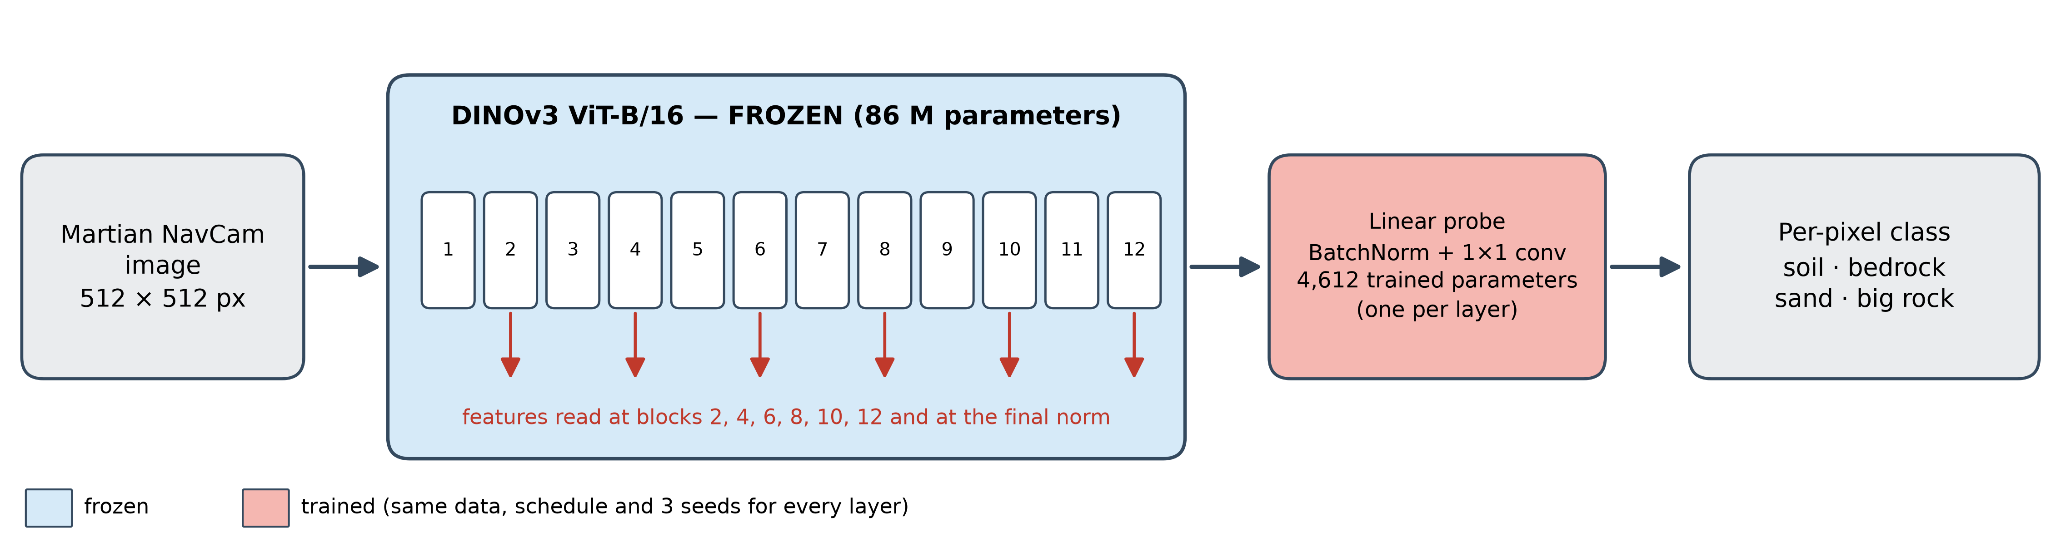
Fig. 1. Frozen DINOv3 ViT-B/16 with one trained linear probe per tapped layer.

3. RESULTS AND DISCUSSION
Transfer. A linear probe on the final layer reaches mIoU 0.677 / 0.725 on test M1 / M2 (0.651 on validation; 0.125 for always predicting the majority class). On M3 it reaches 0.827, but see Failures.
Heavier heads add little. The decoder reaches 0.684 / 0.735 and fine-tuning the last 4 blocks 0.687 / 0.737: at most +0.012 over the probe (decoder minus probe on M1: +0.007, 95 % CI [−0.001, +0.019]). Only 250 labelled images give 99 % of the probe's M1 mIoU obtained with 4,000.
Pretraining matters. A random-init ViT-B/16 reaches 0.264 on M1 (DINOv3: +0.413). DINOv2 B/14 reaches 0.664; DINOv3 is +0.013 higher on M1 (95 % CI [+0.002, +0.025]) but not clearly on M2; matching the token grid (DINOv2 at 448 px) leaves the gap unchanged (+0.014 on M1, 95 % CI [+0.003, +0.026]).
Published baselines. The probe is level with the 512-px published models and 0.023 / 0.015 below the best (UPerNet Swin-S at 1,024 px [3]) on M1 / M2; fine-tuning the last 4 blocks is 0.013 / 0.003 below, with 0.005–28 M trainable parameters instead of 47–81 M (Table 1). The comparison is indicative: published values are single runs on another split.
Layers. mIoU rises with depth and block 6 already gives 98 % of the final M1 value. No intermediate layer beats the last one: the best on validation (block 10) is −0.010 on M1 (95 % CI [−0.021, +0.001]).
Label borders. Excluding an 8 px band around label edges raises every head by about 0.025 mIoU on M1 (probe 0.677 → 0.702), consistent with, but not proof of, label noise at region borders.
Failures. Big rock is the hardest class (validation IoU 0.24 for the probe against 0.62–0.88 for the others, and 0.13 / 0.12 on test M1 / M2; 69 % of its pixels are predicted as bedrock). It appears in only 5 of the 322 images of M3 (77,698 px): every model finds 96–99 % of them and they differ in false alarms (probe 109 k px, decoder 16 k px), which drives the M3 gap (0.83 vs 0.93); without big rock all models score 0.96–0.97. M3 cannot rank models on this class.
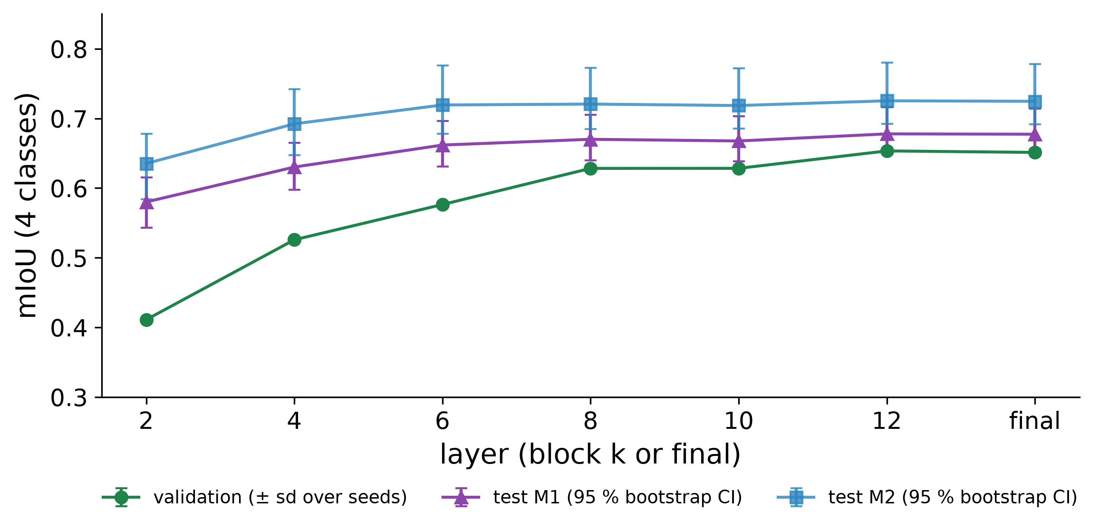
Fig. 2. mIoU of the linear probe at each layer of frozen DINOv3 (validation ± sd over 3 seeds; test sets with 95 % bootstrap CI).
Table 1. Test mIoU (4 classes), mean ± sd over 3 seeds: heads on frozen DINOv3 (and fine-tuning) versus published end-to-end models. M3 is dominated by big-rock false alarms.
Method | M1 | M2 | M3 | Trainable
Majority class | 0.115 | 0.123 | 0.128 | –
Probe, block 6 | 0.662 ± 0.001 | 0.719 ± 0.001 | 0.872 ± 0.007 | 4.6 k
Probe, final norm | 0.677 ± 0.001 | 0.725 ± 0.002 | 0.827 ± 0.018 | 4.6 k
Decoder (blocks 3, 6, 9, 12) | 0.684 ± 0.001 | 0.735 ± 0.001 | 0.931 ± 0.006 | 3.5 M
Last 4 blocks fine-tuned | 0.687 ± 0.002 | 0.737 ± 0.002 | 0.927 ± 0.021 | 28 M
DINOv2 B/14, probe (N = 2,000) | 0.664 ± 0.003 | 0.714 ± 0.004 | 0.798 ± 0.010 | 4.6 k
Random-init ViT, probe (N = 2,000) | 0.264 ± 0.011 | 0.272 ± 0.012 | 0.272 ± 0.015 | 4.6 k
DeepLabV3+ R101, 512 px [3] | 0.67 | 0.72 | 0.82 | 58.8 M
UPerNet Swin-S, 1,024 px [3] | 0.70 | 0.74 | 0.94 | 81.2 M

4. CONCLUSIONS
Frozen DINOv3 features transfer to Martian terrain without adapting the backbone: a linear probe is within 0.025 mIoU of the best published end-to-end model on M1 and M2, heavier heads add at most 0.012, the gain comes from pretraining, and no intermediate layer beats the last one.
Limitations. One backbone, one rover, three seeds and 322 test images per variant; only one of six pre-specified hypotheses was supported and the rest are inconclusive at this sample size; M3 cannot rank models on big rock; the baseline comparison is indicative.
Next steps. Retraining a published baseline under the same protocol, other rovers or datasets, big-rock-oriented losses. Code and results: https://github.com/gonzaquis29/DinoV3-AI4Mars.
Message for discussion. How much of the M1/M2 ceiling is label noise, and how should rare classes be evaluated?
REFERENCES
[1] O. Siméoni et al., “DINOv3,” arXiv:2508.10104, 2025.
[2] R. M. Swan et al., “AI4MARS: A dataset for terrain-aware autonomous driving on Mars,” in CVPR Workshops, 2021.
[3] F. Mohammad, Y. Li and Y. Gao, “Transformers vs CNNs: Enhancing semantic segmentation for Martian terrain classification,” in Int. Conf. Space Robotics (iSpaRo), 2025.
[4] F. Mohammad et al., “Deep learning based semantic segmentation for Mars rover terrain classification,” in Int. Conf. Space Robotics (iSpaRo), 2024.
[5] G. Alain and Y. Bengio, “Understanding intermediate layers using linear classifier probes,” arXiv:1610.01644, 2016.
[6] E. Goh, J. Chen and B. Wilson, “Mars terrain segmentation with less labels,” arXiv:2202.00791, 2022.
[7] P. Durai and G. Doran, “MANTLE: a framework for adaptive in-situ planetary perception using a modular uplink principle,” arXiv:2608.28724, 2026.

