The prevention and response plan that Siyana forwarded describes two interventions that are being planned at the camp. The first focuses on handwashing, masks, and general sanitation. This is similar to the transmission reduction intervention that we have already modelled and is already underway. The second is to identify individuals with COVID-19 and isolate them and their families at a site away from the camp. In preparation for this, managers have identified temporary housing for up to a few hundred people.

I wondered two things about this second intervention. First, can it work? That is, should we expect it to reduce the total or peak number of infections in the population? Second, if it can work, how difficult will it be? That is, how quickly do we have to identify and remove symptomatic individuals and their families, and how many people will we have to isolate?

To answer these questions, I added a remove-and-isolate intervention to our model. In this intervention, we identify symptomatic people with some probability, and remove them and their families from the camp. If they are removed from the camp, they cannot infect others, but they continue through the stages of the disease in isolation. They return to the camp when they have been virus-free for 7 days (i.e., on day 7 after recovery). I have modelled this intervention i) in combination with transmission reduction only (since those efforts are ongoing), and ii) in combination the other three interventions we have advocated. I also modelled three different success rates with which we might identify and remove people. The first is perfect identification – at the first sniffle or cough we instantly appear and whisk the entire household out of the camp. The second assumes that we remove households on average on the second day of symptoms, and the third assumes we remove them on average on the fourth day of symptoms. To answer my first question I studied the total number of infections over time, and to answer my second question I studied the total number of people in isolation over time.

**Question 1: Will the remove and isolate intervention work?**

In the absence of sectoring or lockdown, the effect of the remove-and-isolate intervention is small. The table below shows the peak number of people infected, the number of days until peak infection, and the total proportion of the population that eventually becomes infected without the remove-and-isolate intervention, and with identification and removal on three different days. (Values are medians, not means.)

**Table 1**

|  |  |  |  |
| --- | --- | --- | --- |
|  | peak infection | days to peak | total % infected |
| transmission reduction only | 15,018 | 32 | >99% |
| w/ remove and isolate on day 4 | 14,317 | 36 | >99% |
| w/ remove and isolate on day 2 | 13,994 | 36 | >99% |
| w/ remove and isolate on day 1 | 13,586 | 38 | >99% |

Figure 1 shows representative trajectories for each of the cases above.



Not surprisingly, quick identification and removal is best, but even that achieves only ~10% reduction in the peak infections (see table). In each case, the entire population eventually becomes infected.

The reason for the disappointing performance of remove-and-isolate is that much of the transmission occurs when infected people are presymptomatic or asymptomatic. So, by the time we remove someone, they have already infected others, and we are always playing catch-up. We are, quite literally, treating the symptoms and not the disease.

In combination with lockdown and sectoring (16 sectors), the performance of the remove-and-isolate intervention is markedly better.

**Table 2**

|  |  |  |  |  |
| --- | --- | --- | --- | --- |
|  | peak infection | days to peak | total % infected | epidemics extinct |
| other 3 interventions | 5,673 | 57 | >99% | 0 |
| w/ remove and isolate on day 4 | 4,500 | 68 | 98% | 5% |
| w/ remove and isolate on day 2 | 3,616 | 78 | 95% | 15% |
| w/ remove and isolate on day 1 | 3,058 | 76 | 91% | 25% |



In the presence of the other interventions, the infection cannot move as fast or as far, and sometimes we can stamp it out locally before it takes hold. Column 4 of the table above shows the proportion of epidemics that are stamped out in the camp by day 20. However, if we fail to stamp out the epidemic in its earliest days, then we have very little ability to control it, and we end up with 1000s of people infected at the same time.

**Question 2: How difficult will it be to do?**

Unfortunately, even in the best of cases, the remove-and-isolate intervention may be more difficult to achieve than is currently being anticipated. The table below shows the peak number of people in isolation under each combination of interventions we modelled (again, medians, not means).

**Table 3**

|  |  |  |
| --- | --- | --- |
| identification on | transmission reduction | all interventions |
| none | 0 | 0 |
| on day 4 | 13,881 | 4,858 |
| on day 2 | 14,277 | 4,150 |
| on day 1 | 14,297 | 3,616 |

The figures below show representative trajectories for people in isolation when remove-and-isolate is combined with transmission control only (left), or when it is combined with all three other interventions (right). In each case, the maximum number of people in isolation is on the order of thousands, not hundreds.



If we are able to control the epidemic in its earliest days (rightmost column of table 2), then we end up with only few families in isolation, and the facilities that are currently being planned are likely to be adequate. However, if the epidemic escapes control, as it most often does, then we will need to isolate at least 1000s of people at a time, and we may need much greater isolation capacity than is currently being planned. If we expect multiple introductions of the virus to the camp (rather than just one as I have modelled here), then it is much more likely that at least one of those introductions will escape control, and the isolation requirements will be large rather than small.

**Caveat**

When we start to talk about numbers (e.g., thousands vs. hundreds in isolation), we are thinking about quantitative results of the model rather than qualitative, and quantitative results can be sensitive to parameter values. Some of the parameter values in our model are guesses. The parameter values I worry about most are those that describe i) where and how often people interact in the immediate vicinity around their homes (because I made those up), and ii) the probability of infection transmission per human-human contact (which came from Fang et al. 2020 *Medical Virology*, but *they* appear to have made it up). Indeed, under some sets of parameter values, the remove-and-isolate strategy looks both effective and doable.

The table and figures below illustrate the case where the per interaction transmission rate is 0.0125 rather than the 0.1 assumed by Fang et al. (2020). (Medians are from only those simulations with epidemics that lasted at least 20 days.)

**Table 4**

|  |  |  |  |  |  |
| --- | --- | --- | --- | --- | --- |
|  | peak infection | days to peak | total % infected | peak in isolation | epidemics extinct |
| other 3 interventions | 3,944 | 84 | 99% | 0 | 0 |
| w/ remove and isolate on day 4 | 2,281 | 100 | 83% | 2,508 | 10% |
| w/ remove and isolate on day 2 | 1,076 | 127 | 46% | 1308 | 25% |
| w/ remove and isolate on day 1 | 175 | 47 | 3.5% | 215 | 45% |

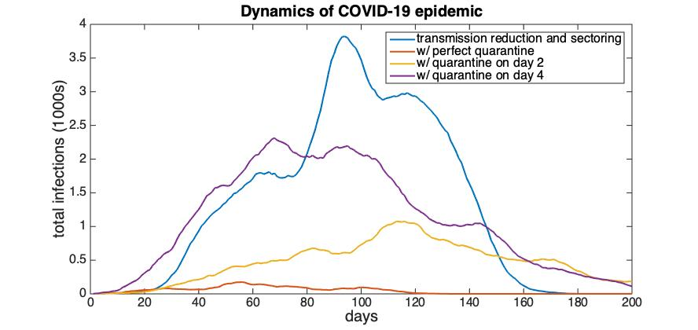

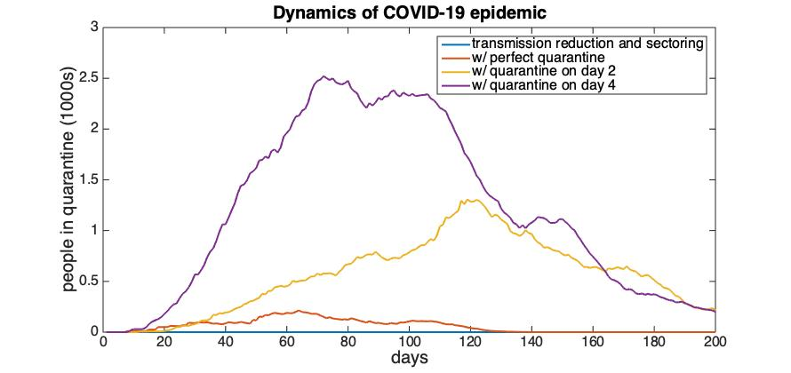

So, under at least some sets of parameter values, a remove-and-isolate intervention could be very successful. But, to make this happen, we had to assume:

1. All of the other interventions are in place*,
2. We can (perhaps with the aid of masks, hand washing, etc.) reduce the per contact transmission rate to approximately 10% of what is being assumed in other models,
3. People follow the lock-down rules 95% of the time,
4. The camp can be divided into 16 sectors for food distribution, and
5. We can find and isolate households on the very day that the first member of that household shows symptoms.

To me, it seems ambitious to think we can do all of this successfully.

**Take home massage**

I am sceptical of the remove-and-isolate plan. That doesn’t mean we shouldn’t try, if we have the resources. It is unlikely to make the problem worse. But, it cannot be an alternative to the other interventions, it has to work in conjunction with them. And, if we do it, we might need to be prepared for the possibility that we have to isolate a lot of people.

*Just to show that this is true, here are the results with transmission reduced to 0.0125 per interaction, but without lockdown or sectoring:

**Table S1**

|  |  |  |  |  |  |
| --- | --- | --- | --- | --- | --- |
|  | peak infection | days to peak | total % infected | peak in isolation | epidemics extinct |
| transmission reduction only | 12,693 | 44 | >99% | 0 | 0% |
| w/ remove and isolate on day 4 | 10,561 | 49 | 98% | 10,874 | 0% |
| w/ remove and isolate on day 2 | 9,621 | 50 | 97% | 10,584 | 5% |
| w/ remove and isolate on day 1 | 8,486 | 55 | 95% | 9,774 | 10% |

