**Aprendizaje automático y minería de datos: Práctica 5**

Jorge Rodríguez García y Gonzalo Sanz Lastra

Código de la práctica:

Parte 1:

def load_mat(file_name):

"""carga el fichero mat especificado y lo devuelve en una matriz data"""

return loadmat(file_name)

def functionGraphic(X, Y, clf):

# pintamos muestras de entrenamiento

pos = np.where(Y==1)[0]

plt.scatter(X[pos, 0], X[pos, 1], marker='+', c= 'k')

pos = np.where(Y==0)[0]

plt.scatter(X[pos, 0], X[pos, 1], marker='o', c= 'y')

ax = plt.gca()

xlim = ax.get_xlim()

ylim = ax.get_ylim()

# create grid to evaluate model

xx = np.linspace(xlim[0], xlim[1], 30)

yy = np.linspace(ylim[0], ylim[1], 30)

YY, XX = np.meshgrid(yy, xx)

xy = np.vstack([XX.ravel(), YY.ravel()]).T

Z = clf.decision_function(xy).reshape(XX.shape)

# plot decision boundary and margins

ax.contour(XX, YY, Z, colors='k', levels=[0]

#, alpha=0.5, linestyles=['--', '-', '--']

)

# plot support vectors

#ax.scatter(clf.support_vectors_[:, 0], clf.support_vectors_[:, 1], s=100,

# linewidth=1, facecolors='none', edgecolors='k')

plt.savefig('TrainingExamples.png')# plot the decision function

plt.show()

def main():

valores = load_mat("ex6data3.mat")

X = valores['X'] # datos de entrenamiento

y = valores['y']

Xval = valores['Xval'] # datos de validacion

yval = valores['yval']

C = 0.01

sigma = 0.01

maxCorrects = 0

bestC = C

bestSigma = sigma

# probamos la mejor combinacion de C y sigma que de el menor error

for i in range(8):

C = C * 3

sigma = 0.1

for j in range(8):

sigma = sigma * 3

clf = SVC(kernel='rbf', C=C, gamma= 1/(2*sigma**2))

clf.fit(X, y)

corrects = (yval[:, 0] == clf.predict(Xval)).sum()

if maxCorrects < corrects:

maxCorrects = corrects

bestC = C

bestSigma = sigma

clf = SVC(kernel='rbf', C=bestC, gamma= 1/(2*bestSigma**2))

clf.fit(X, y)

functionGraphic(X, y, clf)

main()

Ajuste después de aplicar SVM con las mejores C y sigma:

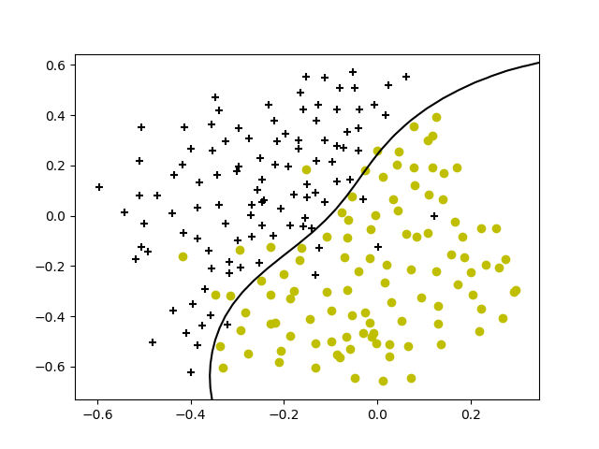

Parte 2:

def emailToWordOcurrence(email, wordsDict):

result = np.zeros(len(wordsDict))

for i in range(len(email)):

if email[i] in wordsDict:

index = wordsDict.get(email[i]) - 1

result[index] = 1

return result

def dataManager(ini, fin, directoryName, yValue):

X = np.empty((0, 1899)) # 60% de 500

Y = np.empty((0, 1))

for i in range(ini + 1, fin + 1):

email_contents = codecs.open('{0}/{1:04d}.txt'.format(directoryName, i), 'r',

encoding='utf-8', errors='ignore').read()

email = email2TokenList(email_contents)

wordsDict = getVocabDict()

wordOcurrence = emailToWordOcurrence(email, wordsDict)

X = np.vstack((X, wordOcurrence))

Y = np.vstack((Y, yValue))

return X, Y

def main():

Xspam, Yspam = dataManager(0, 300, "spam", 1)

Xeasy, Yeasy = dataManager(0, 1531, "easy_ham", 0)

Xhard, Yhard = dataManager(0, 150, "hard_ham", 0)

X = np.vstack((Xspam, Xeasy))

X = np.vstack((X, Xhard))

Y = np.vstack((Yspam, Yeasy))

Y = np.vstack((Y, Yhard))

XspamVal, YspamVal = dataManager(300, 400, "spam", 1)

XeasyVal, YeasyVal = dataManager(1531, 2041, "easy_ham", 0)

XhardVal, YhardVal = dataManager(150, 200, "hard_ham", 0)

Xval = np.vstack((XspamVal, XeasyVal))

Xval = np.vstack((Xval, XhardVal))

Yval = np.vstack((YspamVal, YeasyVal))

Yval = np.vstack((Yval, YhardVal))

XspamTest, YspamTest = dataManager(400, 500, "spam", 1)

XeasyTest, YeasyTest = dataManager(2041, 2551, "easy_ham", 0)

XhardTest, YhardTest = dataManager(200, 250, "hard_ham", 0)

Xtest = np.vstack((XspamTest, XeasyTest))

Xtest = np.vstack((Xtest, XhardTest))

Ytest = np.vstack((YspamTest, YeasyTest))

Ytest = np.vstack((Ytest, YhardTest))

bestC = 21.87

bestSigma = 8.1

clf = SVC(kernel='rbf', C=bestC, gamma= 1/(2*bestSigma**2))

clf.fit(X, Y)

corrects = (Ytest[:, 0] == clf.predict(Xtest)).sum()

print((corrects / Xtest.shape[0])*100)

main()